**Flame sensors and gas sensor.**

Names and PRn no, : Nadaf Sumaiyya , 12111185; Nagrale Aditya ,12110845; Nagrale rutuj, 12110525; Nagre Hrucha,12110911.

Department of Engineering, Sciences and Humanities (DESH)

*Abstract— In the past few decades many studies and researches have taken place in order to improve security systems and to increase their level of protection in different fields. One of the major problems that security must deal with is the fire outbreak that can happen in everywhere including houses , schools , factories and many other places, and to avoid that or to minimize the damage caused by fire outbreak an IOT technology is used to control such a kind of risk. IoT is a modern system that consist of sensors and switches connected to a central hub which called (gate way. In this project we will use temperature sensor known as (Flame sensor) with Arduino device to detect fire outbreak and to measure the amount of heat intensity generated by a fire outbreak or in a specific location in our house, offices and other places. It sometimes take to much time for the fire station to reach to the fire outbreak location and works on extinguish the fire and so these sensors will work as an early alarm system which will send an email notification to our mobile phones, fire stations and hospitals if any fire outbreak occurred to let us know the situation clearly and before its too late, we act to avoid significant damage in case the fire outbreak was observed after a long time from its outbreak.*

Keywords— Arduino UNO, MQ-135 Gas Sensor, DH-11 sensor, GSM Module, LCD and Buzzer.

# Introduction

**Gas leak detection** is the process of identifying potentially hazardous gas leaks by sensors. Additionally a visual identification can be done using a thermal camera These sensors usually employ an audible alarm to alert people when a dangerous gas has been detected. Exposure to toxic gases can also occur in operations such as painting, fumigation, fuel filling, construction, excavation of contaminated soils, landfill operations, entering confined spaces, etc. Common sensors include combustible gas sensors, photoionization detectors, infrared point sensors, ultrasonic sensors, electrochemical gas sensors, and metal-oxide-semiconductor sensors (MOS sensors). More recently, infrared imaging sensors have come into use. All of these sensors are used for a wide range of applications and can be found in industrial plants, refineries, pharmaceutical manufacturing, fumigation facilities, paper pulp mills, aircraft and shipbuilding facilities, hazmat operations, waste-water treatment facilities, vehicles, indoor air quality testing and homes.

Gas detectors can be classified according to the operation mechanism (semiconductors,[[4]](https://en.wikipedia.org/wiki/Gas_detector#cite_note-4) oxidation, catalytic, photoionization, infrared, etc.). Gas detectors come packaged into two main form factors: portable devices and fixed gas detectors.Portable detectors are used to monitor the atmosphere around personnel and are either hand-held or worn on clothing or on a belt/harness. These gas detectors are usually battery operated. They transmit warnings via audible and visible signals, such as alarms and flashing lights, when dangerous levels of gas vapors are detected.Fixed type gas detectors may be used for detection of one or more gas types. Fixed type detectors are generally mounted near the process area of a plant or control room, or an area to be protected, such as a residential bedroom. Generally, industrial sensors are installed on fixed type mild steel structures and a cable connects the detectors to a SCADA system for continuous monitoring. A tripping interlock can be activated for an emergency situation.

The below flowchart is the method by which the smoke detector system works.

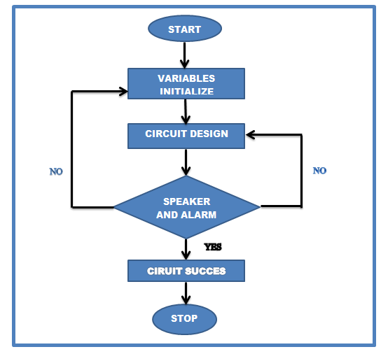

# Implementation details

The hardware of this case consists of Gas sensor, temperature sensor, Arduino microcontroller, MQ-135 sensor that is connected with Arduino through an relay module to control it. A smoke alarm system is made up of a number of devices working together to detect and warn people through visual and audio appliances when smoke, fire, carbon monoxide or other emergencies are present. Fire and smoke that spread within a building can be affected by various factors such as the geometry, dimension, layout and usage of the building. If a detector detects smoke or heat, or someone operates a break glass unit, then alarm sounders operate to warn others in the building that there may be a fire and to abandon.

Here is some over view of our project in form of block diagram(Fig 1) :

Fig 1: Block diagram

|  |  |
| --- | --- |
| **Components Name** | **Quantity** |
| Arduino Uno | 1 |
| MQ-135 Gas Sensor | 1 |
| Flame sensor | 1 |
| Green LED | 2 |
| Red LED | 1 |
| Buzzer | 1 |

## Arduino Fire Alarm Schematics.

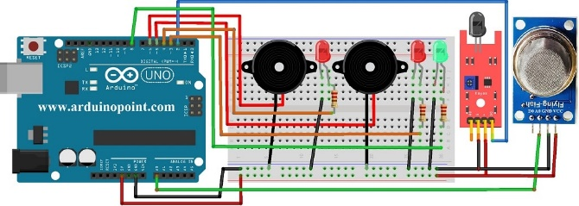

# Results and discussion

When we turn on the system’s power supply, at the same time the MQ2 gas sensor starts to sense the smoke level in the air and it gives the output value to the Arduino. Then the Arduino read this output value and print it on the OLED display in the PPM unit. When the sensor sense smoke in the air, its output value goes high.

When the sensor is in the fresh air, its output value is under 400 ppm. Then the Arduino indicates it by turn on the green LED and the “Fresh Air” message is print on the Display.

When the sensor sense smoke in the air, its output value will exceed 400 PPM. Then the Arduino indicates it by turn on the Red LED and Buzzer, and the “Smoke/ Fire” message is print on the Display.

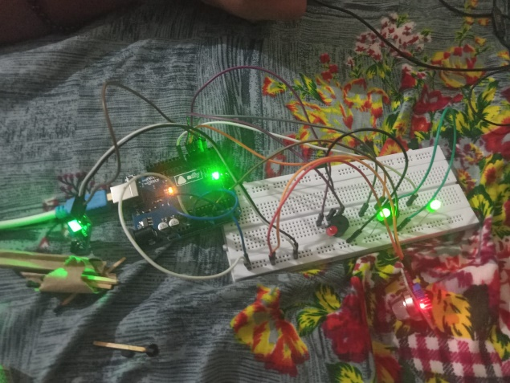

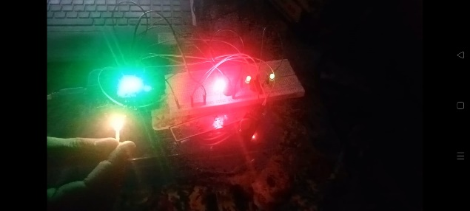

# Conclusion and Future Scope

This paper presents the design and implementation of a cost-effective and reliable automated GSM based fire alarm system. Fire detectors use various sensor, generally a smoke sensor and temperature and humidity sensor. The sensor input data is connected with Arduino controller. LCD display, Buzzer and GSM module also is connected with Arduino for output result. Buzzer is notify for fire alarm and LCD is displayed the fire detection status. GSM module can be informed to specific user to know or prevent their home, office or building. This system can be applied in residential places, offices and hotels. With this system safety is assured. The system can perform different parameter measurements for early detection of building fires. There should be a minimum of two or three smoke and detectors in your home. You should install a smoke and detector on each floor of a house. Always have a smoke and detector and fire alarm system in your home for your own safety. The advantages of the system can help in early reaction, saving lives and property. It can also protects us and our residence.

##### References

List all the books, research papers, websites, etc. that you referred while writing this report in the following format:

1. G. Eason, B. Noble, and I. N. Sneddon, “On certain integrals of Lipschitz-Hankel type involving products of Bessel functions,” Phil. Trans. Roy. Soc. London, vol. A247, pp. 529–551, April 1955. *(references)*
2. J. Clerk Maxwell, A Treatise on Electricity and Magnetism, 3rd ed., vol. 2. Oxford: Clarendon, 1892, pp.68–73.