

A Project Report

On

Bus Booking System

By

Rutuja Koli

B.E

Batch :- 2020 – 4965

Center :- Pune, Chinchwad

Under the Guidance of,

Jayant V.

Technical Trainer

EduBridge

(School of coding)

**Introduction:**

Our project explains about the Bus Booking management. The existing Bus Booking System is not completely computerized. The customer has to visit any booking branch if he wants to book a ticket. Bus scheduling, ticket booking, bill generation and many other operations are done manually. This may lead to incorrect entries and there is a lot of room for errors as the data is not completely synced. The availability of seats is not centrally maintained and the travel operator is not fully aware of the availability and occupancy of the seats in his buses. This is the major bottle neck.

Our Project Includes:-

* Bookings and cancellation Module
* Users Module

I have developed this Application in Java, JSP, Servlets and MySQL. It’s

a web based projects so I have used HTML, CSS also. This module deals with addition and deletion of routes, buses available, pick up points, dropping points, bus codes, passenger details and bus details. He has the complete control over the application. Only admin can perform these functionalities.

**Software Requirements:**

Front end: Java/J2EE technologies (Servlet, JSP), HTML, CSS, JDBC.

Back end: MySQL.

Middleware/Server: Apache Tomcat v 7.0

IDE: Eclipse IDE for Java EE Developers

Browser: Best result on Google Chrome

Operating System: Window 7

**Data Dictionary:**

**Table name: users**

CREATE TABLE users ( userid varchar(20),

password varchar(20),

fname varchar(20),

lname varchar(20),

email varchar(20));

SQL QUERY:

SELECT * FROM user

**Table name: details**

CREATE TABLE details ( userid varchar(20),

pwd varchar(20),

fname varchar(20));

SQL QUERY:

SELECT * FROM user

**Screenshot:**

1. **WELCOME:-**



1. **REGISTRATION:-**

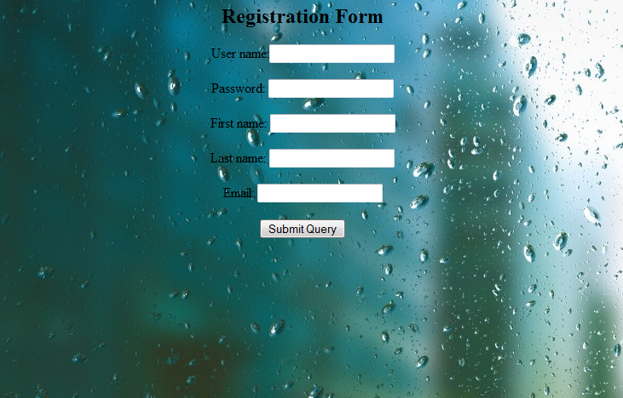

1. **LOGIN:-**

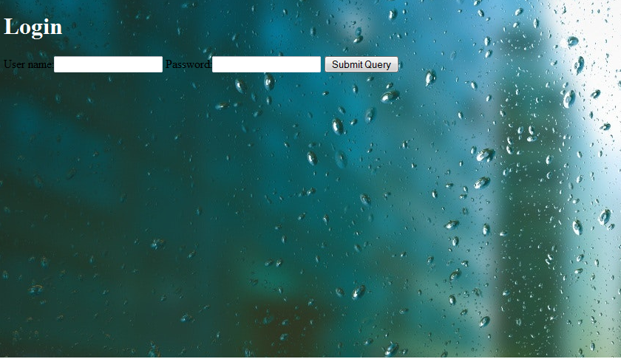

1. **LOGIN SUCCESSFUL:-**

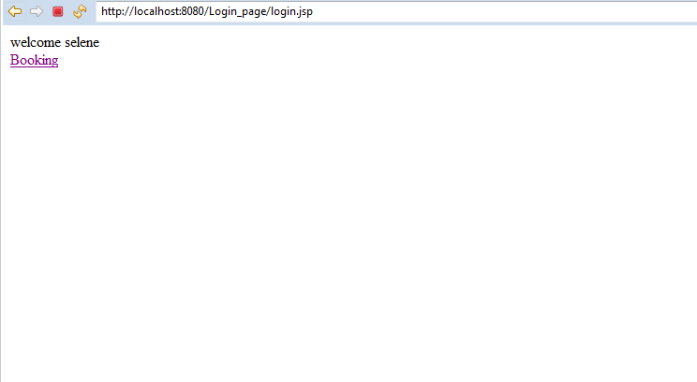

1. **BOOKING:-**

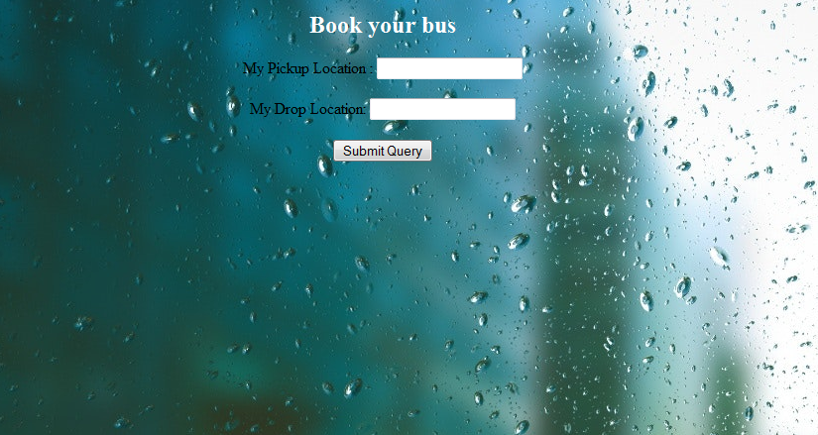

1. **BOOKING SUCCESSFUL:-**

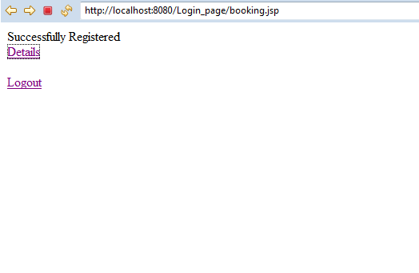

1. **DETAILS:-**

