**CS5590 BD – BID DATA ANALYTICS**

**LAB4 REPORT**

**Name: Roopesh Utukuti**

**Input data is inserted and saved upon Hbase retrieval operation**

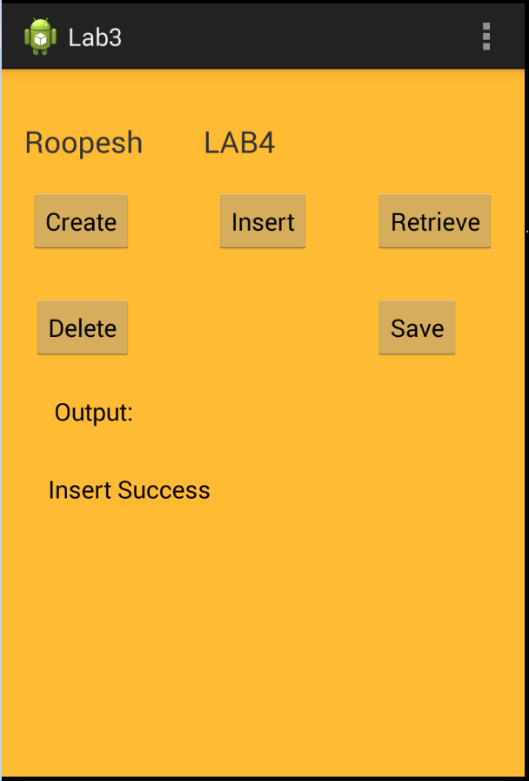

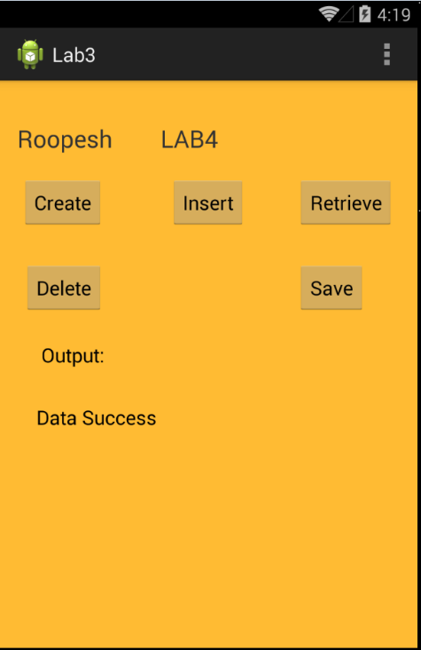

**Input files for training data are converted to sequence files:**

Top to Bottom gesture:

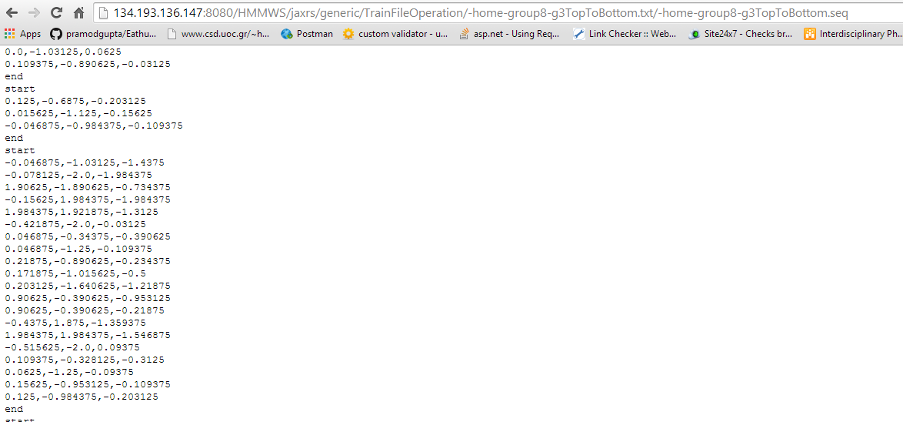

Left to Right Gesture:

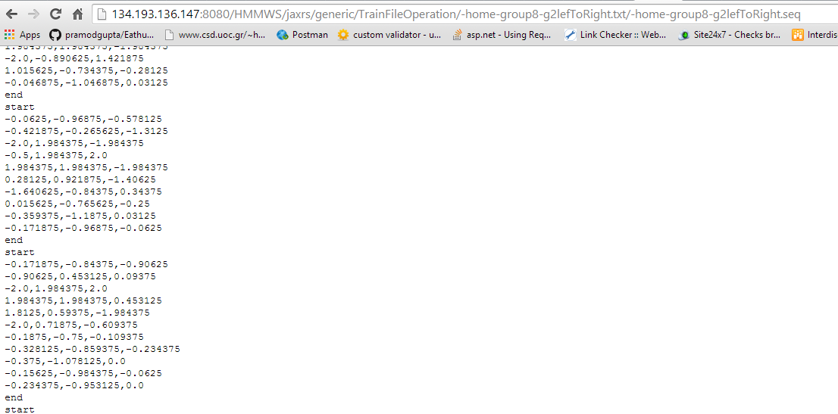

Right to Left gesture:

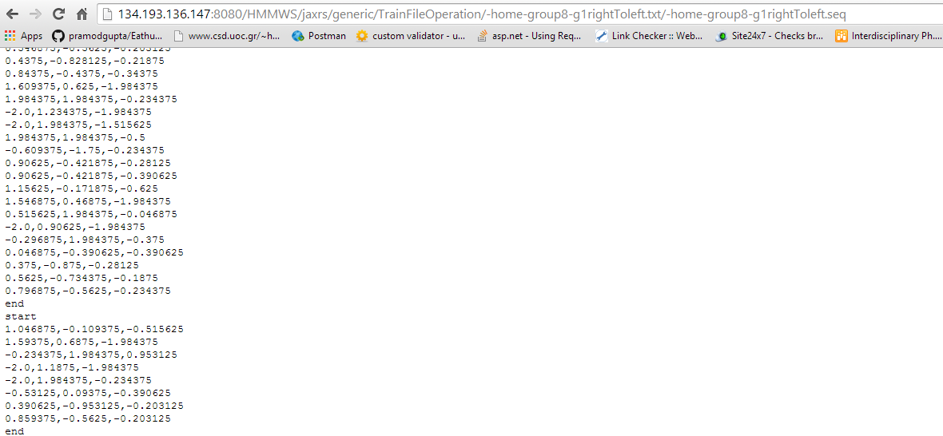

**Testing file:**

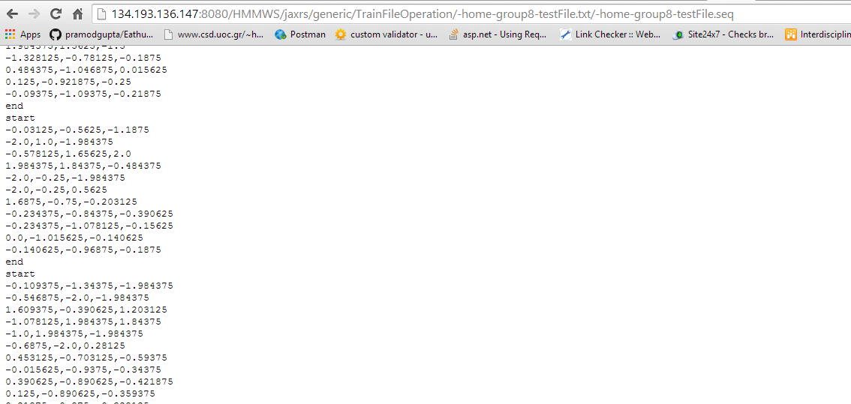

**REST SERVICE:**

URL: http://134.193.136.147:8080/HMMWS/jaxrs/generic/HMMTrainingTest/-home-group8-g1rightToLeft.seq/-home-group8-g2leftToRight.seq/-home-group8-g3TopToBottom.seq/-home-group8-testFile.seq