**Lab 3 Report**

* Roopesh Utukuri

**Sensor data collection:**

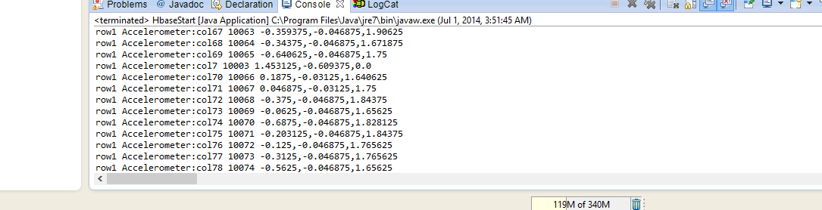

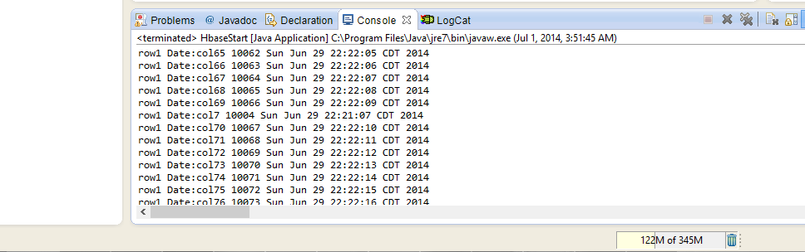

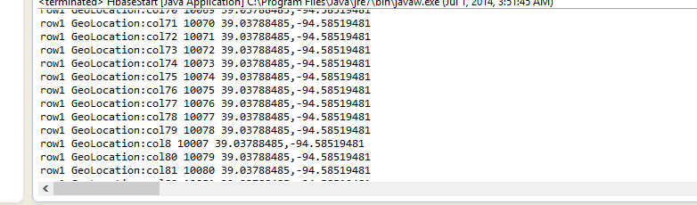

**File transfer using connectSSH:**

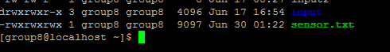

**Glassfish Installation and Deployment:**

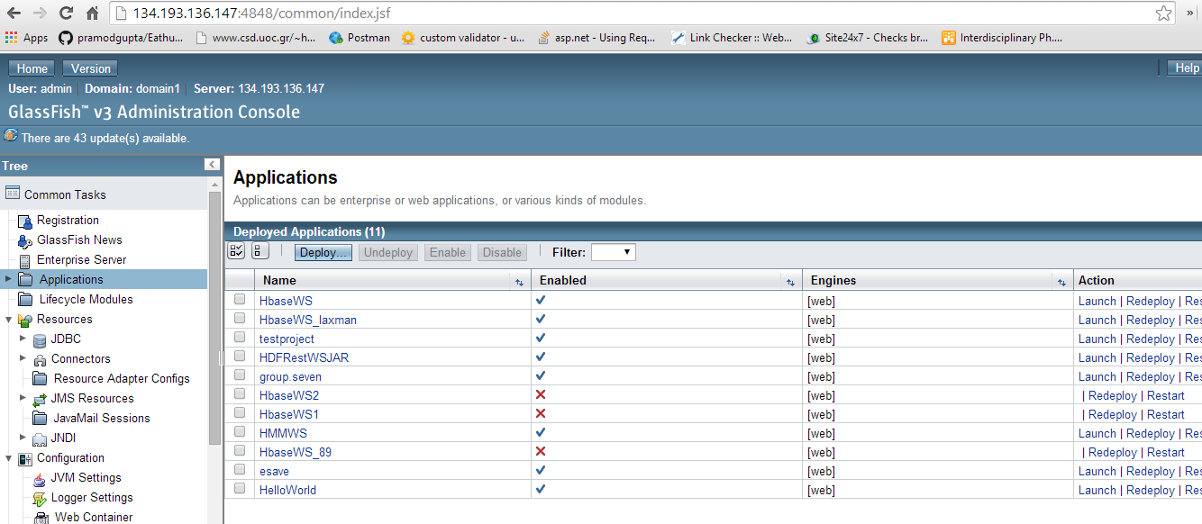

**Hbase CRUD operations:**

**Creation of table:**

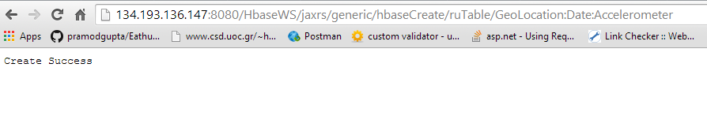

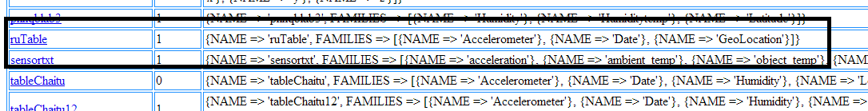

**Inserting values into the table:**

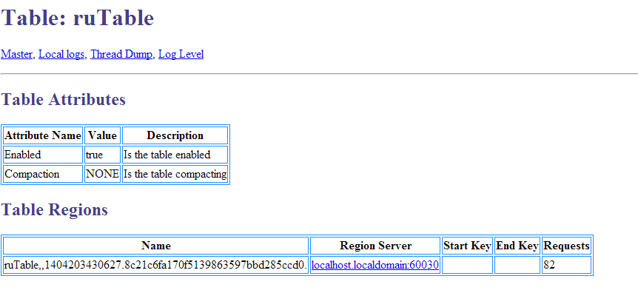

**Retrieval of data from table:**

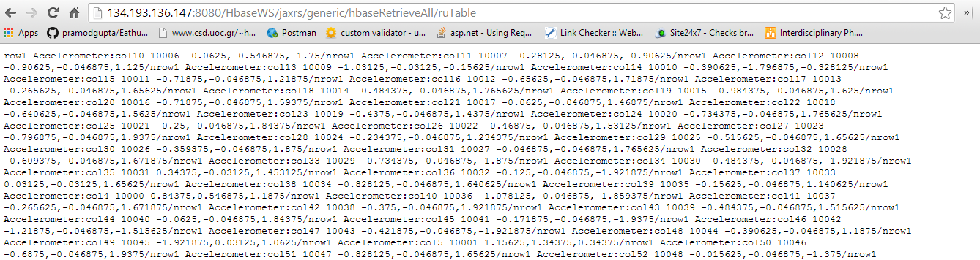

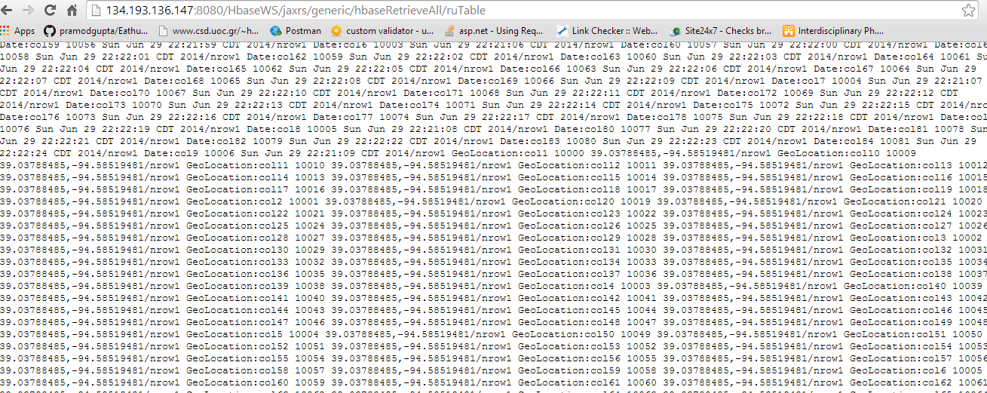

**Deletion of table:**

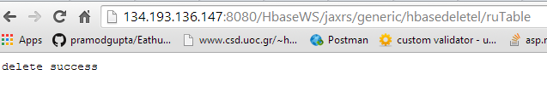

**Creation of table by calling web services:**

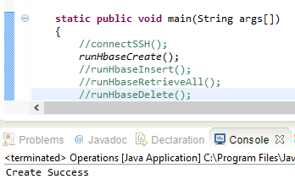

**Deletion of table by calling web service:**

