**CS5590 BIG DATA ANALYTICS**

**LAB5 REPORT**

**Name:** Roopesh Utukuri

**Training App to get gestures:**

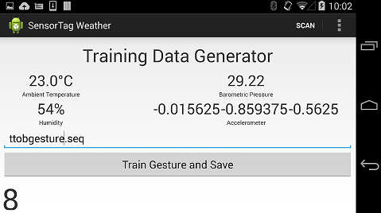

**Test Gesture class:**

The class is changed as below to get right to left, left to right and bottom to top gestures.

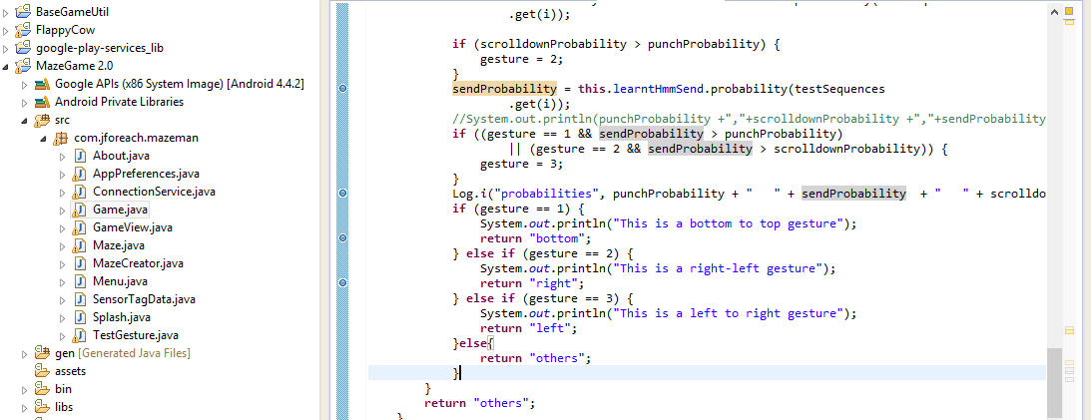

**Connection Service class:**

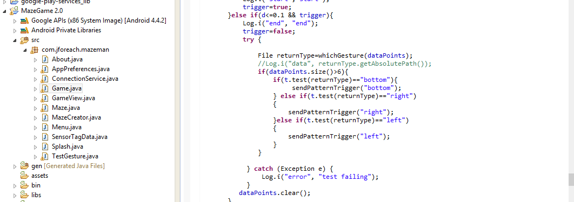

**Maze Game:**

Below changes were made in Game class.

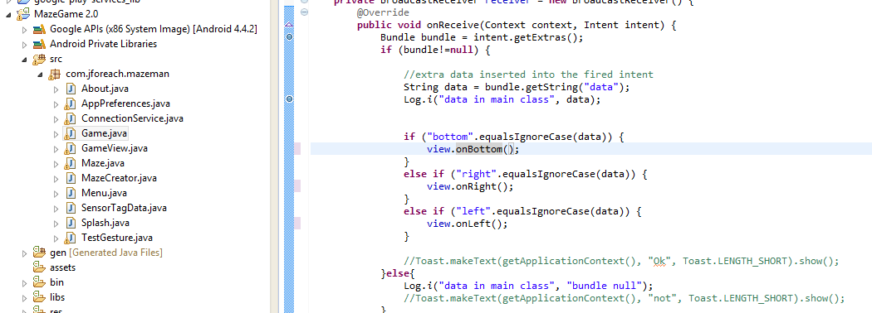

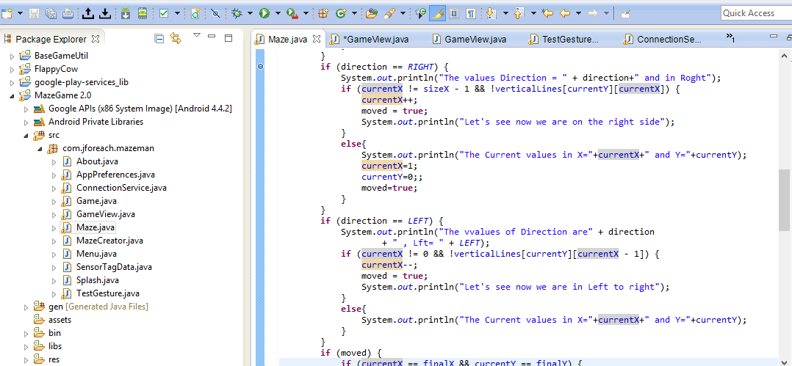

Gameview class:

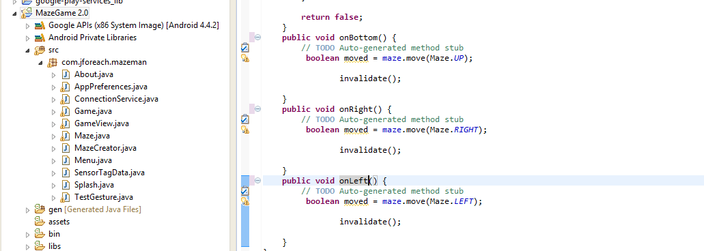

Console output:

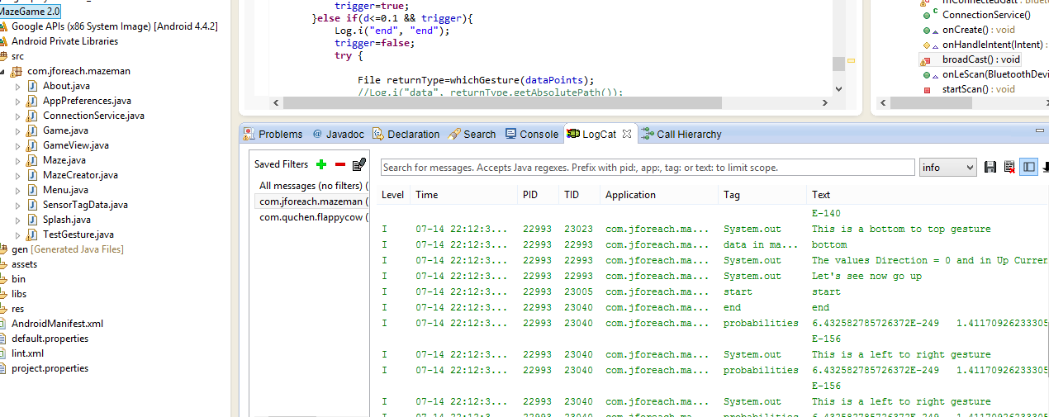

Ball was moved as per the gestures

