**CS 5590 BD – BIG DAYA ANALYTICS – LAB2**

Roopesh Utukuri

Task1:

The text file with GPS,Time, Acceleration and Gyroscope values are created in sensor.txt file.

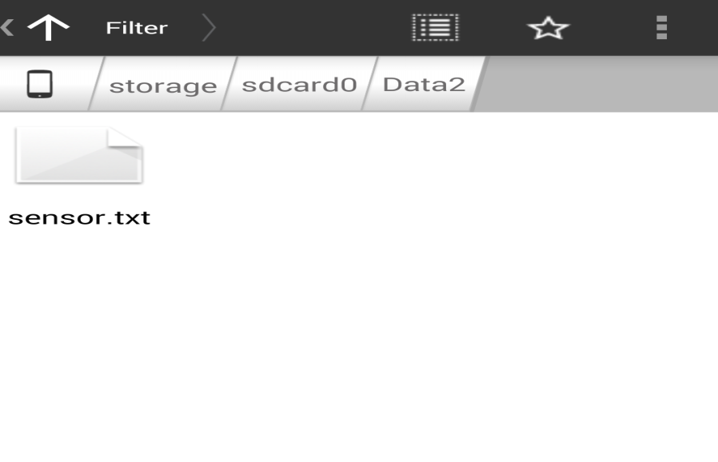

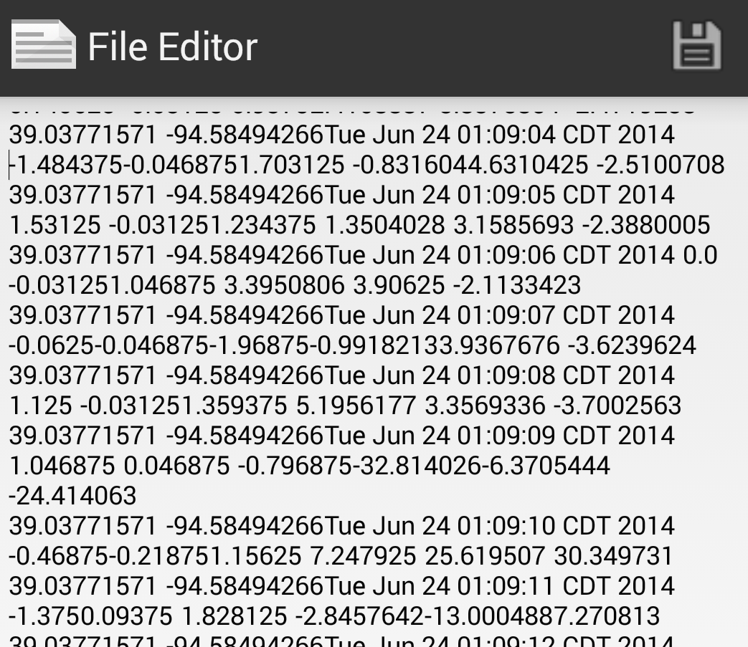

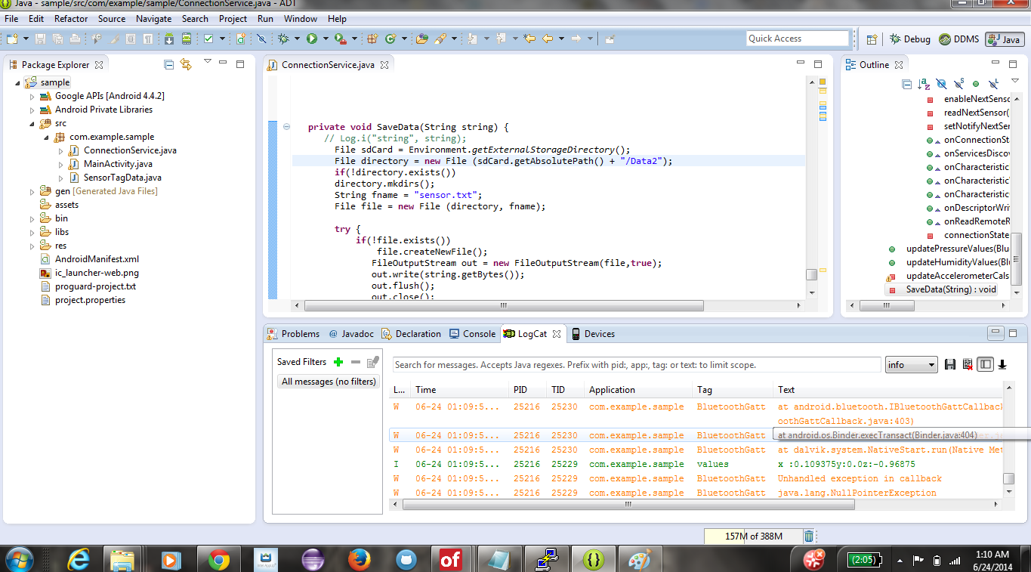

Task2:

Sensortag8-8 table is created.

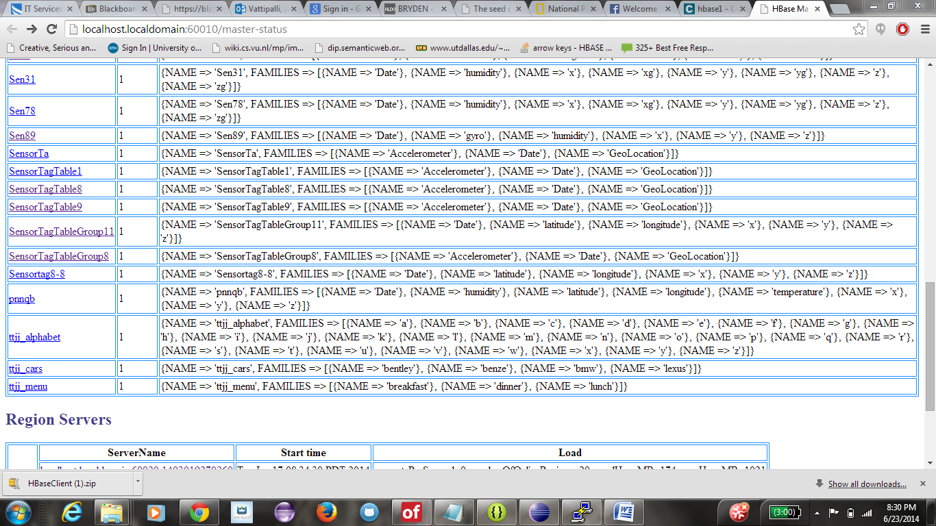

Data is insterted into the table.

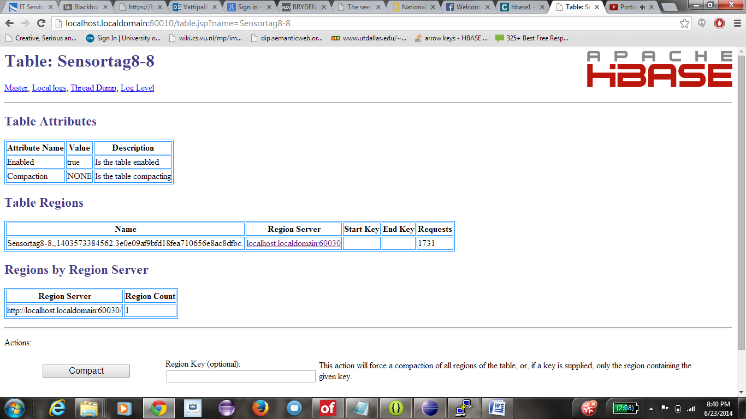

Data displayed in console.

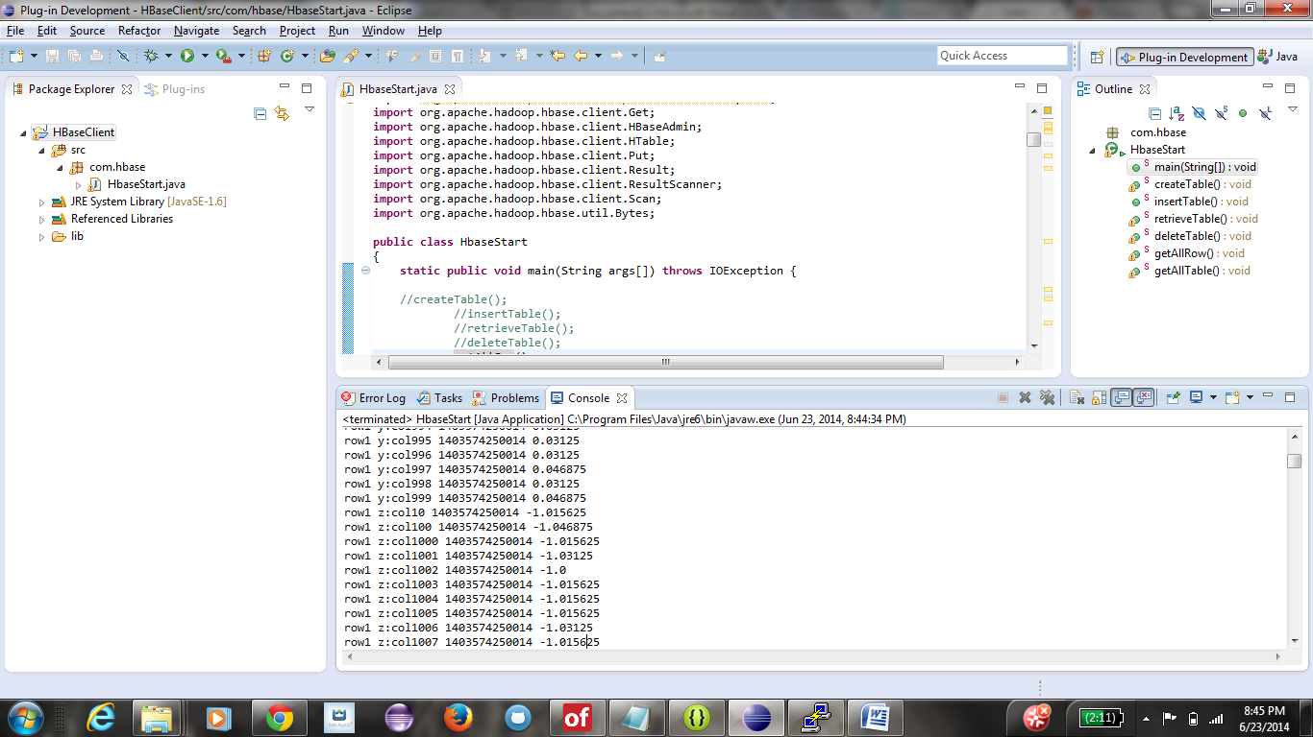

Table deleted at the end.

