**Topics: Descriptive Statistics and Probability**

1. Look at the data given below. Plot the data, find the outliers and find out $μ, σ, σ^{2}$

|  |  |
| --- | --- |
| **Name of company** | **Measure X** |
| Allied Signal | 24.23% |
| Bankers Trust | 25.53% |
| General Mills | 25.41% |
| ITT Industries | 24.14% |
| J.P.Morgan & Co. | 29.62% |
| Lehman Brothers | 28.25% |
| Marriott | 25.81% |
| MCI | 24.39% |
| Merrill Lynch | 40.26% |
| Microsoft | 32.95% |
| Morgan Stanley | 91.36% |
| Sun Microsystems | 25.99% |
| Travelers | 39.42% |
| US Airways | 26.71% |
| Warner-Lambert | 35.00% |

Ans:- Note :- I have converted the above table in csv file with the use of excel

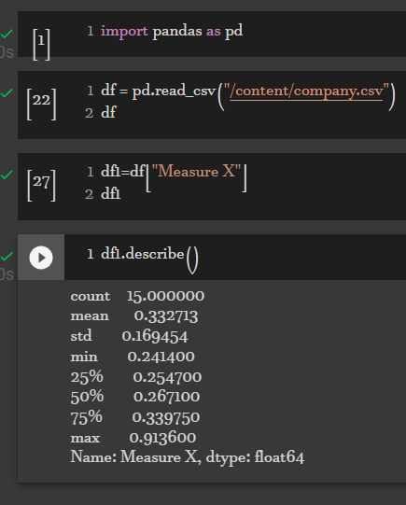



Answer the following three questions based on the box-plot above.

1. What is inter-quartile range of this dataset? (please approximate the numbers) In one line, explain what this value implies.

**Ans:-** IQR = Q3-Q1 = 12-5 = 7

1. What can we say about the skewness of this dataset?

Ans :- Positively skewed

1. If it was found that the data point with the value 25 is actually 2.5, how would the new box-plot be affected?

Ans :- it won't affect the box plot because its just changing the value of the particular axis



Answer the following three questions based on the histogram above.

1. Where would the mode of this dataset lie?

**Ans** :- the mode of the dataset lie between 4 to 10 because there is higher frequency

1. Comment on the skewness of the dataset.

**Ans:-** Its positive skewed

1. Suppose that the above histogram and the box-plot in question 2 are plotted for the same dataset. Explain how these graphs complement each other in providing information about any dataset.

**Ans:-** Yes it will provide the suitable information

1. AT&T was running commercials in 1990 aimed at luring back customers who had switched to one of the other long-distance phone service providers. One such commercial shows a businessman trying to reach Phoenix and mistakenly getting Fiji, where a half-naked native on a beach responds incomprehensibly in Polynesian. When asked about this advertisement, AT&T admitted that the portrayed incident did not actually take place but added that this was an enactment of something that “could happen.” Suppose that one in 200 long-distance telephone calls is misdirected. What is the probability that at least one in five attempted telephone calls reaches the wrong number? (Assume independence of attempts.)

Ans 1/5*200 = 40/100 = 0.4%

1. Returns on a certain business venture, to the nearest $1,000, are known to follow the following probability distribution

|  |  |
| --- | --- |
| x | P(x) |
| -2,000 | 0.1 |
| -1,000 | 0.1 |
| 0 | 0.2 |
| 1000 | 0.2 |
| 2000 | 0.3 |
| 3000 | 0.1 |

1. What is the most likely monetary outcome of the business venture?
2. Is the venture likely to be successful? Explain
3. What is the long-term average earning of business ventures of this kind? Explain
4. What is the good measure of the risk involved in a venture of this kind? Compute this measure

Ans:-

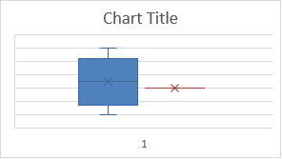

As the box plot and histogram shows the its negatively skewed and its does not follow normal distribution

1. Ans :- The monetary outcome is sum of value X that is 3000
2. Ans :- This venture is likely to be successful because its gradually returning the monetary income
3. Ans:- The Average at this instance is 500 but it may increase in future
4. Ans:- WE have high risk