Concepts of Operating System

Assignment 1

Problem 1: Read the instructions carefully and answer accordingly. If there is any need to insert some data then do that as well.

a) **Navigate and List:** a. Start by navigating to your home directory and list its contents. Then, move into a  
directory named "LinuxAssignment" if it exists; otherwise, create it.

cdac@DESKTOP-1KKEVUC:/$ pwd

/

cdac@DESKTOP-1KKEVUC:/$ cd home

cdac@DESKTOP-1KKEVUC:/home$ ls

cdac

cdac@DESKTOP-1KKEVUC:/home$ cd LinuxAssignment

-bash: cd: LinuxAssignment: No such file or directory

cdac@DESKTOP-1KKEVUC:/home$ mkdir LinuxAssignment

mkdir: cannot create directory ‘LinuxAssignment’: Permission denied

**Now changed the permissions of /home directory by :**

cdac@DESKTOP-1KKEVUC:/home$ cd ..

cdac@DESKTOP-1KKEVUC:/$ sudo chmod a+rwx home

[sudo] password for cdac:

cdac@DESKTOP-1KKEVUC:/$ cd home

cdac@DESKTOP-1KKEVUC:/home$ mkdir LinuxAssignment

cdac@DESKTOP-1KKEVUC:/home$ cd LinuxAssignment

cdac@DESKTOP-1KKEVUC:/home/LinuxAssignment$

b) **File Management:**a. Inside the "LinuxAssignment" directory, create a new file named "file1.txt". Display its  
contents.

cdac@DESKTOP-1KKEVUC:/home/LinuxAssignment$ touch file1.txt

cdac@DESKTOP-1KKEVUC:/home/LinuxAssignment$ cat file1.txt

cdac@DESKTOP-1KKEVUC:/home/LinuxAssignment$ nano file1.txt

cdac@DESKTOP-1KKEVUC:/home/LinuxAssignment$ cat file1.txt

Hello Ubuntu!

I am the 1st file in this directory.

cdac@DESKTOP-1KKEVUC:/home/LinuxAssignment$

c) **Directory Management:**a. Create a new directory named "docs" inside the "LinuxAssignment" directory.

cdac@DESKTOP-1KKEVUC:/home/LinuxAssignment$ mkdir docs

cdac@DESKTOP-1KKEVUC:/home/LinuxAssignment$ ls

docs file1.txt

cdac@DESKTOP-1KKEVUC:/home/LinuxAssignment$

d) **Copy and Move Files:**a. Copy the "file1.txt" file into the "docs" directory and rename it to "file2.txt".

cdac@DESKTOP-1KKEVUC:/home/LinuxAssignment$ cp file1.txt docs

cdac@DESKTOP-1KKEVUC:/home/LinuxAssignment$ cd docs

cdac@DESKTOP-1KKEVUC:/home/LinuxAssignment/docs$ ls

file1.txt

cdac@DESKTOP-1KKEVUC:/home/LinuxAssignment/docs$ mv file1.txt file2.txt

cdac@DESKTOP-1KKEVUC:/home/LinuxAssignment/docs$ ls

file2.txt

cdac@DESKTOP-1KKEVUC:/home/LinuxAssignment/docs$ cat file2.txt

Hello Ubuntu!

I am the 1st file in this directory.

cdac@DESKTOP-1KKEVUC:/home/LinuxAssignment/docs$

e) **Permissions and Ownership:**a. Change the permissions of "file2.txt" to allow read, write, and execute permissions for the owner and only read permissions for others. Then, change the owner of "file2.txt" to the current user.

cdac@DESKTOP-1KKEVUC:/home/LinuxAssignment/docs$ ls -al

total 12

drwxr-xr-x 2 cdac cdac 4096 Feb 26 18:26 .

drwxr-xr-x 3 cdac cdac 4096 Feb 26 18:21 ..

-rw-r--r-- 1 cdac cdac 51 Feb 26 18:25 file2.txt

cdac@DESKTOP-1KKEVUC:/home/LinuxAssignment/docs$ chmod u+rwx file2.txt

cdac@DESKTOP-1KKEVUC:/home/LinuxAssignment/docs$ chmod o+r file2.txt

cdac@DESKTOP-1KKEVUC:/home/LinuxAssignment/docs$ ls -al

total 12

drwxr-xr-x 2 cdac cdac 4096 Feb 26 18:26 .

drwxr-xr-x 3 cdac cdac 4096 Feb 26 18:21 ..

-rwxr--r-- 1 cdac cdac 51 Feb 26 18:25 file2.txt

cdac@DESKTOP-1KKEVUC:/home/LinuxAssignment/docs$ whoami

cdac

cdac@DESKTOP-1KKEVUC:/home/LinuxAssignment/docs$ chown cdac file2.txt

cdac@DESKTOP-1KKEVUC:/home/LinuxAssignment/docs$ ls -al

total 12

drwxr-xr-x 2 cdac cdac 4096 Feb 26 18:26 .

drwxr-xr-x 3 cdac cdac 4096 Feb 26 18:21 ..

-rwxr--r-- 1 cdac cdac 51 Feb 26 18:25 file2.txt

cdac@DESKTOP-1KKEVUC:/home/LinuxAssignment/docs$

f) **Final Checklist:**a. Finally, list the contents of the "LinuxAssignment" directory and the root directory to  
ensure that all operations were performed correctly.

cdac@DESKTOP-1KKEVUC:/home/LinuxAssignment$ ls

docs file1.txt

cdac@DESKTOP-1KKEVUC:/home/LinuxAssignment$ cd ..

cdac@DESKTOP-1KKEVUC:/home$ cd ..

cdac@DESKTOP-1KKEVUC:/$ ls

bin dev init lib64 mnt root sbin.usr-is-merged sys var

bin.usr-is-merged etc lib lost+found opt run snap tmp

boot home lib.usr-is-merged media proc sbin srv usr

cdac@DESKTOP-1KKEVUC:/$

g) **File Searching:**a. Search for all files with the extension ".txt" in the current directory and its subdirectories.  
b. Display lines containing a specific word in a file (provide a file name and the specific  
word to search).

a)

cdac@DESKTOP-1KKEVUC:/home$ find . -type f -name "*.txt"

./LinuxAssignment/file1.txt

./LinuxAssignment/docs/file2.txt

b)

cdac@DESKTOP-1KKEVUC:/home$ cd LinuxAssignment/

cdac@DESKTOP-1KKEVUC:/home/LinuxAssignment$ cd docs

cdac@DESKTOP-1KKEVUC:/home/LinuxAssignment/docs$ touch fileSearch.txt

cdac@DESKTOP-1KKEVUC:/home/LinuxAssignment/docs$ nano fileSearch.txt

cdac@DESKTOP-1KKEVUC:/home/LinuxAssignment/docs$ cat fileSearch.txt

He feels happy.

He raced to the grocery store.

He is being forced into happiness (is he actually happy?)

He went inside but realized he forgot his wallet.

The truth: He is actually not happy at all.

Others feel happy.

He raced back home to grab it.

Once he found it, he raced to the car again and drove back to the grocery store.

cdac@DESKTOP-1KKEVUC:/home/LinuxAssignment/docs$ **grep 'happy' fileSearch.txt**

He feels happy.

He is being forced into happiness (is he actually happy?)

The truth: He is actually not happy at all.

Others feel happy.

cdac@DESKTOP-1KKEVUC:/home/LinuxAssignment/docs$

h) **System Information:**a. Display the current system date and time.

cdac@DESKTOP-1KKEVUC:/home/LinuxAssignment/docs$ date '+%d-%m-%Y %I:%M %p'

26-02-2025 07:29 PM

cdac@DESKTOP-1KKEVUC:/home/LinuxAssignment/docs$ date '+%d-%m-%Y %H:%M %p'

26-02-2025 19:30 PM

cdac@DESKTOP-1KKEVUC:/home/LinuxAssignment/docs$ date

Wed Feb 26 19:31:09 UTC 2025

i) **Networking:**

a. Display the IP address of the system.

b. Ping a remote server to check connectivity (provide a remote server address to ping).

a) (method 1)

cdac@DESKTOP-1KKEVUC:/home/LinuxAssignment/docs$ ip addr show

1: lo: <LOOPBACK,UP,LOWER_UP> mtu 65536 qdisc noqueue state UNKNOWN group default qlen 1000

link/loopback 00:00:00:00:00:00 brd 00:00:00:00:00:00

inet 127.0.0.1/8 scope host lo

valid_lft forever preferred_lft forever

inet6 ::1/128 scope host

valid_lft forever preferred_lft forever

2: eth0: <BROADCAST,MULTICAST,UP,LOWER_UP> mtu 1500 qdisc mq state UP group default qlen 1000

link/ether 00:15:5d:5a:3b:2e brd ff:ff:ff:ff:ff:ff

inet 172.23.184.4/20 brd 172.23.191.255 scope global eth0

valid_lft forever preferred_lft forever

inet6 fe80::215:5dff:fe5a:3b2e/64 scope link

valid_lft forever preferred_lft forever

cdac@DESKTOP-1KKEVUC:/home/LinuxAssignment/docs$

**(method 2)**

cdac@DESKTOP-1KKEVUC:/home/LinuxAssignment/docs$ ifconfig

eth0: flags=4163<UP,BROADCAST,RUNNING,MULTICAST> mtu 1500

inet 172.23.184.4 netmask 255.255.240.0 broadcast 172.23.191.255

inet6 fe80::215:5dff:fe5a:3b2e prefixlen 64 scopeid 0x20<link>

ether 00:15:5d:5a:3b:2e txqueuelen 1000 (Ethernet)

RX packets 765 bytes 263671 (263.6 KB)

RX errors 0 dropped 0 overruns 0 frame 0

TX packets 682 bytes 43091 (43.0 KB)

TX errors 0 dropped 0 overruns 0 carrier 0 collisions 0

lo: flags=73<UP,LOOPBACK,RUNNING> mtu 65536

inet 127.0.0.1 netmask 255.0.0.0

inet6 ::1 prefixlen 128 scopeid 0x10<host>

loop txqueuelen 1000 (Local Loopback)

RX packets 0 bytes 0 (0.0 B)

RX errors 0 dropped 0 overruns 0 frame 0

TX packets 0 bytes 0 (0.0 B)

TX errors 0 dropped 0 overruns 0 carrier 0 collisions 0

b)

cdac@DESKTOP-1KKEVUC:/home/LinuxAssignment/docs$ ping -c 5 74.125.200.136

PING 74.125.200.136 (74.125.200.136) 56(84) bytes of data.

64 bytes from 74.125.200.136: icmp_seq=1 ttl=59 time=63.3 ms

64 bytes from 74.125.200.136: icmp_seq=2 ttl=59 time=64.1 ms

64 bytes from 74.125.200.136: icmp_seq=3 ttl=59 time=63.0 ms

64 bytes from 74.125.200.136: icmp_seq=4 ttl=59 time=62.1 ms

64 bytes from 74.125.200.136: icmp_seq=5 ttl=59 time=66.0 ms

--- 74.125.200.136 ping statistics ---

5 packets transmitted, 5 received, 0% packet loss, time 4178ms

rtt min/avg/max/mdev = 62.067/63.681/66.029/1.342 ms

cdac@DESKTOP-1KKEVUC:/home/LinuxAssignment/docs$

j) **File Compression:**a. Compress the "docs" directory into a zip file.  
b. Extract the contents of the zip file into a new directory.

a)

cdac@DESKTOP-1KKEVUC:/home/LinuxAssignment/docs$ cd ..

cdac@DESKTOP-1KKEVUC:/home/LinuxAssignment$ zip -r docDirectory.zip docs

adding: docs/ (stored 0%)

adding: docs/fileSearch.txt (deflated 41%)

adding: docs/file2.txt (stored 0%)

cdac@DESKTOP-1KKEVUC:/home/LinuxAssignment$ ls

docDirectory.zip docs file1.txt

cdac@DESKTOP-1KKEVUC:/home/LinuxAssignment$

b)

cdac@DESKTOP-1KKEVUC:/home/LinuxAssignment$ unzip docDirectory -d NewDirectory

Archive: docDirectory.zip

creating: NewDirectory/docs/

inflating: NewDirectory/docs/fileSearch.txt

extracting: NewDirectory/docs/file2.txt

cdac@DESKTOP-1KKEVUC:/home/LinuxAssignment$ ls

NewDirectory docDirectory.zip docs file1.txt

cdac@DESKTOP-1KKEVUC:/home/LinuxAssignment$ cd NewDirectory/

cdac@DESKTOP-1KKEVUC:/home/LinuxAssignment/NewDirectory$ ls

docs

cdac@DESKTOP-1KKEVUC:/home/LinuxAssignment/NewDirectory$ cd docs

cdac@DESKTOP-1KKEVUC:/home/LinuxAssignment/NewDirectory/docs$ ls

file2.txt fileSearch.txt

cdac@DESKTOP-1KKEVUC:/home/LinuxAssignment/NewDirectory/docs$

k) **File Editing:**a. Open the "file1.txt" file in a text editor and add some text to it.  
b. Replace a specific word in the "file1.txt" file with another word (provide the original  
word and the word to replace it with).

cdac@DESKTOP-1KKEVUC:/home$ cd LinuxAssignment/

cdac@DESKTOP-1KKEVUC:/home/LinuxAssignment$ ls

NewDirectory docDirectory.zip docs file1.txt

cdac@DESKTOP-1KKEVUC:/home/LinuxAssignment$ cat file1.txt

Hello Ubuntu!

I am the 1st file in this directory.

cdac@DESKTOP-1KKEVUC:/home/LinuxAssignment$ nano file1.txt

cdac@DESKTOP-1KKEVUC:/home/LinuxAssignment$ cat file1.txt

Hello Ubuntu!

I am the 1st file in this directory.

Some more sentences added through nano --------

Welcome to CDAC Mumbai, Feb 2025 batch!

cdac@DESKTOP-1KKEVUC:/home/LinuxAssignment$

b)

cdac@DESKTOP-1KKEVUC:/home/LinuxAssignment$ cat file1.txt

Hello Ubuntu!

I am the 1st file in this directory.

Some more sentences added through nano --------

Welcome to CDAC Mumbai, Feb 2025 batch!

cdac@DESKTOP-1KKEVUC:/home/LinuxAssignment$ sed -i 's/Ubuntu/Windows/g' file1.txt

cdac@DESKTOP-1KKEVUC:/home/LinuxAssignment$ cat file1.txt

Hello Windows!

I am the 1st file in this directory.

Some more sentences added through nano --------

Welcome to CDAC Mumbai, Feb 2025 batch!

cdac@DESKTOP-1KKEVUC:/home/LinuxAssignment$

Explanation:

* sed = Stream EDitor
* -i = in-place (i.e. save back to the original file)
* The command string:
  + s = the substitute command
  + original = a regular expression describing the word to replace (or just the word itself)
  + new = the text to replace it with
  + g = global (i.e. replace all and not just the first occurrence)
* file.txt = the file name

**Problem 2: Read the instructions carefully and answer accordingly. If there is  
any need to insert some data then do that as well.**

a. Suppose you have a file named "data.txt" containing important information. Display the  
first 10 lines of this file to quickly glance at its contents using a command.

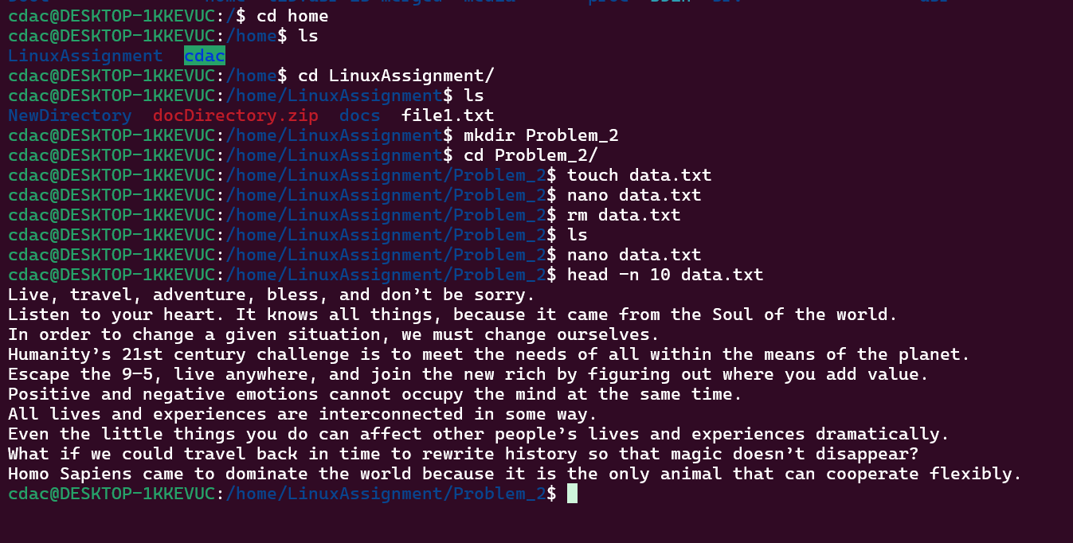

Wrong contents were put in file, so recreated it below

b. Now, to check the end of the file for any recent additions, display the last 5 lines of  
"data.txt" using another command.

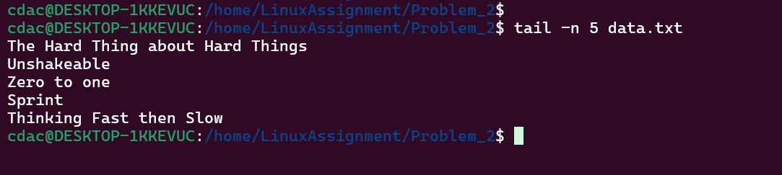

c. In a file named "numbers.txt," there are a series of numbers. Display the first 15 lines of  
this file to analyze the initial data set.

d. To focus on the last few numbers of the dataset, display the last 3 lines of "numbers.txt".

e. Imagine you have a file named "input.txt" with text content. Use a command to translate  
all lowercase letters to uppercase in "input.txt" and save the modified text in a new file  
named "output.txt."

f. In a file named "duplicate.txt," there are several lines of text, some of which are  
duplicates. Use a command to display only the unique lines from "duplicate.txt."

g. In a file named "fruit.txt," there is a list of fruits, but some fruits are repeated. Use a  
command to display each unique fruit along with the count of its occurrences in  
"fruit.txt."

