**Part A.**

**What will the following commands do?**• echo "Hello, World!"

Ans: prints Hello, World! on the terminal

• name="Productive"

Ans: defines a variable name with the value Productive

• touch file.txt  
Ans: creates a file named as file.txt

• ls -a

Ans: lists all the files in the current directory, including hidden files

• rm file.txt

Ans: deletes the file named as file.txt

• cp file1.txt file2.txt

Ans: creates a copy of file1.txt with a name file2.txt

• mv file.txt /path/to/directory/

Ans: moves the file file.txt to the specified directory

• chmod 755 script.sh

Ans: changes the file permission, enables owner to read, write, execute; group to read, execute; others to read, execute.

• grep "pattern" file.txt

Ans: searches for the word pattern in the file file.txt

• kill PID

Ans: terminates a process with the given PID

• mkdir mydir && cd mydir && touch file.txt && echo "Hello, World!" > file.txt && cat file.txt  
Ans: makes a directory called mydir and goes into it creates a file named file.txt and copies the line echo “Hello, World!” in the file file.txt and prints the contents of the file.

• ls -l | grep ".txt"  
Ans: in the listed files and folders, .txt files are enlisted

• cat file1.txt file2.txt | sort | uniq  
Ans: from the files file1.txt and file2.txt it sorts the file and outputs only the unique lines

• ls -l | grep "^d"

Ans: out of the files and directories present in the current directory, it outputs the directories (prints the items in the current directory that are directories)

• grep -r "pattern" /path/to/directory/

Ans: For each directory operand, read and process all files in that directory, recursively.  Note that if no file operand is given, grep searches the working directory.

• cat file1.txt file2.txt | sort | uniq –d  
Ans: It outputs the duplicate lines

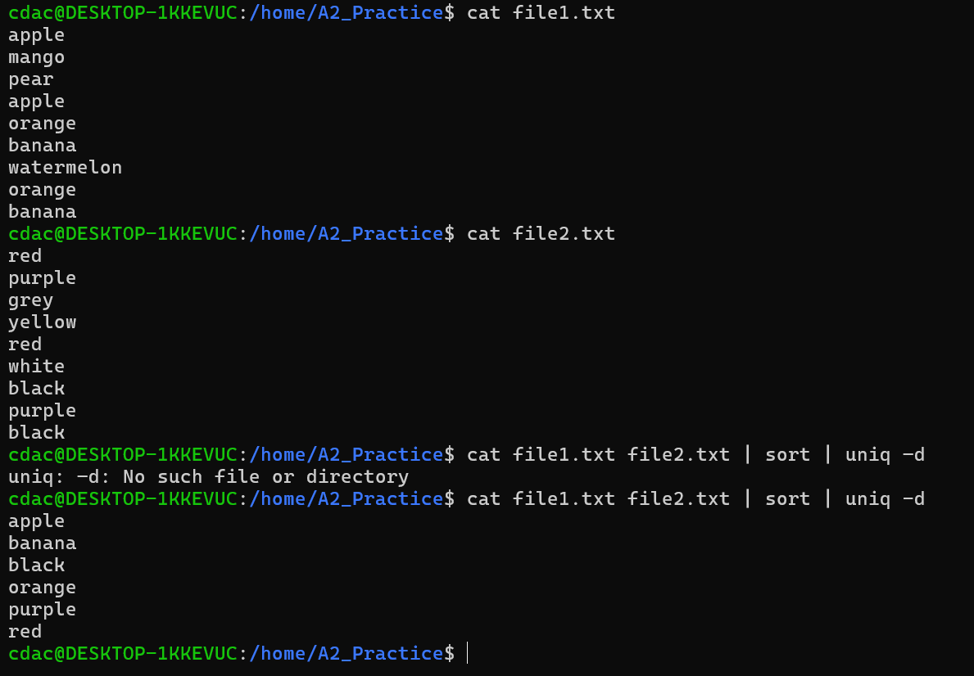

• chmod 644 file.txt

Ans: Changes the permissions of the file for owner to read, write; group to read; others to read

• cp -r source_directory destination_directory  
Ans: copies recursively all the files/subdirectories in the current directory to the destination directory (The -r option tells cp to descend into subdirectories and copy everything within the source_directory)

• find /path/to/search -name "*.txt"  
Ans: it searches for all files ending with ".txt" within the specified directory and its subdirectories.

• chmod u+x file.txt  
Ans: adds the file permissions of the current user (owner) to execute

• echo $PATH

Ans: displays the value of the PATH environment variable

**Part B.**

Identify True or False:

1. ls is used to list files and directories in a directory.

=> True.

2. mv is used to move files and directories.

=> True

3. cd is used to copy files and directories.

=> False (cp is used to copy files and directories)

4. pwd stands for "print working directory" and displays the current directory.

=> True

5. grep is used to search for patterns in files.  
=> True

6. chmod 755 file.txt gives read, write, and execute permissions to the owner, and read and execute permissions to group and others.  
=> True

7. mkdir -p directory1/directory2 creates nested directories, creating directory2 inside directory1 if directory1 does not exist.

=> True

8. rm -rf file.txt deletes a file forcefully without confirmation.

=> True

**Identify the Incorrect Commands:**1. **chmodx** is used to change file permissions.

=> chmod is used

2. **cpy** is used to copy files and directories.  
=> cp is used

3. **mkfile** is used to create a new file.  
=> touch is used

4. **catx** is used to concatenate files.  
=> cat is used

5. **rn** is used to rename files.

=> mv is used

**Part C  
Question 1:** Write a shell script that prints "Hello, World!" to the terminal.

**Question 2:** Declare a variable named "name" and assign the value "CDAC Mumbai" to it. Print the value of the variable.

**Question 3:** Write a shell script that takes a number as input from the user and prints it.

**Question 4:** Write a shell script that performs addition of two numbers (e.g., 5 and 3) and prints the result.

**Question 5:** Write a shell script that takes a number as input and prints "Even" if it is even, otherwise prints "Odd".

**Question 6:** Write a shell script that uses a for loop to print numbers from 1 to 5.

**Question 7:** Write a shell script that uses a while loop to print numbers from 1 to 5.

**Question 8:** Write a shell script that checks if a file named "file.txt" exists in the current directory. If it does, print "File exists", otherwise, print "File does not exist".

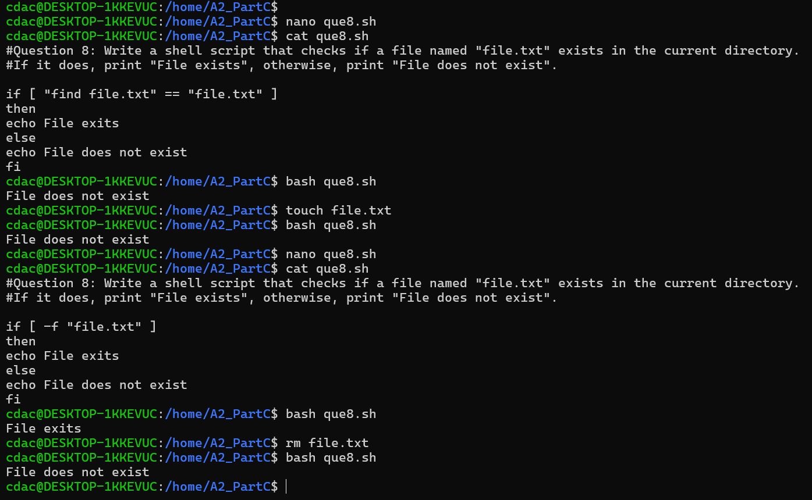

**Question 9:** Write a shell script that uses the if statement to check if a number is greater than 10 and prints a message accordingly.

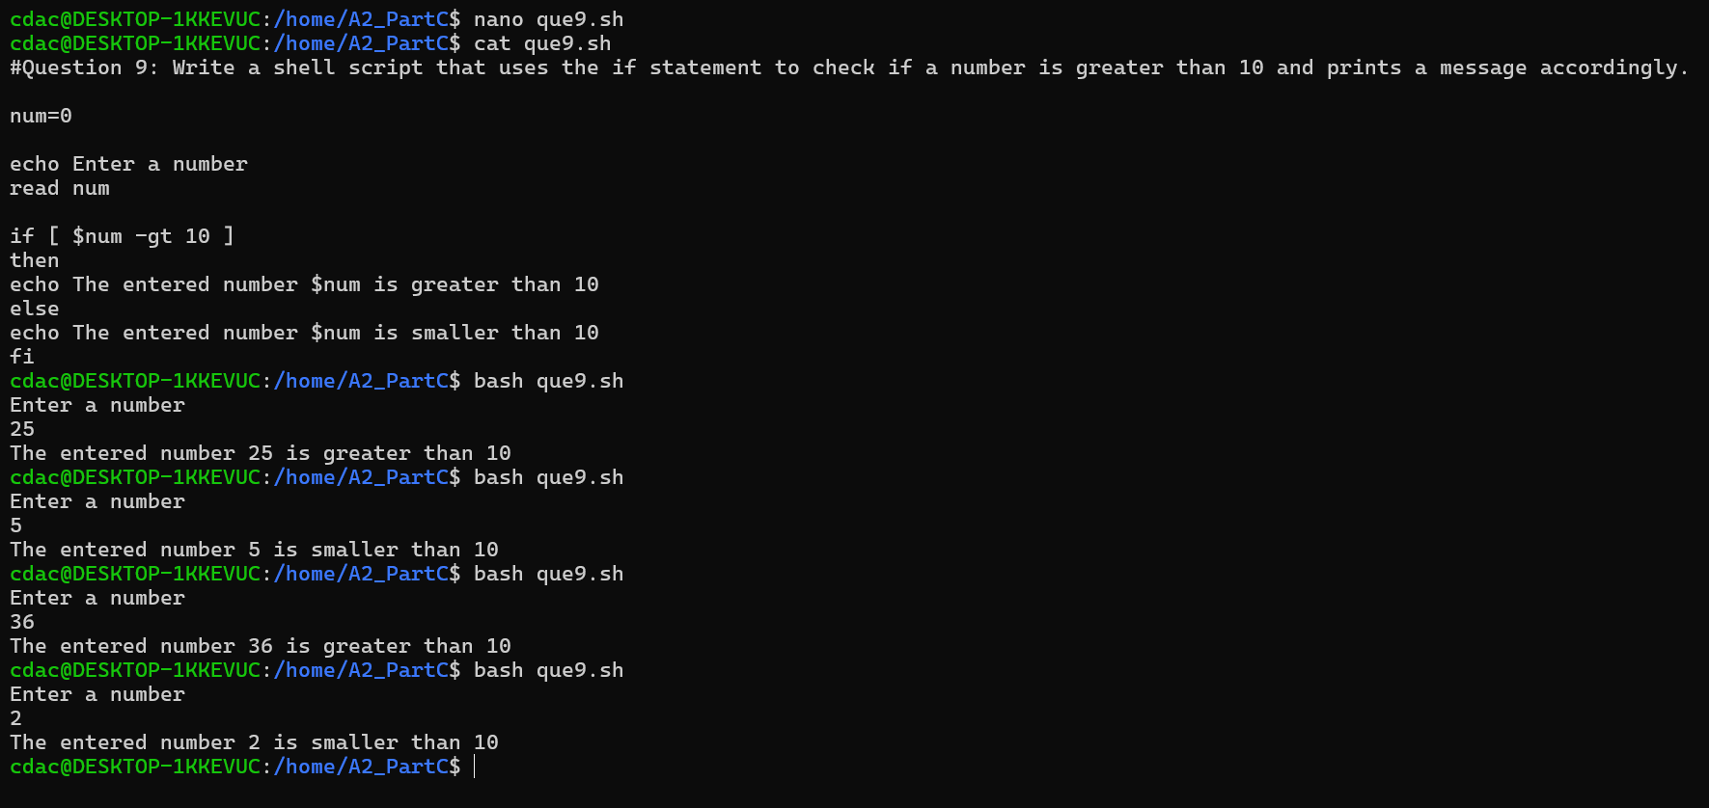

**Question 10:** Write a shell script that uses nested for loops to print a multiplication table for numbers from 1 to 5. The output should be formatted nicely, with each row representing a number and each column representing the multiplication result for that number.

**Question 11:** Write a shell script that uses a while loop to read numbers from the user until the user enters a negative number. For each positive number entered, print its square. Use the **break** statement to exit the loop when a negative number is entered.

**Part E.**



