FLEETHUB 2.0
Multi-Client Fleet & Logistics Management System
MCA PROJECT DOCUMENTATION
Submitted by
Ruturaj Sandip Ghorpade
Master of Computer Applications (MCA)
Maharashtra Education Society's Institute of Management and Career Courses (IMCC), Pune
Academic Year: 2025–2027

Table of Contents
- 1. Abstract
- 2. Introduction and Problem Statement
- 3. Objectives and Scope
- 4. Technology Stack
- 5. User Roles and Modules
- 7. System Diagrams
- 7. Data Dictionary
- 8. Input / Output Screens
- 9. Advantages and Limitations
- 10. Future Enhancements
- 11. Conclusion

1. Abstract
FleetHub 2.0 is a web-based Multi-Client Fleet and Logistics Management System designed to centralize vehicle, driver, delivery, and maintenance operations. It supports multiple client organizations while separating operational responsibilities by user role.
The application uses the MERN stack: React.js with Vite and Tailwind CSS for the frontend, Node.js and Express.js for backend REST APIs, and MongoDB for data storage. The system has four main roles—Super Admin, Admin, Client, and Driver—with role-based access control.
Super Admin and Admin manage fleet resources, including drivers and vehicles. Clients place and track delivery orders. Admin or Super Admin assigns a suitable driver and vehicle to a delivery. Maintenance records, notifications, and audit logs support operational monitoring and accountability.

2. Introduction and Problem Statement
Fleet and logistics organizations need to coordinate clients, branches, vehicles, drivers, deliveries, and vehicle servicing. When these activities are handled through spreadsheets, paper records, phone calls, or separate tools, information can become duplicated, delayed, or difficult to audit.
FleetHub addresses this problem by providing one web application for fleet operations. It organizes client orders and fleet resources, applies role-based permissions, and maintains operational records in a central database.

2.1 Existing-System Challenges
- Manual record keeping and repeated data entry.
- Difficulty coordinating drivers, vehicles, and deliveries.
- Limited visibility into delivery and maintenance status.
- Inconsistent access control and limited activity history.

3. Objectives and Scope

3.1 Objectives
- Manage multiple clients and their branches from one platform.
- Allow Admin/Super Admin to manage drivers and vehicles.
- Allow clients to create and track delivery orders.
- Assign drivers and vehicles to deliveries.
- Maintain vehicle maintenance records.
- Apply role-based access and keep notifications and audit logs.

3.2 Scope
Current scope includes authentication, role-based dashboards, client and branch management, driver and vehicle management, delivery management, maintenance, notifications, and audit logs. Report generation, live GPS tracking, route optimization, and dedicated mobile apps are not included as current features and may be considered later.

4. Technology Stack
Layer | Technology | Purpose
Frontend | React.js, Vite, Tailwind CSS | Responsive user interface and reusable components.
Backend | Node.js, Express.js | REST API endpoints and application logic.
Database | MongoDB | Document-based storage for application data.
Tools | VS Code, MongoDB Compass, Git/GitHub, Postman | Development, database inspection, version control, and API testing.

5. User Roles and Modules
Role | Main responsibilities
SUPER_ADMIN | Central administration; manages users, clients, branches, vehicles, drivers, maintenance, settings, and audit-log access according to permissions.
ADMIN | Manages fleet operations, including drivers, vehicles, delivery assignments, and maintenance.
CLIENT | Views available branch information, creates delivery orders, tracks order status, and cancels orders where permitted.
DRIVER | Views assigned deliveries and relevant vehicle/delivery details; updates delivery status where permitted.

5.1 Main Modules
Module | Purpose
Authentication & Authorization | Login, identify the user role, and restrict access to permitted pages and API operations.
Client & Branch Management | Maintain client organizations and their branch information.
Vehicle Management | Create and maintain vehicle records; managed by Admin/Super Admin.
Driver Management | Create and maintain driver records; managed by Admin/Super Admin.
Delivery Management | Clients place orders; Admin/Super Admin assign driver and vehicle; delivery status is tracked.
Maintenance | Admin/Super Admin maintain service and repair records linked to vehicles.
Notifications | Provide users with relevant system notifications.
Audit Logs | Record important actions for traceability and accountability.
Dashboard | Show role-appropriate operational summaries available in the application.

6. System Diagrams
Insert the final approved diagrams below. Each diagram should have a clear caption and match the current implementation.
Figure 1. Project database / ER diagram.

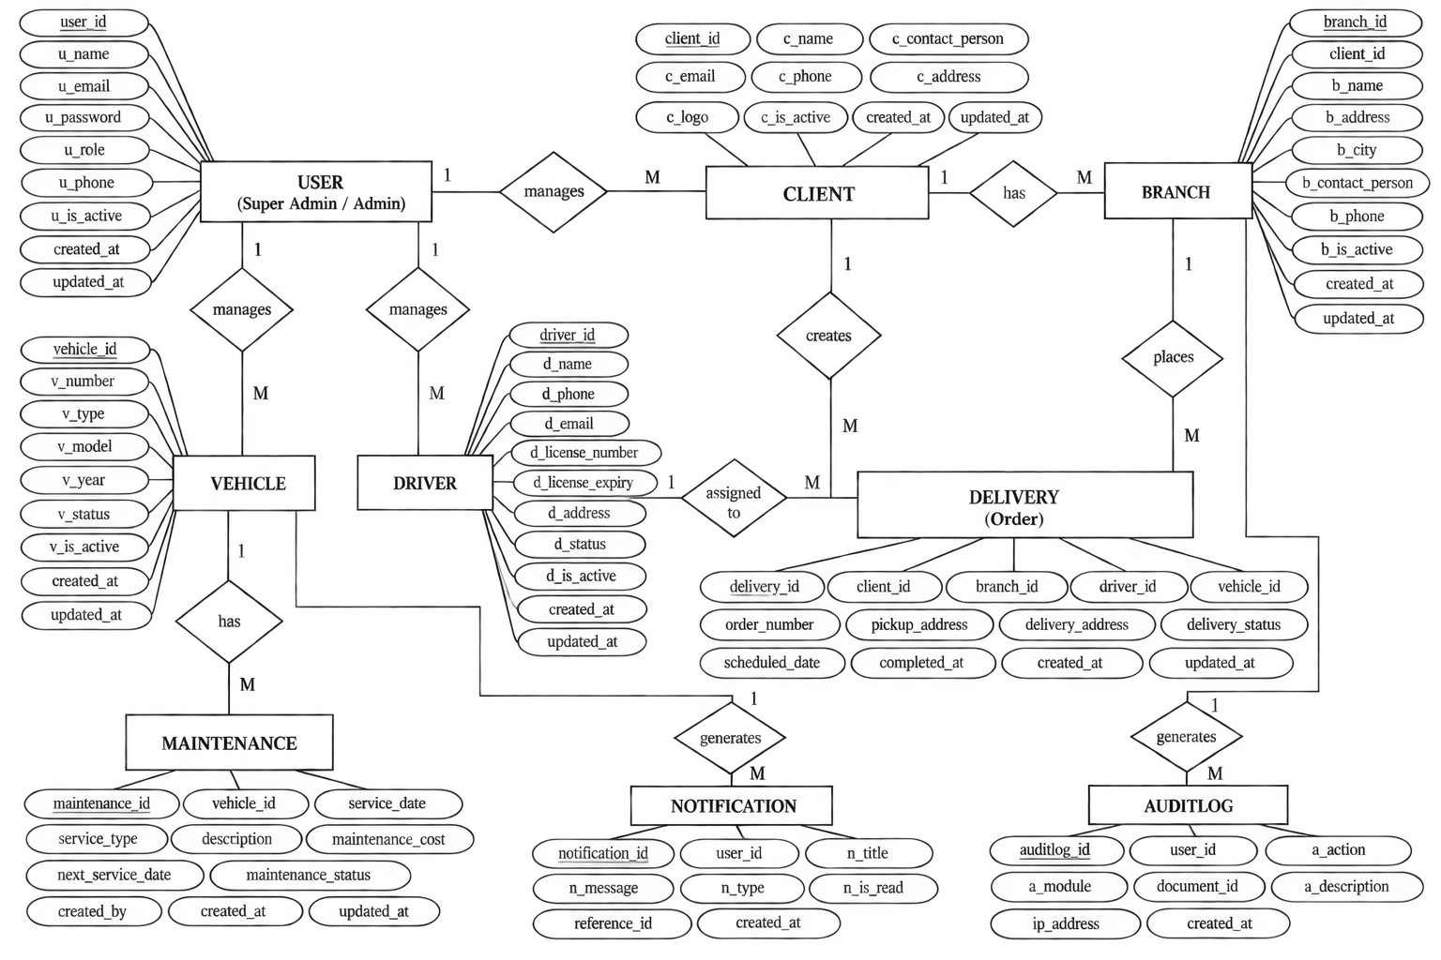

Figure 2. Use case diagram showing role-based interactions.
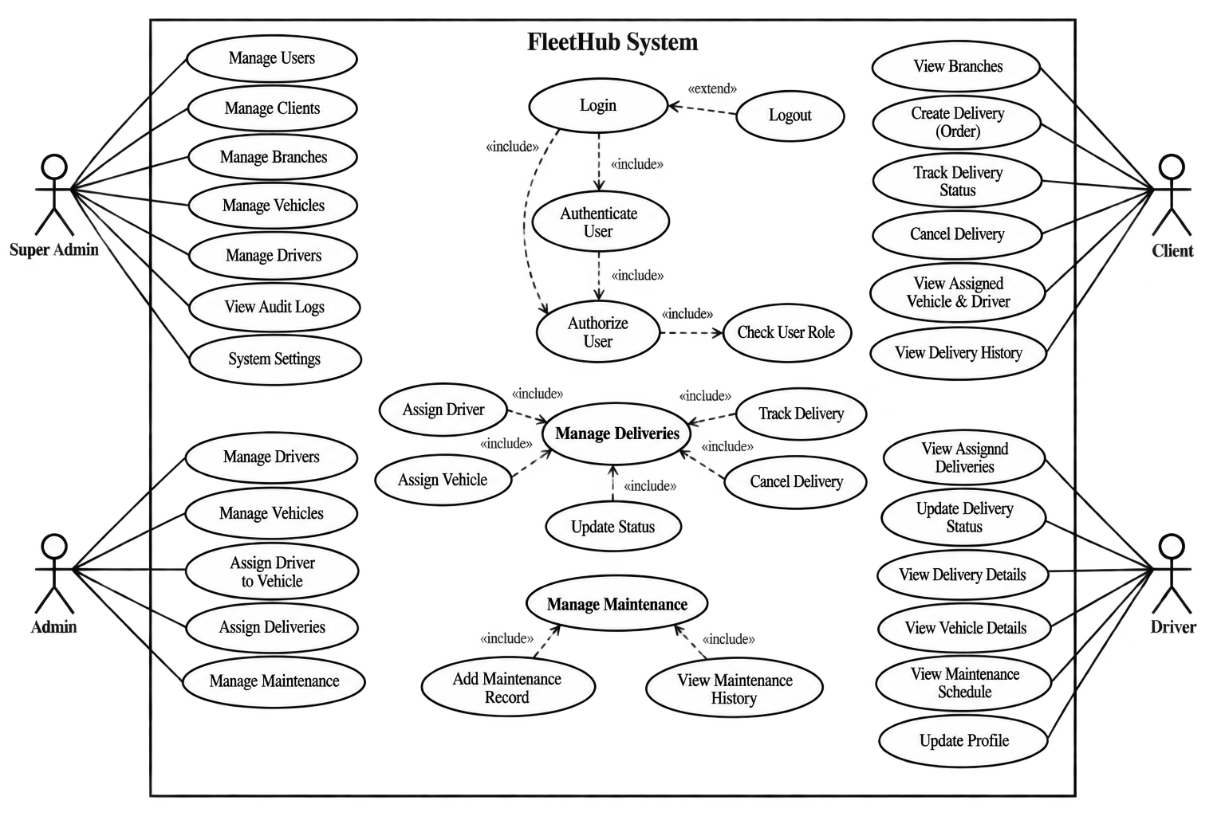

7.Data Dictionary:
1. User Collection
Field name | Data type | Description
u_id | ObjectId | Unique user identifier
name | String | User's full name
email | String | User's email address
password | String | Hashed password
role | String | SUPER_ADMIN, ADMIN, CLIENT, or DRIVER
phone | String | Contact number
status | String | Account status
isActive | Boolean | Whether the account is active
createdAt | Date | Account creation date
updatedAt | Date | Last update date

2. Client Collection

Field name | Data type | Description
c_id | ObjectId | Unique client identifier
name | String | Client organization name
contactPerson | String | Name of the contact person
email | String | Client email address
phone | String | Contact number
address | String | Client's address
logo | String | Logo or image reference
isActive | Boolean | Client account status
createdAt | Date | Record creation date
updatedAt | Date | Last update date
3. Branch Collection

Field name | Data type | Description
b_id | ObjectId | Unique branch identifier
clientId | ObjectId | Reference to the client
name | String | Branch name
address | String | Branch address
city | String | Branch city
contactPerson | String | Branch contact person
phone | String | Branch contact number
isActive | Boolean | Branch status
createdAt | Date | Record creation date
updatedAt | Date | Last update date

4. Vehicle Collection
Field name | Data type | Description
v_id | ObjectId | Unique vehicle identifier
vehicleNumber | String | Vehicle registration number
type | String | Vehicle type, such as bike or truck
model | String | Vehicle model
year | Number | Manufacturing year
status | String | Vehicle availability or operational status
isActive | Boolean | Whether the vehicle is active
createdBy | ObjectId | User who created the record, if stored
createdAt | Date | Record creation date
updatedAt | Date | Last update date

5. Driver Collection

Field name | Data type | Description
d_id | ObjectId | Unique driver identifier
userId | ObjectId | Linked user account, if applicable
name | String | Driver's full name
email | String | Driver's email address
phone | String | Contact number
licenseNumber | String | Driving licence number
licenseExpiry | Date | Driving licence expiry date
address | String | Driver's address
status | String | Driver availability or work status
isActive | Boolean | Whether the driver record is active
createdBy | ObjectId | Admin/Super Admin who created the record, if stored
createdAt | Date | Record creation date
updatedAt | Date | Last update date

6. Delivery Collection

Field name | Data type | Description
del_id | ObjectId | Unique delivery identifier
orderNumber | String | Unique order reference
clientId | ObjectId | Client who placed the order
branchId | ObjectId | Branch associated with the order
driverId | ObjectId | Assigned driver, when assigned
vehicleId | ObjectId | Assigned vehicle, when assigned
pickupAddress | String | Pickup location
deliveryAddress | String | Destination address
deliveryStatus | String | Current order status
scheduledDate | Date | Scheduled delivery date
completedAt | Date | Delivery completion time
createdAt | Date | Order creation date
updatedAt | Date | Last update date

7. Maintenance Collection

Field name | Data type | Description
m_id | ObjectId | Unique maintenance identifier
vehicleId | ObjectId | Vehicle being serviced
serviceDate | Date | Maintenance date
serviceType | String | Type of maintenance
description | String | Details of the service or repair
maintenanceCost | Number | Maintenance expense
nextServiceDate | Date | Planned next service date
maintenanceStatus | String | Current maintenance status
createdBy | ObjectId | User who recorded the maintenance
createdAt | Date | Record creation date
updatedAt | Date | Last update date

8. Notification Collection

Field name | Data type | Description
n_id | ObjectId | Unique notification identifier
userId | ObjectId | User receiving the notification
title | String | Notification heading
message | String | Notification content
type | String | Notification category
isRead | Boolean | Whether the notification has been read
referenceId | ObjectId or String | Related record identifier, if applicable
createdAt | Date | Notification creation time

9. AuditLog Collection
Field name | Data type | Description
audit_id | ObjectId | Unique audit-log identifier
userId | ObjectId | User who performed the action
action | String | Action performed, such as create or update
module | String | Affected module, such as Driver or Vehicle
documentId | ObjectId or String | Identifier of the affected record
description | String | Description of the activity
ipAddress | String | User's IP address, if recorded
createdAt | Date | Time the action occurred

8.Input/Output Screens :

1. Login Screen
The Login Screen allows registered users to log in to FleetHub2.0 using their email address and password. It provides demo login options for Super Admin, Admin, Client, and Driver.
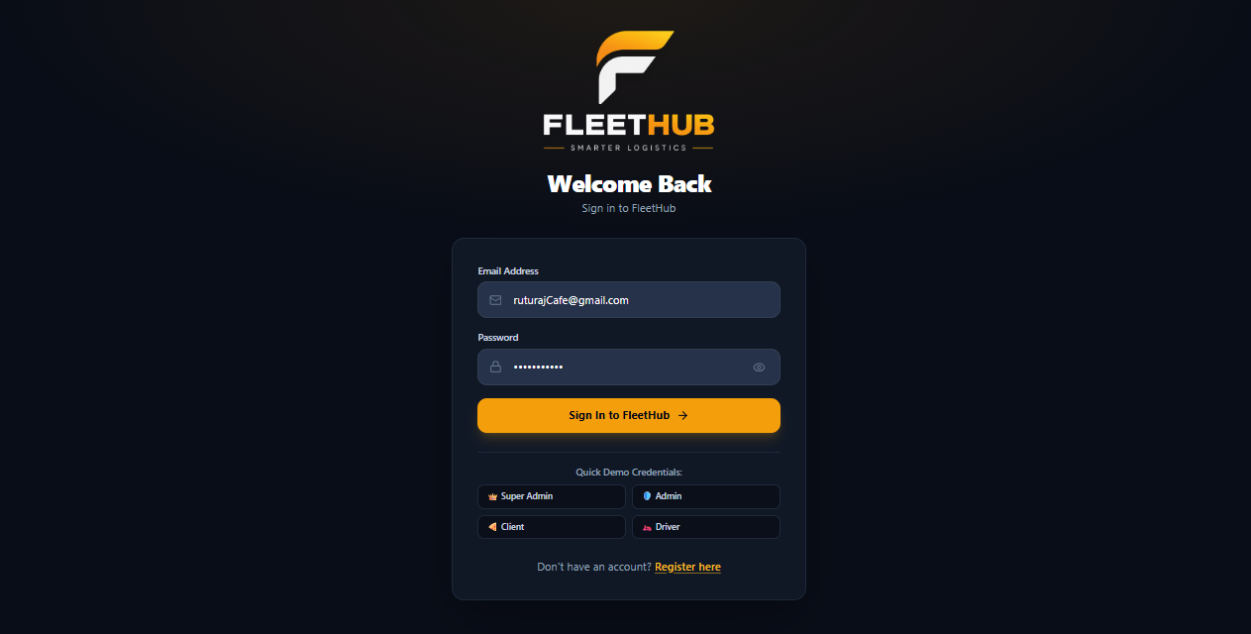

2. Client Registration Screen
The Client Registration Screen allows restaurant and business clients to create an account by entering personal details, contact information, company name, and business address. Users can also enter optional branch details.
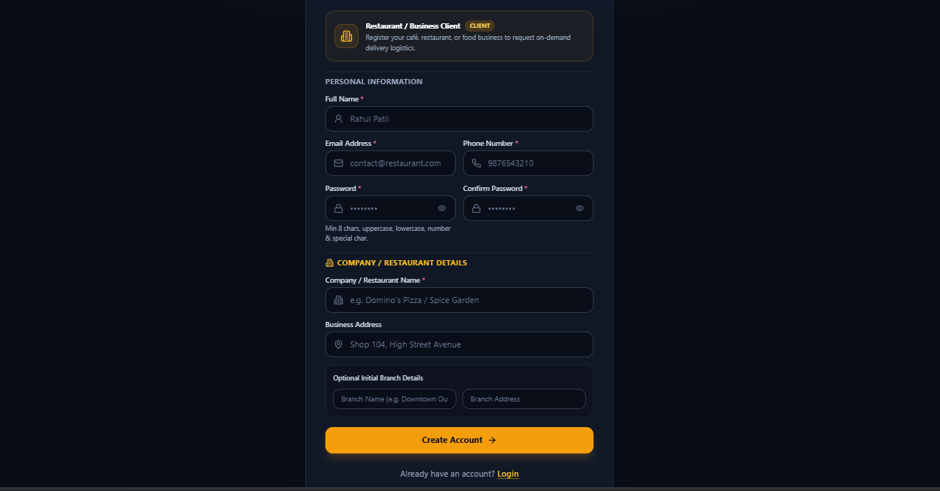

3. Super Admin Dashboard Screen
The Super Admin Dashboard provides an overview of FleetHub 2.0 and allows the Super Admin to manage users, clients, branches, drivers, vehicles, and other system operations.
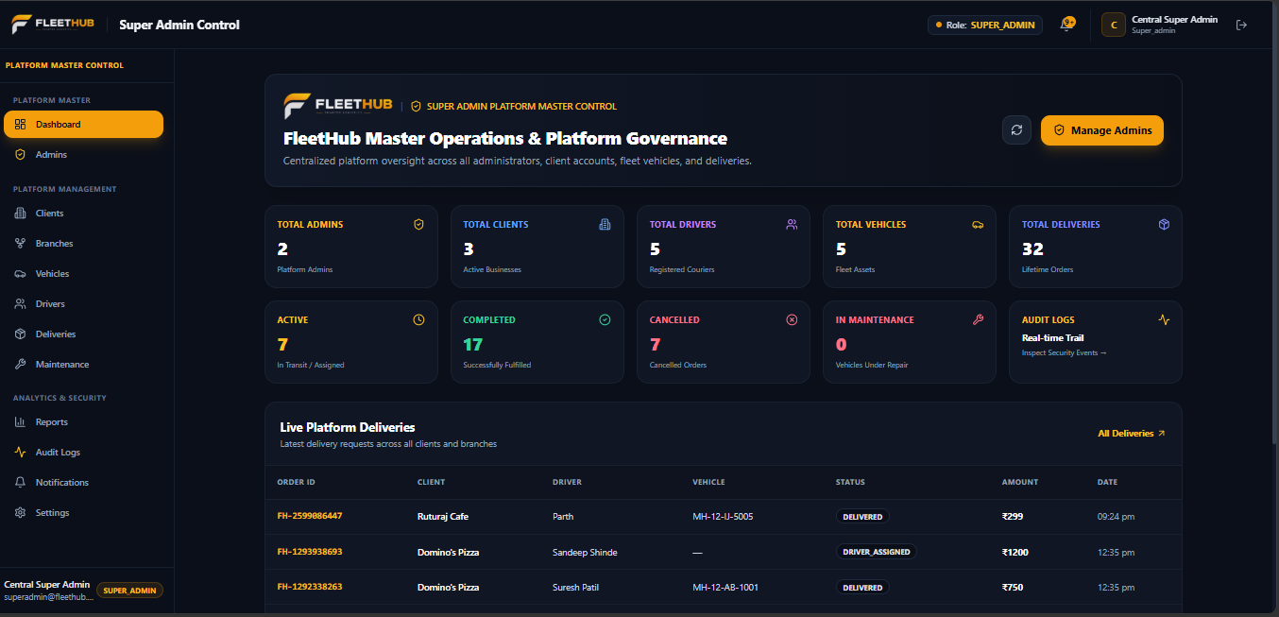

4. Admin Dashboard Screen
The Admin Dashboard allows the administrator to manage FleetHub operations, including drivers, vehicles, delivery assignments, and vehicle maintenance. It helps the Admin monitor delivery status and manage daily fleet activities.
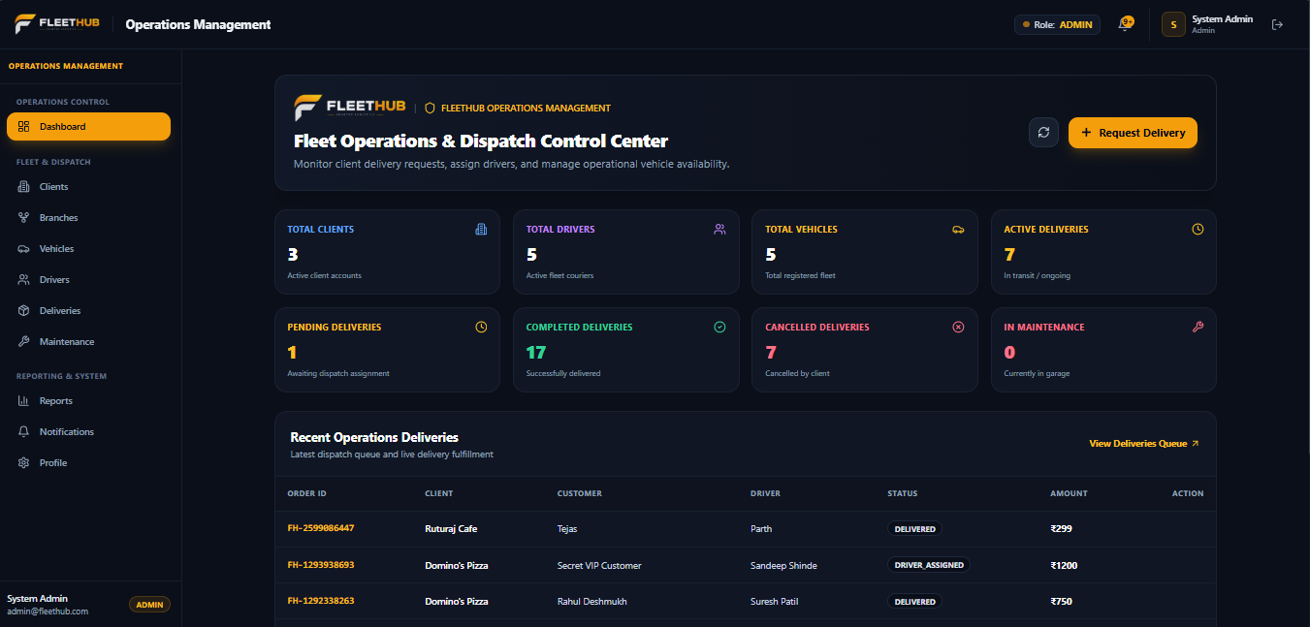

5. Client Dashboard Screen
The Client Dashboard allows clients to view their delivery orders and monitor their current status. It helps clients manage their delivery requests and access information about assigned drivers and vehicles.
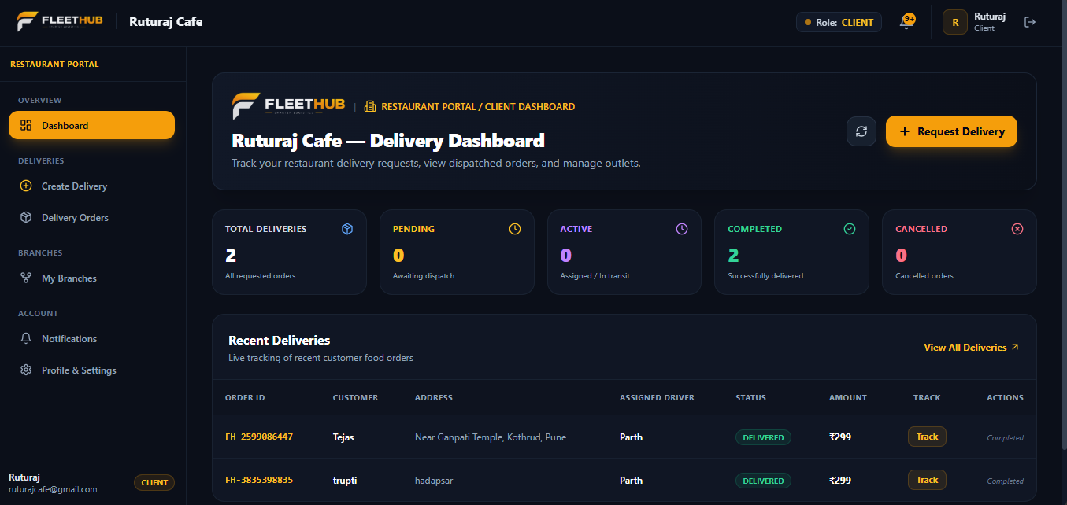

6. Driver Dashboard Screen
The Driver Dashboard allows drivers to view their assigned deliveries and check delivery details. It helps drivers monitor delivery status and access relevant vehicle information for their assigned orders.
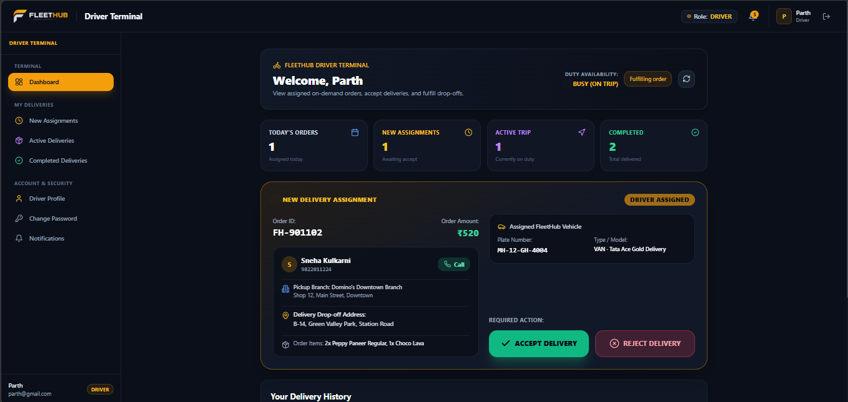

7. Admin Management Screen
This screen allows the Super Admin to create and manage Admin accounts. It displays admin details, including name, email, phone number, role, status, and creation date. The Super Admin can search accounts, filter by status, and perform available account management actions.
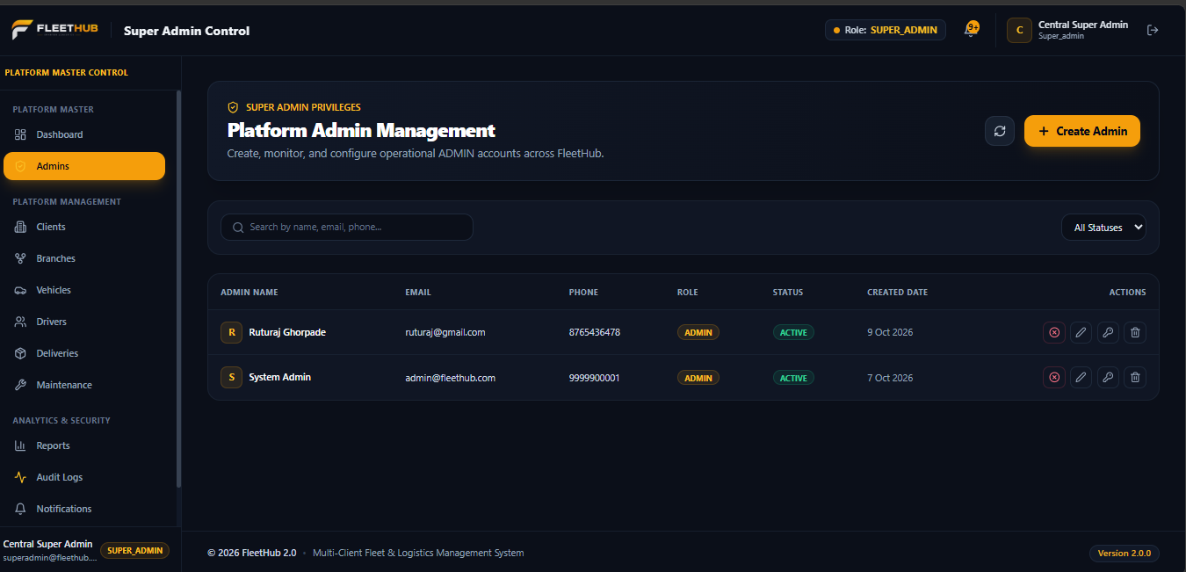

8. Client Management Screen
The Client Management Screen allows the Admin to view and manage registered client organizations. It displays client names, contact email addresses, phone numbers, addresses, and account statuses. The Admin can add new clients, edit existing details, and delete client records using the available actions.
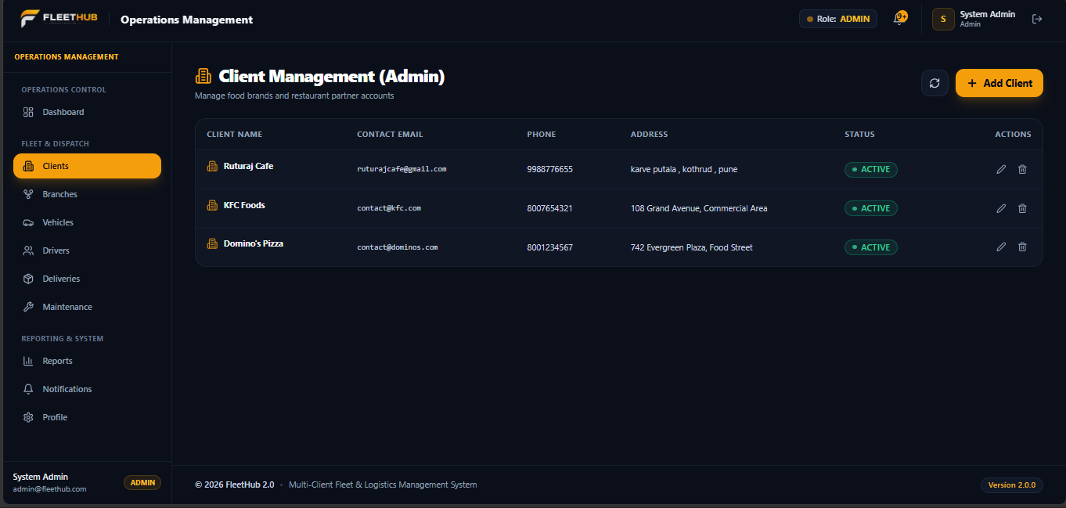

9. Vehicle Management Screen
The Vehicle Management Screen allows the Admin to manage fleet vehicles, including bikes, scooters, cars, and vans. It displays vehicle numbers, types, models, associated branches, and current status. The Admin can add new vehicles, search existing records, filter vehicles by status, and edit or delete vehicle details.
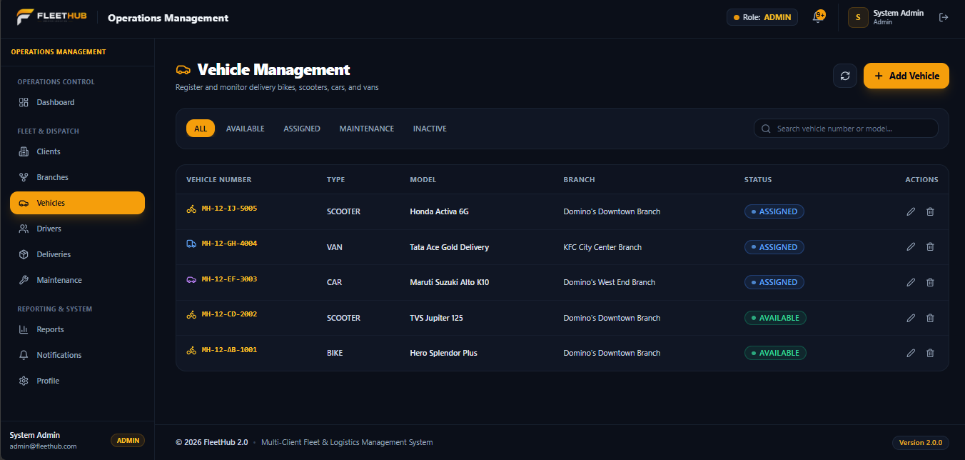

10. Driver Management Screen
The Driver Management Screen allows the Admin to create and manage driver accounts. It displays driver details, licence information, current delivery assignments, and availability status.
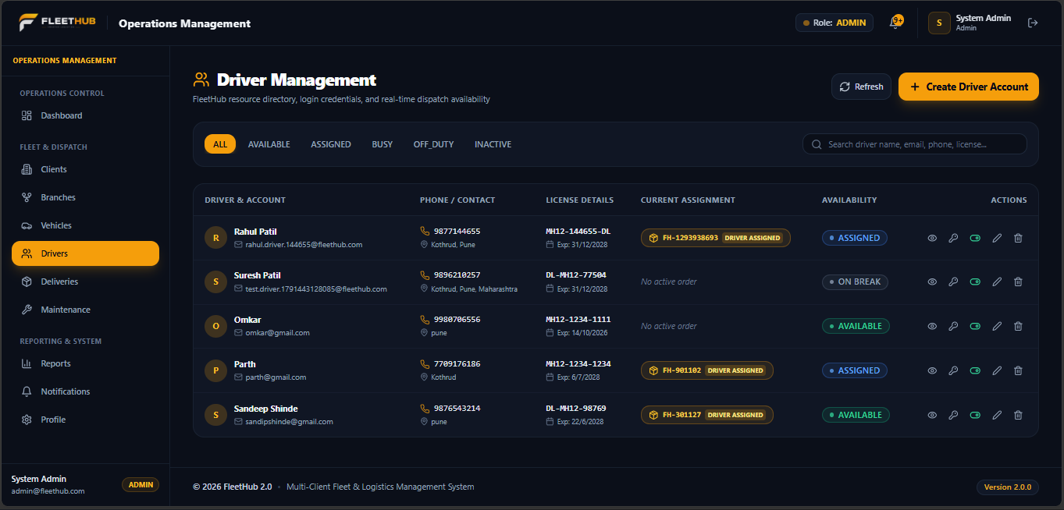

11. Delivery Management Screen
The Delivery Management Screen allows the Admin to view and manage client delivery orders. It helps the Admin assign drivers and vehicles to orders and monitor delivery status.
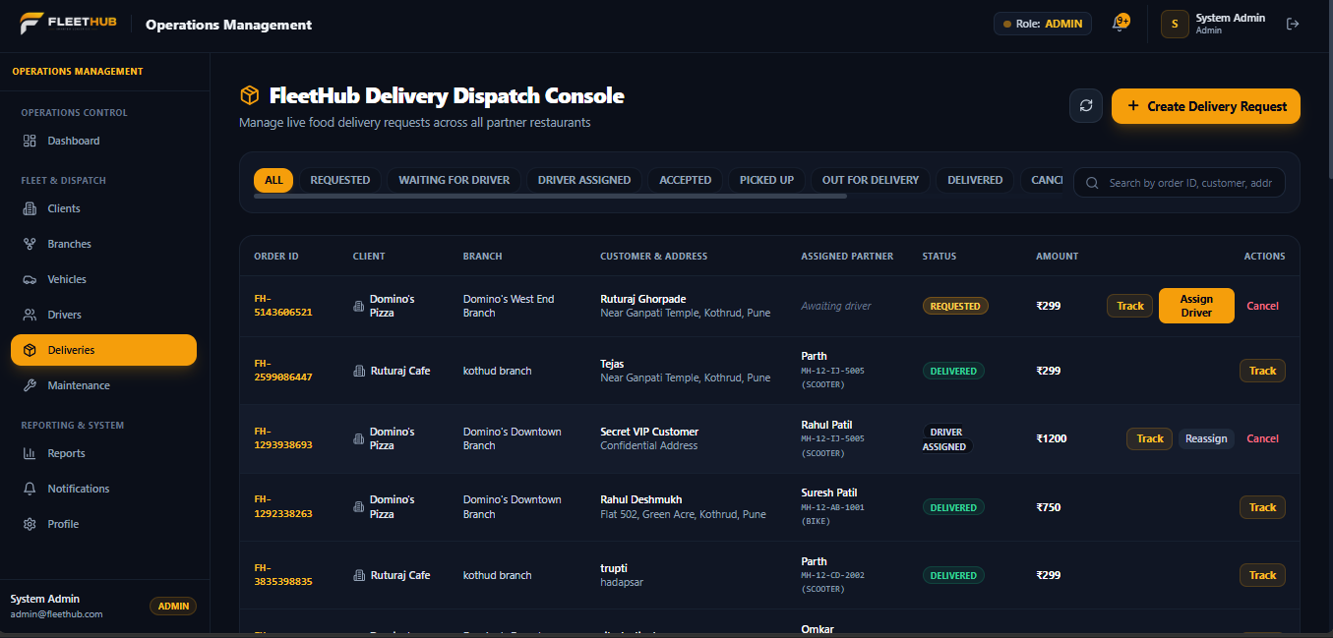

12. Notifications Screen
The Notifications Screen allows users to view important updates related to FleetHub 2.0, including delivery assignments, order status changes, and other system activities.
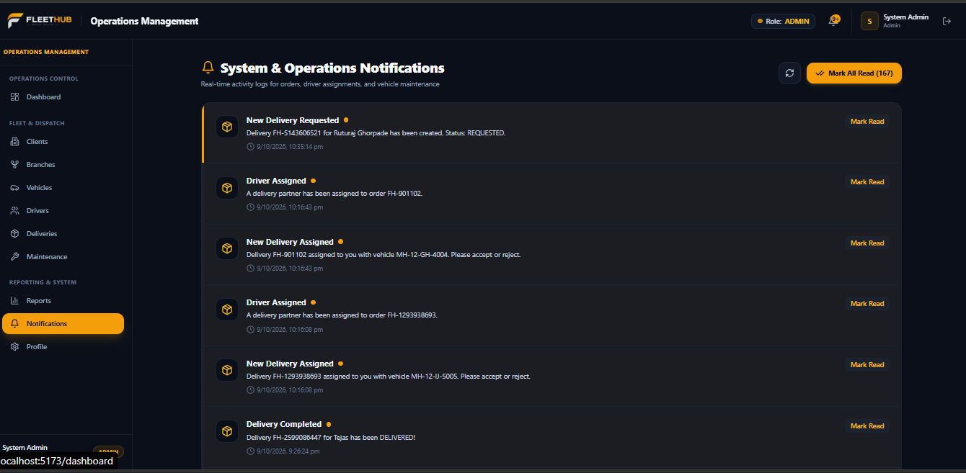

9. Advantages and Limitations

9.1 Advantages
- Centralizes clients, branches, vehicles, drivers, deliveries, and maintenance.
- Separates permissions by role.
- Improves visibility into delivery status and fleet records.
- Supports accountability through audit logging.

9.2 Current Limitations
- Live GPS tracking and advanced route optimization are not part of the current scope.
- Report generation is not currently implemented.
- Dedicated mobile applications and AI-based prediction are future possibilities.

10. Future Enhancements
- GPS-based live vehicle tracking and map view.
- Route optimization and automated assignment recommendations.
- Dedicated driver/client mobile application.
- Fuel tracking and predictive maintenance.
- Report generation and advanced analytics.
- Email, SMS, or push notification integrations.

11. Conclusion
FleetHub 2.0 is a MERN-based web application for multi-client fleet and logistics management. It brings client and branch information, fleet resources, delivery operations, maintenance, notifications, and audit logs into a centralized platform. Role-based access helps separate the responsibilities of Super Admin, Admin, Client, and Driver. Future improvements may add GPS tracking, route optimization, mobile support, and reporting features.

