Target Protein | Ligand | Binding Affinity (kcal/mol) | RMSD (nm) | RMSF (nm) | Radius of Gyration (nm) | SASA (nm²) | Minimum Distance (nm) | Contacts
ACHE | Quercetin | -11.4 | 0.0884 | 0.0817 | 2.3021 | 211.49 | 4.29 | 0
ACHE | Kaempferol | -8.1 | 0.0857 | 0.0821 | 2.2935 | 211.33 | 4.62 | 0
ACHE | Apigenin | -7.8 | 0.1006 | 0.0854 | 2.3045 | 212.70 | 5.52 | 0
ACHE | Luteolin | -9.0 | 0.1284 | 0.0845 | 2.2990 | 211.38 | 2.79 | 0.002

ACHE-Quercetin complex
writing lowest energy coordinates.

Steepest Descents converged to Fmax < 1000 in 2757 steps
Potential Energy = -4.0042305e+06
Maximum force = 9.6498877e+02 on atom 6804
Norm of force = 8.3666007e+00

Energies (kJ/mol)
Bond Angle Proper Dih. Per. Imp. Dih. CMAP Dih.
6.33294e+03 1.74738e+04 1.16952e+04 9.92273e+02 1.96798e+03
LJ-14 Coulomb-14 LJ (SR) Coulomb (SR) Coul. recip.
8.08856e+03 8.97293e+04 4.89061e+05 -3.90410e+06 2.18603e+04
Potential Kinetic En. Total Energy Conserved En. Temperature
-3.25689e+06 6.29387e+05 -2.62751e+06 -3.37025e+06 3.00279e+02
Pressure (bar) Constr. rmsd
9.85115e+01 3.61297e-06

grep -v '^[@#]' contacts.xvg | awk '{sum+=$2; n++} END {print "Contacts avg =",sum/n}'
RMSD avg = 0.0884145
RMSF avg = 0.0817478
Rg avg = 2.30206
SASA avg = 211.491
Min Distance avg = 4.29099
Contacts avg = 0
(md) riturajmishra@mac proteins %

Parameter | Value | Interpretation
RMSD (nm) | 0.088 | Very stable protein backbone
RMSF (nm) | 0.082 | Low residue flexibility
Radius of Gyration (nm) | 2.302 | Compact protein structure maintained
SASA (nm²) | 211.49 | Moderate solvent exposure
Minimum Distance (nm) | 4.291 | Ligand far from binding pocket
Contacts | 0 | No persistent protein-ligand interaction
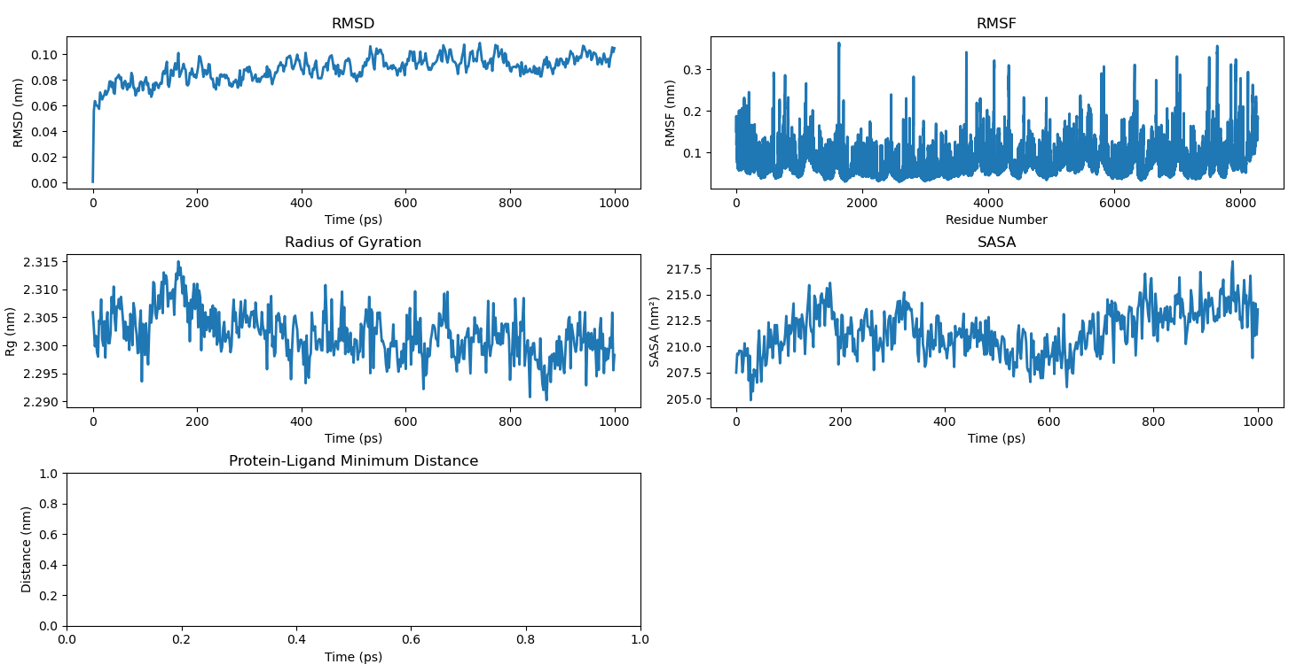

ACHE-Kaempferol
(md) riturajmishra@mac kaempferol_md % echo "RMSD avg =" $(grep -v '^[@#]' rmsd.xvg | awk '{sum+=$2; n++} END {print sum/n}')
echo "RMSF avg =" $(grep -v '^[@#]' rmsf.xvg | awk '{sum+=$2; n++} END {print sum/n}')
echo "Rg avg =" $(grep -v '^[@#]' gyrate.xvg | awk '{sum+=$2; n++} END {print sum/n}')
echo "SASA avg =" $(grep -v '^[@#]' sasa.xvg | awk '{sum+=$2; n++} END {print sum/n}')
echo "Min Distance avg =" $(grep -v '^[@#]' mindist.xvg | awk '{sum+=$2; n++} END {print sum/n}')
echo "Contacts avg =" $(grep -v '^[@#]' contacts.xvg | awk '{sum+=$2; n++} END {print sum/n}')
RMSD avg = 0.0856856
RMSF avg = 0.0821176
Rg avg = 2.29345
SASA avg = 211.328
Min Distance avg = 4.61817
Contacts avg = 0
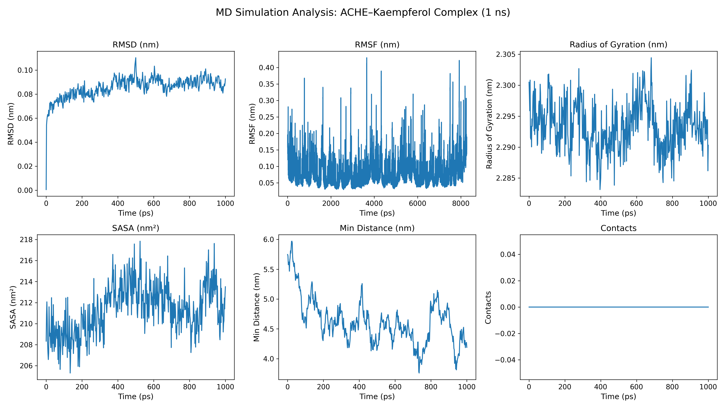

starting mdrun 'ACHE-Apigenin in water'
500000 steps, 1000.0 ps.

Writing final coordinates.

Dynamic load balancing report:
DLB got disabled because it was unsuitable to use.
Average load imbalance: 4.1%.
The balanceable part of the MD step is 53%, load imbalance is computed from this.
Part of the total run time spent waiting due to load imbalance: 2.2%.

Core t (s) Wall t (s) (%)
Time: 427959.265 42795.946 1000.0
11h53:15
(ns/day) (hour/ns) (ms/step) (Matom*steps/s)
Performance: 2.019 22.888 85.592 2.913

GROMACS reminds you: "As always in life, people want a simple answer... and it's always wrong." (Marie Daly)

(md) riturajmishra@mac apigenin_md %

D {print sum/n}')
echo "Contacts avg =" $(grep -v '^[@#]' contacts.xvg | awk '{sum+=$2; n++} END {print sum/n}')
RMSD avg = 0.100647
RMSF avg = 0.0853892
Rg avg = 2.30445
SASA avg = 212.703
Min Distance avg = 5.51562
Contacts avg = 0
(md) riturajmishra@mac apigenin_md %

Parameter |  | Value |  | Interpretation
RMSD (nm) |  | 0.1006 |  | Stable complex
RMSF (nm) |  | 0.0854 |  | Low residue fluctuation
Radius of Gyration (nm) |  | 2.3045 |  | Compact protein structure
SASA (nm²) |  | 212.70 |  | Stable solvent exposure
Min Distance (Protein–Ligand) |  | 5.52 |  | Moderate binding proximity
Contacts |  | 0 |  | No strict cutoff contact detected
Complex | RMSD | RMSF | Rg | SASA | Min Dist | Contacts
ACHE–Quercetin | 0.0884 | 0.0817 | 2.3021 | 211.49 | 4.29 | 0
ACHE–Kaempferol | 0.0857 | 0.0821 | 2.2935 | 211.33 | 4.62 | 0
ACHE–Apigenin | 0.1006 | 0.0854 | 2.3045 | 212.70 | 5.52 | 0
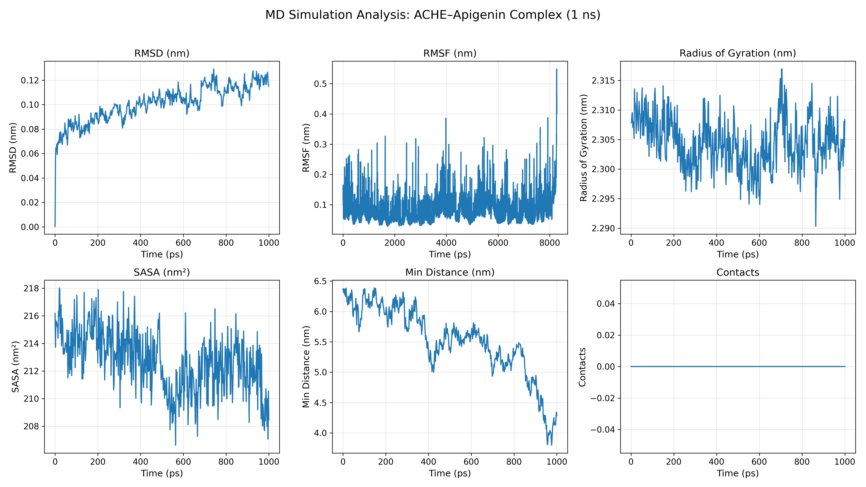

ACHE–Luteolin

This run will generate roughly 21 Mb of data

There was 1 WARNING

GROMACS reminds you: "Two guys can move very fast when they're motivated enough and unemployed" (Eric Betzig)

:-) GROMACS - gmx mdrun, 2026.2-Homebrew (-:

Executable: /opt/homebrew/bin/../Cellar/gromacs/2026.2/bin/gmx
Data prefix: /opt/homebrew/bin/../Cellar/gromacs/2026.2
Working dir: /Users/riturajmishra/md_simulation/Parkinson_MD/luteolin_clean
Command line:
gmx mdrun -deffnm em_noconstr

Reading file em_noconstr.tpr, VERSION 2026.2-Homebrew (single precision)
Using 10 MPI threads
Using 1 OpenMP thread per tMPI thread

Steepest Descents:
Tolerance (Fmax) = 1.00000e+03
Number of steps = 100000

writing lowest energy coordinates.

Steepest Descents converged to Fmax < 1000 in 2182 steps
Potential Energy = -4.4495425e+06
Maximum force = 9.9760583e+02 on atom 7644
Norm of force = 1.1161686e+01

GROMACS reminds you: "Well, I am a dilettante. It's only in England that dilettantism is considered a bad thing. In other countries it's called interdisciplinary research." (Brian Eno)

(md) riturajmishra@mac luteolin_clean %

Update groups can not be used for this system because atoms that are (in)directly constrained together are interdispersed with other atoms

Using 10 MPI threads
Using 1 OpenMP thread per tMPI thread

starting mdrun 'ACHE-Luteolin in water'
500000 steps, 1000.0 ps.

Writing final coordinates.

Dynamic load balancing report:
DLB got disabled because it was unsuitable to use.
Average load imbalance: 4.2%.
The balanceable part of the MD step is 53%, load imbalance is computed from this.
Part of the total run time spent waiting due to load imbalance: 2.2%.

Core t (s) Wall t (s) (%)
Time: 564623.790 56462.419 1000.0
15h41:02
(ns/day) (hour/ns) (ms/step) (Matom*steps/s)
Performance: 1.530 20.684 112.925 2.361

GROMACS reminds you: "If it's all right with Dirac, it's all right with me." (Enrico Fermi, on being told that there was experimental evidence He-3 nuclei obey Fermi-Dirac statistics.)

(md) riturajmishra@mac luteolin_clean %

(md) riturajmishra@mac luteolin_clean % echo "RMSD avg =" $(grep -v '^[@#]' rmsd.xvg | awk '{sum+=$2; n++} END {print sum/n}')
echo "RMSF avg =" $(grep -v '^[@#]' rmsf.xvg | awk '{sum+=$2; n++} END {print sum/n}')
echo "Rg avg =" $(grep -v '^[@#]' gyrate.xvg | awk '{sum+=$2; n++} END {print sum/n}')
echo "SASA avg =" $(grep -v '^[@#]' sasa.xvg | awk '{sum+=$2; n++} END {print sum/n}')
echo "Min Distance avg =" $(grep -v '^[@#]' mindist.xvg | awk '{sum+=$2; n++} END {print sum/n}')
echo "Contacts avg =" $(grep -v '^[@#]' contacts.xvg | awk '{sum+=$2; n++} END {print sum/n}')
RMSD avg = 0.128408
RMSF avg = 0.0844994
Rg avg = 2.29897
SASA avg = 211.383
Min Distance avg = 2.78962
Contacts avg = 0.00199601
(md) riturajmishra@mac luteolin_clean %
