AI3002: Operating Systems

Name of the student:
Ruturaj rawate

Roll

No.
8

Div:
AI C
Batch:
B1

Date of performance:
14/07/25

Experiment No.1
Title: Execution of Basic and Advanced Linux commands.
File and file system management:

1. cat: The cat (concatenate) command is used to display the contents of a file on the terminal or to combine multiple files.
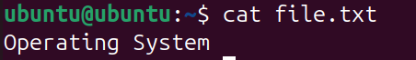

2. cd: The cd (change directory) command is used to navigate between directories in the file system.
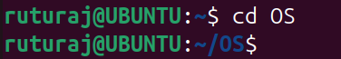

3. chmod: The chmod (change mode) command is used to change the read, write, and execute permissions of files or directories.

4. chown: The chown (change owner) command changes the ownership of a file or directory to a specified user and/or group.
5. chgrp: The chgrp command is used to change the group ownership of a file or directory.

6. cp: The cp (copy) command is used to copy files or directories from one location to another.


7. du: The du (disk usage) command estimates and displays the amount of disk space used by files and directories.
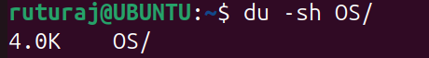

8. df: The df (disk free) command shows the available and used disk space of all mounted file systems.
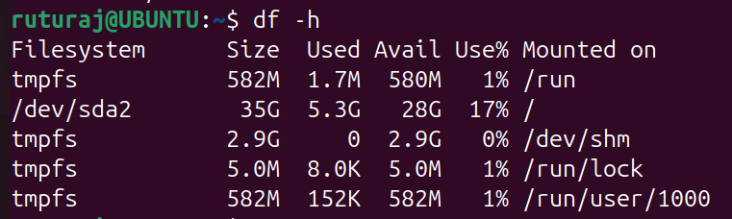

9. file: The file command determines the type of a file by reading its content or metadata.
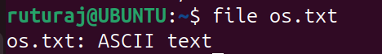
10. fsck: The fsck (file system check) command checks and repairs inconsistencies or errors in a file system.
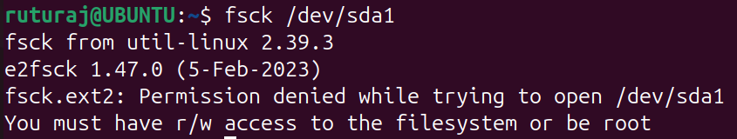
11. ln: The ln (link) command creates hard links or symbolic (soft) links between files.

12. ls: The ls (list) command lists files and directories in the current or specified directory.
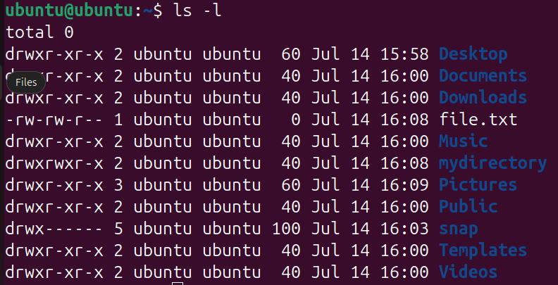

13. lsof: The lsof (list open files) command lists information about files opened by processes.
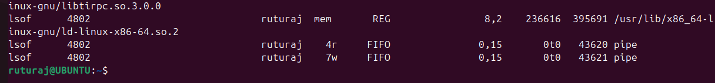

14. mkdir: The mkdir (make directory) command is used to create new directories.
15. mount: The mount command is used to attach a file system to a directory tree, making it accessible.

16. mv: The mv (move) command is used to move or rename files and directories.

17. pwd: The pwd (print working directory) command displays the full path of the current working directory.
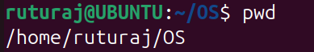

18. rm: The rm (remove) command is used to delete files and directories.

19. rmdir: The rmdir (remove directory) command deletes empty directories from the file system.
20. split: The split command divides a large file into smaller files based on size or number of lines.

21. touch: The touch command creates empty files or updates the access/modification timestamp of existing files.
Process management Commands:

at
Schedules a one-time task to run at a specific time. Used to execute commands at a later time, such as scheduling a system shutdown or script run.
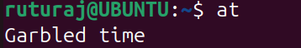

2. chroot
Changes the apparent root directory for the current running process and its children. Useful for isolating a process in a restricted environment (like a jail or recovery shell). 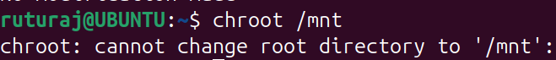

3. crontab
Manages cron jobs that schedule tasks to run periodically (daily, weekly, etc.). Commonly used for automating backups, maintenance, and report generation.
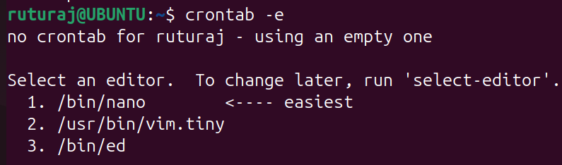

4. kill
Sends a signal to a process, usually to terminate it. Default signal is SIGTERM (15), but can also send SIGKILL (9) for forceful stop.
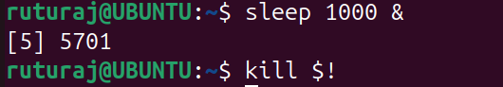

5. killall
Kills all processes matching a given name. Unlike kill, you don’t need to know the PID—just the process name.

6. nice
Starts a process with a user-defined scheduling priority. Lower values = higher priority; higher values (e.g., 10) = lower priority, meaning less CPU access.

7. pgrep
Searches for processes by name and returns their PID(s). Simplifies identifying active processes without ps | grep.

8. pidof
Returns the process ID (PID) of a running program. Used to quickly identify the PID of a specific application (e.g., pidof sshd).
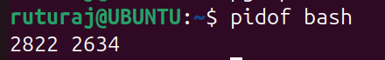

9. pkill
Sends signals to processes by name or pattern (similar to killall). Supports regular expressions and advanced filtering like -f to match full command lines.

10. ps
Displays a snapshot of current running processes. Useful for checking running tasks, CPU usage, and memory statistics. 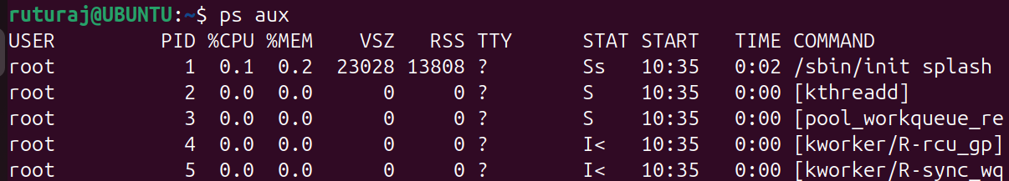

11. sleep
Pauses execution of the shell for a specified time (in seconds). Helpful in scripting for delays or timed execution.
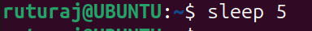

12. time
Measures how long a command takes to execute. Reports real time, user CPU time, and system CPU time. 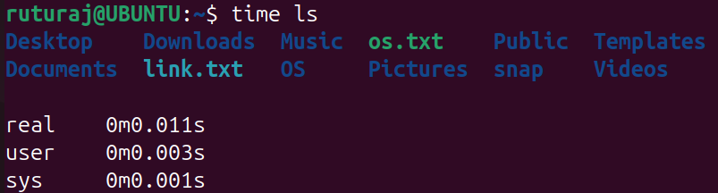

13. top
Shows real-time view of system processes, CPU usage, memory usage, etc. Allows dynamic monitoring and management of running processes. 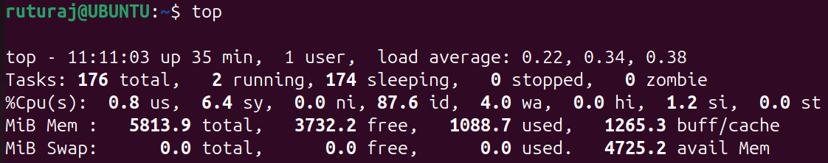

14. wait
Pauses the current shell script until a specified background process finishes. Useful in scripts to ensure proper execution order.

15. watch
Runs a command repeatedly at fixed intervals and shows the output. Ideal for monitoring changes (like file sizes, process status, etc.) in real time.
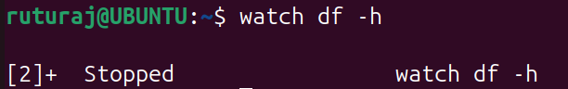

Text Processing commands:

1. head: The head command displays the first few lines of a file (default is 10 lines).
It’s commonly used to preview the beginning of large files.
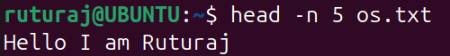

2. iconv: The iconv command converts the character encoding of a file.
It’s useful for changing text files between formats like ISO-8859-1 and UTF-8.

3. join: The join command merges lines from two sorted files based on a common field.
It acts like a simple relational database join for text data.

4. less: The less command allows you to view a file one page at a time interactively.
You can scroll up and down, making it ideal for reading large files.

5. more: The more command displays text page-by-page in the terminal.
It’s an older alternative to less with limited navigation.
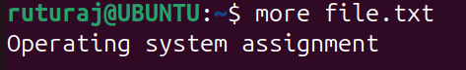

6. paste: The paste command merges lines of multiple files side by side using a tab.
It is useful for combining columns of data into a single line.
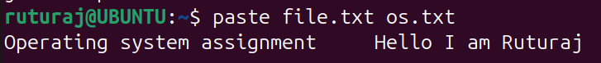

7. sort: The sort command arranges lines of text in alphabetical or numerical order.
It supports options for reverse sorting, numeric values, and custom delimiters. 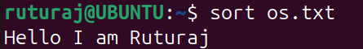

8. tail: The tail command displays the last part of a file, usually the last 10 lines.
It’s commonly used to monitor real-time logs with the -f option.
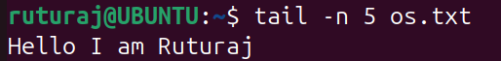

9. tr: The tr command translates or deletes characters from input text.
It’s often used to change case, remove characters, or compress spaces.

10. uniq: The uniq command removes or highlights duplicate lines from sorted input.
It’s useful in filtering repeated data from logs or lists.
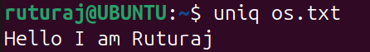

11. wc: The wc (word count) command counts lines, words, and characters in a file.
You can use options like -l, -w, or -c to get specific counts.
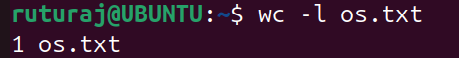
User Management/ Environment Commands:

1. env: Displays the current user's environment variables. Useful for viewing paths, shell settings, and configuration values.
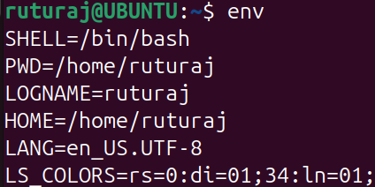

2. finger: Shows detailed information about a user account. Includes login name, home directory, shell, and last login time.
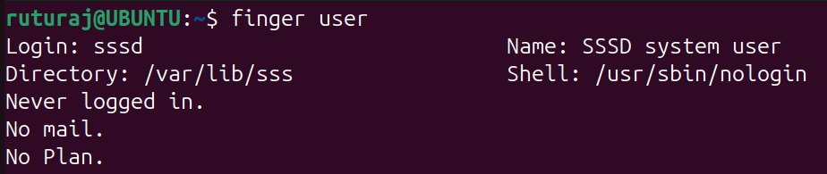

3. id: Displays the current user's UID, GID, and group memberships. Helps verify identity and access permissions.

4. mesg: Controls whether other users can send messages to your terminal. mesg n disables write access; mesg y enables it.
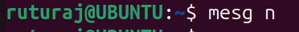

5. passwd: Changes the password of the current or specified user. It securely prompts for the old and new password.
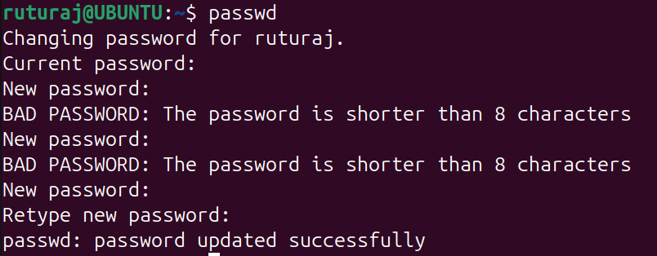

6. sudo: Executes a command as another user (usually root). It grants temporary elevated privileges without switching users.
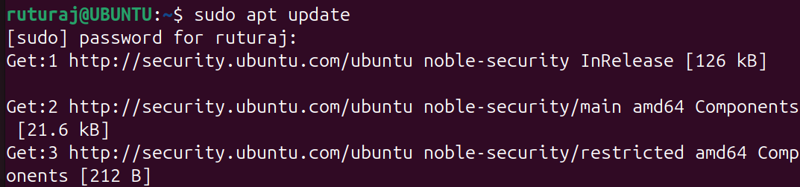

7. uname: Displays system information such as kernel name and architecture. Use uname -a for complete system details.

8. uptime: Shows how long the system has been running. Also displays load averages and current time.

9. w: Displays who is logged in and what they are doing. It includes login time, idle time, and the command being executed.
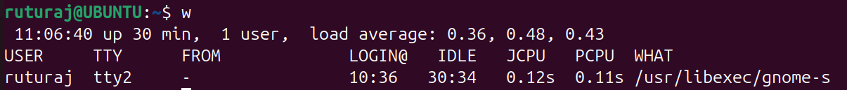

10. wall: Sends a message to all users logged into the system. Commonly used by admins to broadcast shutdown or maintenance alerts.

11. who: Lists users currently logged in. Also shows the terminal, login time, and originating IP (if remote).
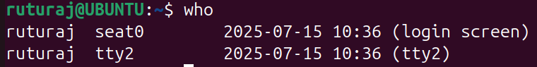

12. whoami: Displays the current logged-in username. Equivalent to id -un.
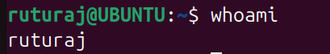

13. write: Sends a message to another user’s terminal. Used for real-time, one-to-one communication on multi-user systems.
Communication commands:

1. inetd: The inetd is a super-server daemon that manages incoming network connections for various services. It launches the appropriate service when a request is received (largely replaced by xinetd or systemd).
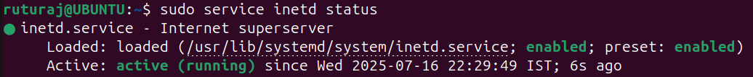

2. netstat: The netstat command displays network connections, routing tables, interface stats, and ports. It's commonly used to check which ports are listening and network traffic.

3. ping: The ping sends ICMP echo requests to test if a host is reachable over the network. It measures round-trip time and packet loss between systems.
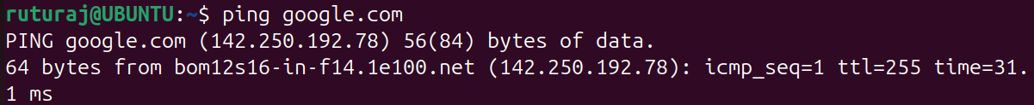

4. rlogin: The rlogin (remote login) is used to log in to another system over the network. It’s outdated and insecure, and has been mostly replaced by SSH.

5. traceroute: The traceroute traces the path that packets take to reach a destination host. It shows each hop (router) along the route with timing information.
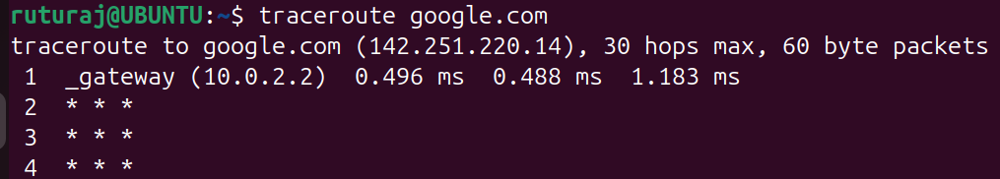
Searching Commands:

1. find: The find command searches for files and directories in a given path based on name, size, type, or time. It can be combined with actions like -exec to perform tasks on matching files.

2. grep: The grep command searches for lines in files that match a given pattern or keyword. It supports regular expressions and is ideal for filtering log files and text output.
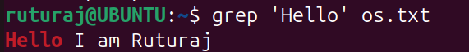

3. strings: The strings command extracts readable (printable) text from binary or compiled files. It’s useful for analyzing executable files or unknown binary data.

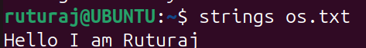
Miscellaneous Commands:
1. banner – Displays large ASCII text in the terminal, often used for headings or decoration.
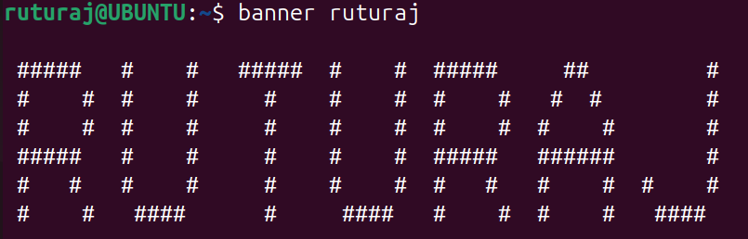
2. bc – A command-line calculator used for precise arithmetic with decimals.
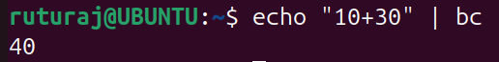
3. cal – Shows a monthly or yearly calendar in the terminal.
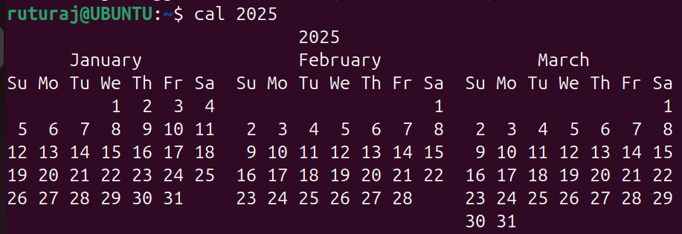
4. man – Displays the manual/help page for any Linux command.
5. size – Shows memory section sizes of compiled binaries like a.out.
6. yes – Continuously outputs a string until stopped, useful for auto-confirmation.
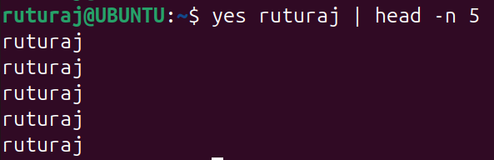
Conclusion:
Linux commands are powerful tools for managing files, processes, users, and system tasks. Mastering them improves efficiency, automation, and control over the system, making daily operations faster and smarter.

