AI3002: Operating Systems

Name of the student:
Ruturaj rawate

Roll

No.
8

Div:
AI C
Batch:
B1

Date of performance:
21/07/25

Experiment No. 2
Title:
- Write a shell Script to find the sum of digits of the entered number.
- Write a shell Script to sort array elements in Descending order.
Write a shell Script to find the sum of digits of the entered number.

Code:
read -p "Enter a number: " num
sum=0
while [ "$num" -gt 0 ]; do
digit=$((num % 10))
sum=$((sum + digit))
num=$((num / 10))
done

echo "Sum of digits: $sum"

Output:
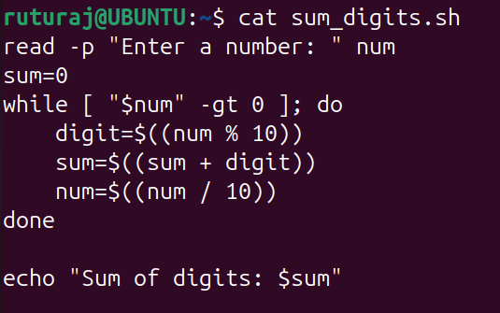
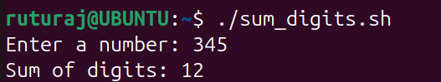

Write a shell Script to sort array elements in Descending order.
Code:

read -p "Enter array elements separated by space: " -a arr
sorted=($(printf "%s\n" "${arr[@]}" | sort -nr))

echo "Sorted array in descending order: ${sorted[@]}"

Output:
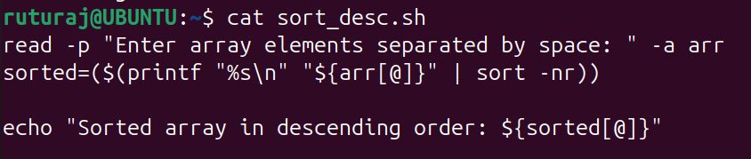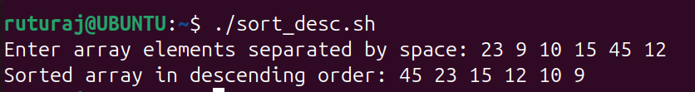

Conclusion:
This shell script reads array elements from the user and sorts them in descending order using the sort command with numeric and reverse options. It efficiently handles integer inputs and displays the sorted array. Using printf and command substitution makes the script concise and effective. This approach is suitable for quick sorting tasks in bash.

