**D. Y. PATIL COLLEGE OF ENGINEERING & TECHNOLOGY**

**KASABA BAWADA, KOLHAPUR**

**DEPARTMENT OF COMPUTER SCIENCE AND ENGINEERING**

(2018-2019)



A

Domain Specific Mini Project Synopsis

On

**“Waste Monitoring”**

**Submitted by:**

|  |  |  |  |
| --- | --- | --- | --- |
| **Roll No.** | | **Name** | |
| 36 | | Ruturaj Hemant Desai | |
| 37 | | Ruturaj Ravindra Sawant | |
| 38 | | Siddhi Ashok Jadhav | |
| 39 | | Rushikesh Ravindra More | |
| 40 | | Karan Dattatray Kenjale | |

UNDER THE GUIDANCE OF

Prof. Mr. K.T. Mane

**Class: TE (CSE) Div.: A Batch: T3**

**INDEX**

|  |  |  |
| --- | --- | --- |
| **S.N.** | **Title** | **Pg.no** |
| **1.** | Abstract |  |
| **2.** | Introduction |  |
| **3.** | Problem statement |  |
| **4.** | Objectives |  |
| **5.** | Proposed System Architecture |  |
| **6.** | Modules |  |
| **7.** | System Requirements |  |
| **8.** | Conclusion |  |
| **9.** | References |  |

**1. Abstract**

In this project we will be using ultrasonic sensors for measuring the waste deposited in respective garbage bin, thus analysing and reporting the bin divers for collection of the waste.

In this project, we are providing statistical report of garbage bins with the help of web user interface, notify the bin divers via SMS.

We are also keeping a database in which we will store analysed data sensed through ultrasonic sensors installed in respective bins.

Our aim is to provide optimized path for bin divers (Garbage Collectors), thus providing efficient diving time.

**2. Introduction**

Internet of Things (IoT) is a concept in which surrounding objects are connected through wired and wireless networks without user intervention. In the field of IoT, the objects communicate and exchange information to provide advanced intelligent services for users.

In this project we are designing and building a prototype system that could efficiently manage bin-diving to provide ideal diving schedules

**3. Problem Statement**

To design and implement system for waste monitoring to provide optimal path for bin diving.

**4. Objectives**

* To design and build a prototype of a system that could efficiently manage bin-diving.
* To provide the ideal diving schedules.
* To implement this ultrasonic sensors HC-SR04 used attached with each bin forming a layered structure.
* The sensed data is then forwarded over the cloud to the database.
* Then this data will be processed using algorithm.
* Algorithm provides optimized path for collecting waste from the bin.
* Optimal diving schedule is forwarded to respective waste management organisation and data is then been displayed on web interface.

**5. Proposed System Architecture**

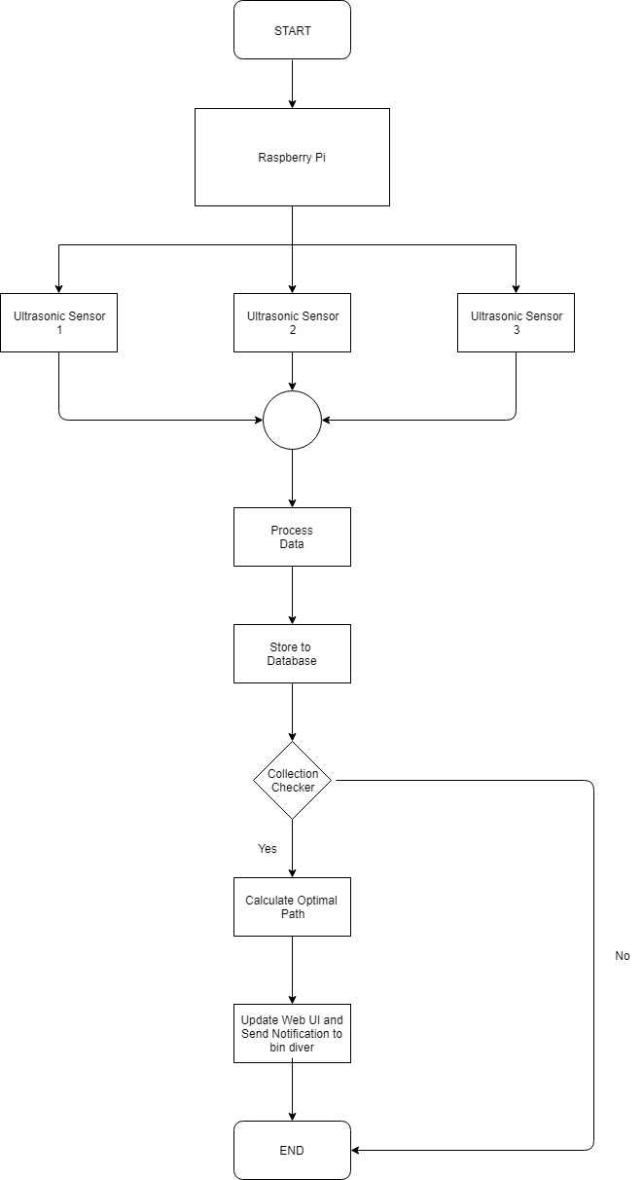

**6. Modules**

* **Process Data:** Data received from sensors are in form of voltages, then we convert that voltage into distance using algorithm.
* **Store Data:** Then we store that processed data into database for analysis.
* **Collection Checker:** Here we analyse the stored data and check if the waste collection is required.
* **Optimal Path Calculator:** If Collection Checker returns true then we calculate optimal path for garbage collection using algorithm.
* **Notifier:** After calculating optimal path respective bin divers are notified using SMS.
* **Web UI Updater:** In this we periodically update statistics for monitoring.

**7. Conclusion**

This Domain Specific Mini Project is developed to provide the ideal diving schedules.

**8. System Requirements:**

1. **Hardware Requirements**

RAM : 1 GB

Processor : Pentium 4 onwards

1. **Software Requirements**

Languages : Python,HTML,CSS,Javascript,Bootstrap,D3.js

Database : MySQL

Operating system : Windows

Compiler : Python Interpreter

**9. References**

**Website Links**

1. <https://icpc.baylor.edu/>
2. [https://stackoverflow.com/questions/16498066/finding-all-paths-between- points-on-a-square-matrix](https://stackoverflow.com/questions/16498066/finding-all-paths-between-%20points-on-a-square-matrix)
3. <http://en.cppreference.com/w/>
4. [www.stackoverflow.com](http://www.stackoverflow.com)
5. [www.geeksforgeeks.com](http://www.geeksforgeeks.com)