**Installation of JDK (Java Development Kit)**

**Step 1:** Go to the official Oracle website

<https://www.oracle.com/java/technologies/downloads/#java17-windows>

**Step 2:**

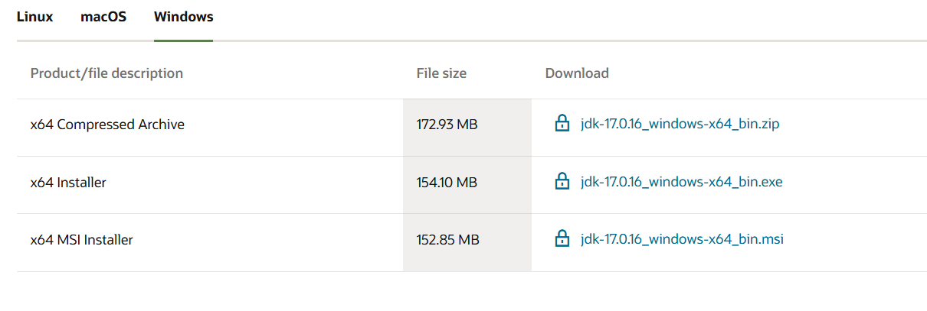

Download the x64 installer and run the .exe file.

**Step 3:**

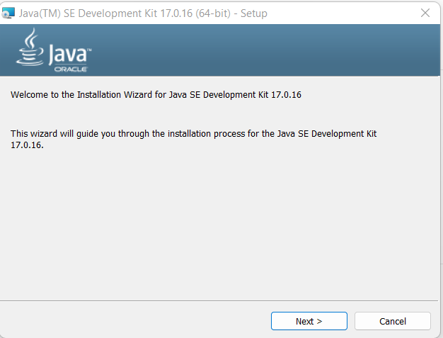

You’ll see the JDK installer window. Click **Next.**

**Step 4:**

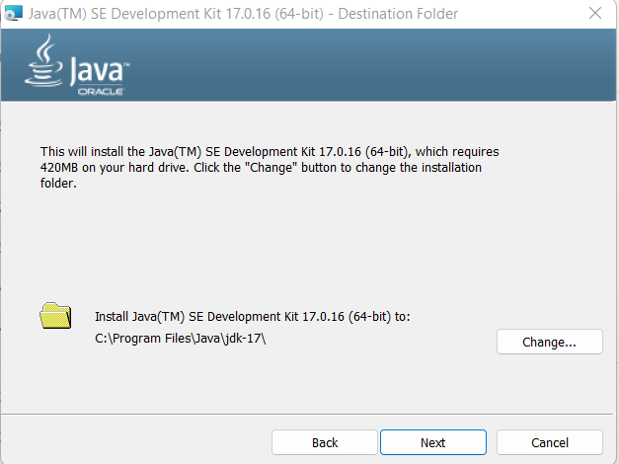

Click **Next** and wait for it to install.

**Step 5:**

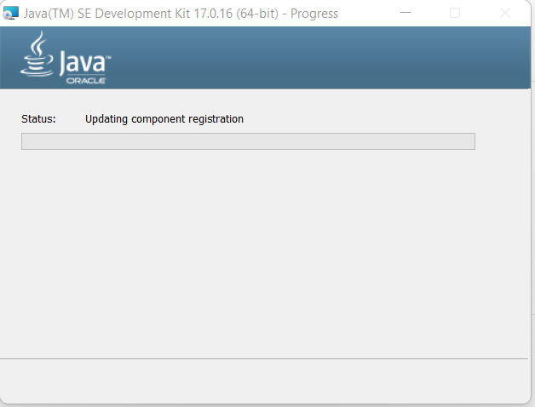

Installing.

**Step 6:**

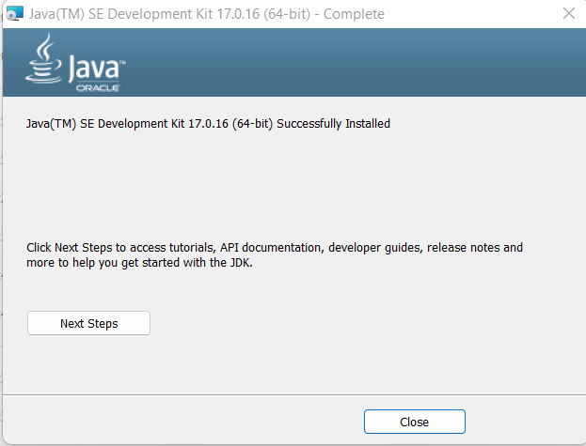

Click on **Close button.**

JDK installation Done Successfully.

**Installation of Intellij IDE**

**Step 1:** Go to the website

<https://www.jetbrains.com/idea/download/?section=windowns>

**Step 2:** Choose the correct version Community Edition.

**Step 3:** Click on the “Download” button and select .exe file.

**Step 4:**

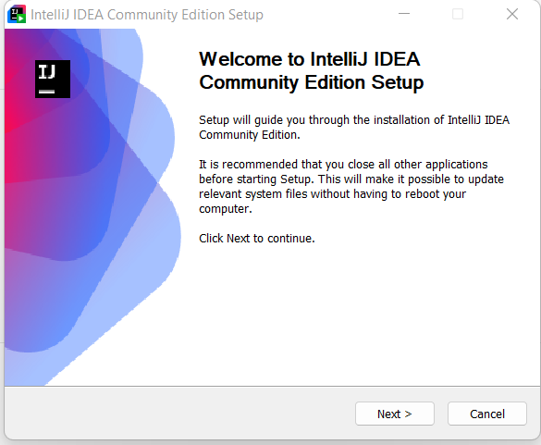

Click Next to continue

**Step 5:**

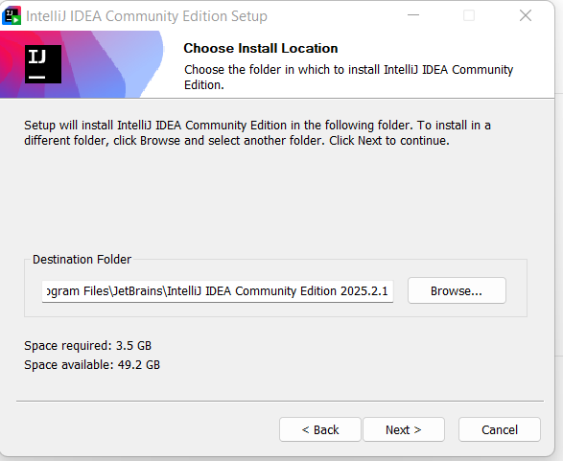

Click on next button.

**Step 6:**

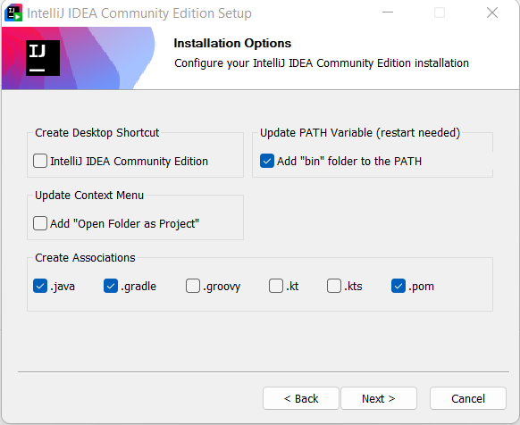

Select Add “bin” folder to the PATH & in Create Associations option select .java, .gradle, .pom.

**Step 7:**

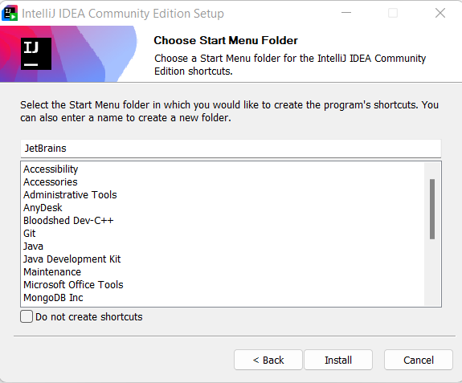

Click on install button.

**Step 8:**

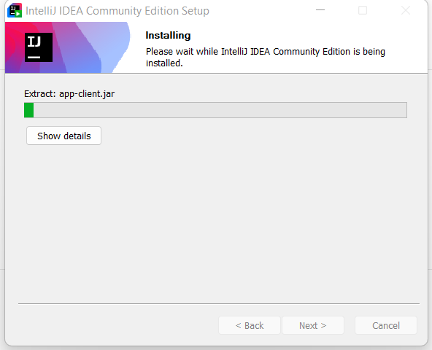

Installing

**Step 9:**

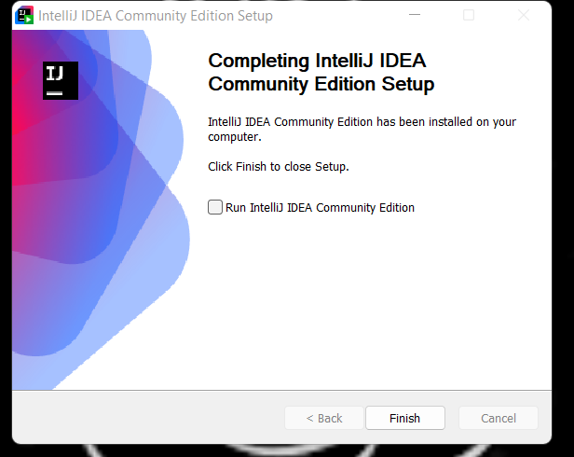

Click on Finish Button.

Intellij IDEA Community Edition installation Done Successfully.

**Installation of Git**

**Step 1:** Go to the website

<https://git-scm.com/downloads>

**Step 2:** Click on windows.

**Step 3:** Click on Git for Windows/x64 Setup.

**Step 4:**

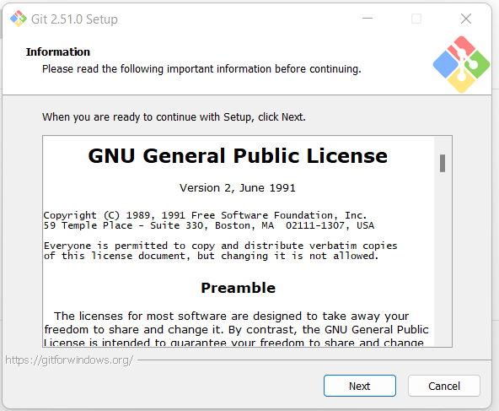

Click Next to continue

**Step 5:**

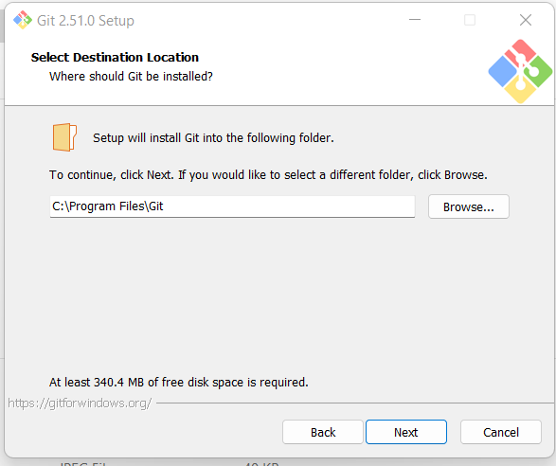

Click Next to continue

**Step 6:**

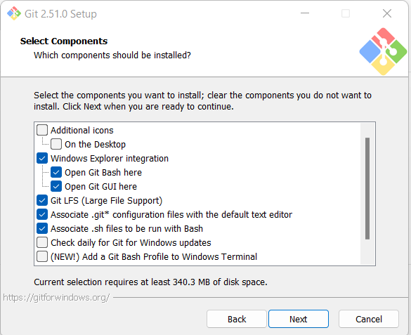

Select the components to want to install; clear the components you do not want to install.

Click Next when you are ready to continue.

**Step 7:**

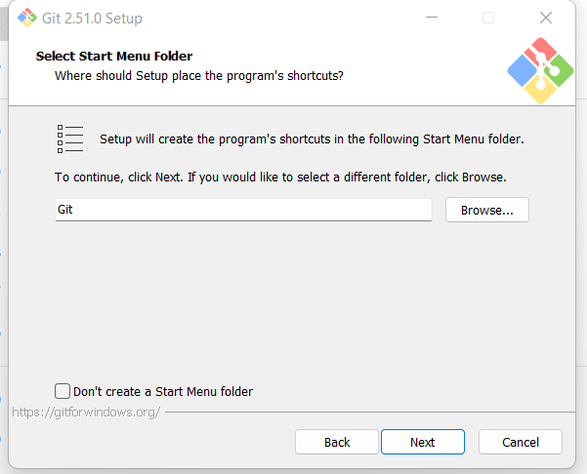

Click Next to continue.

**Step 8:**

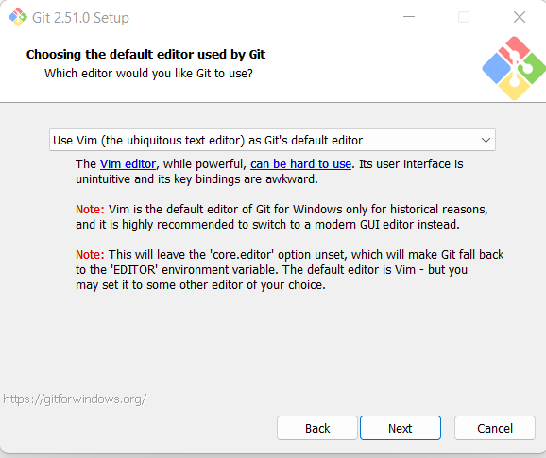

Select “Use Vim (the ubiquitous text editor) as Git’s default editor.

Click Next.

**Step 9:**

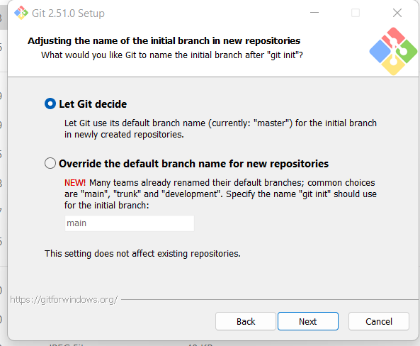

Click Next.

**Step 10:**

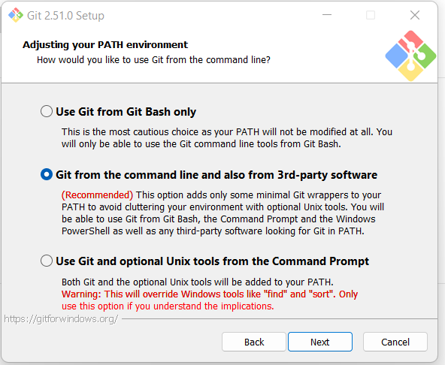

Click Next.

**Step 11:**

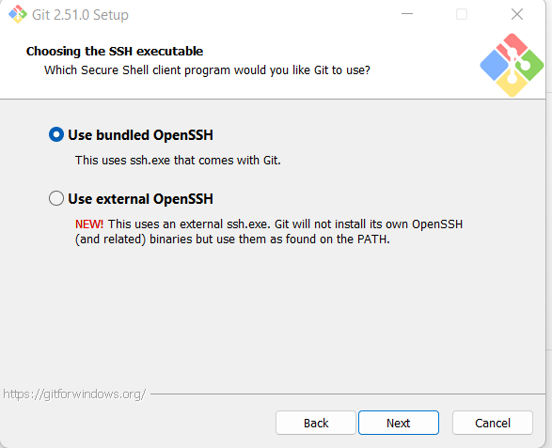

Click Next.

**Step 12:**

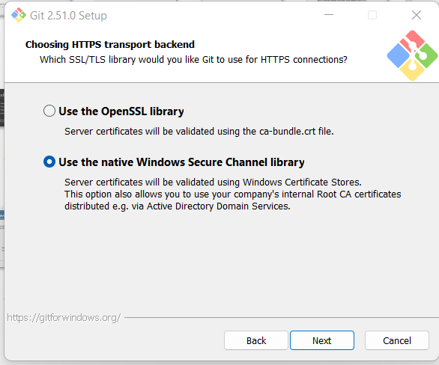

Click Next.

**Step 13:**



Click Next.

**Step 14:**

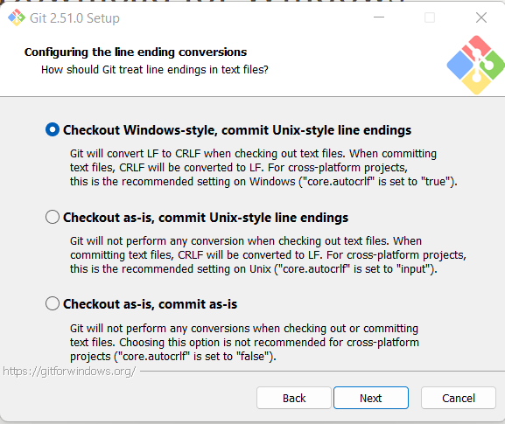

Click Next.

**Step 15:**

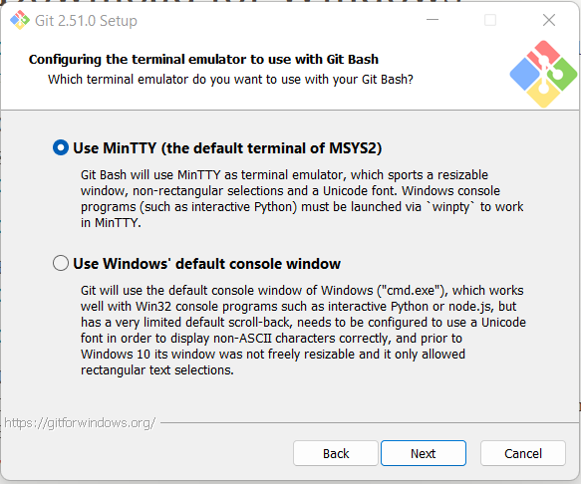

Click Next.

**Step 16:**

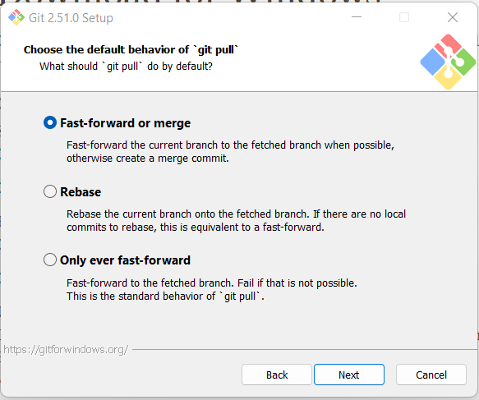

Click Next.

**Step 17:**

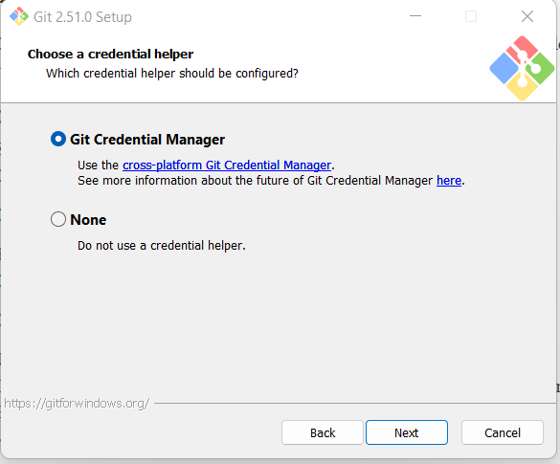

Click Next.

**Step 18:**

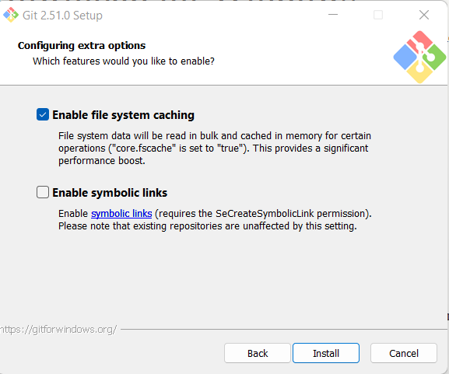

Click on Install button.

**Step 19:**

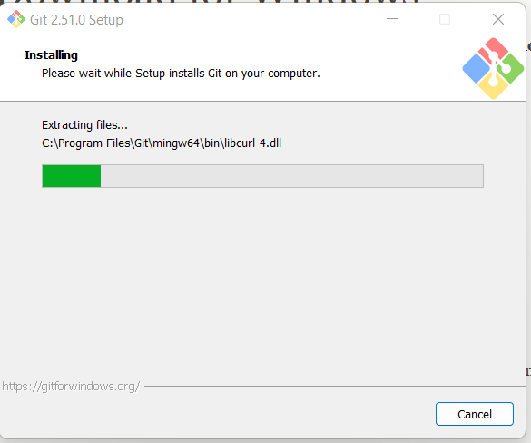

Installing.

Git installation Done Successfully.