Assignment 7: Multi-Paradigm Problem Solving
Rutu Ketankumar Shah
University of Cumberlands
MSCS-632-M20- Advance Programming Languages
Professor: Dr Jay Thom
04/19/2026

Overview
The problem of computing mean, median, and mode from a list of integers was implemented in three languages, each representing a distinct programming paradigm: C (procedural), OCaml (functional), and Python (object-oriented). This report reflects on the experience, challenges, and key differences observed.
C Approach
The C functions operating on arrays passed by pointer. The most distinctive aspect was manual memory management: malloc was called to create sorted copies of the array (to avoid mutating the original), and every allocation required a corresponding free. Forgetting this causes memory leaks a class of bug that higher-level languages eliminate entirely.
Sorting was handled via qsort from the standard library, requiring a comparator function. Mode calculation involved two passes over the sorted array: one to find the maximum frequency, another to collect all values matching it. There were no built-in data structures like dictionaries, so frequency counting required index-based logic.
Key challenge: Managing memory correctly while keeping the original array unmodified required deliberate copying. The low-level nature demanded careful attention to pointer arithmetic and array bounds.
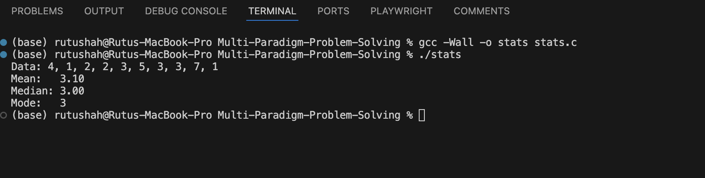
OCaml Functional Approach
OCaml enforced a fundamentally different mindset: no mutable state. Every operation produced a new value rather than modifying existing data. List.sort returned a new sorted list; List.fold_left accumulated frequency counts into an association list without any variable being reassigned.
The mode calculation was the most expressive part. List.filter_map cleanly combined filtering and transformation in one pass. Pattern matching with List.assoc_opt made frequency map lookups concise and safe.
Key challenge: Thinking without mutation requires a mental shift, especially for developers accustomed to loops and assignment. Recursion and higher-order functions replace imperative control flow. The OCaml type system is strict mismatched types (e.g., int vs float) are compile-time errors, which initially slows development but prevents runtime surprises.
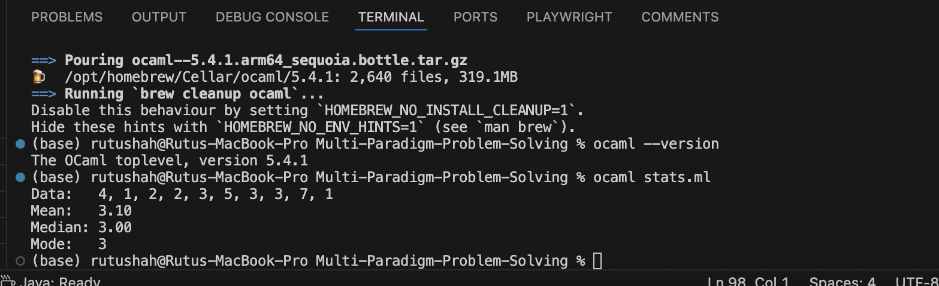
Python Implementation
The Python implementation was the simplest and fastest to write. A StatisticsCalculator class was created with self.data holding the input list, and a single report method handled all output. The key reason for this simplicity was Python's built-in statistics module calling statistics.mean(), statistics.median(), and statistics.mode() eliminated the need to implement any calculation logic manually.
This contrasts sharply with C and OCaml, where every algorithm had to be written from scratch. In Python, the entire computation was reduced to three library calls, with the class serving mainly as an organizational wrapper around them. While this demonstrates OOP encapsulation, it also highlights how Python's rich standard library can abstract away complexity that other languages require the developer to handle explicitly.
Key challenge: There was minimal challenge in Python precisely because the statistics module handles edge cases, type conversions, and algorithm details internally. The only OOP consideration was designing the class structure deciding what belongs in __init__ versus methods. If anything, the challenge was appreciating what the library is doing under the hood, which became clearer after implementing the same logic manually in C and OCaml.
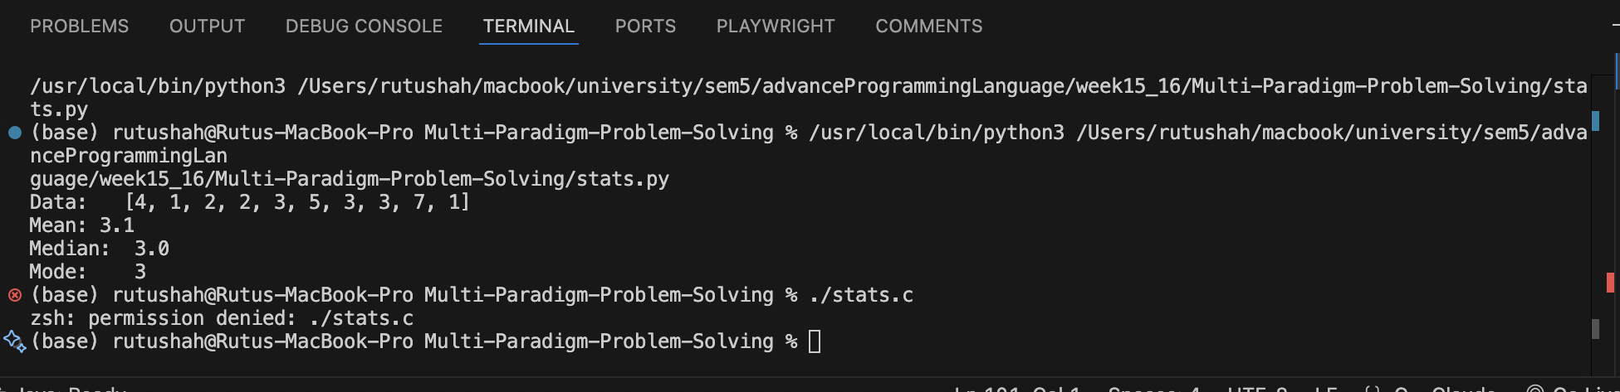
Key Difference observed using all the languages
Aspect | C (Procedural) | OCaml (Functional) | Python (Object-Oriented)
State Management | Explicit and mutable state handling | Immutable by default with functional paradigms | Managed through object encapsulation
Memory Management | Manual allocation and deallocation (malloc/free) | Automatic garbage collection | Automatic garbage collection
Abstraction Unit | Functions | Expressions and functions | Classes and methods
Algorithm Implementation | Implemented from scratch | Implemented from scratch | Often delegated to built-in libraries (e.g., statistics module)
Error Handling Risk | Prone to memory leaks and buffer overflows | Compile-time type safety reduces runtime errors | Susceptible to runtime exceptions
Development Speed | Slowest due to low-level control | Moderate with functional abstractions | Fastest due to high-level abstractions and libraries

Conclusion
Each paradigm shaped the solution differently. C demanded awareness of machine-level concerns like memory and algorithm implementation. OCaml required thinking in transformations rather than steps, with the compiler enforcing correctness. Python, aided by its statistics module, prioritized developer productivity the problem was solved in minimal code with no manual algorithm work. This progression from C to Python illustrates a clear trade-off: lower-level languages offer control and performance at the cost of complexity, while higher-level languages sacrifice that control in exchange for speed of development and ease of use.
GitHub Repository:

