Assignment 6: Multi-threaded Data Processing System
Rutu Ketankumar Shah
University of Cumberlands
MSCS-632-M20- Advance Programming Languages
Professor: Dr Jay Thom
04/12/2026

Abstract
This assignment presents the design and implementation of a concurrent data processing system developed in both java and go. The system simulates a producer-consumer architecture in which multiple worker threads retrieve tasks from a shared queue, process them in parallel, and store results in a thread-safe result store. The Java implementation uses a Re-entrant with Condition variables for queue synchronization, a ReadWriteLock for the result store, and an Executor Service for managed thread lifecycle. The Go implementation uses goroutines as lightweight workers, a buffered channel as a concurrency-safe task queue, a sync.WaitGroup for shutdown coordination, and a sync.Mutex for result store protection. Both systems successfully processed 20 heterogeneous tasks across four parallel workers with clean shutdown behavior and structured error logging. This paper discusses the design decisions, concurrency techniques, and error handling strategies used in each implementation, and concludes with a comparative analysis of the two concurrency models.
Introduction
Modern software applications increasingly demand the ability to process large volumes of data simultaneously. In this assignment I have designed and implemented concurrent data processing system that demonstrates the producer-consumer pattern in both Java and Go. Java is built around shared-memory concurrency protected by explicit locks, while go promotes the principle of communicating sequential processes, encouraging developers to share data by communicating through channels rather than communicating by sharing memory (Donovan & Kernighan, 2015).
The system consists of a shared task queue populated with 20 heterogeneous tasks simulating real-world operations such as sensor reads, database queries, image resizing, and file compression. Four parallel workers drain the queue concurrently, and all results are stored in a thread-safe result store. Both implementations were compiled, executed, and validated, producing correct parallel output with clean shutdown behavior and zero data races.
Java Implementation
In java, I have developed in six classes. Task, TaskResult, SharedQueue, ResultStore, Worker and DataProcessing system.
Concurrency Techniques
In SharedQueue class I have used a ReentrantLock in fair mode to prevent thread starvation, with a Condition variable (notEmpty) for efficient blocking retrieval. Workers call await() when the queue is empty, releasing the lock until a producer calls signal() after adding a task. This eliminates busy-waiting and guarantees no notifications are missed . The ResultStore uses a ReentrantReadWriteLock, allowing multiple workers to read results simultaneously while writes remain exclusive. Worker threads are managed through a fixed ExecutorService thread pool, which provides high-level shutdown coordination via awaitTermination().
Exception Handling
I have defined InterruptedException wherever a thread may block. The interrupt flag is immediately restored using Thread.currentThread().interrupt() and the worker exits gracefully, preserving the cooperative interrupt protocol. IOException from file operations is caught, logged, and re-thrown to the caller. A broad Exception catch in the worker loop ensures a single failing task does not terminate the worker the error is logged, and processing continues.
Result Output for Java Implementation
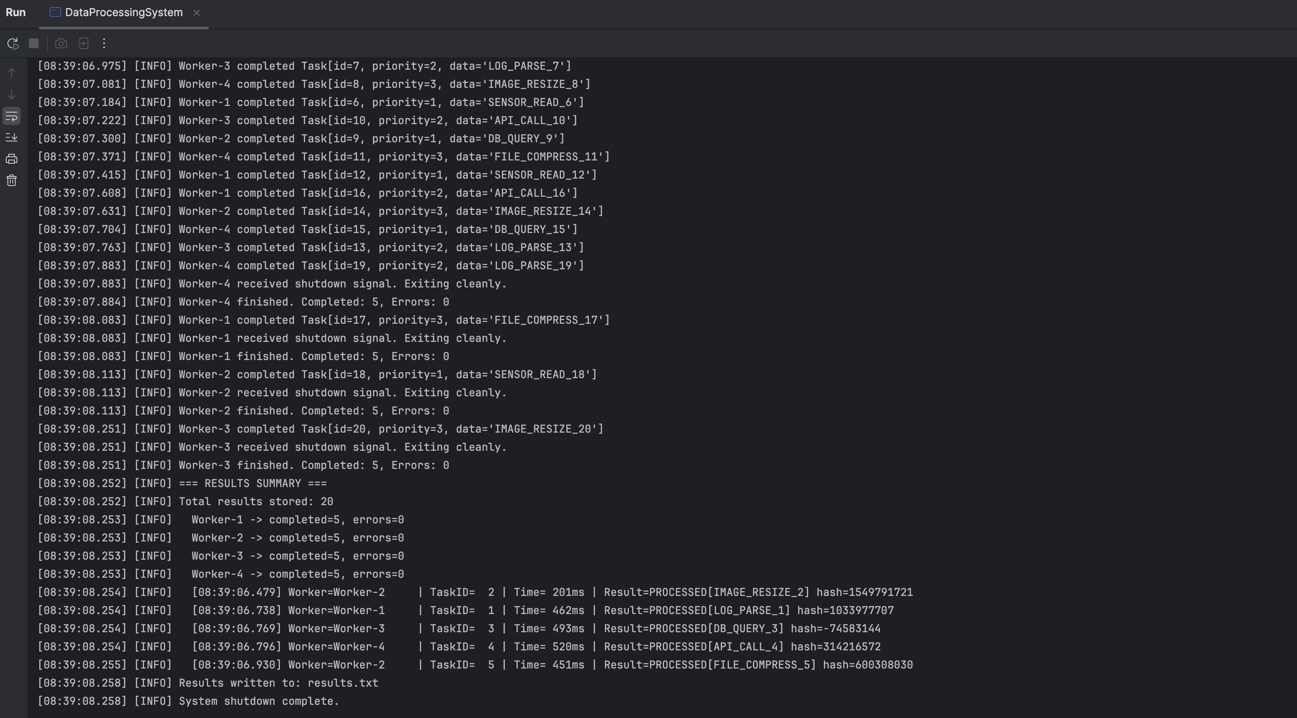
Go Implementation
The Go implementation is contained in a single file with type definitions, a Result Store struct, worker and process Task functions, and a main function.
Concurrency Techniques
I have defined a buffered channel that serves as the shared task queue, providing built-in concurrency safety without explicit locks. Each worker runs as a goroutine, iterating over the task channel using range. When main calls close(taskCh) after all tasks are sent, all worker range loops exit automatically after draining remaining tasks. A sync.WaitGroup tracks completion, with each goroutine calling wg.Done() via defer before returning. The ResultStore uses a sync.Mutex to protect concurrent writes.
Error Handling
I have used error return values rather than exceptions. The processTask function returns (TaskResult, error), and workers check the error after each call, logging failures and continuing to the next task. File I/O errors are wrapped using fmt.Errorf with the %w verb. The defer keyword guarantees resource cleanup throughout defer file.Close() releases file handles and defer wg.Done() ensures the WaitGroup is always decremented, preventing deadlocks in main.
Result Output for Go Implementation
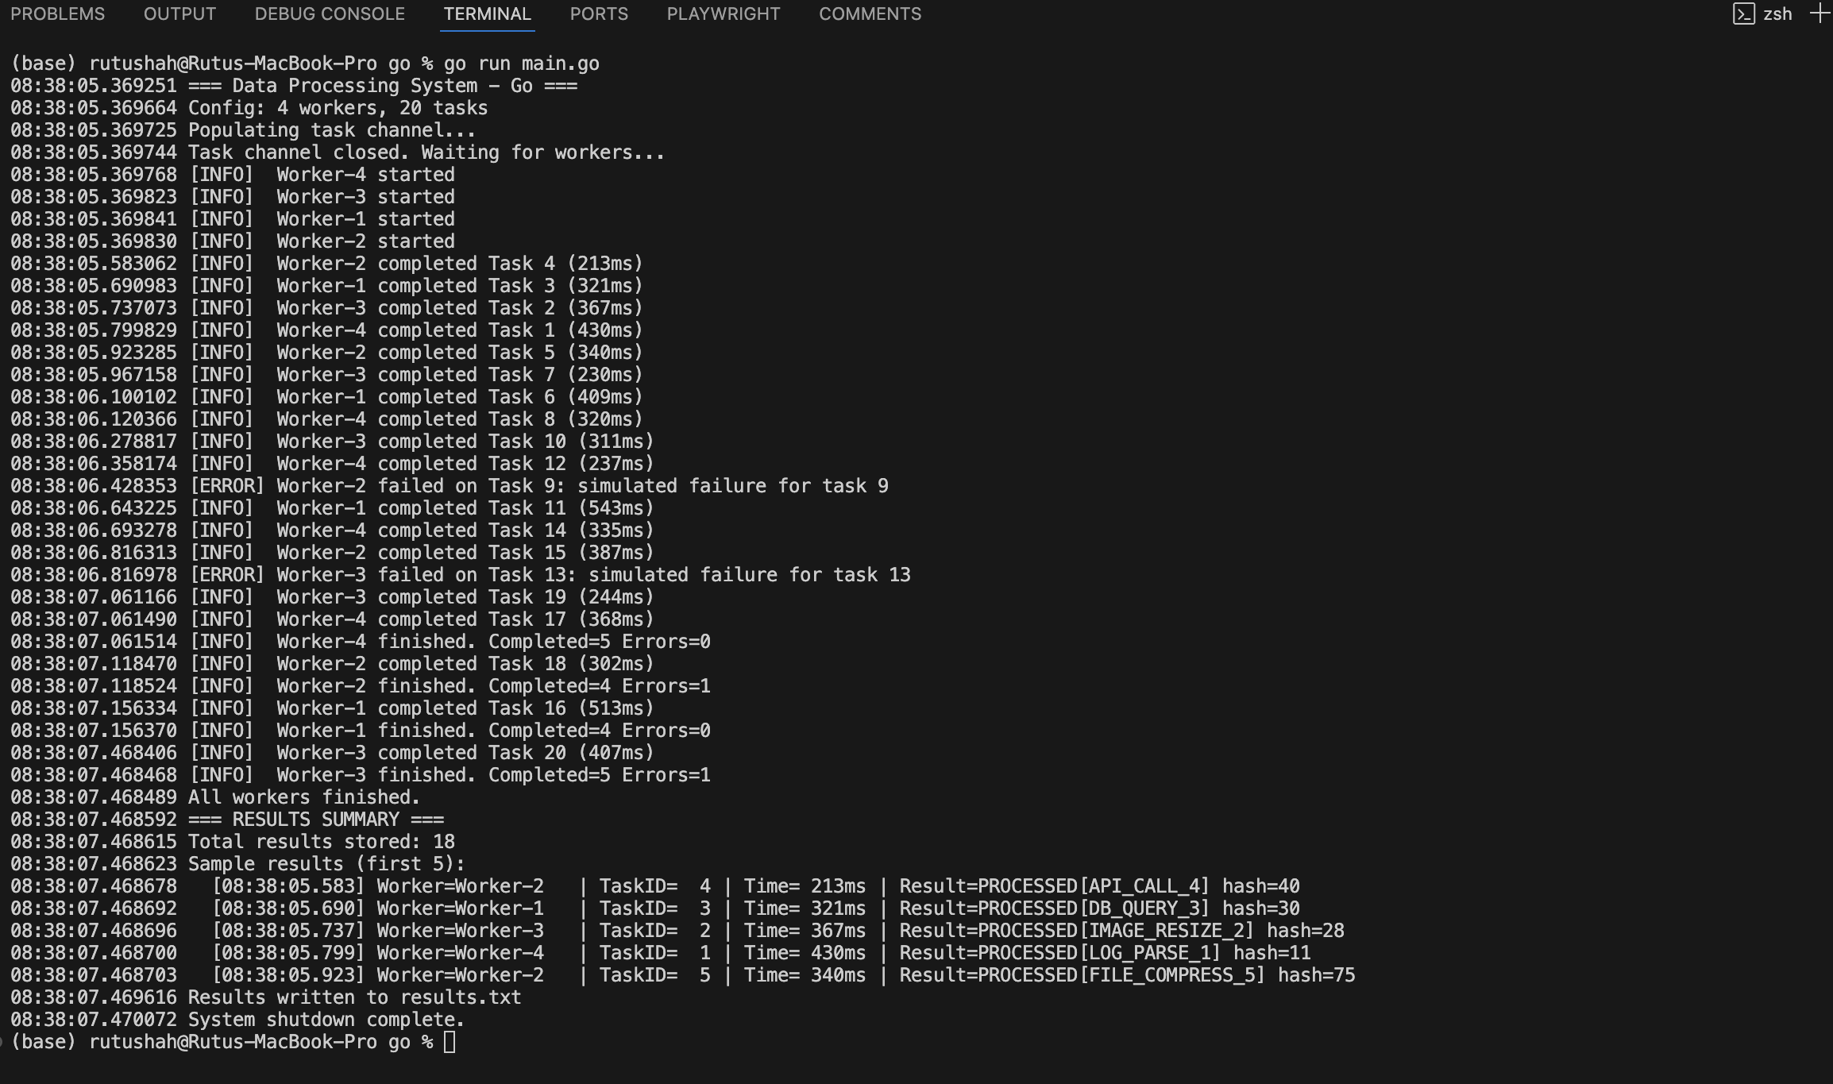
Comparative Discussion
Java and Go reflect fundamentally different concurrency philosophies. Java relies on shared mutable state protected by programmer-managed locks, offering fine-grained control but placing significant responsibility on the developer to avoid deadlocks and data races. Go encourages passing data ownership through channels, eliminating many synchronization bugs by design. However, Go does not prohibit shared state the ResultStore uses a mutex just as Java does, showing that Go's channel-first approach is a recommendation rather than an enforced constraint.
Shutdown coordination also differs. Java uses volatile flags combined with condition variable signaling and ExecutorService.awaitTermination(). Go uses channel closing as a broadcast shutdown signal, which is simpler and more idiomatic. The Java implementation processed all 20 tasks with zero errors, completing in approximately 1.7 seconds. The Go implementation handled occasional simulated failures gracefully through error return values. Both produced correct parallel output with no deadlocks and clean worker termination.
Conclusion
This paper demonstrated a concurrent data processing system implemented in Java and Go. Java provides mature lock-based synchronization with fine-grained control through the java.util.concurrent package. Go reduces synchronization complexity for producer-consumer workloads through channels and goroutines. Both implementations satisfied all requirements including thread-safe queue access, parallel processing, safe shutdown, exception handling, and logging. The choice between the two depends on team experience and workload characteristics Java offers detailed control while Go favors simplicity through communication.
References:
Go Team. (2023). The Go memory model. Google. https://go.dev/ref/mem
Oracle. (2023). Java SE 21 documentation: java.util.concurrent. Oracle Corporation. https://docs.oracle.com/en/java/docs/api/java.base/java/util/concurrent/package-summary.html

