NIKE, INC. A GRO W TH COMPANY a

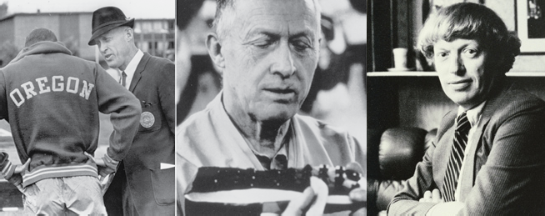
IT STAR TED WITH A HANDSHAKE.

INTRO

- SPOR TS

- GL OBAL

- POR TFOLIO

- INNO VATION

- CONNEC TION

- MARKETPL A CE

- EX CELLENCE

- GRO W TH

It started with a handshake. Two visionaries, Bill Bowerman and his University of Oregon runner Phil Knight, thought they could do a better job of designing and selling shoes to runners. They were right. Today Nike is the world’s leading innovator in athletic footwear, apparel, equipment and accessories.

Along the way, Nike helped the world’s best athletes win races, games and championships. And the athletes helped Nike design and market the products and brand that changed the face of sports. Together we continue to push through the boundaries of what is possible. We are constantly at work creating growth opportunities that set Nike apart from the competition and provide value for our shareholders.

Nike is many things – a product designer, a consumer goods manufacturer, a brand communicator, a leader in corporate responsibility, a portfolio of authentic and relevant brands. Behind every corner of the Nike business is a singular focus – innovation. It is our nature to innovate. It is the fuel that powers our performance.

When we look at long-term growth, there are eight things that define who we are, what we do, and how we operate to reach our potential.

Let’s take a look at these eight things.

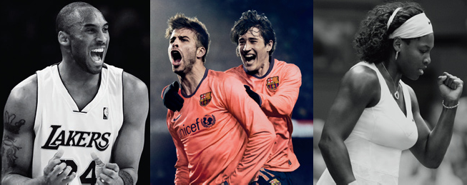
NUMBER 1: WE L O VE SPOR TS.

INTRO

- SPOR TS

- GL OBAL

- POR TFOLIO

- INNO VATION

- CONNEC TION

- MARKETPL A CE

- EX CELLENCE

- GRO W TH

Nike’s mission statement is, “To bring inspiration and innovation to every athlete in the world.” And as co-founder Bill Bowerman once said, “If you have a body, you are an athlete.”

This is how Nike sees the world – it defines the endless possibilities for human potential, sets the tone and direction for the numerous long-term growth opportunities we see, and continues to inspire new generations of athletes and consumers.

Sports is a universal language. It transcends cultures, borders and barriers. It’s an enduring passion for consumers and a source of human aspiration and empowerment. Sports teaches us about life – individual effort, teamwork, respect, how to win, how to lose, how to compete intensely and play fairly. Sports inspire, amaze and reward us in good times and in bad.

Sports is a great business to be in, and an even better business to lead.

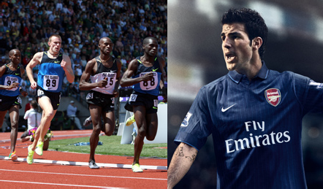
NUMBER 2: WE ARE GL OBAL .

INTRO

- SPOR TS

- GL OBAL

- POR TFOLIO

- INNO VATION

- CONNEC TION

- MARKETPL A CE

- EX CELLENCE

- GRO W TH

From a sleepy little town in Oregon, Nike has grown into the world’s largest athletic footwear and apparel company. We started with a shoe and a t-shirt. Today we’re a diversified and complex global organization:

- We sell our products in 170 countries.
- We have more than 30,000 worldwide employees.
- We have a dozen brands that serve more than 30 major sports and consumer lifestyles.
- We work with 600+ factory partners.
- We serve millions of consumers with thousands of products.

From the beginning, our business model was built on partnerships – athletes, teams, retailers, manufacturers, and supply chain providers. We work with the best of the best all over the world. And we do it all with a singular purpose – to serve the needs of our global consumers.

Since 2005, more than 50 percent of our revenue has come from outside the U.S. With leadership positions in established markets like the U.S. and Western Europe and in emerging markets like China and Brazil, we believe we have tremendous and unique opportunities to grow.


NUMBER 3: WE ARE A STRONG POR TFOLIO OF BR ANDS.

INTRO

- SPOR TS

- GL OBAL

- POR TFOLIO

- INNO VATION

- CONNEC TION

- MARKETPL A CE

- EX CELLENCE

- GRO W TH

When most people think of Nike, they think of the Swoosh. It’s one of the most recognized symbols in the world. The brand it represents is our strongest asset. We’ve been very strategic in adding dimension to the Nike Brand, making it a powerful and flexible engine for growth.

Using the same kind of thoughtful and deliberate strategy, we’ve created a portfolio of brands capable of reaching across multiple sports, lifestyle categories, and price points.

In addition to the Nike and Jordan brands, our wholly-owned subsidiaries include Cole Haan (luxury shoes, handbags, accessories and coats); Converse (athletic and lifestyle footwear, apparel and accessories); Hurley (action sports and youth lifestyle footwear, apparel and accessories); Nike Golf, and Umbro (a leading U.K. based football/soccer brand). Each strengthens our ability to maximize our reach and relevance worldwide.

Each brand speaks to a different, clearly defined consumer, which diversifies opportunities for long-term growth. And even as we benefit from the diversity of our brand portfolio, we’re also leveraging our resources and core competencies in product, marketing, and operations to drive consistent growth and profitability.

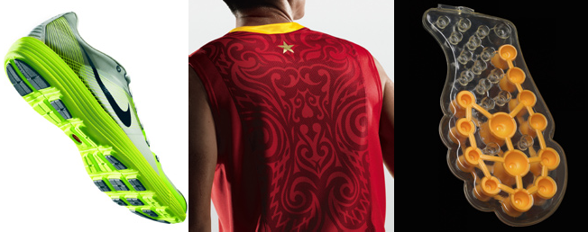
NUMBER 4 : WE LE AD WITH INNO VATIVE PRODUC T.

INTRO

- SPOR TS

- GL OBAL

- POR TFOLIO

- INNO VATION

- CONNEC TION

- MARKETPL A CE

- EX CELLENCE

- GRO W TH

True innovation isn’t just new and different. It’s new and better. It’s surprising. Sometimes it’s shocking. Nobody does that better than Nike. Yet we know you can’t anoint yourself as innovative – the consumer ultimately decides that for themselves. That’s why we spend so much time with athletes and consumers – listening, observing, studying and then creating products that enhance athletic performance and overall consumer experiences.

It’s our connection to athletes and consumers that allows us to create game-changing technologies and products. Innovations like the Nike Flywire support system, Lunarlite foam cushioning, Hyperdunk basketball shoe, new generations of Free footwear, and the new Trainer 1 shoe continue to set the standard for the industry.

Much of this insight into performance happens at the Nike Sport Research Lab. It’s the premier center for advanced R&D in biomechanics, exercise physiology, engineering, industrial design and related fields. We also rely on research committees and advisory boards made up of athletes, coaches, trainers, equipment managers, orthopedists, podiatrists and other experts who consult with us and review designs, materials and concepts for product improvement.

Just like in sports, talent can take you only so far. You have to put in the hard work. That’s how we approach product innovation. Our talent and work ethic are key to our performance and continued success.

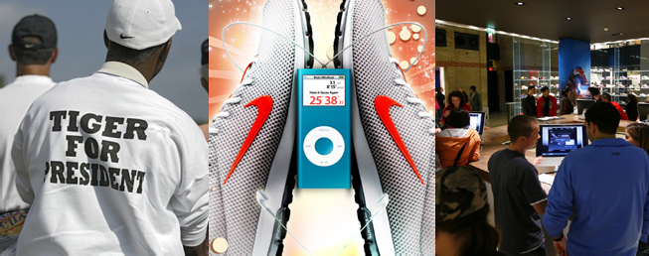
NUMBER 5: WE CONNEC T WITH CONSUMERS.

INTRO

- SPOR TS

- GL OBAL

- POR TFOLIO

- INNO VATION

- CONNEC TION

- MARKETPL A CE

- EX CELLENCE

- GRO W TH

Connecting with consumers is the single most important competitive advantage in business today. And nobody does this better than Nike. Deep meaningful relationships with consumers are at the center of everything we do. The days of one size fits all are long over for both products and brands.

Consumers today are smart, sophisticated and demanding. They have more choices and more access to those choices than ever before. They value authentic brands that interact with them on an intensely personal level. The conversation can’t be one way. Consumers want to be surprised and excited by their favorite brands, but they also want to play a part in defining them.

Connecting with consumers is so important at Nike that we reorganized the Nike Brand around seven categories that we believe represent the largest growth opportunities: action sports, basketball, football (soccer), men’s training, running, sportswear, and women’s training. These businesses represent the vast majority of our revenue, and we believe will generate the majority of our growth opportunity over the next five years.

Our category teams are completely focused on their target consumers. They speak their language, they see the world through their eyes, and they’re completely at home in their culture. Being inside the world of our consumers gives us the ability to create compelling product, to tell their stories in an exciting way, and deliver experiences at every level, from a one-on-one relationship to a global experience like World Cup or the Olympics.

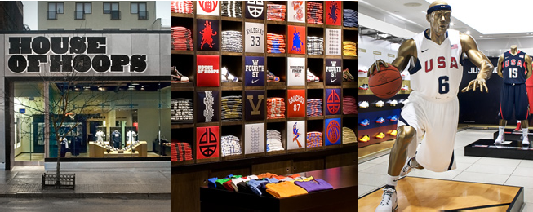
NUMBER 6: WE MANA GE THE MARKETPL A CE.

INTRO

- SPOR TS

- GL OBAL

- POR TFOLIO

- INNO VATION

- CONNEC TION

- MARKETPL A CE

- EX CELLENCE

- GRO W TH

As Nike has evolved, so has the consumer. They connect and collaborate with each other all over the world. As retail evolves to meet these changing needs – from athletic specialty to department stores – old, predictable formats tend to blur the line among products and brands. So we ask tougher questions. What kind of choices does a consumer have? What type of experiences does a consumer respond to best? We see this as opportunity for Nike and our retail partners.

As the industry leader, we have the ability and the responsibility to take the industry and our partners someplace new. Our retailers want Nike to lead and that’s exactly what we’re doing – driving innovative product and brand presentation into the stores of our wholesale partners.

We do this by working with our wholesale partners to create differentiated retail destinations and product assortments that are tailored to their consumers. We do it by investing in direct retail concepts that elevate our products and our brands online and in store. And we tightly manage the distribution of our products to balance supply and demand, maintain the strength of our brands and the profitability of our business.

Wherever the consumer interacts with Nike it is an opportunity for us to share our products, our stories and our passion in a way nobody else can.

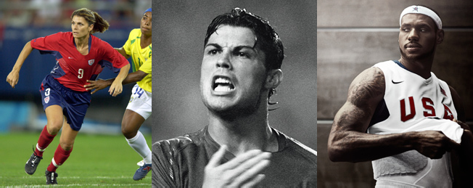
NUMBER 7 : WE OPER ATE WITH EX CELLENCE. (PA GE 1 OF 2)

INTRO

- SPOR TS

- GL OBAL

- POR TFOLIO

- INNO VATION

- CONNEC TION

- MARKETPL A CE

- EX CELLENCE

- GRO W TH

As Phil Knight, our co-founder and Chairman, once said, “It’s not a single product model, or a single manager, or one ad, or a single celebrity, not even a single innovation that is key to Nike. It is the people of Nike, and their unique and creative way of working together that makes Nike special.”

If our products, brands, and marketplace management are the engines of profitable growth, operating with excellence is the transmission that converts revenue growth into profitability and shareholder value.

Our financial model is built on expanding profit margins and increasing capital productivity. This goal demands that we deliver on the fundamentals that create value:

- Driving top-line revenue
- Expanding gross margins
- Leveraging SG&A expenses
- Focusing on the highest return opportunities

Profit margins are a dynamic global equation and a function of many factors – some we control and some we do not. We’re deeply committed to driving productivity on those factors that we do control. Expanding profit margin starts with gross margins, where we’ve worked to reduce product costs by paring down the number of styles, eliminating waste, and streamlining our sourcing base. Additionally, we’ve been managing our supply chain to reduce closeouts and improve their profitability. And we’ve become much more strategic in managing our product mix and pricing to increase both revenue and profitability.

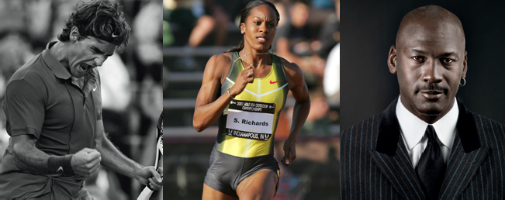
NUMBER 7 : WE OPER ATE WITH EX CELLENCE. (PA GE 2 OF 2)

INTRO

- SPOR TS

- GL OBAL

- POR TFOLIO

- INNO VATION

- CONNEC TION

- MARKETPL A CE

- EX CELLENCE

- GRO W TH

SG&A (selling, general and administrative) cost is an area where we’ve made good investments over the last few years, and those investments have delivered industry-leading growth in revenue, market share and profitability. That said, the current macro-economic environment presents a unique opportunity for us to reset our business – both operationally and fundamentally – making strategic investments to deliver consistent, profitable growth for the future. An opportunity we won’t miss.

While we certainly put a great deal of focus on the P&L, we never forget that cash is king. Operating with excellence means increasing the productivity of the capital our shareholders entrust to us. We tightly manage working capital by keeping our inventories lean and proactively managing accounts receivable. We deliver a solid return on our capital investments – being careful not to sacrifice long-term growth for near-term gain. From a capital structure standpoint, we work to consistently increase dividends and payout ratios. Over the past 10 years, Nike has returned
$5.5 billion to shareholders through stock repurchases and dividends.

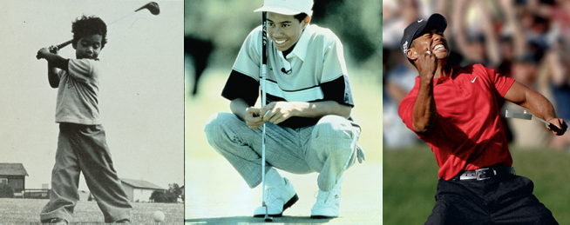
NUM BE R 8: WE ARE COMMITTED TO GRO W TH.

INTRO

- SPOR TS

- GL OBAL

- POR TFOLIO

- INNO VATION

- CONNEC TION

- MARKETPL A CE

- EX CELLENCE

- GRO W TH

And finally number eight – we’re committed to consistent, profitable growth over the long term.

From FY05 to the end of FY09 we averaged 9% growth in revenue, 12% growth in EPS, and delivered a 60% increase in stock price while the S&P 500 averaged down 18%.

Today’s environment continues to challenge every company to leverage their core strengths while adapting quickly. At Nike, we do both by focusing on what we do best – create great product, tell compelling stories, and seize every opportunity to increase competitive separation. We are a strong and competitive leader in our industry across every dimension – by geography, by product type where the innovation drives us and now, and most importantly, by sport performance categories where we have the most focus. When we do these things successfully, we’re convinced over time, we will be a larger, more profitable, and ultimately more valuable company.

www.nikebiz.com www.nike.com

