

Royal Education Society’s
College of Computer Science and Information Technology, Latur.

Affiliated to
Swami Ramanand Teerth Marathwada University, Nanded.

A Project Synopsis

On

Mental Health Prediction System
A Machine Learning Based System for Predicting Student Mental Health Scores

Submitted for the award of degree of

Bachelor of Science (Data Science)

By:
Vaibhav Badrinarayan Solanke: A37
Rutuja Satish Dhumal: A59

In

Year 2026 – 2027

Mr. S. T. Somavanshi Mr. N. D. Jagtap
Project Guide HoD

Table of Content

Sr. No. | Contents | Page No.
1. | Abstract | 3
2. | Introduction of Project | 4
3. | Project Module | 5
4. | Project Plan (Gantt chart) | 6
5.. | Project Requirement | 7
6. | E-R Diagram | 8
7. | Data Flow Diagram (DFD) | 9
8. | Conclusion | 10
9. | Bibliography | 11

Abstract

Mental health is an essential component of student well-being and can be influenced by various lifestyle, academic, and digital-behaviour factors. The Mental Health Prediction System is a data science and machine learning-based project designed to analyze these factors and predict a student’s Mental Health Score. The system uses a dataset containing 5,000 student records with 13 attributes, including demographic information, academic level, social-media usage, daily device unlocks, study hours, physical activity, sleep duration, stress level, and mental health score.
The project follows a structured data science workflow consisting of data understanding, data cleaning, exploratory data analysis (EDA), feature engineering, model training, model evaluation, and prediction. Data preprocessing involves checking missing values, duplicate records, categorical consistency, and invalid numerical values. EDA is performed to identify patterns and relationships between lifestyle and digital-behaviour factors and mental health.
Since the Mental Health Score is a continuous numerical variable, the problem is formulated as a regression task. Multiple machine learning algorithms, including Linear Regression, Random Forest, Gradient Boosting, and XGBoost, are considered for model comparison. Model performance is evaluated using MAE, MSE, RMSE, and R² score to identify the most suitable model.
The proposed system aims to provide an educational and analytical tool for understanding factors associated with student mental well-being and generating data-driven predictions. It is intended for academic and awareness purposes and should not be considered a clinical diagnosis or medical assessment.

Introduction of Project

Mental health is an important aspect of a student's overall well-being and affects emotional stability, academic performance, concentration, sleep, relationships, and the ability to handle stress. Students today experience various academic and lifestyle pressures along with increasing use of digital and social-media platforms. Factors such as excessive social-media usage, frequent device interaction, insufficient sleep, reduced physical activity, study patterns, and higher stress levels may be associated with changes in mental well-being.
The Mental Health Prediction System is a data science and machine learning-based project developed to analyze these behavioural, lifestyle, academic, and digital factors and estimate a student's Mental Health Score. The project uses a dataset containing 5,000 student records and 13 attributes, including age, gender, country, academic level, social-media platform usage, purpose of usage, average daily usage hours, daily unlocks, study hours, physical activity, sleep duration, stress level, and mental health score.
The project follows a structured machine learning pipeline involving data understanding, data cleaning, exploratory data analysis, feature engineering, model training, model evaluation, and prediction. Multiple regression algorithms are used and compared to identify a suitable model for predicting the continuous Mental Health Score. Performance is evaluated using MAE, MSE, RMSE, and R² score.
The primary aim of the project is to demonstrate how data science and machine learning can be used to identify patterns in student behavioural and lifestyle data and generate data-driven mental health score predictions. The system is designed for educational and analytical purposes only and is not intended to provide clinical diagnosis or medical treatment.

Project Module

- Data Understanding:
• Load and understand the Mental Health dataset.
• Analyze dataset structure, features, data types, statistics, missing and duplicate values.
- Data Cleaning:
• Remove duplicate records and handle inconsistent or invalid values.
• Prepare and save a clean dataset for further analysis.
- Exploratory Data Analysis:
• Perform univariate, bivariate and correlation analysis.
• Analyze factors such as social media usage, sleep, study hours, physical activity and stress in relation to mental health.
- Feature Engineering:
• Separate features and target variable.
• Encode categorical features, scale numerical features and split the data into training and testing sets.
- Model Training:
• Encode categorical features, scale numerical features and split the data into training and testing sets.
- Model Evaluation:
• Evaluate models using MAE, MSE, RMSE and R² score.
• Compare performance and select the best-performing model.
- Mental Health Prediction:
• Use the selected model to predict the Mental Health Score.
• Demonstrate the complete end-to-end prediction workflow.

Project Plan

Gantt chart:
Sr.  No | Task Name | 10 July | 02 August | 21  September | 29  October | 04  Nov
1 | Requirement Gathering
2 | Planning
3 | Designing
4 | Coding/Development
5 | Testing and Deployment

Project Requirements:
- Hardware Requirements:
- Processor: i5 and above
- RAM: 8GB and above
- Hard Disk: 256 GB or above
- Input device: keyboard, Mouse
- Output device : Monitor or LCD/LED, Printer
- LAN Network or Internet Connection

- Software Requirement:
• Operating System: Windows 10/11 or equivalent.
• Programming Language: Python 3.x.
• IDE: Visual Studio Code.
• Notebook Environment: Jupyter Notebook.
• Libraries: Pandas, NumPy, Matplotlib, Seaborn, Scikit-learn, XGBoost.
• Data Storage: CSV dataset files.
• Version Control: Git and GitHub.
• Web/Prediction Interface: Python-based frontend for the final prediction demo.
• Browser: Google Chrome / Microsoft Edge for accessing the application.

E R Diagram

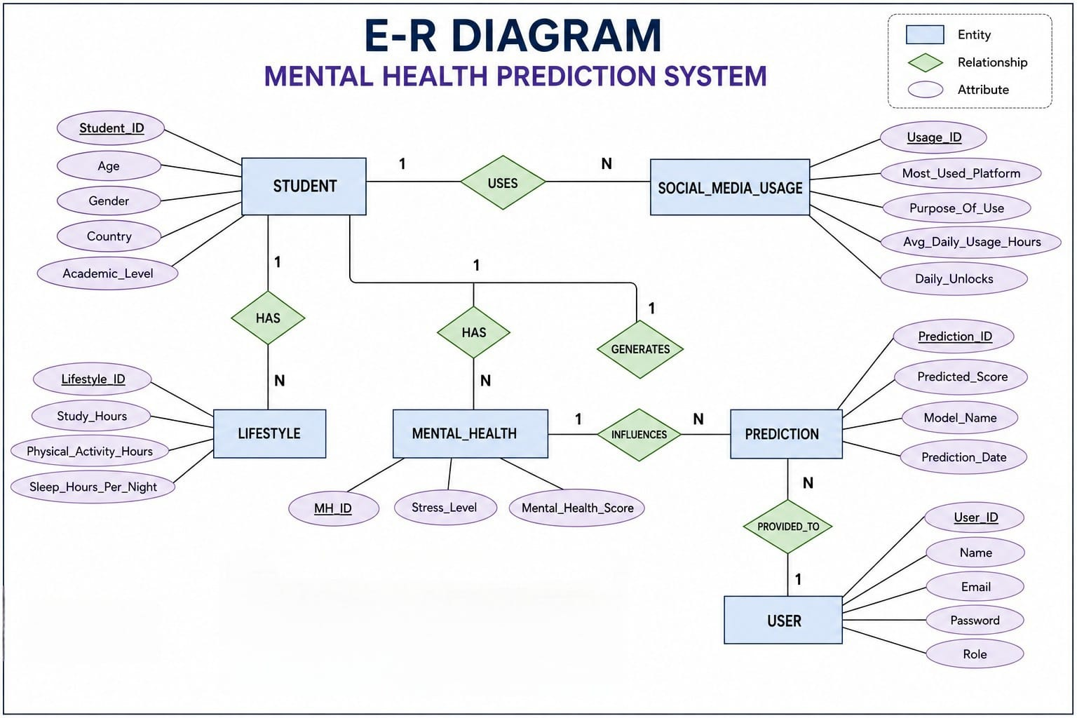

Data Flow Diagram

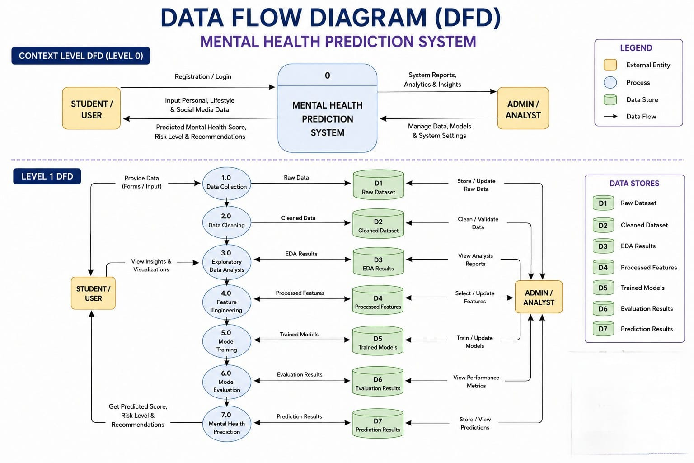

Conclusion

The Mental Health Prediction System is designed as a complete data science and machine learning project for studying student mental health score in relation to social-media usage and lifestyle factors. The project follows a structured workflow beginning with data understanding and cleaning, followed by exploratory analysis and feature engineering. The planned machine learning stage will compare multiple regression algorithms and evaluate their ability to predict the target score.
The work completed so far demonstrates that the dataset contains useful behavioural and lifestyle variables and that several factors show meaningful associations with Mental_Health_Score. The project therefore provides a practical example of how data science can transform raw student data into analytical insights and predictive models. With model training, evaluation and application integration completed, the system can serve as a strong academic demonstration of the end-to-end machine learning lifecycle.

Bibliography

Books:
- Practical Statistics for Data Scientists — Peter Bruce, Andrew Bruce & Peter Gedeck
- Pattern Recognition and Machine Learning — Christopher M. Bishop
- Python for Data Analysis -Wes McKinney
- Speech and Language Processing -Daniel Jurafsky & James H. Martin
- Hands-On Machine Learning with Scikit-Learn, Keras & TensorFlow -Aurlien Gron

Websites:

- Python Documentation — https://docs.python.org/3/
- Pandas Documentation — https://pandas.pydata.org/docs/
- NumPy Documentation — https://numpy.org/doc/
- Scikit-learn Documentation — https://scikit-learn.org/
- XGBoost Documentation — https://xgboost.readthedocs.io/en/stable/

