Practical – 5

# AIM: 1. Demonstrate various Ways to handle Events Source Code:

**HTML:**

<!DOCTYPE html>

<html lang="en">

<head>

<meta charset="UTF-8">

<meta http-equiv="X-UA-Compatible" content="IE=edge">

<meta name="viewport" content="width=device-width, initial-scale=1.0">

<title>Event Handling</title>

</head>

<body>

<h1>Event Handling Demonstration</h1>

<h3>Click on the button to see the result</h3>

<h4><b>Event Handling using html</b></h4>

<button onclick="alert('Event handling using HTML')">Click Me</button>

<br>

<h4><b>Event Handling using javascript</b></h4>

<button id="btn">Click Me</button>

<script src="1.js">

</script>

</body>

</html>

# JAVASCRIPT:

var btn = document.getElementById("btn"); btn.addEventListener("click", function() {

alert("Event handling using Javascript EventListner method");

});

**Output:**

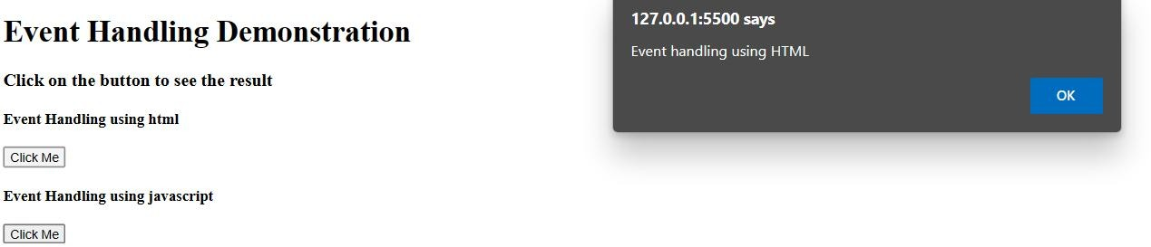

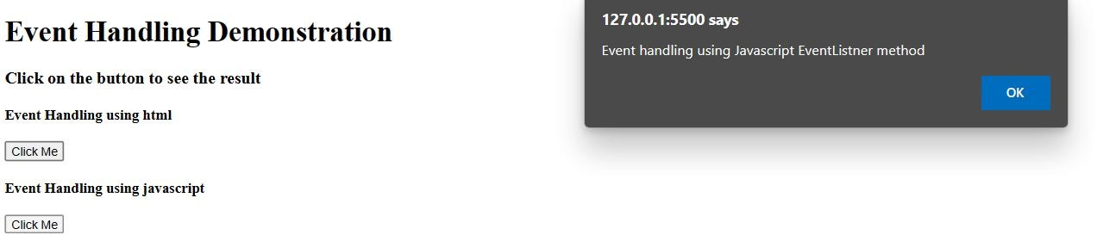

# 2. Write the Script to Change the background color randomly after every 1 mins Source Code:

**HTML:**

<!DOCTYPE html>

<html lang="en">

<head>

<meta charset="UTF-8">

<meta http-equiv="X-UA-Compatible" content="IE=edge">

<meta name="viewport" content="width=device-width, initial-scale=1.0">

<title>Background Changer</title>

</head>

<body>

<script>

function changeColor() {

var color = ["red", "green", "blue", "yellow", "pink", "orange",

"purple", "brown", "black", "white", "grey", "cyan", "magenta"

];

var random = Math.floor(Math.random() * color.length);

document.body.style.backgroundColor = color[random];

}

setInterval(changeColor, 1000);

</script>

</body>

</html>

# Output:

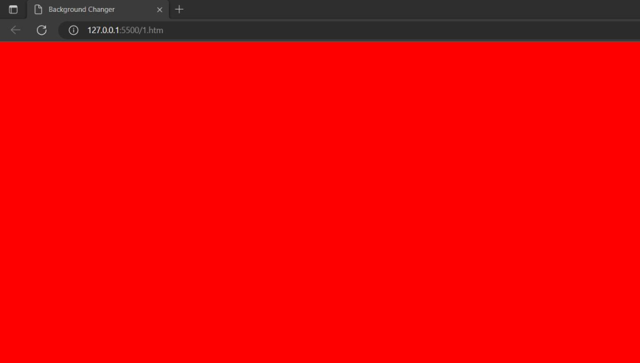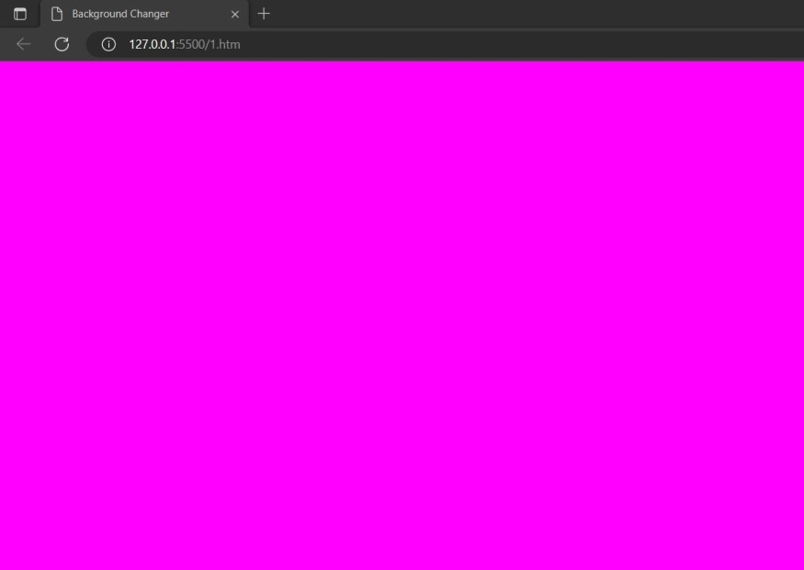

* **3. Create Arrays of Colors and Apply these colors in order to tr background of table Source Code:**

# HTML:

<!DOCTYPE html>

<html lang="en">

<head>

<meta charset="UTF-8">

<meta http-equiv="X-UA-Compatible" content="IE=edge">

<meta name="viewport" content="width=device-width, initial-scale=1.0">

<title>Array with colors</title>

<style>

h2 {

text-align: center;

}

table {

width: 30%; margin: auto;

}

</style>

</head>

<body>

<h2>Placing colors in table rows using array</h2>

<table border="2">

<tr>

<td>Red</td>

</tr>

<tr>

<td>Green</td>

</tr>

<tr>

<td>Blue</td>

</tr>

<tr>

<td>Yellow</td>

</tr>

<tr>

<td>Orange</td>

</tr>

<tr>

<td>Pink</td>

</tr>

<tr>

<td>Brown</td>

</tr>

<tr>

<td>Purple</td>

</tr>

<tr>

<td>Grey</td>

</tr>

<tr>

<td>Black</td>

</tr>

</table>

<script src="1.js"></script>

</body>

</html>

# JAVASCRIPT:

var color = ["red", "green", "blue", "yellow", "orange", "pink", "brown", "purple", "grey", "black"

];

var table = document.getElementsByTagName("table")[0]; var tr = table.getElementsByTagName("tr");

for (var i = 0; i < tr.length; i++) { tr[i].style.backgroundColor = color[i];

}

**Output:**

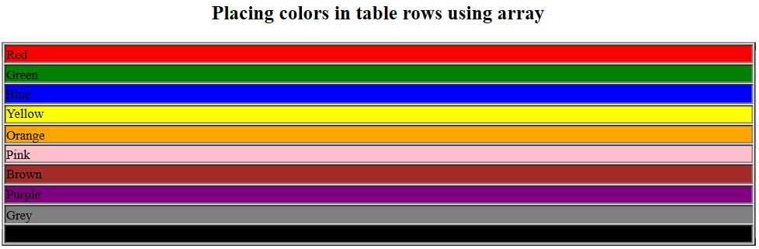

# 4. Zoom image on mouseover and zoom out on mouse out Source Code:

**HTML:**

<!DOCTYPE html>

<html lang="en">

<head>

<meta charset="UTF-8">

<meta http-equiv="X-UA-Compatible" content="IE=edge">

<meta name="viewport" content="width=device-width, initial-scale=1.0">

<title>Image Zooming</title>

<style>

h3 {

text-align: center; margin-top: 50px;

}

img {

margin: auto; display: block; align-self: center;

}

</style>

</head>

<body>

<h3>ZoomIn and ZoomOut image on mouse over and mouse out</h3>

<img src="https://wallpaper.dog/large/10961678.jpg" alt="image" id="image" width="500px" height="500px">

<script src="1.js">

</script>

</body>

</html>

# JAVASCRIPT:

var image = document.getElementById("image"); image.addEventListener("mouseover", zoomIn); image.addEventListener("mouseout", zoomOut);

function zoomIn() { image.style.width = "700px"; image.style.height = "700px";

}

function zoomOut() { image.style.width = "200px";

image.style.height = "200px";

}

**Output:**

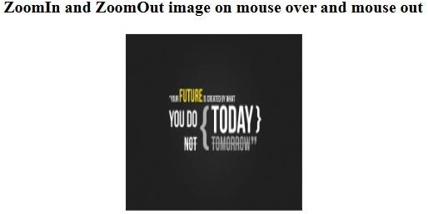



# 5. Change the location of image based on arrow key of keyboard using callback function Source Code:

**HTML:**

<!DOCTYPE html>

<html lang="en">

<head>

<meta charset="UTF-8">

<meta http-equiv="X-UA-Compatible" content="IE=edge">

<meta name="viewport" content="width=

, initial-scale=1.0">

<title>Moving Image</title>

</head>

<body>

<h2>Moving image based on arrow key of keyboard !!</h2>

<img src="https://encrypted- tbn0.gstatic.com/images?q=tbn:ANd9GcRJsDpn16gIwzI_L-6k-

_rWqLYE06YG5j_QGQ&usqp=CAU" id="img" style="position:absolute; left:0px; top:0px;" />

<script src="1.js"></script>

</body>

</html>

# JAVASCRIPT:

function moveImage(e) {

var img = document.getElementById("img"); if (e.keyCode == 37) {

cs37();

} else if (e.keyCode == 38) { cs38();

} else if (e.keyCode == 39) { cs39();

} else if (e.keyCode == 40) { cs40();

}

}

function cs37() {

img.style.left = parseInt(img.style.left) - 10 + "px";

}

function cs38() {

img.style.top = parseInt(img.style.top) - 10 + "px";

}

function cs39() {

img.style.left = parseInt(img.style.left) + 10 + "px";

}

function cs40() {

img.style.top = parseInt(img.style.top) + 10 + "px";

}

document.onkeydown = moveImage;

**Output:**

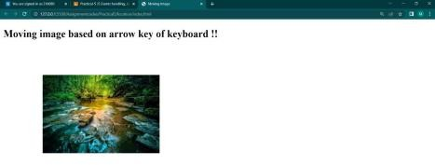

# Conclusion:

An event is defined as a change in an object's state. There are a number of events in HTML that show when a user or browser performs a certain action. Event handling refers to the way that js responds to events. As a result, js uses event handlers to handle HTML events. JavaScript array is an object that represents a collection of similar type of elements.

# Course Outcome:

I learnt about event handling, JavaScript arrays, callbacks and timer functions.