# AIM 1:

Practical – 6

# Demonstrate Class, Properties, Methods and Objects.

**Source Code: (HTML)**

<!DOCTYPE html>

<html lang="en">

<head>

<meta charset="UTF-8">

<meta http-equiv="X-UA-Compatible" content="IE=edge">

<meta name="viewport" content="width=device-width, initial-scale=1.0">

<title>P6.1</title>

</head>

<body>

<script src="./6.1.js"></script>

</body>

</html>

**(JAVASCRIPT)**

class Bike {

constructor(type, avgspeed) { this.type = type; this.avgspeed = avgspeed;

document.write(`<br> Type :- ${type}<br> Average-Speed:- ${avgspeed} in

bike`);

}

displayBike(){

document.write(`<br> Inside bike class`);

}

}

class Electric extends Bike { constructor(price, model) {

super(price, model); this.price = price; this.model = model;

document.write(`<br> Price :- ${this.price}<br> Model :- ${this.model} in Electric`);

}

displayEle(){

document.write(`<br> Inside Electric class`);

}

}

let r = new Electric(200000,"20EC"); r.displayEle();

r.displayBike();

# Output:

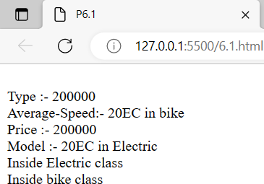

**AIM 2:**

# Demonstrate how to work with JSON File. Source Code:

**(HTML)**

<!DOCTYPE html>

<html lang="en">

<head>

<meta charset="UTF-8">

<meta http-equiv="X-UA-Compatible" content="IE=edge">

<meta name="viewport" content="width=device-width, initial-scale=1.0">

<title>P6.2</title>

</head>

<body>

<h1>Value fatched from json converting in js obj</h1>

<p id="P"></p>

<script src="./6.2.js"></script>

</body>

</html>

# (JAVSCRIPT)

var Rutva = '{"First_Name" : "RUTVA", "Last_Name" : "SHINGALA", "Location" : "GUJARAT", "Gender" : "FEMALE"}';

const obj = JSON.parse(Rutva);

let t = `First-Name:- ${obj.First_Name} <br> Last-Name:-

${obj.Last_Name} <br> Location: ${obj.Location} <br> Gender: ${obj.Gender} <br>`; document.getElementById('P').innerHTML = t;

**Output:**

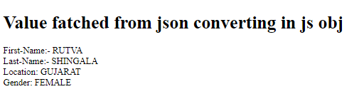

# AIM 3:

**Do Spoural Registration Form Validation (Error object and try…catch..)**

# Source Code: (HTML)

<!DOCTYPE html>

<html lang="en">

<head>

<meta charset="UTF-8">

<meta http-equiv="X-UA-Compatible" content="IE=edge">

<meta name="viewport" content="width=device-width, initial-scale=1.0">

<title>sP6.3</title>

</head>

<body>

<div class="main">

<h1>Spoural Registration Forms</h1>

<form action="">

<label for="name">Name:-</label>

<input type="text" id="name">

<br>

<label for="id">Id :-</label>

<input type="text" id="id">

<br>

<label for="Branch">Branch</label>

<input type="text" id="br">

<br><input type="button" value="Submit" id="submit">

<p id="p"></p>

</form>

</div>

<style>

.main {

top: 25%;

left: 25%;

font-size: 30px; padding: 20px; width: 50%;

height: 45%;

background-color: #6098b0; position: absolute; display: block;

text-align: center; justify-content: center; border: 2px solid gray;

}

input {

padding: 5px; margin: 10px;

}

</style>

<script src="./6.3.js"></script>

</body>

</html>

**(JAVSCRIPT)**

let btn = document.getElementById('submit'); btn.onclick = () => {

let name = document.getElementById('name'); let id = document.getElementById('id'); let br = document.getElementById('br'); let p = document.getElementById('p');

try {

if (name.value == "" || id.value == "" || br.value == "") { throw new Error("NULL Value NOT allowed")

}

else if (br.value != "it" && br.value != "ce" && br.value !=

"cse") {

throw new Error("invilide branch")

}

else{

p.innerHTML = "success"

}

} catch (error) {

p.innerHTML = "Error: " + error.message;

}

}

# Output:

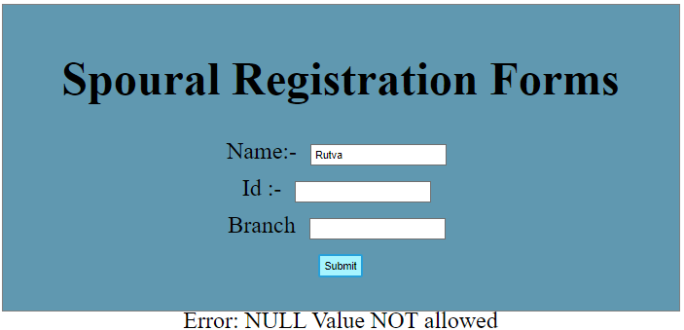

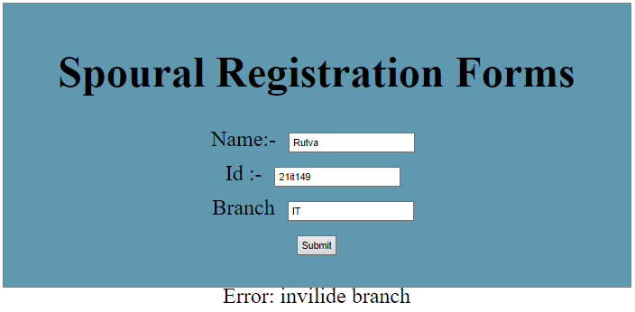

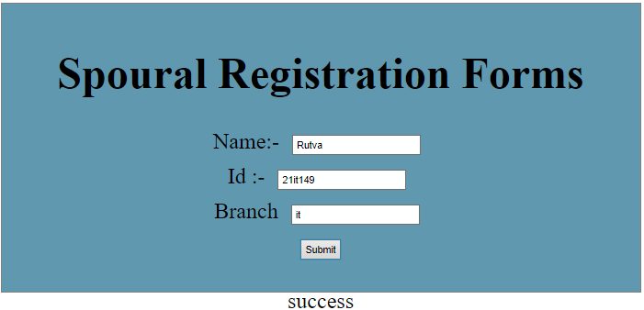

**Conclusion :** In this practical I learnt about the javascript class ,object and also js methods. and also learned the basic introduction of the Json .and also error handling in js through the try catch block in javascript.

**Course Outcome :** Learned about the basics of JavaScript and its functionality of helping introduce dynamic operations on webpage.