# PRACTICAL-8

**AIM : ES-6 part-2 Objext Constructor Function. Form Validation**

**Program :**

<!DOCTYPE html>

<html>

<head>

<title>Form Validation</title>

<script>

function validateForm() {

// Get values of form elements

var userid = document.forms["myForm"]["userid"].value;

var password = document.forms["myForm"]["password"].value;

var name = document.forms["myForm"]["name"].value;

var address = document.forms["myForm"]["address"].value;

var country = document.forms["myForm"]["country"].value;

var zipcode = document.forms["myForm"]["zipcode"].value;

var email = document.forms["myForm"]["email"].value;

var sex = document.forms["myForm"]["sex"].value;

var english = document.forms["myForm"]["english"].checked;

var non_english = document.forms["myForm"]["non_english"].checked;

var about = document.forms["myForm"]["about"].value;

// Validate userid

if (userid == "" || userid.length < 5 || userid.length > 12) {

alert("Userid must be between 5 and 12 characters");

return false;

}

// Validate password

if (password == "" || password.length < 7 || password.length > 12) {

alert("Password must be between 7 and 12 characters");

return false;

}

// Validate name

if (name == "" || !/^[a-zA-Z]+$/.test(name)) {

alert("Name can only contain alphabets");

return false;

}

// Validate country

if (country == "") {

alert("Please select a country");

return false;

}

// Validate zipcode

if (zipcode == "" || isNaN(zipcode)) {

alert("Zipcode must be a number");

return false;

}

// Validate email

if (email == "") {

alert("Email is required");

return false;

}

// Validate sex

if (sex == "") {

alert("Please select a sex");

return false;

}

// Validate language

if (!english || !non_english) {

alert("Please select at least one language");

return false;

}

// All validations passed

return true;

}

</script>

</head>

<body>

<h1>Registratation Form</h1>

<h4>(RUTVA SHINGALA-21IT149)</h4>

<form name="myForm" onsubmit="return validateForm()">

<label for="userid">Email:-</label>

<input type="text" id="userid" name="userid" required minlength="5"

maxlength="12"><br>

<label for="password">Password:   </label>

<input type="password" id="password" name="password" required

minlength="7" maxlength="12"><br>

<label for="name">Name:</label>

    <input type="text" id="name" name="name" required pattern="[a-zA-Z]+"><br>

<label for="address">Address:</label>

<input type="text" id="address" name="address"><br>

<label for="country">Country:</label>

<select id="country" name="country" required>

<option value="">--Select a country--</option>

<option value="USA">USA</option>

<option value="Canada">Canada</option>

<option value="UK">UK</option>

<option value="Australia">Australia</option>

<option value="Japan">Japan</option>

</select><br>

<label for="zipcode">Zipcode:</label>

<input type="number" id="zipcode" name="zipcode" required><br>

<label for="email">Email:</label>

<input type="email" id="email" name="email" required><br>

<label for="sex">Sex:</label>

<input type="radio" id="sex_male" name="sex" value="Male" required>

<label for="sex_male">Male</label>

<input type="radio" id="sex_female" name="sex" value="Female" required>

<label for="sex_female">Female</label><br>

<label>Languages:</label>

<input type="checkbox" id="english" name="english" value="English" >

<label for="english">English</label>

<input type="checkbox" id="nonenglish" name="nonenglish" value="Non-English" >

<label for="nonenglish">Non-English</label><br>

<label for="about">About:</label>

<textarea id="about" name="about"></textarea><br>

<input type="submit" value="Submit">

</form>

</body>

</html>

# Output :

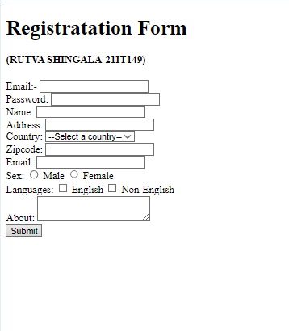

**Conclusion :**

From this practical I learned the concept of JS-VALIDATION.