Practical – 4

* **AIM: 1. Create Javascript Object of Spoural Registration User input and Display the Object Details on Webpage(Table).**

**Source Code: HTML:**

<!DOCTYPE html>

<html lang="en">

<head>

<meta charset="UTF-8">

<meta http-equiv="X-UA-Compatible" content="IE=edge">

<meta name="viewport" content="width=device-width, initial-scale=1.0">

<title>Spoural</title>

<body>

<img src="https://connectgujarat.com/wp-content/uploads/2020/06/Cha.jpg" alt="Spoural Event">

<h1><i><b>SPOURAL 2023- THE MOST AWAITED EVENT !!</b></i></h1>

<div>

<p><i><b>The most anticipated event for Charusatians, SPOURAL 2023,

will

take place from January 23 to February 11,2023.</b>.</i></p>

</div>

<br>

<h2>Register for the event</h2>

<form>

<label for="name">Name:</label>

<input type="text" id="name" name="name"><br><br>

<label for="email">Email:</label>

<input type="email" id="email" name="email"><br><br>

<label for="phone">Phone:</label>

<input type="number" id="phone" name="phone"><br><br>

<label for="college">College:</label>

<input type="text" id="college" name="college"><br><br>

<label for="year">Year:</label>

<input type="number" id="year" name="year"><br><br>

<label for="branch">Branch:</label>

<input type="text" id="branch" name="branch"><br><br>

<input type="submit" value="Submit" onclick="display()">

</form>

<footer>

<p>For any queries, contact us at : [spouralteam@charusat.edu.in](mailto:spouralteam@charusat.edu.in)</p>

</footer>

<script src="1.js"></script>

</body>

</html>

**JAVASCRIPT:**

function display() { var obj = {

name: document.getElementById("name").value, email: document.getElementById("email").value, phone: document.getElementById("phone").value, college: document.getElementById("college").value, year: document.getElementById("year").value, branch: document.getElementById("branch").value,

}

document.write("<table border='1'>"); document.write("<tr><th>Name</th><th>Email</th><th>Phone</th><th>College</th>

<

th > Year < /th><th>Branch</th > < /tr>"); document.write("<tr><td>" + obj.name + "</td><td>" + obj.email +

"</td><td>" +

obj.phone + "</td><td>" + obj.college + "</td><td>" + obj.year +

"</td><td>" +

obj.branch + "</td></tr>"); document.write("</table>");

}

//console.log(obj);

**Output:**

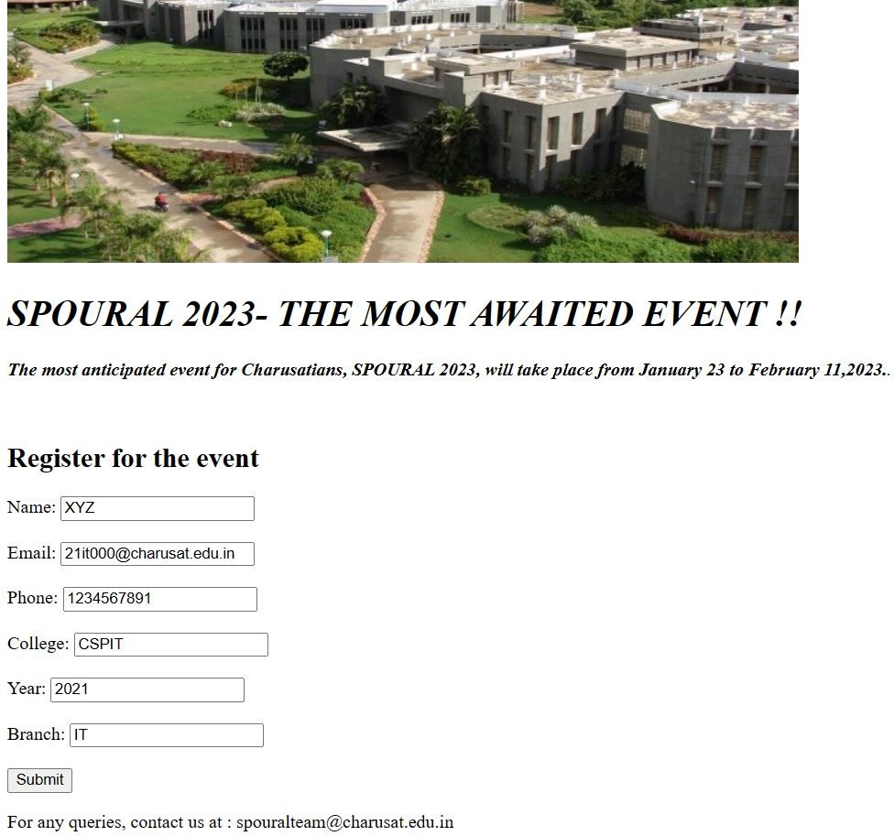

**2. Create Car Object and Its methods like isFuelType(CNG, Petrol, Diesel, Hybrid), isType(like SUV, Hatchback,Luxury), isBrand(like BMW, Audi, Tata, Mahindra).**

**Source Code: HTML:**

<!DOCTYPE html>

<html lang="en">

<head>

<meta charset="UTF-8">

<meta http-equiv="X-UA-Compatible" content="IE=edge">

<meta name="viewport" content="width=device-width, initial-scale=1.0">

<title>Car details</title>

<style>

div {

border: 1px solid black; border-radius: 10px; background-color: #0a0a0a;

color: white;

}

h1 {

}

text-align: start; color: white;

table, th,

td {

align-content: center; border: 1px solid black; border-collapse: collapse; color: ghostwhite;

}

th,

td {

}

align-content: center; padding: 5px;

text-align: left; font: bold; color: white;

img {

place-items: center;

IT255 Web Technologies CSPIT 4IT (2022-2023) 21IT080 Page | 21 border: 1px solid black;

border-radius: 10px;

}

table#t01 {

width: 100%;

background-color: #f1f1c1;

}

body {

background-color: #0a0a0a;

}

</style>

</head>

<body>

<h1><b><i>CAR DETAILS</i></b></h1>

<div>

<h2>TOYOTA FORTUNER</h2>

<img src="https://encrypted- tbn0.gstatic.com/images?q=tbn:ANd9GcTsWiQZkCgriEolnzytZpLbl1uOjGDleU9asQYu_vlG&s" alt="Toyota Fortuner" height="250px">

<div id="toyota">

<br>

<input type="button" value="Toyota Details" onmouseover="toyocar.displayToyotaDetails()">

<br>

</div>

</div>

<br>

<div>

<h2>MARUTI SWIFT</h2>

<img src="https://encrypted- tbn0.gstatic.com/images?q=tbn:ANd9GcSXxAE7Z9cPeTMd6nQB4oBNiRxv77J5YJXtKw&usqp=CAU

" alt="Maruti Swift" height="250px">

<div id="maruti">

<br>

<input type="button" value="Maruti Details" onmouseover="maruticar.displayMarutiDetails()">

<br>

</div>

</div>

<br>

<div>

<h2>HYUNDAI VENUE</h2>

IT255 Web Technologies CSPIT 4IT (2022-2023) 21IT080 Page | 22

<img src="https://encrypted- tbn0.gstatic.com/images?q=tbn:ANd9GcQaQ7l7sF_linfkoLEUCzm86kUO6ZnDM4XQzw&usqp=CAU

" alt="Hyundai Venue" height="250px">

<div id="hyundai">

<br>

<input type="button" value="Hyundai Details" onmouseover="hyundaicar.displayHyundaiDetails()">

<br>

</div>

</div>

<script src="1.js"></script>

</body>

</html>

**JAVASCRIPT:**

var toyocar = {

name: "Toyota Fortuner", price: "Rs. 30,00,000",

model: "2021", displayToyotaDetails: function() {

document.getElementById("toyota").innerHTML = "<table><tr><th>Name</th><th>Price</th><th>Model</th></tr><tr><td>" +

this.name +

"</td><td>" + this.price + "</td><td>" + this.model + "</td></tr></table>";

}

}

var maruticar = {

name: "Maruti Swift", price: "Rs. 5,00,000",

model: "2021", displayMarutiDetails: function() {

document.getElementById("maruti").innerHTML = "<table><tr><th>Name</th><th>Price</th><th>Model</th></tr><tr><td>" +

this.name +

"</td><td>" + this.price + "</td><td>" + this.model + "</td></tr></table>";

}

}

var hyundaicar = {

name: "Hyundai Venue", price: "Rs. 10,00,000",

model: "2021", displayHyundaiDetails: function() {

document.getElementById("hyundai").innerHTML = "<table><tr><th>Name</th><th>Price</th><th>Model</th></tr><tr><td>" +

this.name +

"</td><td>" + this.price + "</td><td>" + this.model + "</td></tr></table>";

}

}

**Output:**

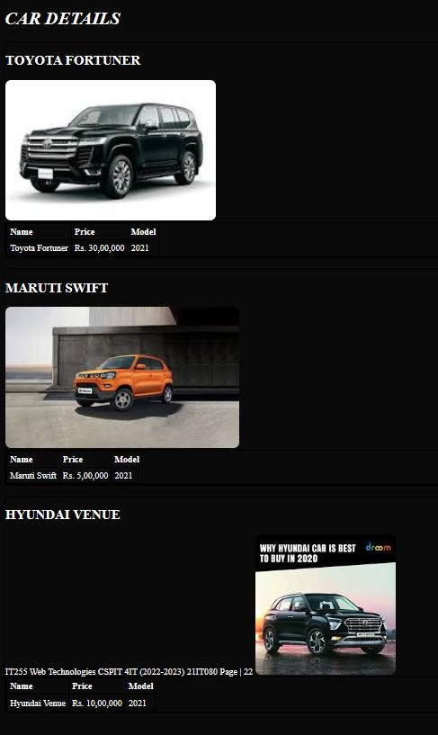

**Conclusion:**

From this practical I learnt that in JavaScript, almost everything is an object(except primitive values). Object properties can be both primitive values, other objects, and functions.

**Course Outcome:**

I learnt how to create objects, methods and functionality of this keyword.