Practical-7

## **Aim:** Demonstrate ES6 New Syntax and Test Browser Compatibility.

* 1. **Arrow Function: -**

# Program:

const regularFunction = function (param1, param2) { return param1 + param2;

};

const arrowFunction = (param1, param2) => param1 + param2; const arrowFunctionMultiParams = (param1, param2, param3) => { return param1 + param2 + param3;

};

const noParameters = () => "RUTVA SHINGALA-21IT149!"; console.log(regularFunction(1,2)); console.log(arrowFunction(2,3)); console.log(arrowFunctionMultiParams(1,2,3)); console.log(noParameters());

**Output:**

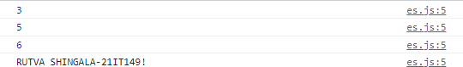

1. **Destructuring:-**

# Program:

let myNumbers = [1, 2, 3, 4];

let [firstNum, secondNum, thirdNum, fourthNum] = myNumbers; console.log(firstNum);

console.log(secondNum); console.log(thirdNum); console.log(fourthNum); let myObject = {

name: 'RUTVA SHINGALA-21IT149',

age: 25,

job: 'Software Engineer'

};

let {name, age, job} = myObject; console.log(myObject.name); console.log(age);

console.log(job); // Software Engineer

* + **Output:**

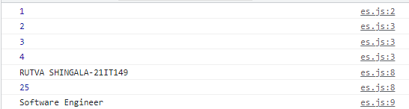

1. **Spread vs Rest Operator:-**

# Program:

const numbers = [1,2,3,4,5]; function add(a, b, c, d, e) { return a + b + c + d + e;

}

const sum = add(...numbers); console.log(sum);

let myObject = {

name: 'RUTVA SHINGALA-21IT149',

};

let {name} = myObject; console.log(myObject.name);

const numbers2 = [6,7,8,9,10];

const combinedNumbers = [...numbers, ...numbers2]; console.log(combinedNumbers);

* + **Output:**



# Conclusion

* + In this practical I have learned how to perform various Object, function making likes Arrow function, Destructuring and Spread vs Rest Operator method also learn how to demonstrate class, properties and work also learn in the JavaScript.

# Course Outcome:

## Learnt about the Arrow function, Destructuring and Spread vs Rest Operator and function and object and different type of method and its functionality of helping introduce dynamic operations on webpage.