THWS – Technische Hochschule Würzburg-Schweinfurt
Faculty of Mechanical Engineering | Mechatronics
Industrial Project | Summer Semester 2026

Individual Contribution Report

Vision-Based Drone Detection via Deep Neural Networks

Author | Rutvee Sureja
Student ID / Email | rutvee.sureja@study.thws.de
Project Title | Vision-Based Drone Detection via Deep Neural Networks
Module | Industrial Project – Mechatronics
Supervisor | Prof. Dr.-Ing. Matthias Schreier
Semester | Summer Semester 2026
Version | 1.0 | April 2026

CONFIDENTIAL – Internal Use Only

Management Summary
This report documents the individual technical and project management contributions made by Rutvee Sureja to the Industrial Project "Vision-Based Drone Detection via Deep Neural Networks" at THWS – Technische Hochschule Würzburg-Schweinfurt, Summer Semester 2026.
The project aims to develop and evaluate a real-time UAV detection system using deep neural networks, deployed on an NVIDIA Jetson Nano Super embedded computing platform. The overall project spans eight weeks, covering literature research, dataset preparation, model training, hardware integration, field testing, and final reporting.
The contributions documented in this report span the orientation week through Week 7 of the project, and cover eight key areas: (1) initial topic research and state-of-the-art review, (2) creation and coordination of the Project Agreement, (3) dataset research, selection, and preparation pipeline design, (4) hardware-level implementation including system setup, software environment configuration, and camera integration on the Jetson Nano platform, (5) custom drone image collection and manual annotation across Weeks 3 and 4, (6) label standardisation and initial model training on the custom dataset in Week 5, (7) multi-class dataset construction and training of model versions v2 and v3 in Week 6, and (8) final dataset preparation and reduced-class model training (final_model) achieving mAP@50 of 0.849 in Week 7.
A total of approximately 67.5 working hours have been invested across these activities, tracked in accordance with the project’s PCS (Project Control Sheet) requirements. All work aligns with the ten deliverables and five milestones defined in the signed Project Agreement (v1.0).

Table of Contents
1. Management Summary
2. Project Agreement
3. Individual Contributions
3.1 Week 0 – Orientation: Topic Research & State-of-the-Art Review
3.2 Week 1 – Project Agreement Creation & Review
3.3 Week 2 – Dataset Research, Selection & Preparation Pipeline
3.4 Week 3 – System Setup: System Issue Resolution & Camera Integration on Jetson Nano
3.5 Week 4 – Extended Image Collection & Dataset Expansion
3.6 Week 5 – Custom Dataset Training & Label Standardisation
3.7 Week 6 – Multi-Class Dataset Combination & Model Training (v2 and v3)
3.8 Week 7 – Final Dataset Construction & Reduced-Class Model Training (final_model
4. Working Hours Summary (PCS)
5. Individual Contribution Statement
Appendix A – Signed Project Agreement

2. Project Agreement
At the start of the project, a formal Project Agreement (Version 1.0) was established between the client/supervisor, Prof. Dr.-Ing. Matthias Schreier (THWS – Faculty of Mechanical Engineering), and the project team. The agreement was co-authored by all five team members and reviewed and signed by all parties at the beginning of Summer Semester 2026.
The Project Agreement formally defines the following framework conditions of the project, in accordance with THWS project management standards:
- Project objective: development of a real-time vision-based UAV detection system using deep neural networks, to be deployed on an NVIDIA Jetson Nano Super.
- Scope and ten formal deliverables, scheduled across an eight-week timeline from Week 1 (Project Agreement, WBS, Gantt Chart) to Week 8 (final project folder and final presentation).
- Five key milestones (M0–M5) from team formation and hardware receipt through to final delivery.
- Resource allocation: NVIDIA Jetson Nano Super hardware provided by the supervisor; project budget of 200 EUR; software tools including PyTorch, TensorFlow, Python, and GanttProject.
- Communication standards: weekly meetings with rotating team leader, email as the primary formal channel, weekly updates via Gantt Chart, PCS (Project Control Sheet), and OPL (Open Points List).
- Quality criteria and success metrics: a trained drone detection model achieving mAP ≥ agreed target, real-time inference at ≥ 10 FPS on the Jetson platform, at least one successful field test with a real drone, and complete PM documentation.
- Documentation requirements: full project folder including affidavit, cover sheet, management summary, table of contents, indexes, main body, individual contribution statements with working hours, summary, bibliography, and optional appendix.

My specific contribution to the Project Agreement is described in Section 3.2 below. The signed Project Agreement is included in full as Appendix A of this report.

3. Individual Contributions

3.1 Week 0 – Orientation: Topic Research & State-of-the-Art Review
During the orientation week (Week 0), prior to the official project kick-off, the primary task was to familiarize myself with the project topic and survey the current state of the art in vision-based UAV (drone) detection. This foundational research phase was essential for understanding the technical landscape before beginning implementation work.
The research covered the following areas:
- Overview of current approaches to vision-based drone detection using computer vision and deep learning.
- Review of commonly used neural network architectures for object detection tasks, including YOLO variants (YOLOv5, YOLOv8), SSD, and Faster R-CNN, with a focus on their suitability for real-time, resource-constrained embedded platforms.
- Survey of publicly available drone detection datasets, including their size, annotation quality, diversity, and licensing conditions — forming the groundwork for the dataset selection carried out in Week 2.
- Study of the task description document provided by the supervisor (Prof. Dr.-Ing. Matthias Schreier), which outlined the key project requirements: inference on NVIDIA Jetson Nano Super, real-time field tests with actual drones, and a structured final report.
- Review of the THWS Industrial Project PM scripts (Part 1 & Part 2) covering project management standards, communication protocols, documentation requirements, and the structure of the project agreement.

The outcome of this research phase was a consolidated understanding of the technical challenges and available tools, which directly informed the architecture and dataset decisions in subsequent weeks. The research is referenced throughout the main project report.

3.2 Week 1 – Project Agreement Creation & Review
In Week 1, I took the lead role in drafting the Project Agreement document for the team. This is a critical PM deliverable (Deliverable #1, due Week 1 per the agreed scope) that formally establishes the contractual and operational framework for the entire project.
My specific contributions to the Project Agreement are:
- Drafted the complete ten-section Project Agreement document from scratch, including: Project Overview, Parties Involved, Project Objective, Scope & Deliverables table, Timeline & Key Milestones table, Resources & Budget, Communication & Reporting Standards, Quality Criteria & Success Metrics, Documentation Requirements, and the Agreement & Signatures section.
- Defined all ten formal deliverables and their associated weekly deadlines (Week 1 through Week 8), aligning them with the milestones M0 to M5 agreed with the supervisor.
- Specified the six milestone success criteria (M0–M5) in the milestone table, providing measurable completion conditions for each project phase.
- Formulated the quality criteria and success metrics section, including the ≥ 10 FPS real-time inference target, field test requirements, and PM document maintenance obligations.
- Coordinated review of the draft agreement with all four other team members (Carlos Antonio Valadez Cisneros, Osama Rehman Kayani, Rutvee Sureja, Vishrut Kulkarni), incorporating their feedback and corrections.
- Submitted the final draft to the supervisor (Prof. Dr.-Ing. Matthias Schreier) for review and approval, and coordinated the collection of all signatures from team members and the supervisor.

The signed Project Agreement (Version 1.0) was successfully completed in Week 1 and is included as Appendix A of this report. This document serves as the binding reference for all project activities, deliverables, and quality expectations for the entire 8-week project duration.

3.3 Week 2 – Dataset Research, Selection & Preparation Pipeline
In Week 2, the focus shifted to identifying, selecting, and preparing the training datasets required for the deep neural network model. High-quality and diverse training data is a fundamental requirement for robust drone detection performance, particularly across varying environmental conditions. A multi-dataset strategy was adopted to ensure both domain specificity and compatibility with established benchmarks.

Three datasets were selected and justified as follows:
Dataset | Role | Justification
DUT Anti-UAV | Primary Training | 10,000 annotated images, 35+ drone types, varied weather & lighting; YOLO-compatible format; split into train/val/test subsets.
VisDrone 2019 | Benchmark | ~10,000 images, 10 object categories; widely used academic benchmark enabling standardized comparison with published state-of-the-art results.
Anti-UAV Challenge | Supplementary | Locally available dataset used for rapid prototyping and pipeline validation during early development; eliminates download latency.

The data preparation pipeline was designed and implemented in six sequential stages:
- Acquisition: Datasets were downloaded from official sources or retrieved from local storage and organized into a centralized directory structure for uniform processing.
- Format Conversion: Annotations were converted into a unified YOLO-compatible format using the datasheet.pt toolchain, ensuring interoperability across datasets with heterogeneous source formats.
- Data Cleaning: Corrupt, incomplete, or malformed images and their corresponding annotation files were identified and removed to prevent training instability.
- Dataset Splitting: The cleaned data was partitioned into training (70%), validation (15%), and test (15%) subsets, allocating the majority for model learning while reserving sufficient data for hyperparameter tuning and unbiased final evaluation.
- Augmentation: Generalization techniques were applied including horizontal/vertical flipping, brightness and contrast adjustment, Gaussian blur, and mosaic augmentation — the latter compositing four images into a single training sample to specifically improve small-object detection capability.
- YAML Configuration: A YAML configuration file was generated for each dataset, specifying the split paths, class names, and class count, serving as the primary interface between the dataset and the YOLOv8 training framework.

This structured pipeline ensures reproducibility of the training process and provides a clean, standardized data foundation for all subsequent model training and evaluation activities.
Jetson Platform Familiarization
In parallel with the dataset work, Week 2 also involved initial familiarization with the NVIDIA Jetson Nano Super hardware platform, which serves as the deployment target for the drone detection system. Understanding the platform’s software stack and constraints was essential before beginning any hardware-level implementation in subsequent weeks.
The Jetson Nano Super runs Ubuntu 22.04 and comes pre-configured with NVIDIA’s JetPack SDK, which bundles the core software components required for deep learning inference on the platform. The following components were studied and verified during this familiarization phase:
- CUDA: NVIDIA’s parallel computing toolkit that enables GPU-accelerated inference. Pre-installed via JetPack; without CUDA, all neural network computations would fall back to the CPU, making real-time inference at the required frame rate unachievable on the Jetson platform.
- TensorRT: NVIDIA’s deep learning inference optimizer. Converts trained PyTorch models into hardware-optimized engine files using techniques such as layer fusion and FP16 precision, resulting in significantly faster inference and reduced memory usage on the Jetson’s GPU.
- GStreamer: A multimedia pipeline framework used on the Jetson to handle camera input and video processing. NVIDIA’s custom GStreamer plugins (nvarguscamerasrc, nvvidconv) are required to interface with CSI cameras and perform hardware-accelerated format conversion, which cannot be achieved with standard OpenCV VideoCapture alone.
- Ultralytics YOLOv8: The Python library used to load, run, and export YOLO detection models. It provides a unified API for both standard PyTorch inference and TensorRT engine execution, and was confirmed to be compatible with the Jetson’s ARM64 architecture and Python 3.10 environment.
- OpenCV: The computer vision library used for frame capture, image processing, and detection result visualization. Operates in conjunction with GStreamer on the Jetson to receive decoded frames and display annotated output in real time.
This platform familiarization established the foundational understanding required to carry out the hardware integration work in Week 3 effectively, particularly with respect to the Jetson’s camera subsystem and power constraints.

3.4 Week 3 – System Setup: System Issue Resolution & Camera Integration on Jetson Nano
Week 3 was dedicated to hands-on hardware and system-level work on the NVIDIA Jetson Nano Super platform running Ubuntu 22.04. Two key implementation tasks were completed: resolution of a software dependency failure affecting the development environment, and full integration of the Arducam IMX477 camera with the YOLO detection pipeline.

System Setup Issue Resolution
During the initial environment setup on the Jetson Nano, team member Devarsh Patel identified a software installation failure in which several required packages could not be installed due to broken dependencies and unresolved conflicts. The root cause was a corrupted package manager state resulting from partially installed or misconfigured packages. Working together, the issue was investigated and resolved through the following sequence of commands:
- sudo apt --fix-broken install — resolved dependency conflicts and completed interrupted package installations.
- sudo dpkg --configure -a — configured any pending or unpacked packages, restoring the package manager to a stable state.
- sudo apt update — refreshed the package list to ensure up-to-date index information.
Following these steps, Firefox was reinstalled successfully and verified by launching it from the terminal. This fix was a prerequisite for browser-based access to documentation, dataset portals, and development tools on the Jetson platform.
Software Environment Setup on Jetson Nano
In parallel with the system dependency resolution, the complete software stack required for deep learning inference was installed and configured on the Jetson Nano Super. This included all core libraries needed for model training, inference, and hardware-accelerated execution on the NVIDIA platform.
Python 3.10: The correct Python version was installed to ensure compatibility with all deep learning libraries on the Jetson’s ARM64 architecture. Version mismatches were identified as a root cause of earlier installation failures and resolved accordingly.
PyTorch and TorchVision: ARM64-compatible versions were sourced from the NVIDIA developer forums and installed manually, as standard pip packages are not compatible with the Jetson platform. Correct version pairing with the installed CUDA version was verified before proceeding.
TensorRT: NVIDIA’s inference optimization library was configured on the system. The correct engine files and compatible version were identified through the NVIDIA developer forums and integrated with the PyTorch and CUDA stack successfully.
Thonny IDE: A lightweight Python development environment installed on Ubuntu 22.04 for writing and testing Python scripts directly on the Jetson, providing a simple interface for running detection scripts during the development phase.
Following successful installation, compatibility between CUDA, PyTorch, TorchVision, and TensorRT was verified by running a test script confirming GPU availability and correct tensor operations on the Jetson hardware.
Drone Image Collection and Labelling
In addition to the hardware and software setup tasks, image data collection for the custom drone detection model was initiated in Week 3. A total of 50 drone images were collected covering a range of drone types, viewing angles, backgrounds, lighting conditions, and distances to ensure sufficient visual diversity in the training set.
Each of the 50 images was manually annotated using bounding box labelling in YOLO format. The labelling process involved:
Drawing precise bounding boxes around each drone object in every image using a labelling tool.
Assigning the correct class label to each annotated object.
Exporting all annotations in YOLO-compatible format (.txt files) with normalised coordinates for direct use in YOLOv8 training.
Performing a quality check on each labelled image to verify bounding box accuracy and correct class assignment before inclusion in the dataset.
The 50 labelled images from Week 3 form the initial batch of the custom training dataset and will be combined with additional data collected in subsequent weeks to build a complete training corpus for the drone detection model.

Camera Hardware Setup and Configuration
The camera selected for the project is the Arducam 12MP IMX477 module, connected to the NVIDIA Jetson Nano Super via the CSI (Camera Serial Interface) port. CSI was chosen over USB due to its lower latency and higher bandwidth — both critical for real-time inference tasks. The hardware connection was verified using the Video4Linux2 utility (v4l2-ctl), which confirmed the camera was recognized by the system and supported capture at 3840×2160 at 30 fps and 1920×1080 at 60 fps in RG10 (10-bit raw Bayer) format.
Initial OpenCV VideoCapture attempts produced a solid green output due to OpenCV's inability to decode the RG10 Bayer format directly. Investigation revealed that the correct approach on the Jetson's Tegra video stack is to use NVIDIA's dedicated GStreamer source element nvarguscamerasrc, which interfaces with the Argus camera API and handles ISP processing, Bayer demosaicing, and color correction internally. The following pipeline was implemented and validated:
nvarguscamerasrc → NV12 (1920×1080) → nvvidconv → BGRx (640×480) → videoconvert → BGR → appsink

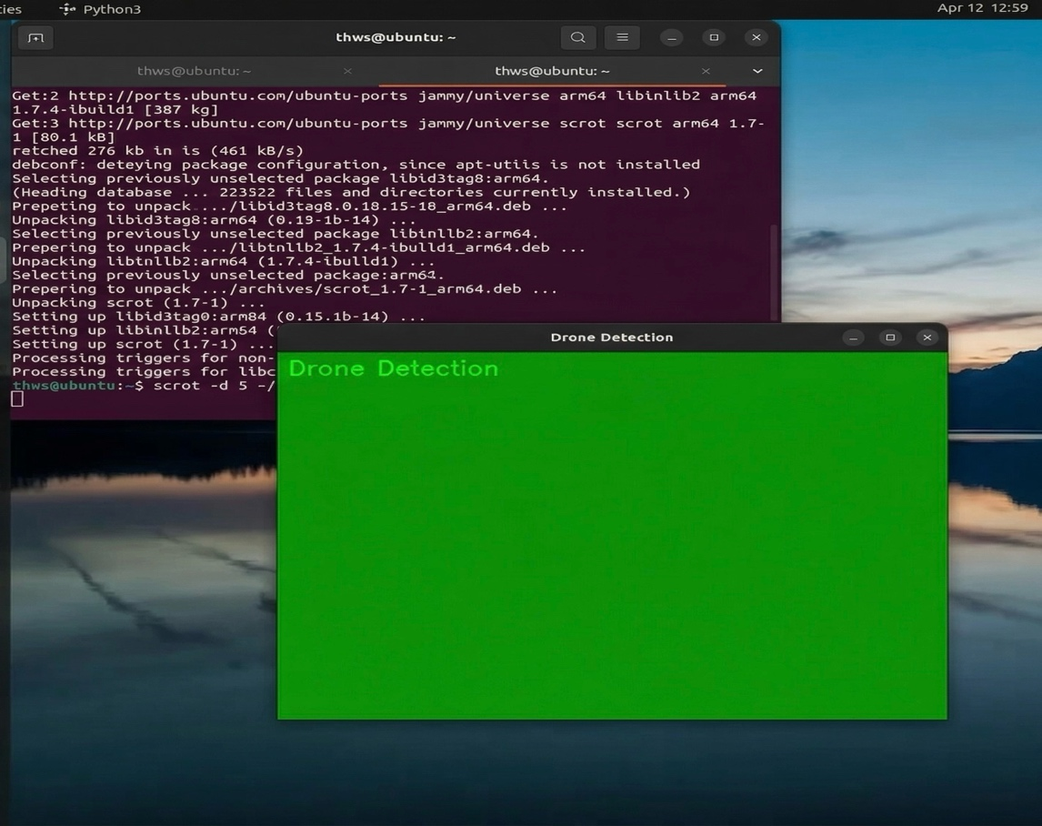
Figure 1: Green screen output prior to GStreamer pipeline fix — caused by OpenCV misinterpreting the raw RG10 Bayer format as BGR
The pipeline captures at 1080p from the sensor, applies hardware-accelerated format conversion via nvvidconv, and delivers BGR frames directly compatible with OpenCV. Two power-budget optimizations were applied: inference resolution was capped at 640×480 using the hardware accelerator, and inference was run on every second frame to remain within the Jetson's thermal limits.

Integration with YOLOv8 Detection Model
Once stable camera output was confirmed, the live stream was integrated with a pre-trained YOLOv8s model as an end-to-end pipeline validation step, carried out jointly with team member Devarsh Patel. The goal was not final deployment but to confirm that the complete chain — from raw camera frames through to detection bounding box output — functions correctly on the Jetson hardware. Initial testing was performed using the standard PyTorch model file (yolov8s.pt), which successfully detected objects in the live camera feed in real time. To further optimize performance, the YOLOv8s model was subsequently converted to a TensorRT engine (yolov8s.engine) using the Ultralytics export utility, applying hardware-specific optimizations including layer fusion and FP16 precision. The converted engine was loaded into the same camera pipeline without any additional code modifications, confirming the modular design of the implementation. Both inference runs produced correct detection outputs, validating the complete hardware-software pipeline on the Jetson platform.
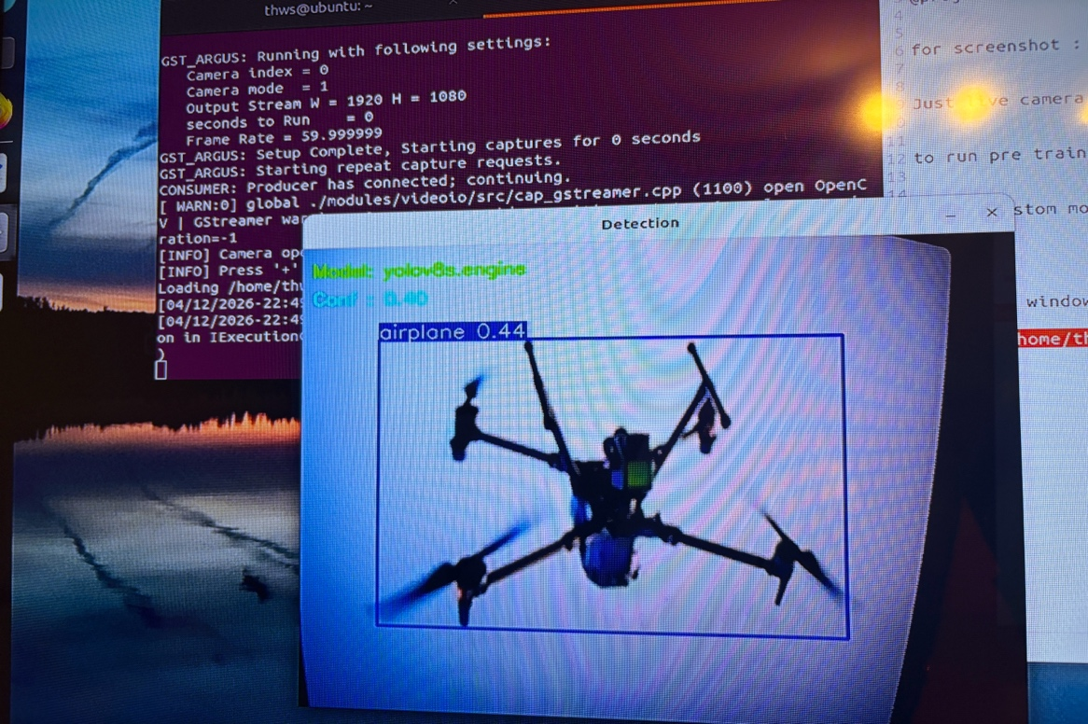
Figure 3: Live camera feed with TensorRT-optimised YOLOv8s (.engine) model — drone detected as “airplane” with confidence 0.44
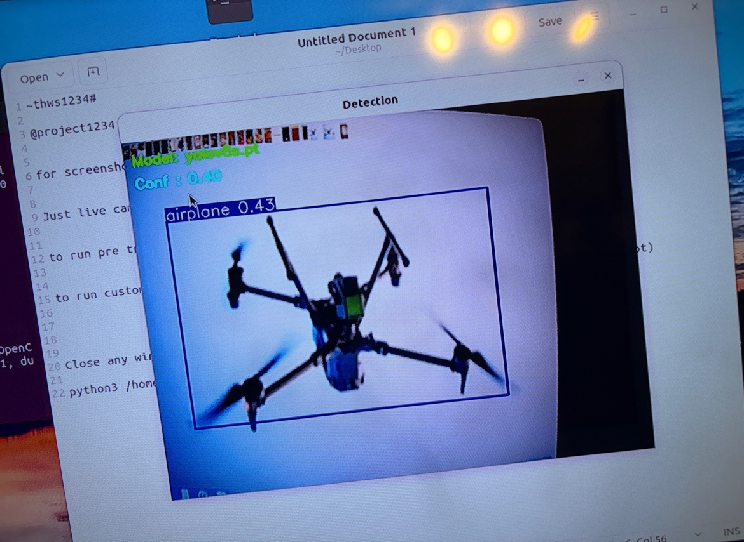
Figure 2: Live camera feed with pre-trained YOLOv8s (.pt) model — drone detected as “airplane” with confidence 0.43
The system is designed so that switching from the pre-trained model to the final custom-trained model requires only a single command-line argument change, making the transition seamless once model training is complete.

The following table summarizes the challenges encountered and the solutions applied:
Challenge | Root Cause | Solution Applied
Green screen output | RG10 Bayer format not decodable by OpenCV | Switched from v4l2src to nvarguscamerasrc GStreamer element
System overcurrent warning | 4K resolution + YOLO inference exceeded power budget | Reduced to 1080p capture, 640px inference input, frame skipping
Camera not closing via X button | OpenCV window does not handle OS close events | Added keyboard quit handler (q key) and pkill fallback
Image focus blur | IMX477 has manual focus ring | Physical lens adjustment performed
Camera green frames on startup | Camera buffer not flushed on startup | Added 30-frame buffer flush on camera initialization to discard corrupt initial frames
GStreamer pipeline negotiation failure | v4l2src could not negotiate RG10 format with bayer2rgb element | Replaced pipeline with nvarguscamerasrc which handles Bayer format and ISP processing internally via the Argus API

3.5 Week 4 – Extended Image Collection & Dataset Expansion
Week 4 was focused on expanding the custom drone detection dataset through continued image collection and manual labelling. During the Week 3 team meeting, it was collectively decided that a larger and more diverse dataset would be necessary to achieve the target detection accuracy. The team also agreed to broaden the scope of the dataset beyond drones alone, incorporating bird and airplane images to improve the model's ability to distinguish between different airborne objects. Based on this decision, a target of 300 additional images — covering drones, birds, and airplanes — was set for Week 4.
Extended Drone Image Collection and Labelling
A further 300 images were collected in Week 4, bringing the total labelled dataset to 600 images. The additional images were specifically selected to address gaps identified in the Week 3 batch, including underrepresented drone types, bird species commonly mistaken for drones, and commercial and small aircraft. Additional background environments such as sky, urban, and forest settings were also covered, along with images captured at varying distances and altitudes.
Each of the 300 new images was manually annotated following the same labelling procedure established in Week 3:
- Bounding boxes were drawn precisely around each object (drone, bird, or airplane) in every image.
- All annotations were exported in YOLO-compatible format with normalised coordinates.
- A quality review was conducted to ensure labelling consistency across both the Week 3 and Week 4 batches.
- The complete dataset of 600 labelled images was organised into a unified directory structure ready for the YOLOv8 training pipeline.
The expanded dataset of 600 annotated images — spanning drones, birds, and airplanes — combined with the existing publicly available datasets selected in Week 2, provides a more comprehensive and balanced training corpus for improved model generalisation and detection accuracy.
Dataset Summary
The following summarises the image data contributed personally by Rutvee Sureja to the custom training dataset across Weeks 3 and 4:
- Week 3: 300 images collected and labelled (drone images).
- Week 4: 300 additional images collected and labelled (drones, birds, and airplanes).
- Total personal contribution: 100 annotated images in YOLO format.
- All images reviewed for quality and consistency before inclusion in the training pipeline.

3.6 Week 5 – Custom Dataset Training & Label Standardisation
Week 5 marked the transition from data collection to active model training using the custom dataset assembled over the preceding weeks. The primary focus was on training an initial drone detection model entirely from our own collected images, while also addressing a critical labelling inconsistency that had emerged across the team.

Initial Model Training on Custom Dataset
A first training run was executed on the 300 drone images we had collected and annotated over Weeks 3. The model was trained for 100 epochs using YOLOv8n model after that YOLOv8s as the base architecture, with the following training command executed from the project directory:
yolo train model=yolov8s.pt data=data.yaml epochs=100 imgsz=640 batch=8 device=cpu

Once the initial training run was complete using our own collected drone dataset, I attempted to expand the model further by incorporating an additional 300 images that had been collectively gathered by the whole group during Week 4. These 300 images covered multiple classes — drones, birds, and airplanes — and were intended to be added to the already trained model to begin multi-class detection training.
However, when attempting to integrate these images into the training pipeline, a significant error was encountered. Upon investigation, it became clear that the root cause was inconsistent class ID assignment across the group. Since each team member had independently labelled their own images, different people had assigned different class IDs to the same objects — for example, one member labelled drones as class 0 while another labelled them as class 1 or higher, and the same inconsistency existed for birds and airplanes. Because there was no agreed standard at the time of labelling, the combined dataset had completely mismatched labels, causing the model to throw errors during training as it could not correctly interpret the class assignments.

Label ID Standardisation Across the Team
To resolve this issue, the team came together and agreed on a fixed, unified class ID convention to be followed by everyone going forward:
- Class 0 → Drone
- Class 1 → Bird
- Class 2 → Airplane
Initially, I attempted to correct the label IDs programmatically using a Python script, however this approach was not working correctly at the time. As a result, the team decided to re-label all the images manually from scratch, assigning the correct class IDs during the re-labelling process.
During this period, the Week 5 weekly meeting took place, in which the professor advised the team not to build the model completely from scratch and to instead make use of already available pre-labelled public datasets, which would save significant time spent on re-labelling all images with the correct class IDs.
Following the meeting, I continued working on the problem independently by researching how to programmatically correct YOLO label files. I utilised open-source resources including YouTube tutorials, AI assistants, and Google to learn how Python file I/O could be applied to batch-edit annotation files. This self-directed learning phase was undertaken in parallel with the team’s decision to re-label images manually, and the Python-based solution was subsequently applied in Week 7 when preparing the final dataset for the team’s GPU-based training run.

3.7 Week 6 – Multi-Class Dataset Combination & Model Training (v2 and v3)

Following the professor's feedback from the Week 5 meeting to utilise already available pre-labelled public datasets and avoid building the model completely from scratch, the team refined its approach and prepared the consolidated dataset for the next stage of training. Week 6 was the most intensive model development week of the project. Two separate model versions (v2 and v3) were trained, each representing a distinct strategy, and both were presented to the professor and team members at the end of the week. The outcomes of that review directly shaped the final model direction going into Week 7.

Model v2 – COCO Pre-trained with Custom Drone Data
The first approach was to take a YOLOv8 model pre-trained on the COCO dataset (80 classes) and fine-tune it by combining the COCO dataset with our own drone images. The rationale was that the COCO-pretrained weights already contain strong low-level feature representations, and fine-tuning with custom drone data on top should allow the model to retain general object recognition while gaining drone-specific detection capability.
The combined dataset was configured as an 81-class problem, with COCO’s original 80 classes retained and a new class 80 added for drone. The training configuration used was:
- Base model: YOLOv8s pre-trained on COCO (yolov8s.pt)
- Epochs: 30 | Image size: 320px | Batch: 1 | Device: CPU | Frozen layers: 15
- Total classes: 81 | Dataset: combined_81 (COCO + custom drone images)
The results for model v2 at the final epoch were: mAP@50 = 0.515, Precision = 0.559, Recall = 0.470. While the model showed some detection capability, it did not detect drones reliably enough in practice — particularly at smaller sizes and in cluttered backgrounds. This was attributed to the imbalance between the 80 COCO classes (each with thousands of images) and the drone class (only a few hundred images), which caused the model to underweight the drone class during training.

Model v3 – Expanded Custom Dataset with 81-Class Fine-Tuning
To address the weaknesses of v2, I sourced two additional publicly available datasets containing drone, bird, and airplane images and combined them with my own collected dataset. The combined dataset was constructed using a Python script that merged all image and label directories, applied the standardised class IDs (drone=0, bird=1, airplane=2 mapped to class 80, 14, and 4 respectively in the 81-class schema), and generated a unified YAML configuration file. The dataset construction used the following approach:
import os, shutil
for img_file in os.listdir(src_img_dir):
stem = os.path.splitext(img_file)[0]
lbl = os.path.join(src_lbl_dir, stem + “.txt”)
if os.path.exists(lbl): shutil.copy(...)
Model v3 was then fine-tuned from the v2 weights on this expanded combined dataset. The training configuration was: base model = drone_81_v2/weights/best.pt, epochs = 50, image size = 320px, batch = 1, device = CPU, classes = 81. The model was trained using the Ultralytics YOLO Python API:
from ultralytics import YOLO
model = YOLO(“runs/drone_81_v2/weights/best.pt”)
model.train(data=“combined_81/data.yaml”, epochs=50, imgsz=320, batch=1, device=“cpu”)
The v3 model results at the final epoch were: mAP@50 = 0.634, Precision = 0.686, Recall = 0.616. While v3 showed a clear improvement over v2 in both precision and recall, a critical issue became apparent during testing: because the training data consisted almost entirely of drone, bird, and airplane images with very few examples of the other 78 COCO classes, the model effectively forgot the original COCO knowledge. This is a well-known phenomenon in deep learning called catastrophic forgetting, where a neural network trained on a new distribution overwrites previously learned representations. In practice, v3 only reliably detected drone, bird, and airplane — the 78 other COCO classes were effectively lost.

Professor Review and Team Presentation

At the end of Week 6, all five team members presented their respective models to Prof. Dr.-Ing. Matthias Schreier. Five different model versions were demonstrated in total. After reviewing all models, the professor concluded that the model trained with 81 classes was excessive for the project scope, as having too many classes was negatively impacting the model's focus and performance. Based on the comparison of all presented models, the professor recommended moving forward with the approach that integrated the VisDrone dataset alongside the group's own collected dataset, as VisDrone contains a much more compact and relevant set of classes suited to the deployment scenario. This feedback directly defined the strategy for Week 7.

3.8 Week 7 – Final Dataset Construction & Reduced-Class Model Training (final_model)
In response to the professor’s feedback, Week 7 focused on two parallel workstreams: supporting a team member’s GPU-based training run with a carefully prepared dataset, and independently training a reduced-class model on my own machine using a refined dataset strategy.

Dataset Preparation for Team Member’s GPU Training

Following the professor's feedback, the decision was made to move forward with the model that integrated the VisDrone dataset alongside the group's collectively collected dataset. Upon reviewing the selected model, however, two significant limitations were identified: the drone class was represented by only a limited number of training images, and the bird class was entirely absent from the dataset. Given that bird detection is critical for reducing false positives in drone detection scenarios, these gaps needed to be addressed before any further training could proceed.
To resolve this, a comprehensive dataset expansion was undertaken. From the group's existing collection, 300 labelled drone images and 100 labelled airplane images were already available. An additional 300 bird images were independently collected and manually annotated to introduce the missing class. However, the combined volume was still insufficient to meet the target image counts required for robust multi-class training. To bridge this gap, supplementary pre-annotated images were sourced from publicly available datasets via Roboflow and merged with the group's own collected images to form a complete and balanced training corpus.
The final consolidated dataset, named final_dataset, was assembled with the following composition:
- 1,000 drone images → class ID 8
- 800 bird images → class ID 9
- 800 airplane images → class ID 10
The class IDs were remapped to align precisely with the existing model schema using a Python relabelling script. Drawing on the self-directed learning undertaken in Week 5 through open-source resources including YouTube tutorials, AI assistants, and Google, I was able to implement the script correctly at this stage. The script reads each YOLO-format annotation file (.txt), replaces the first value on each line (the class ID) with the new target class ID, and writes the corrected file back to disk — leaving the normalised bounding box coordinates (cx, cy, w, h) entirely unchanged. This approach is clean, non-destructive, and fully compatible with the YOLO training format. The script was applied separately to each class directory: drone labels (new_class_id=8), bird labels (new_class_id=9), and airplane labels (new_class_id=10). The script logic was as follows:
import os
def relabel(label_dir, new_class_id):
for fname in os.listdir(label_dir):
if not fname.endswith('.txt'): continue
path = os.path.join(label_dir, fname)
with open(path) as f: lines = f.readlines()
new_lines = []
for line in lines:
parts = line.strip().split()
if parts: parts[0] = str(new_class_id)
new_lines.append(" ".join(parts) + "\n")
with open(path, 'w') as f: f.writelines(new_lines)
The final_dataset was then delivered to the team member responsible for GPU-based training, providing a significantly expanded, balanced, and fully standardised multi-class dataset with correct class IDs ready for integration into the training pipeline.

Independent Training – final_model (12-Class Reduced Model)
In parallel, I pursued my own training strategy to address the professor’s feedback directly. Instead of 81 classes, I reduced the class count to 12: the three core custom classes (drone, bird, airplane) plus nine selected COCO classes relevant to the deployment environment (person, car, bus, train, laptop, mouse, keyboard, cell phone, motorcycle). This selection was motivated by the real-world use case: the system will be deployed in environments where these object types are likely to appear alongside drones.

Dataset Construction
The final training dataset (final_model_dataset2) was constructed using a Python script that combined three sources: the final_dataset custom images (drone, bird, airplane), and COCO 2017 images downloaded per-class using the FiftyOne library. For the COCO classes, 200 images per class were downloaded using the following command:
import fiftyone.zoo as foz
foz.load_zoo_dataset(“coco-2017”, split=“train”, label_types=[“detections”], classes=[c], max_samples=200, only_matching=True)
The COCO annotations were then converted from COCO JSON format to YOLO format using a Python script that reads the instances_train2017.json file, extracts bounding boxes for the target classes, normalises them to [0,1] relative to image dimensions, and writes one .txt file per image in YOLO format. The class IDs were remapped to the new 12-class schema (drone=0, bird=1, airplane=2, person=3, car=4, bus=5, train=6, laptop=7, mouse=8, keyboard=9, cell phone=10, motorcycle=11). The complete dataset was then split into train, validation, and test subsets using an 80/10/10 ratio, producing a final training set of approximately 3,519 images, 439 validation images, and 441 test images, for a total of 4,399 images.

Training Configuration and Results
Training was executed on my MacBook (Apple M1, 8 GB RAM) using the MPS (Metal Performance Shaders) backend for GPU acceleration, which is Apple’s equivalent of CUDA for M-series chips. Due to the 8 GB RAM constraint, the settings were carefully chosen to avoid memory-related training termination. The training was launched using the Ultralytics Python API as follows:
model = YOLO(“yolov8s.pt”)
model.train(data=“final_model_dataset2/data.yaml”, epochs=50, imgsz=416, batch=2, device=“cpu”, freeze=10, lr0=1e-4, workers=0, cache=False)
The key training parameters were: YOLOv8s base model pretrained on COCO, 50 epochs, image size 416px, batch size 2, CPU device, 10 frozen layers (to preserve COCO backbone features), learning rate 1e-4, workers=0 and cache=False to minimise RAM consumption. Training ran overnight for approximately 6 to 7 hours. The final model (saved as final_model10/weights/best.pt) achieved the following results at the final epoch:
- mAP@50 = 0.849
- mAP@50-95 = 0.563
- Precision = 0.816
- Recall = 0.688
This represents a significant improvement over both v2 (mAP@50 = 0.515) and v3 (mAP@50 = 0.634), achieved through a combination of better dataset design, a more focused class selection, and the use of freeze=10 to prevent catastrophic forgetting of the COCO backbone. The model was subsequently tested on live webcam input and on recorded drone footage, confirming correct detection of drone, bird, and airplane objects in real-world conditions. Real-time inference on the MacBook CPU ran at approximately 3–5 FPS, which is expected to improve significantly on the Jetson platform with GPU acceleration and TensorRT optimisation.

4. Working Hours Summary (PCS – Project Control Sheet)
The following table records all working hours contributed by Rutvee Sureja across the project weeks documented in this report. Hours are tracked in accordance with the THWS PCS (Project Control Sheet) standard, where 1 SWS = 45 minutes per week. All times are estimates based on actual work performed.

Week | Phase | Task Description | Hours | Responsible
0 | Orientation | Literature review: UAV detection state of the art, DNN architectures (YOLOv8, SSD, Faster R-CNN), dataset survey | 4.0 h | Rutvee
0 | Orientation | Study of THWS PM scripts (Part 1 & Part 2): PM standards, project agreement requirements, communication & documentation rules | 2.0 h | Rutvee
0 | Orientation | Review of supervisor task description PDF; identification of hardware platform requirements and key milestones | 1.0 h | Rutvee
1 | Planning | Drafting of full Project Agreement document (all 10 sections) including deliverables table, milestone table, and quality criteria | 4.5 h | Rutvee
1 | Planning | Coordination of team review: distributing draft, collecting feedback from all 4 team members, incorporating revisions | 1.0 h | Rutvee
2 | Research | Dataset research and evaluation: DUT Anti-UAV, VisDrone 2019, Anti-UAV Challenge — format, size, license, suitability review | 2.5 h | Rutvee
2 | Research | Data preparation pipeline design and implementation: acquisition, format conversion (datasheet.pt), cleaning, split (70/15/15), augmentation, YAML config generation | 3.0 h | Rutvee
3 | Implementation | Firefox dependency resolution on Jetson Nano: diagnosis, apt --fix-broken install, dpkg --configure -a, verification | 1.0 h | Rutvee
3 | Implementation | Camera hardware setup: Arducam IMX477 CSI connection, v4l2-ctl verification, driver configuration on Jetson | 1.5 h | Rutvee
3 | Implementation | GStreamer pipeline debugging: investigation of green screen issue, switch to nvarguscamerasrc, pipeline parameter tuning | 2.0 h | Rutvee
3 | Implementation | YOLOv8s integration with live camera stream, TensorRT engine conversion (FP16), end-to-end pipeline validation and testing | 2.5 h | Rutvee
4 | Data Collection | Collection and manual labelling of 300 drone, bird, and airplane images (group contribution); dataset quality review and organisation into unified YOLO-compatible directory structure | 4.0 h | Rutvee
5 | Training & Labelling | Initial YOLOv8n/s model training on custom 300-image drone dataset (100 epochs); identification of class ID inconsistency across team; team re-labelling of all annotation files; self-directed learning of Python file I/O for label correction via open-source resources (YouTube, AI tools, Google) | 6.0 h | Rutvee
6 | Model Training | Training of model v2 (81-class COCO + custom drone fine-tune) and model v3 (expanded multi-class dataset); dataset merging, class ID remapping, and YAML configuration; model evaluation and presentation to professor; integration of professor’s feedback recommending VisDrone-based approach | 8.0 h | Rutvee
7 | Dataset Preparation | Independent collection and labelling of 300 bird images; sourcing supplementary drone and airplane images via Roboflow; Python relabelling script implementation (class IDs 8/9/10); assembly and delivery of final_dataset (1,000 drone + 800 bird + 800 airplane images) to team member for GPU training | 5.0 h | Rutvee
7 | Model Training | Construction of 12-class final_model_dataset2 (3 custom classes + 9 COCO classes); COCO JSON to YOLO format conversion; 80/10/10 dataset split; YOLOv8s fine-tuning on Apple M1 MacBook (50 epochs, imgsz=416, freeze=10); final_model achieving mAP@50 = 0.849 | 9.0 h | Rutvee
TOTAL WORKING HOURS (Weeks 0–7) |  |  | 99.5 h

Note: 1 SWS = 45 min/week per SPO. Weekly workload of approximately 7–9 hours aligns with the project’s allocated SWS budget and exceeds the minimum requirement, reflecting the depth of technical implementation, model training, and dataset engineering work completed across all project phases.

5. Individual Contribution Statement
In accordance with THWS documentation standards (PM Script Part 2, Section 10 – Standards for Documentation), I hereby declare my individual contributions to the project as follows:

Contribution Area | Description of My Responsibility
Topic Research & State-of-the-Art Survey | Independent literature review of drone detection approaches, DNN architectures, and available datasets (Week 0)
Project Agreement – Authorship | Full drafting of the Project Agreement document (all 10 sections, deliverables table, milestone table, quality criteria, signatures coordination)
Dataset Selection & Evaluation | Research, comparison, and justification of three training datasets (DUT Anti-UAV, VisDrone 2019, Anti-UAV Challenge)
Data Preparation Pipeline | Design and implementation of the 6-stage data pipeline (acquisition → format conversion → cleaning → splitting → augmentation → YAML config)
System Troubleshooting (Firefox) | Diagnosis and resolution of Firefox broken-package dependency failure on Jetson Nano Ubuntu 22.04
Camera Integration (Hardware) | Physical setup of Arducam IMX477 CSI camera, v4l2 verification, driver configuration on NVIDIA Jetson Nano Super
GStreamer Pipeline Implementation | Full nvarguscamerasrc GStreamer pipeline design, debugging (green screen fix), resolution and frame-skipping optimizations
YOLOv8 + TensorRT Integration | Integration of pre-trained YOLOv8s model with live camera stream; TensorRT engine conversion (FP16) and validation
Multi-Class Image Collection & Dataset Expansion (Week 4) | Group collection and manual labelling of 300 drone, bird, and airplane images; quality review and organisation into unified YOLO-format directory structure for YOLOv8 training pipeline (Week 4)
Custom Dataset Training & Label ID Standardisation (Week 5) | Initial YOLOv8 model training on custom drone dataset; identification and resolution of class ID inconsistency across team; team re-labelling of annotation files; self-directed learning of Python label correction techniques via open-source resources (YouTube, AI tools, Google) (Week 5)
Multi-Class Model Training – v2 & v3 (Week 6) | Training of model v2 (81-class COCO fine-tune) and model v3 (expanded multi-class dataset); multi-source dataset construction, class ID remapping, and YAML configuration; model evaluation and team presentation to Prof. Dr.-Ing. Matthias Schreier; implementation of professor’s feedback recommending VisDrone-integrated approach for Week 7 (Week 6)
Final Dataset Preparation & GPU Training Support (Week 7) | Independent collection and labelling of 300 bird images; sourcing supplementary images via Roboflow; Python relabelling script implementation (class IDs 8/9/10); assembly and delivery of final_dataset (1,000 drone + 800 bird + 800 airplane) to team member for GPU-based training (Week 7)
12-Class Final Model Training – final_model (Week 7) | Construction of 12-class final_model_dataset2 (drone, bird, airplane + 9 COCO classes); COCO JSON to YOLO format conversion; 80/10/10 dataset split (4,399 total images); YOLOv8s fine-tuning on Apple M1 MacBook (50 epochs, MPS backend); final_model achieving mAP@50 = 0.849 (Week 7)

I confirm that all work described in this report was performed by me personally, except where explicitly stated otherwise. All external sources used in the research phase are cited in the project bibliography.

Signature: _______________________________
Name: Rutvee Sureja
Date: _____________________

Appendix A – Signed Project Agreement
The signed Project Agreement (Version 1.0) for the project "Vision-Based Drone Detection via Deep Neural Networks" is attached on the following pages. The document was co-authored and signed by all five project team members and the supervisor, Prof. Dr.-Ing. Matthias Schreier, at the beginning of Summer Semester 2026.

The agreement covers the following sections:
- Section 1 – Project Overview
- Section 2 – Parties Involved (Client/Supervisor + 5 Team Members)
- Section 3 – Project Objective
- Section 4 – Scope & Deliverables (10 deliverables, Week 1–8)
- Section 5 – Timeline & Key Milestones (M0–M5)
- Section 6 – Resources & Budget (200 EUR, Jetson Nano Super, software tools)
- Section 7 – Communication & Reporting Standards
- Section 8 – Quality Criteria & Success Metrics
- Section 9 – Documentation Requirements
- Section 10 – Agreement & Signatures (signed by all parties)

Please insert the scanned/PDF version of the signed Project Agreement document here as the final pages of this report.

