Below I have attached the screenshots of the create-react-app which I have been

Working on for learning the concepts in React -

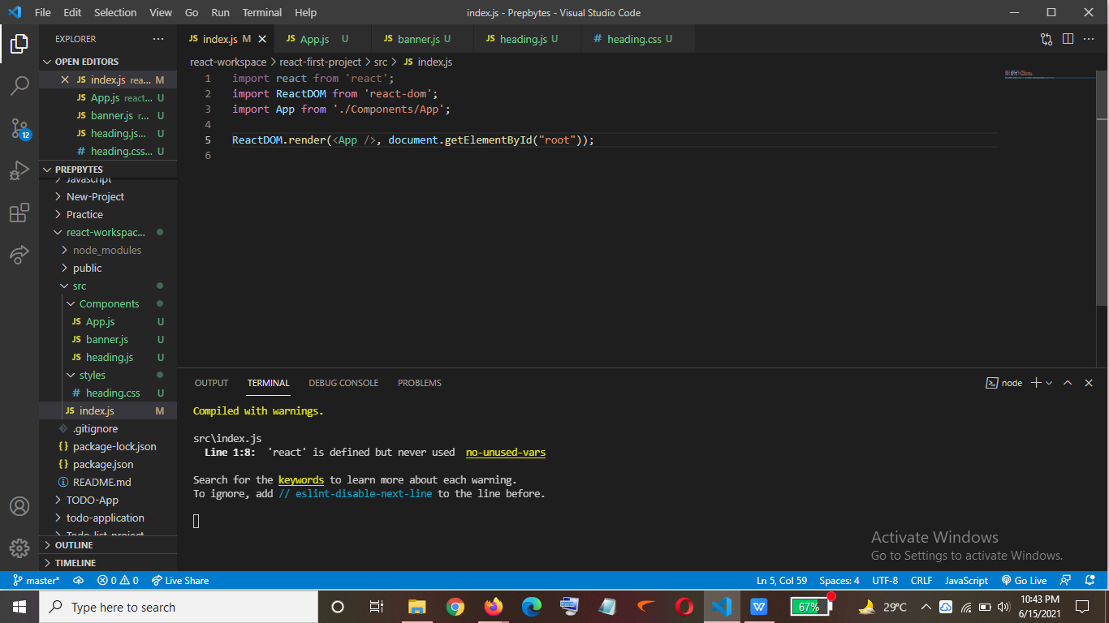

1. Firstly, I created a folder react-workspace.
2. In that folder then I used ‘npx create-react-app react-first-project’ to create a

folder named as react-first-project which contained all the libraries needed by us to run

our react app as you can see in the picture above.

1. Then I created various files in the src folder.
2. Then to run our project use command ‘npm start’.
3. Below is the screenshot of the basic structure of the react app which I created.

