useEffect ->

Importing useEffect -

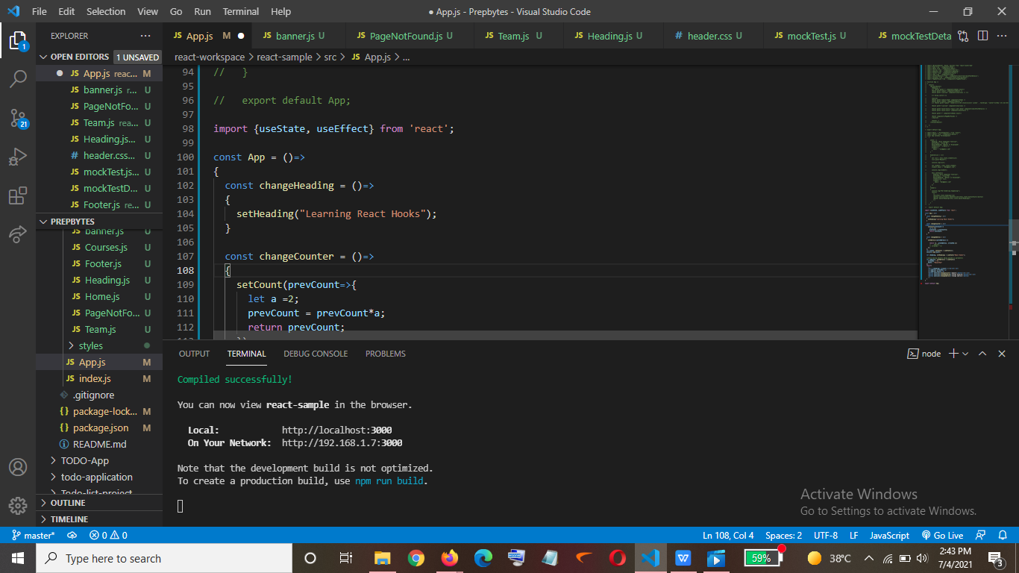

How to use it ->

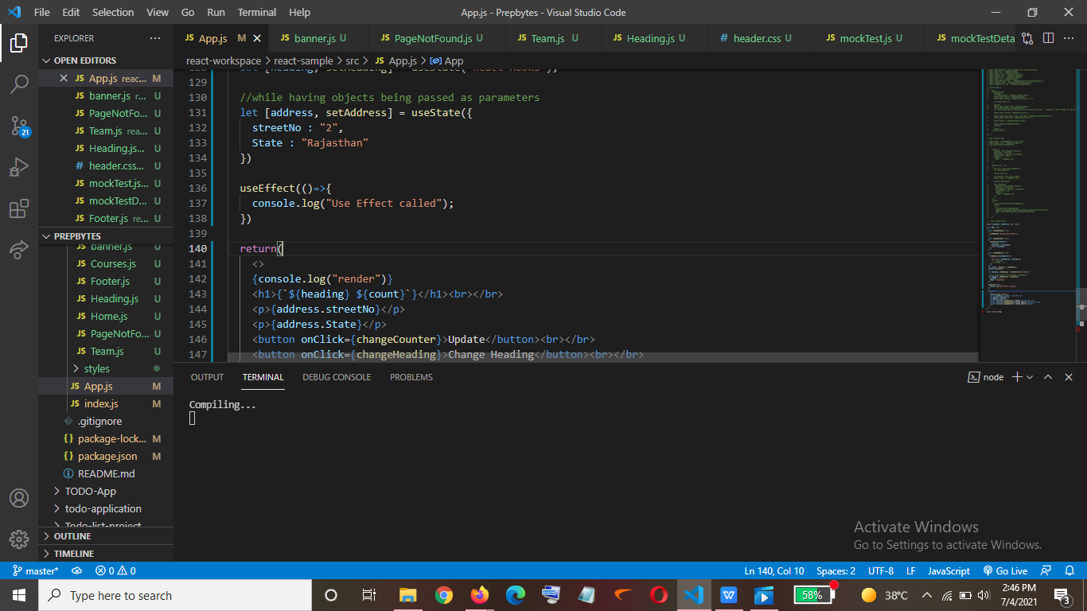

Output->

So , when the page loads firstly render method is been called and then the useEffect method is been called-

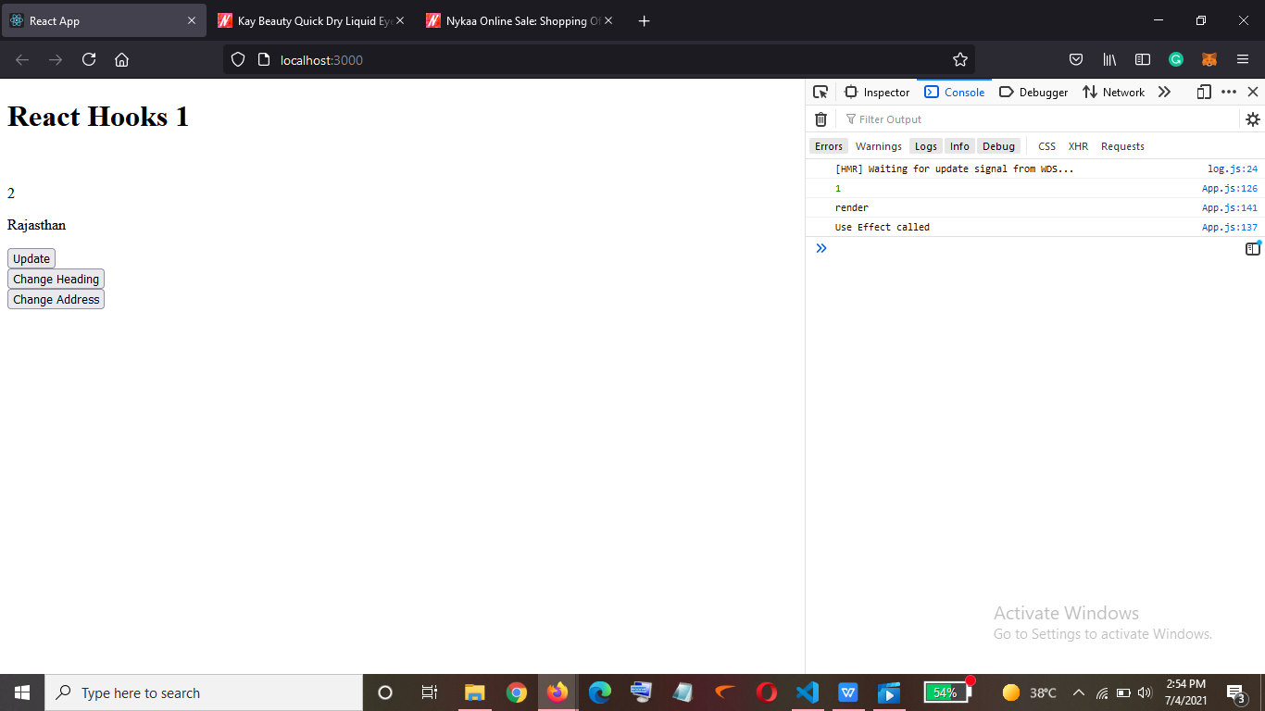

And if there will be any update happening on the page then the useEffect method will be called again and again->

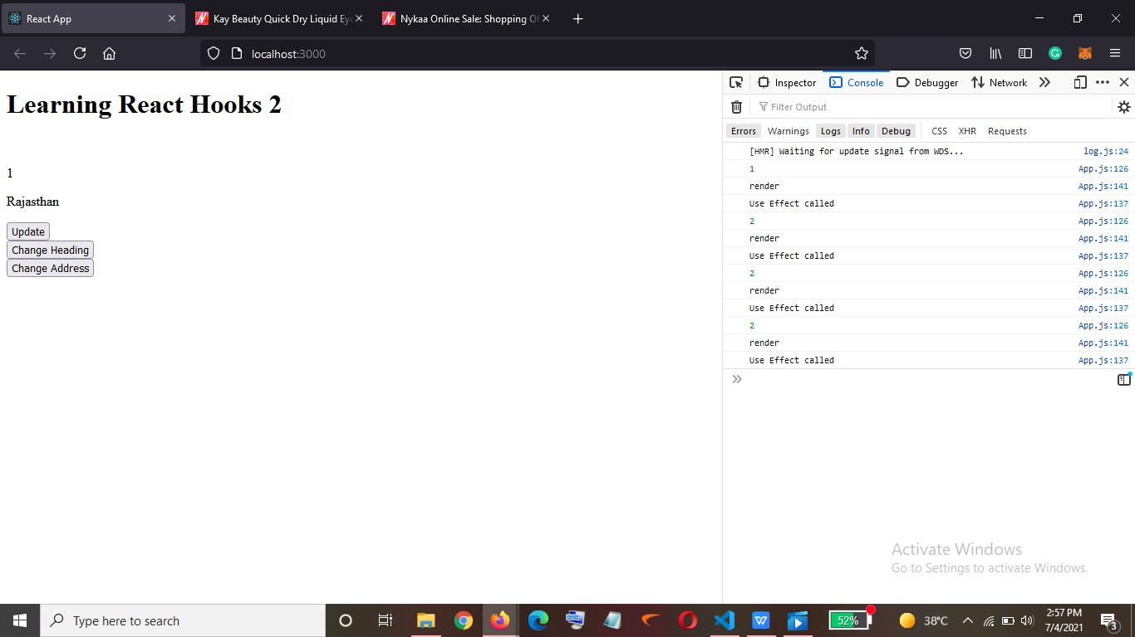

What if I want the useEffect to get called only when my count state is been updated->

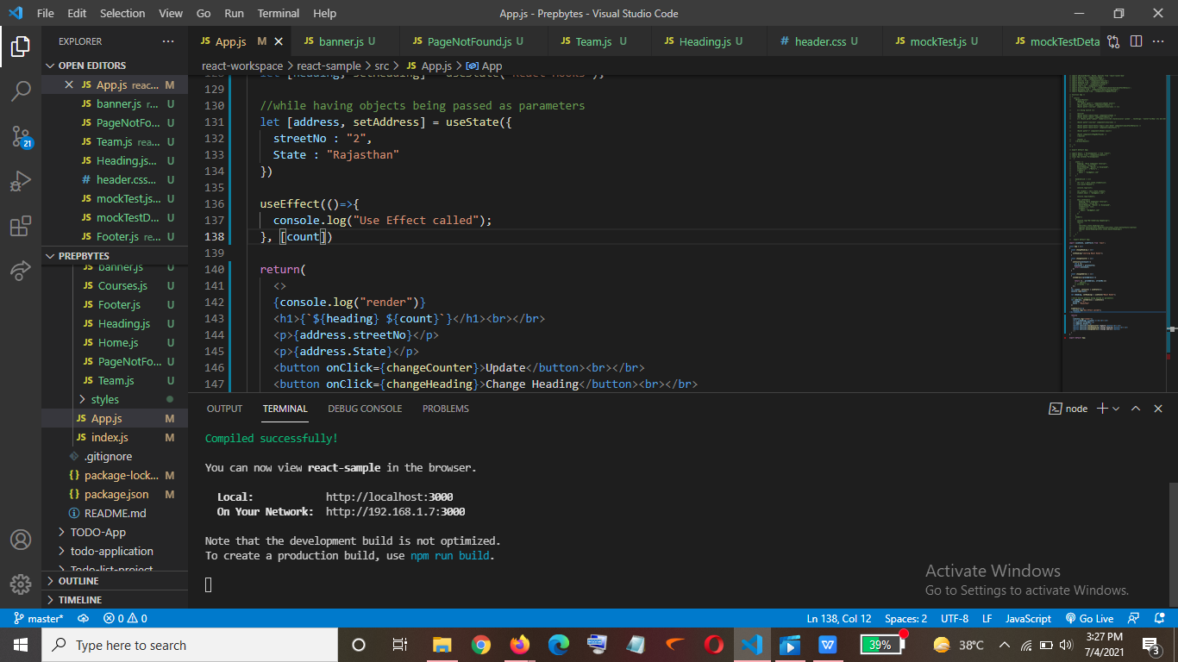

Output->

The method was only called when I clicked update button and not on Change Heading button

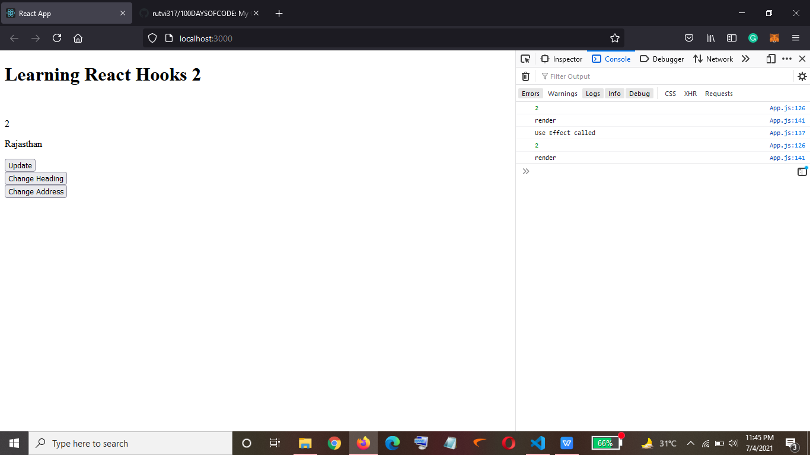

What if I want to call the method in case both state ->

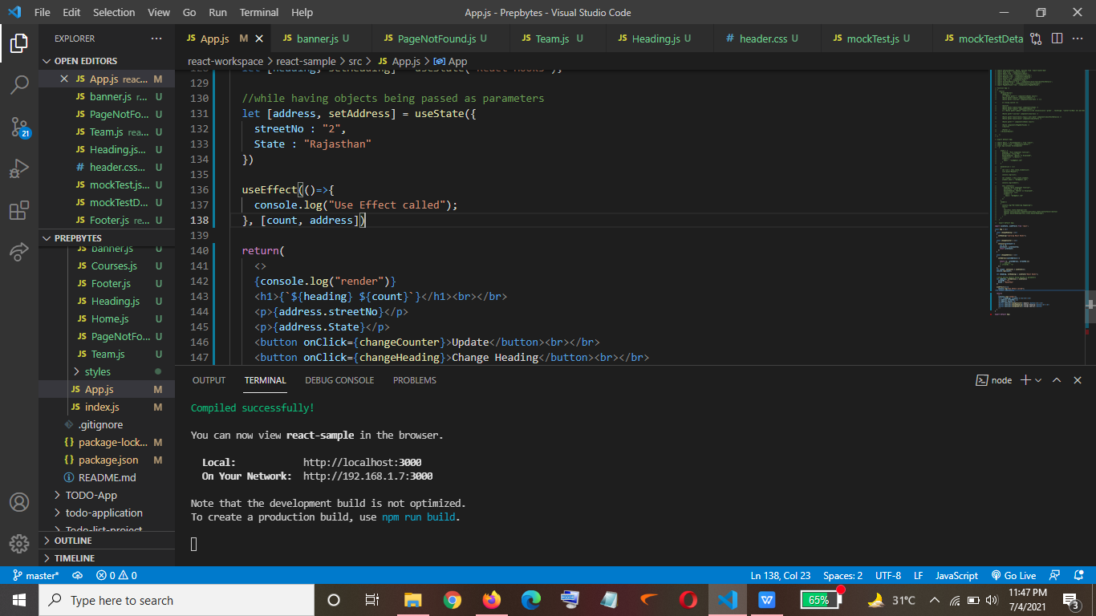

Output->

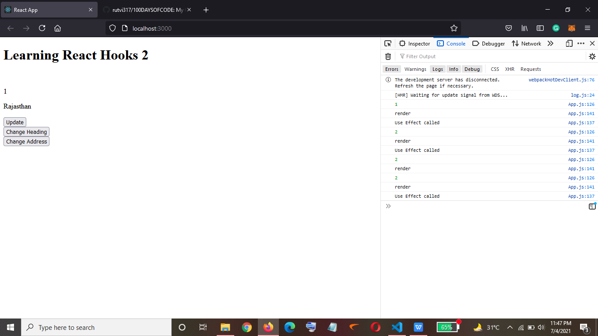

Now If I want that it should be only called once when the page gets loaded then we pass an empty array->

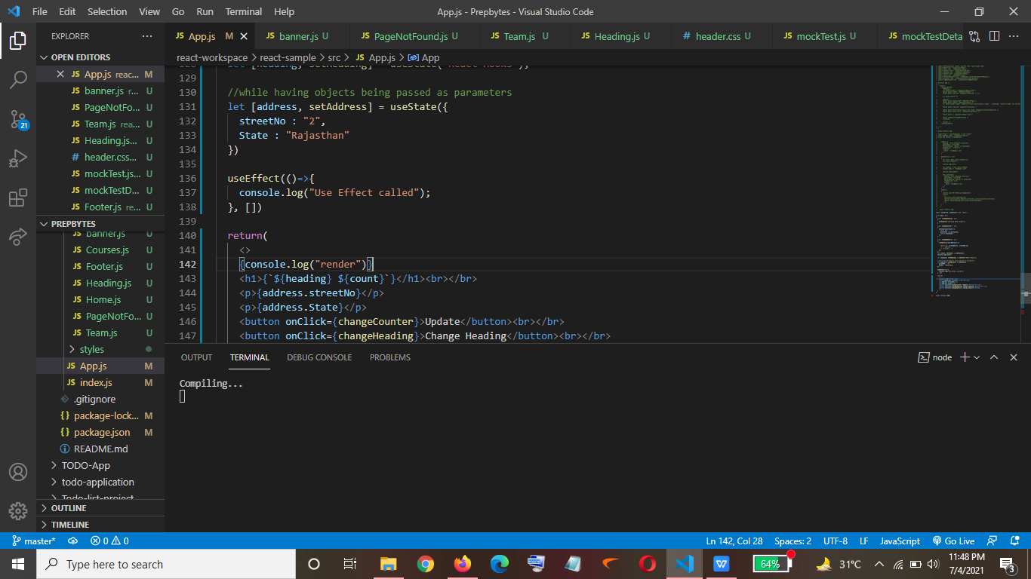

Output-> So now only the render method will be called.

