Weekly Report

Work done in last week ( Attach supporting Documents):

- Learn basics of HTML and CSS.
- Use of CSS.
- Why we learn web development?
- What’s makes CSS best?
- Survey on HTML and CSS?

Reason for incomplete work:

- Not efficient knowledge for create the website.
- Find the best resources and survey on it.
- Make planning for web design and its functionality.

Plans for next week:

- Starting to create a web site.
- And also learn some useful topic related to it.

References:
https://youtu.be/vpAJ0s5S2t0
https://youtu.be/GeykycZ4Ixs

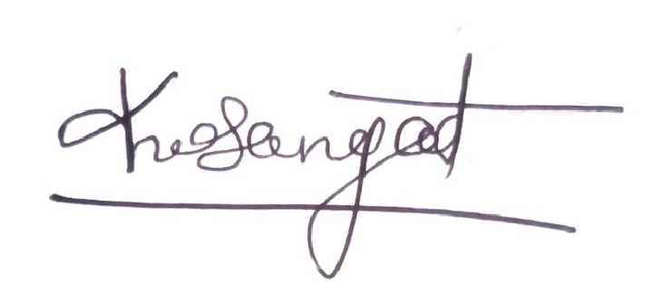

Signature of External Guide Signature of Internal Guide

