Weekly Report

Work done in last week ( Attach supporting Documents):

1. Create about and contact us page in website.
2. Research about design.
3. Collection of information about traveling placed.
4. Learn about JavaScript.
5. Add form validation in contact us page.

Reason for incomplete work:

1. Not proper design about home page
2. Not idea that which type of functionality should add.

Plans for next week:

- Create home page in website using bootstrap.
- Will Create Services page add functionality.
2. Collect information about tour and traveling.
3. Submit all work to our company.

References:
https://youtu.be/vpAJ0s5S2t0
https://youtu.be/GeykycZ4Ixs

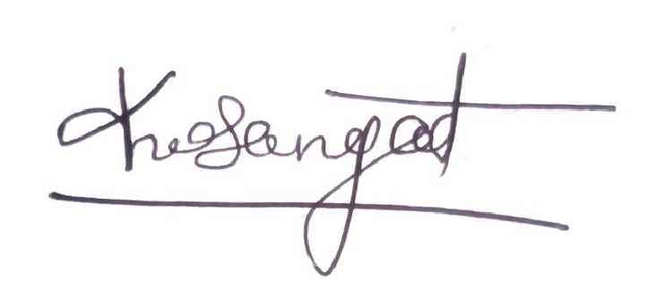

Signature of External Guide Signature of Internal Guide

