**Date:19/07/2021**

**Certificate of Completion**

Dear **Mr. Rutvik Balar**

This letter serves to certify that **Mr. Rutvik Balar**, a **B.Tech IT** in **Charusat University**, has successfully completed 4th semester internship at our company**, Raven Technolabs**, held last 1st June 2021 to 07th July 2021.

Our company's internship program includes Fourth Semester Internship Program which he had the privilege to experience He showed enthusiasm in learning and involved himself in every task required or assigned to him during his internship under **the Website Design & Development**. only heard good and positive feedbacks from **Mr. Kushang Joshi**  who is his immediate supervisor during the internship program.

I have enclosed in this letter the official certificate of **Mr. Rutvik Balar**  regarding his successful completion of our internship program. We at **Raven Technolabs** wish him the best and success in his life and career.

Yours sincerely,

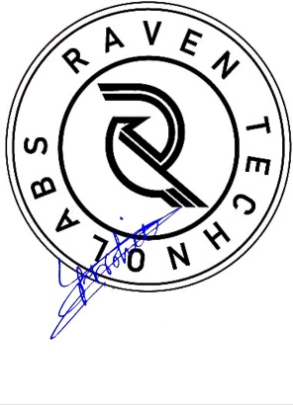

**Mr. Vivek Purohit**

**CEO**