# Weekly Report

**Work done in last week ( Attach supporting Documents):**

1. Learn basics of HTML and CSS.
2. Use of CSS.
3. Why we learn web development?
4. What’s makes CSS best?
5. Survey on HTML and CSS?

**Reason for incomplete work:**

1. Not efficient knowledge for create the website.
2. Find the best resources and survey on it.
3. Make planning for web design and its functionality.

**Plans for next week:**

1. Starting to create a web site.
2. And also learn some useful topic related to it.

## References:

<https://youtu.be/vpAJ0s5S2t0>

<https://youtu.be/GeykycZ4Ixs>

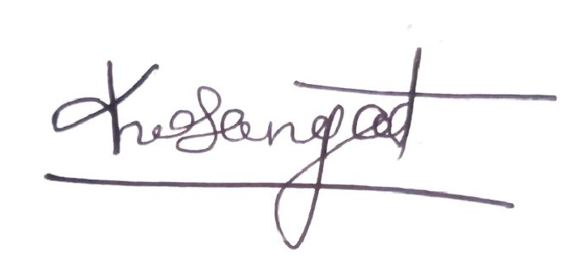

## Signature of External Guide Signature of Internal Guide

# Weekly Report

**Work done in last week ( Attach supporting Documents):**

1. Create one simple page and started work on it.
2. Create the slider design and research slider related to this project.
3. Also, research what’s more functionality use.
4. Learn basics of bootstrap.

**Reason for incomplete work:**

1. Research to add new functionality.
2. Not efficient knowledge for create the website using bootstrap.

**Plans for next week:**

1. Research about type to product like makeup.
2. Complete Home and product page.
3. Learn JavaScript.

## References:

<https://youtu.be/vpAJ0s5S2t0>

<https://youtu.be/GeykycZ4Ixs>



## Signature of External Guide Signature of Internal Guide

# Weekly Report

**Work done in last week ( Attach supporting Documents):**

1. Create home page in website using bootstrap.
2. Create Services page add functionality.
3. Add JavaScript.
4. Add website in GitHub.

3. Submit all work to our company.

**Reason for incomplete work:**

1. Not clear information about second project.

**Plans for next week:**

1. Create new website related traveling.

2. Research about design.

3. Collection of information about traveling placed.

## References:

<https://youtu.be/vpAJ0s5S2t0>

<https://youtu.be/GeykycZ4Ixs>



## Signature of External Guide Signature of Internal Guide

# Weekly Report

**Work done in last week ( Attach supporting Documents):**

1. Create about and contact us page in website.

2. Research about design.

3. Collection of information about traveling placed.

4. Learn about JavaScript.

5. Add form validation in contact us page.

**Reason for incomplete work:**

1. Not proper design about home page

2. Not idea that which type of functionality should add.

**Plans for next week:**

1. Create home page in website using bootstrap.
2. Will Create Services page add functionality.

2. Collect information about tour and traveling.

3. Submit all work to our company.

## References:

<https://youtu.be/vpAJ0s5S2t0>

<https://youtu.be/GeykycZ4Ixs>



## Signature of External Guide Signature of Internal Guide

# Weekly Report

**Work done in last week ( Attach supporting Documents):**

1. Create home page in website using bootstrap.
2. Create Services page add functionality.

2. Add website in GitHub.

3. Submit all work to our company.

**Reason for incomplete work:**

1.

2.

3.

**Plans for next week:**

1.

2.

3.

## References:

<https://youtu.be/vpAJ0s5S2t0>

<https://youtu.be/GeykycZ4Ixs>



## Signature of External Guide Signature of Internal Guide

**Date:19/07/2021**

**Certificate of Completion**

Dear **Mr. Rutvik Balar**

This letter serves to certify that **Mr. Rutvik Balar**, a **B.Tech IT** in **Charusat University**, has successfully completed 4th semester internship at our company**, Raven Technolabs**, held last 1st June 2021 to 07th July 2021.

Our company's internship program includes Fourth Semester Internship Program which he had the privilege to experience He showed enthusiasm in learning and involved himself in every task required or assigned to him during his internship under **the Website Design & Development**. only heard good and positive feedbacks from **Mr. Kushang Joshi**  who is his immediate supervisor during the internship program.

I have enclosed in this letter the official certificate of **Mr. Rutvik Balar**  regarding his successful completion of our internship program. We at **Raven Technolabs** wish him the best and success in his life and career.

Yours sincerely,

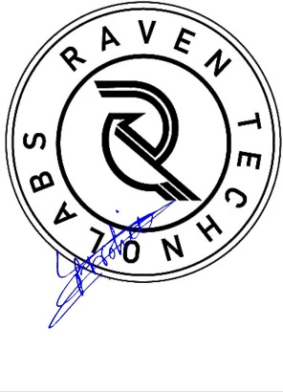

**Mr. Vivek Purohit**

**CEO**