- Part 1 Introduction to asp net web services - YouTube,(4)
- Part 2 Consuming a web service - YouTube

- CREATE-> NEW-> ASP.NET(.NET FRAMEWORK)->EMPTY WEBSITE
- Steps Of Web Service:-ADD NEW ITEM->WEB SERVICES
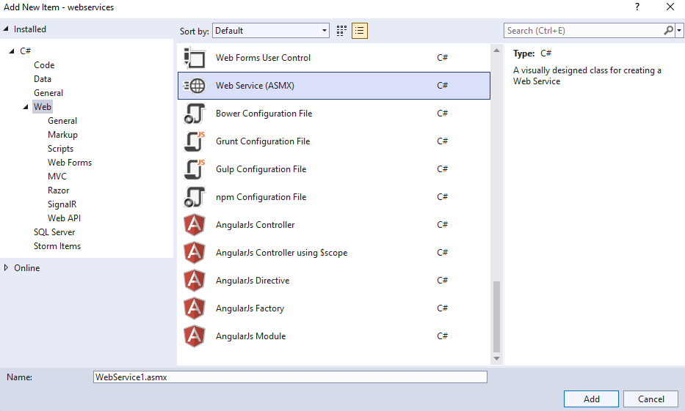
3.CLICK ON ADD
[WebService(Namespace = "add the project name of your project")]
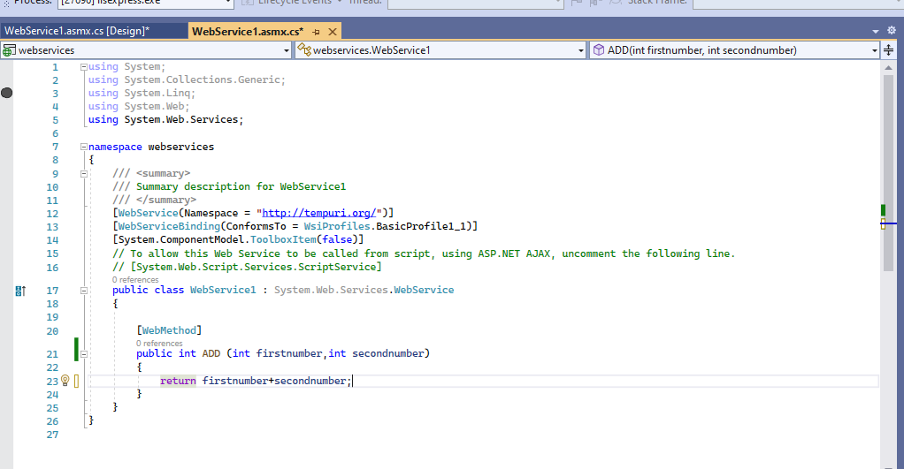
Step4: add code method for addition of 2 number

[WebMethod]
public int ADD (int firstnumber,int secondnumber)
{
return firstnumber+secondnumber;
}
Step5:execute the webservices

Step 6: right click on project-> add-> new item-> web form
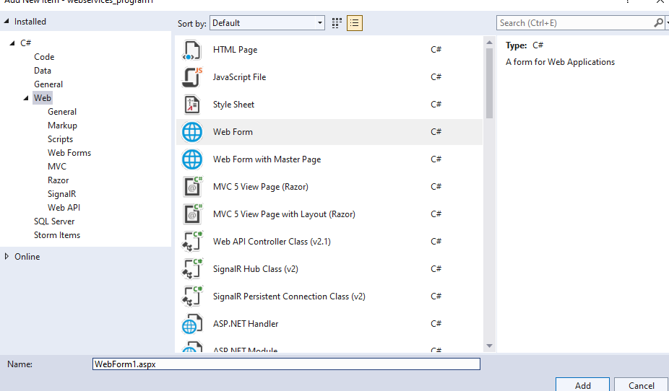
Click on add button
Step 8:in the web form
Take 2 textbox to take input from user for first number and second number
One label to display the result
Ont button control

Design code:
<%@ Page Language="C#" AutoEventWireup="true" CodeBehind="WebForm1.aspx.cs" Inherits="webservices_program1.WebForm1" %>

<!DOCTYPE html>

<html xmlns="http://www.w3.org/1999/xhtml">
<head runat="server">
<title></title>
</head>
<body>
<form id="form1" runat="server">
<div>
<asp:Label ID="Label2" runat="server" Text="enter first number"></asp:Label>
<asp:TextBox ID="TextBox1" runat="server" style="margin-bottom: 0px"></asp:TextBox>
<br />
<asp:Label ID="Label3" runat="server" Text="enter second number"></asp:Label>
<asp:TextBox ID="TextBox2" runat="server"></asp:TextBox>
<br />
<asp:Label ID="Label1" runat="server" Text=""></asp:Label>
<asp:Button ID="Button1" runat="server" OnClick="Button1_Click" Text="Addition" />
</div>
</form>
</body>
</html>

Step 7:right click on project->add-> service reference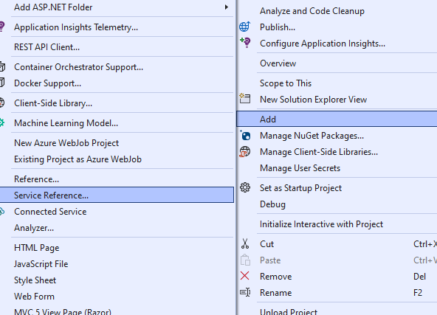
step 8:click on discover dropdown-> select servicesin solution
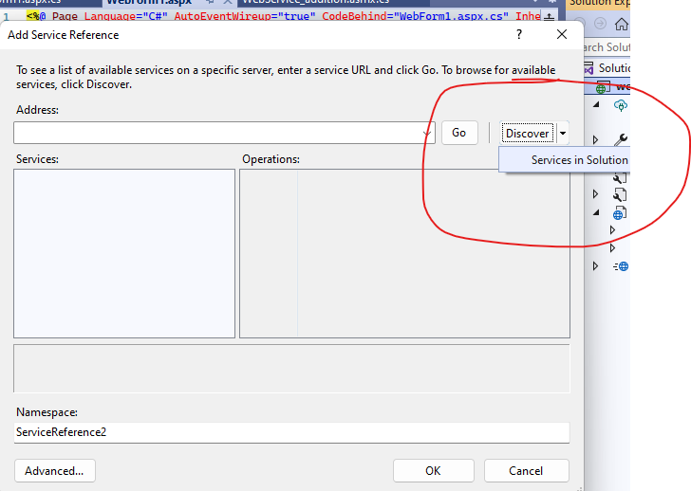
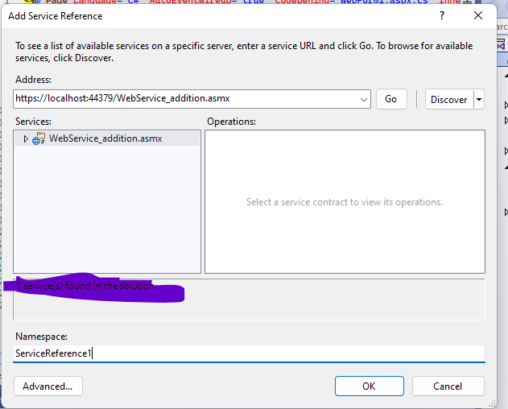
Click on ok

In solution references
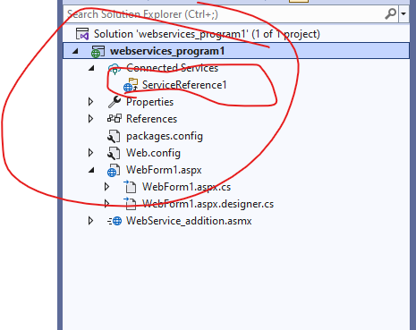
Service references1 is created

Now we will use this service in webform1
Step 9:go to webform1.aspx.cs

button_onclick()
Add the below code
protected void Button1_Click(object sender, EventArgs e)
{
WebService1 client = new WebService1();

int result = client.ADD(Convert.ToInt32(TextBox1.Text), Convert.ToInt32(TextBox2.Text));
Label1.Text = result.ToString();

}

- Name of webservice is WebServicce_addition the object we have is client for webservice_addition
- We are calling add method of webservice_addition
Right click on webform1.aspx-> set as start page-> run the code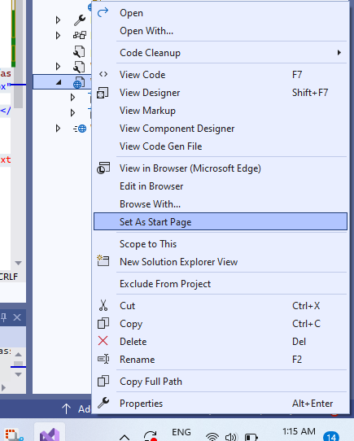
Webform1.aspx.cs
using System;
using System.Collections.Generic;
using System.Linq;
using System.Web;
using System.Web.UI;
using System.Web.UI.WebControls;

namespace webservices_program1
{
public partial class WebForm1 : System.Web.UI.Page
{
protected void Page_Load(object sender, EventArgs e)
{

}

protected void Button1_Click(object sender, EventArgs e)
{
webservices_program1.WebService_addition client
=new webservices_program1.WebService_addition();
int result=client.add(Convert.ToInt32(TextBox1.Text),Convert.ToInt32(TextBox2.Text));
Label1.Text = result.ToString();

}
}
}

-> you can also use webservices in another project->
Create a new project ->add service references-> add new webform->
Uses the services in new form

namespace webservices_call
{
public partial class WebForm1 : System.Web.UI.Page
{
protected void Page_Load(object sender, EventArgs e)
{
localhost.WebService1 obj = new localhost.WebService1();
Response.Write(obj.add(10, 20));
}
}
}

