STEP 1:OPEN VISUAL STUDIO -> CREATE NEW PROJECT-> CHOOSE ASP.NET WEB APPLICATION(.NET fRAMEWORK)
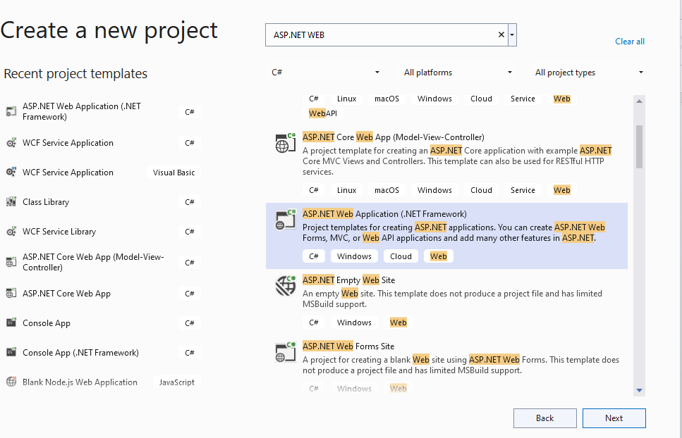
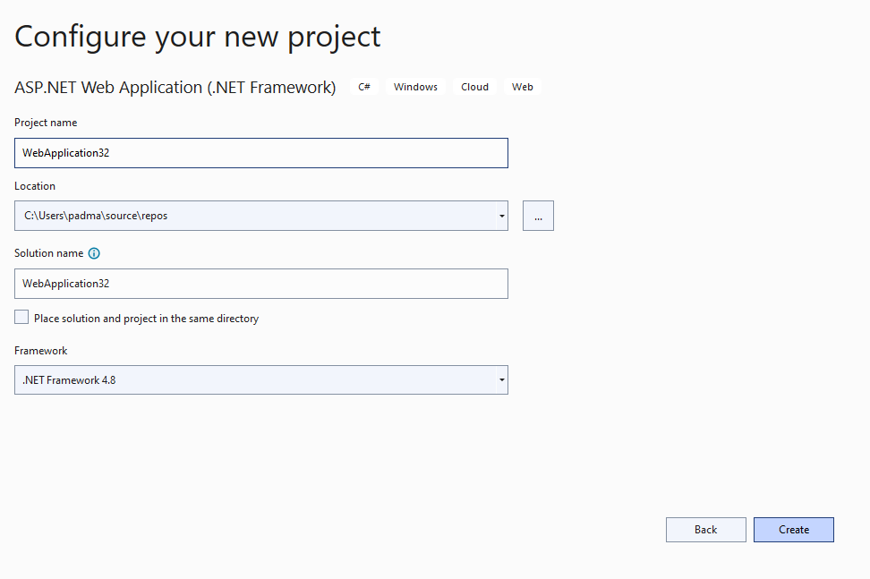CLICK ON CREATE BUTTON-> CHOOSE MVC
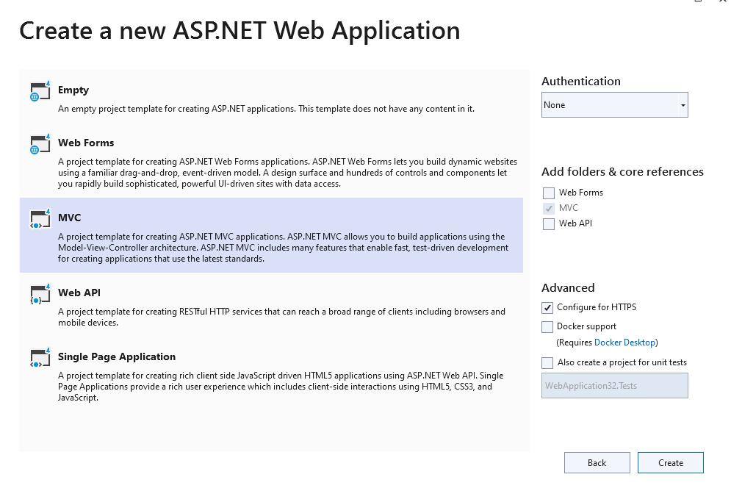CLICK ON CREATE BUTTON
STEP 2: GO TO -> VIEW-> SERVER EXPLORER OBJECT EXPLORER
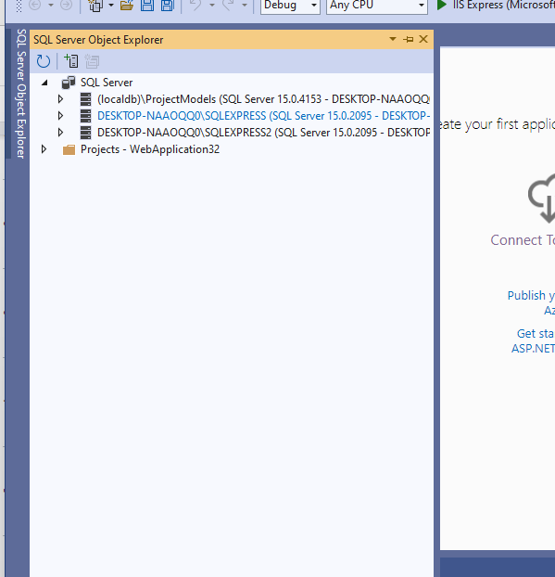
EXPAND THE LOCALDB->GO TO DATABASE FOLDER-> ADD NEW DATABASE
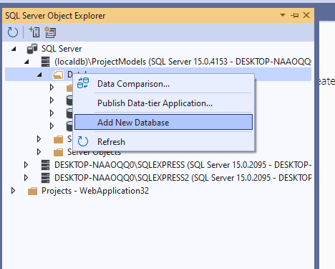
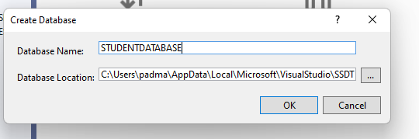
CLICK ON BUTTON
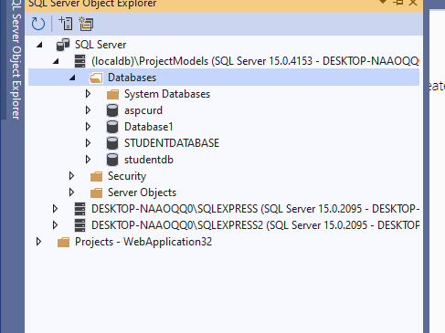
EXPAND THE STUDENTDATABASE->GO TO TABLE FOLDER->RIGHT CLICK ON TABLE FOLDER-> ADD NEW TABLE

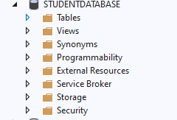
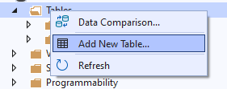
SELECT THE ->ID -> MAKE IT PRIMARY KEY->RIGHT CLICK->PROPERTIES
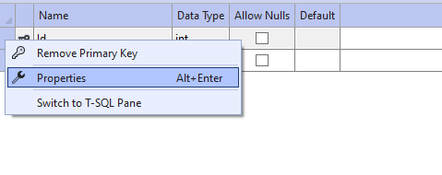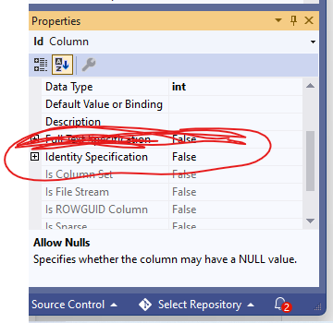
EXPAND THE IDENTITY SPECIFICATION BY CLICKING ON +
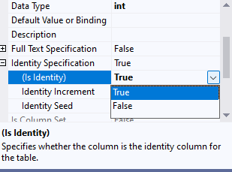
MAKE THE IS IDENTITY -> TRUE
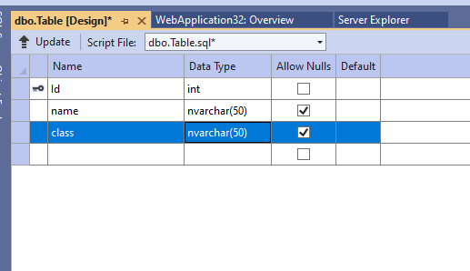
CREATE TABLE student_data
(
[Id] INT NOT NULL IDENTITY,
[name] NVARCHAR(50) NULL,
[class] NVARCHAR(50) NULL,
CONSTRAINT [PK_Table] PRIMARY KEY ([Id])
)
Click on update
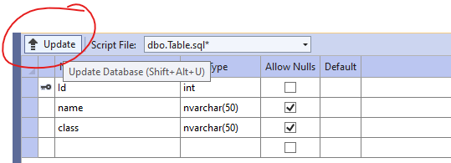
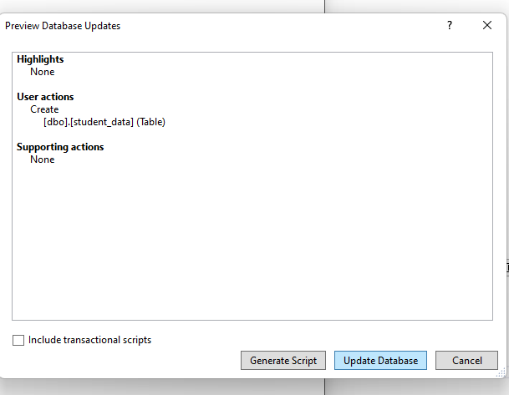
Click on update database
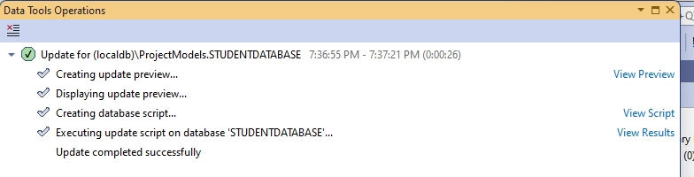
Go to server explorer-> Tables->right click -> click on refresh
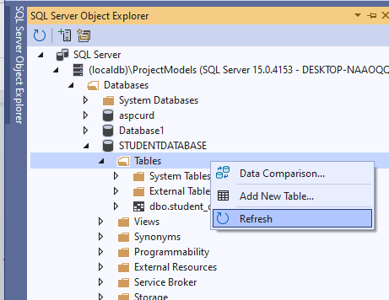
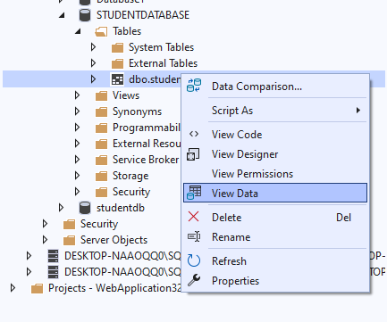
right click on student_data->view Data-
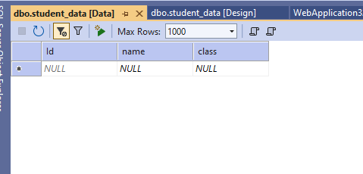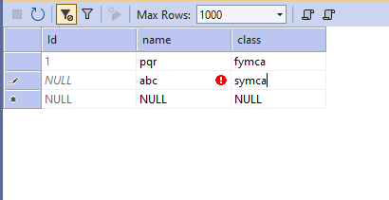
Click on enter
Step 3: go to solution explorer->right click on project-> add new item->

Once you click on the OK button, it will take some time to create the project for us.

Adding ADO.NET Entity Data Model
Right-click on Models folder then select Add => New Item from the context menu that will open the Add New Item window. Select the Data tab from the left panel and then choose ADO.NET Entity Data Model from the middle panel. Provide a meaningful name for your data model and click on the Add button as shown in the below image.
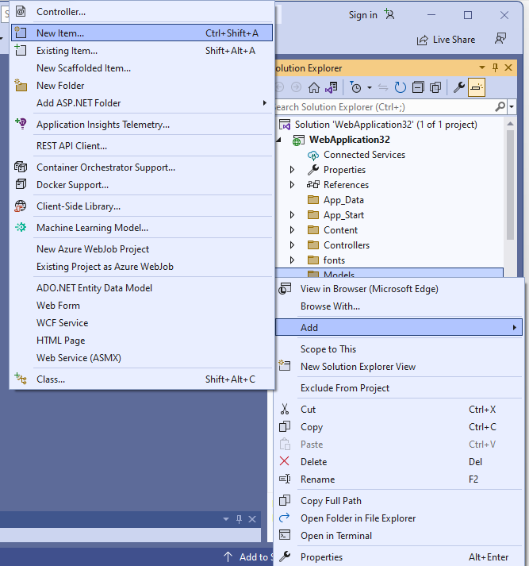
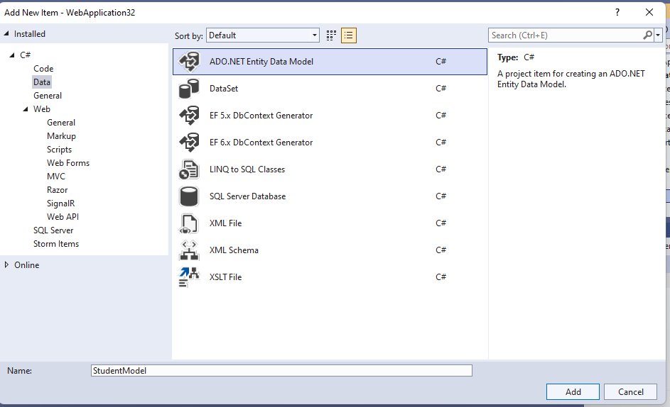
Click on Add button
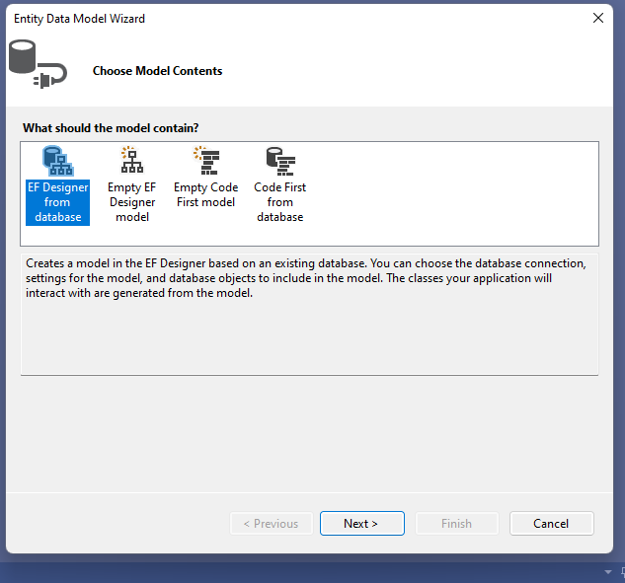
Click on Next button
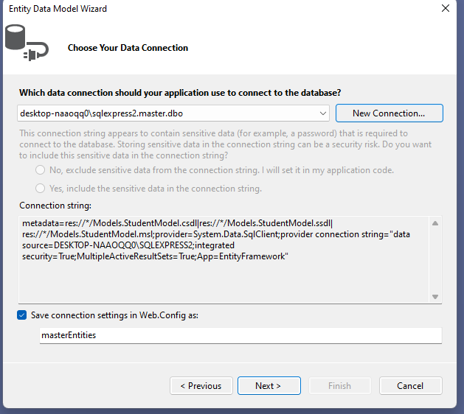click on New Connection Button
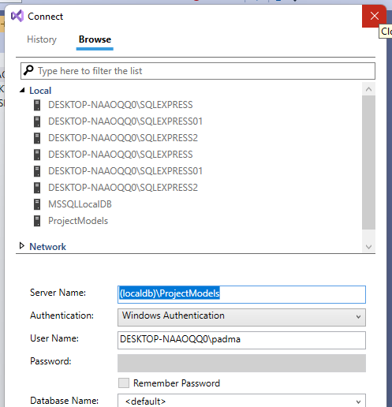

copy the server name
Right on model folder -> add new item->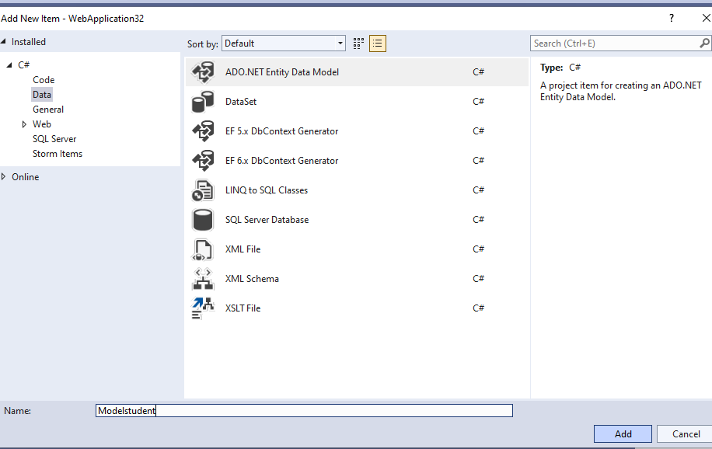
Click on add button
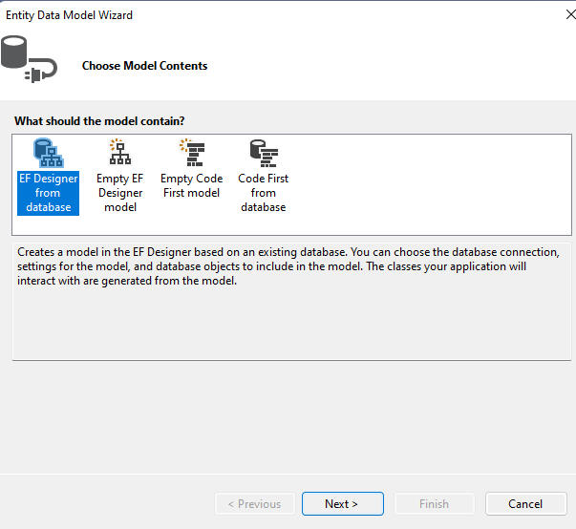
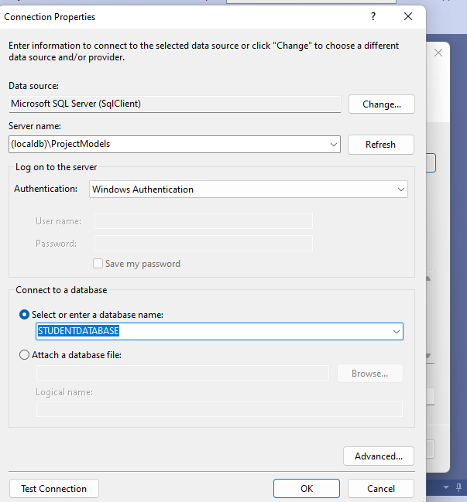
Click Test Connection -> Click on Ok
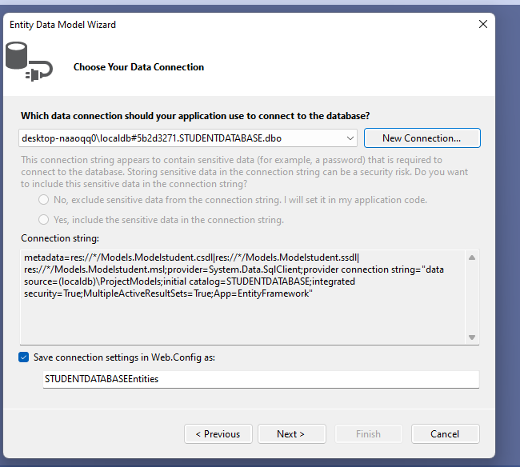
Click on Next->
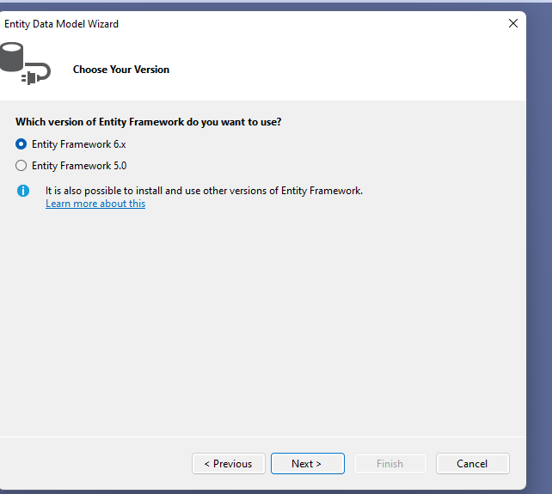
Select the Entity FrameWork 6.x
Click on Next
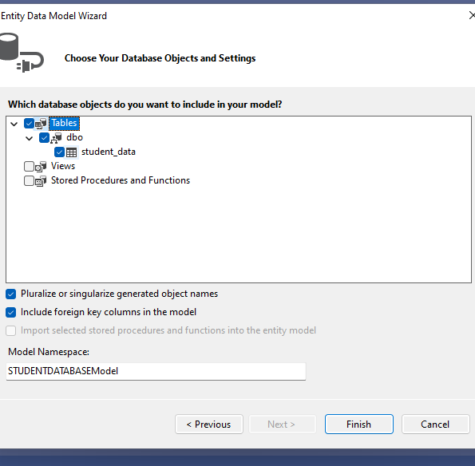
Select the table-> select the dbo->select the student_data-> click on FInish Button

Selecting The Entity Framework Approach to interact with the database.
Once you click on the Add button it will ask you to choose the entity framework approach. Here, we are going to use the database first approach as we already created the required database tables. So, from the Entity Data Model Wizard, select “Generate from database” option and click “Next” as shown below.

Creating Database Connection:
On “Choose your data connection screen” and click on the “New Connection” button which will open the connection properties window. Here, we are going to interact with the SQL Server database. So, from the Data Source select Microsoft SQL Server (SqlClient). Provide your SQL Server name. Choose the Authentication type. Here, I am choosing Windows Authentication. Then select the database to which you are going to interact from the select or enter a database name drop-down list. Finally, click on the “OK” as shown below.
Then provide a meaningful connection string name such as “EmployeeDBContext” and click on the “Next” button as shown below.

Choose Entity Framework Version:
Here, we are going to use Entity Framework 6. So, from the Choose Your Version screen, choose the Entity framework 6.x and click on the Next button as shown below.

Selecting Database Objects and Settings:
On “Choose your database objects and Settings” screen, expand the “Tables” and then. Set Model Namespace as Models and click on the “Finish” button as shown in the below image.

Step 5: r

Creating MVC 5 Controller:
Right-click on the “Controllers” folder and select Add – Controller from the context menu. Then select MVC 5 Controller with views, using Entity Framework and click on the Add button as shown in the below image.
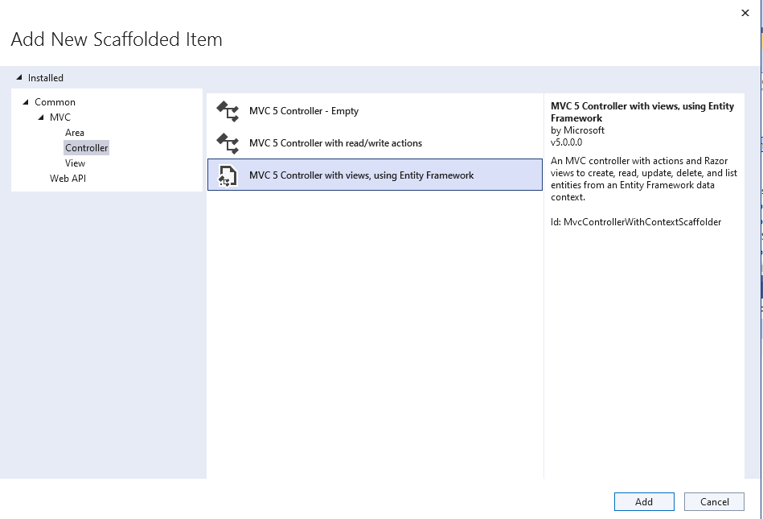
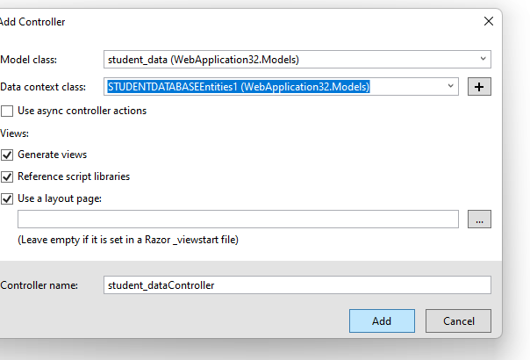
On the next screen set the below details
- Model class =
- Data Context Class =
- Controller Name =
- Rest values are as it is and click on the Add button as shown in the below image
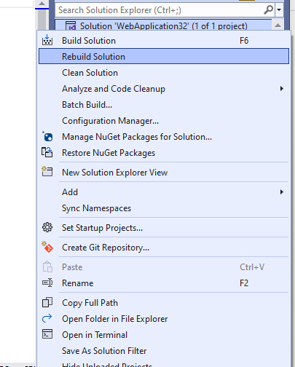

Step 6: go to solution explorer->App_start->routeConfig.cs
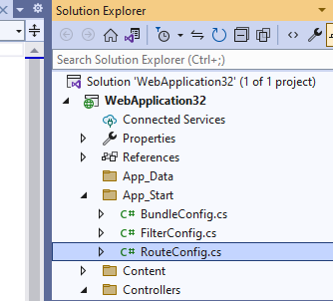
Open the RouteConfig.cs
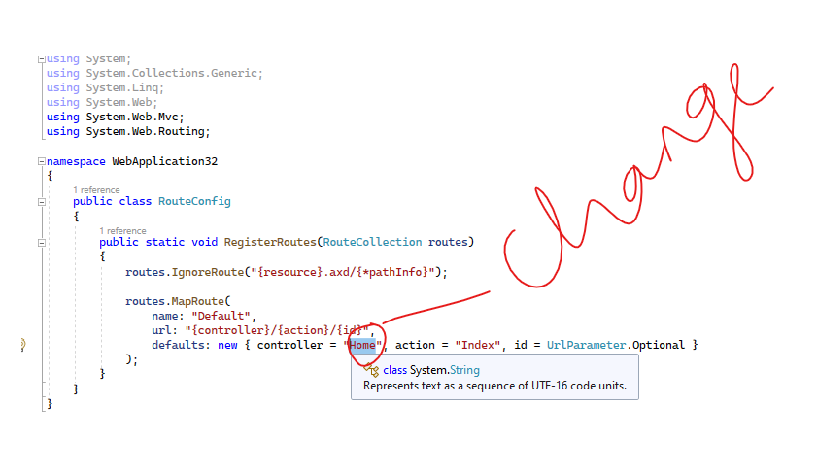
Replace the controller value as student_data
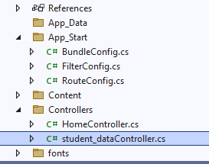
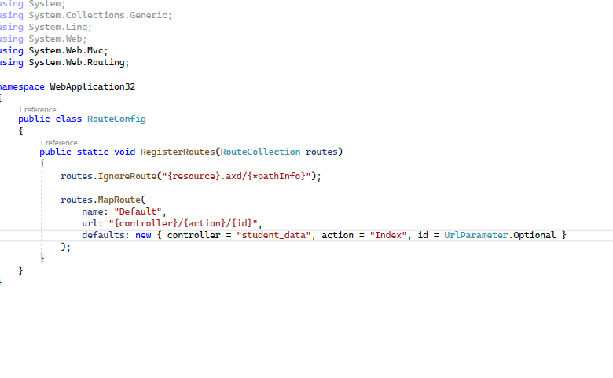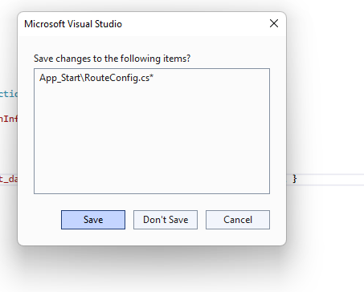
save the routeconfig.cs
Right click solution explorer and rebuild
Step 7:
At this point, we should have the following files automaticallystudent_dataController.cs file in “Controllers” folder. Index, Create, Edit, Detail and Delete views in the “student_data” folder which is inside the Views folder.
Run the application again. Notice that all the student_data are listed on the index view. We can also create a new student, edit an student, view their full details and delete an student as well.

