ASSIGNMENT

# **Q-1** Are the HTML tags and elements the same thing?

**A** Tags - HTML tags are used to hold the HTML element.

HTML tag starts with < and ends with />.

Element - HTML element hold the content.

Ex. - Start tag Element End tag

<h1> my name is rutvik <h1>

# **Q-2** What are tags and attributes in HTML?

**A** Tags - HTML tags are used to hold the HTML element.

HTML tag starts with < and ends with />.

Attributes – HTML attribute is what modifies an HTML element.

Attributes are always specified in the start tag.

Ex. - <td align=canter> my name is rutvik </td>

td is an HTML tag.

align is an HTML attribute.

my name is rutvik is an HTML element.

# **Q-3 What are void element in HTML.**

**A** A void element is an element in HTML that doesn’t have a

closing tag.

It is a start tag only and they cannot have any child elements.

Void elements can have attributes.

Ex. - <br>, <hr>, <input>, <link>, <img>

# **Q-4** What are HTML Entities?

**A** Some character are reserved in HTML.

Character entities are used to display reserved characters in

HTML.

A character entity looks like this:

&#169 – copyright symbol

# **Q-5 What are different types of lists in HTML.**

**A** There are 3 types of lists in HTML

* Unordered list
* Ordered list
* Description list

<ul> Define an unordered list

<ol> Define an ordered list

<li> Define a list item

<dl> Define a description list

<dt> Define a term in description list

<ul> Describes the term in a description list

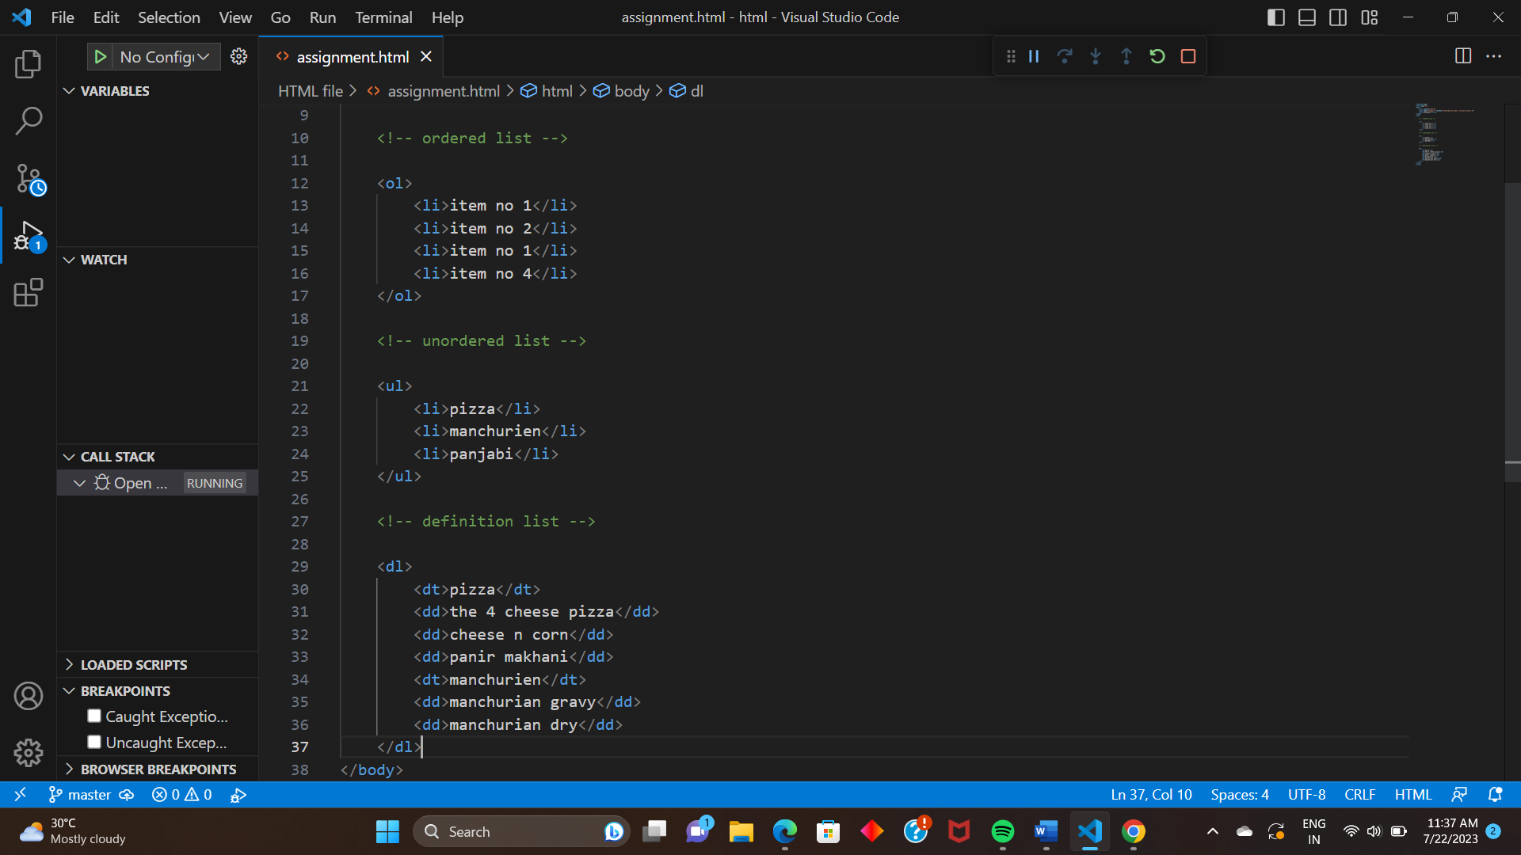

# **Q-6 What is the ‘class’ attribute in HTML?**

**A** The class attribute specifies one or more classnames for

An element. 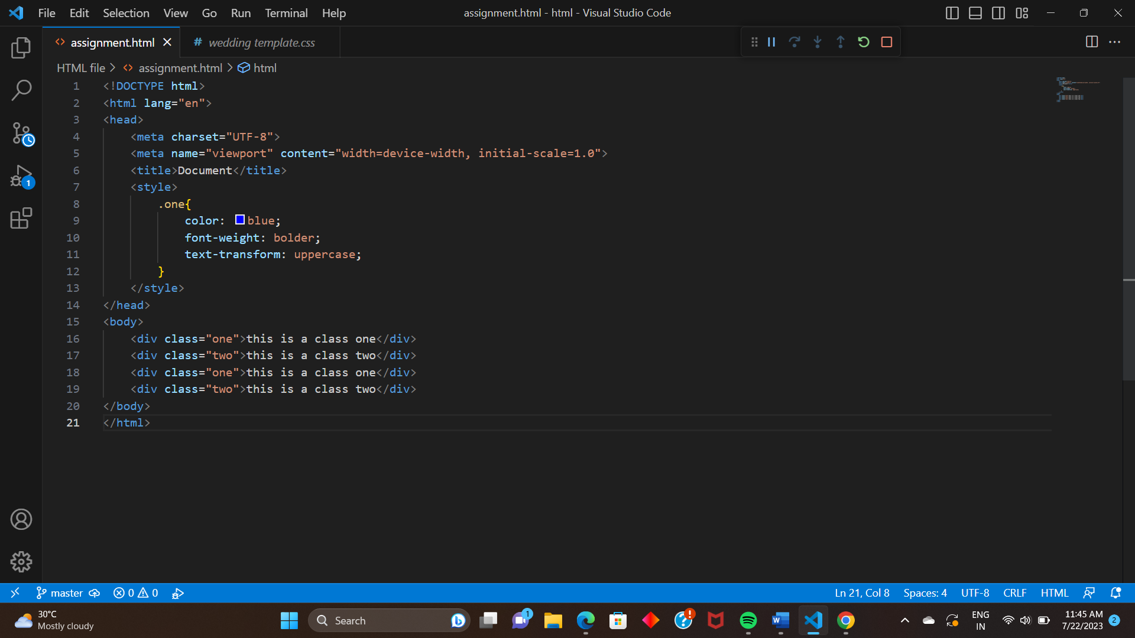

# **Q-7 What is the different between the ‘id’ attribute and the ‘class’**

# **attribute of HTML elements?**

**A** A class name can be used by multiple HTML elements.

An id name must only be used by one HTML element within

the page. 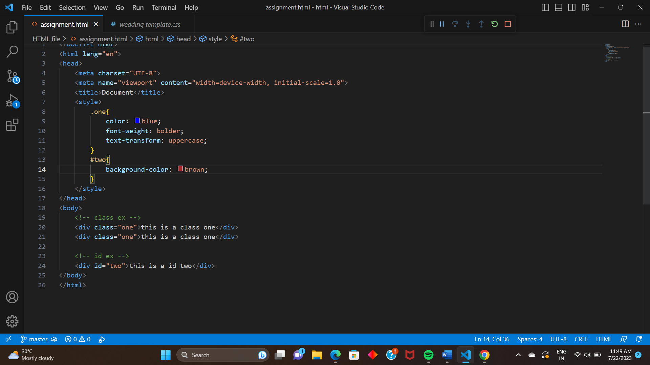

# **Q-8** What are the various formatting tags in HTML?

**A** Formatting elements were designed to display speciel types

of text.

* <b> bold text
* <strong> important text
* <i> italic text
* <sub> subscript text
* <sup> superscript text

# **Q-9 How is Cell Padding different from Cell Spacing?**

**A -** Space between cell wall and content is cell padding.

* Space between tow cell is cell spacing.
* 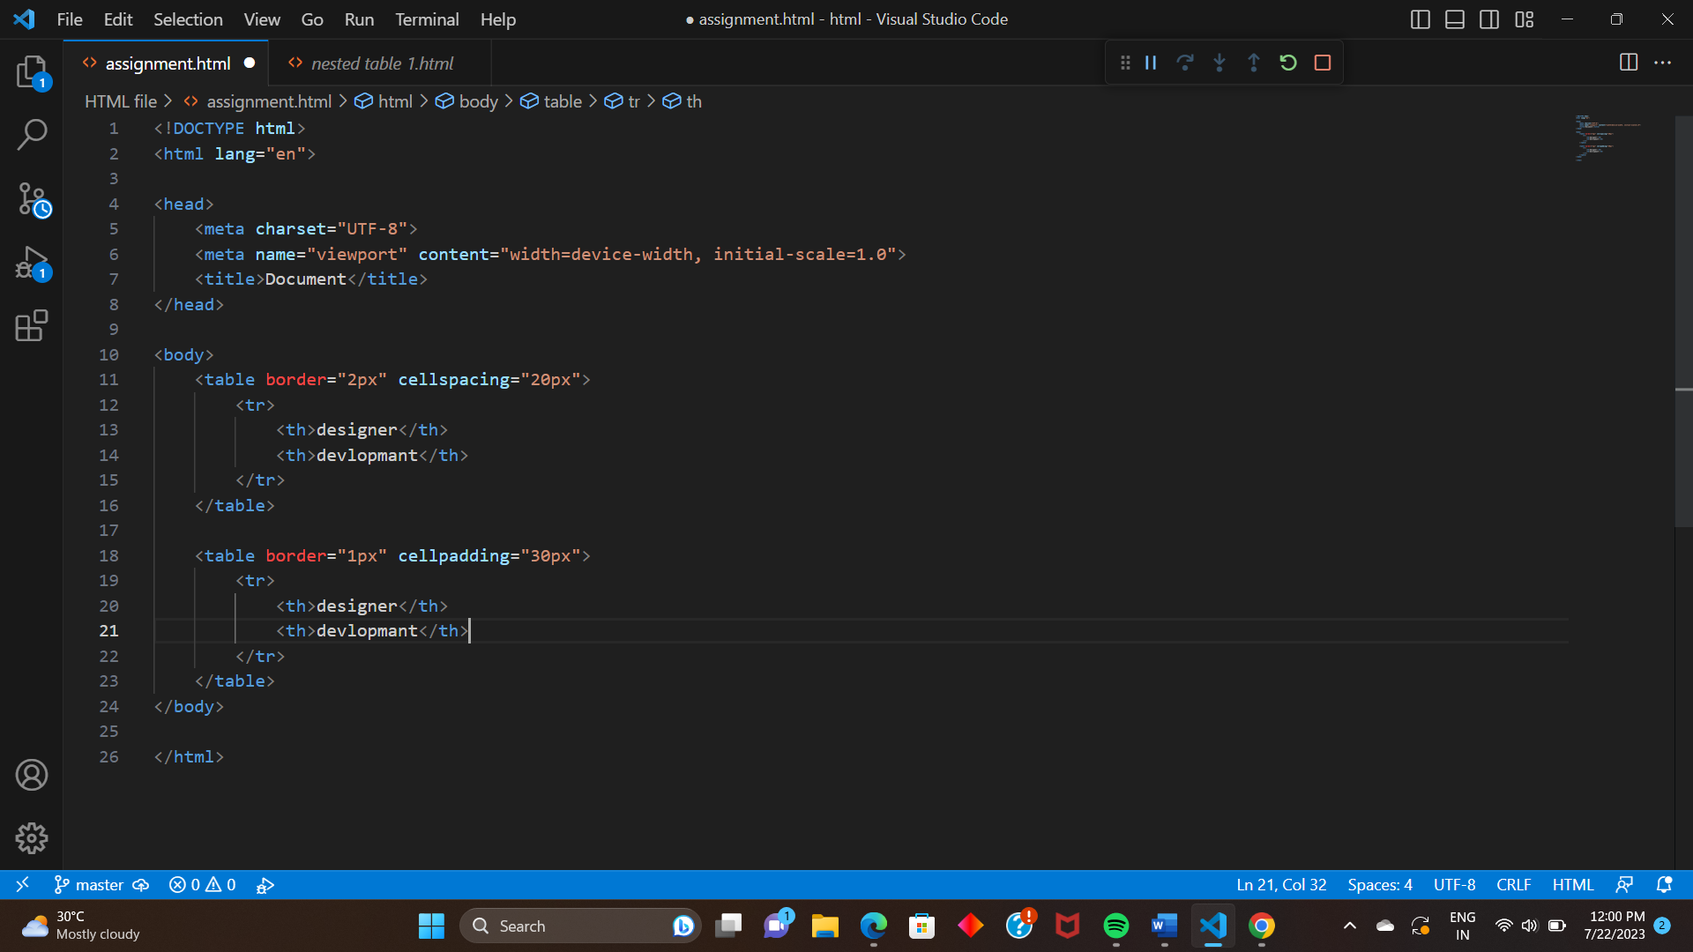

# **Q-10 How can we club two or more rows or columns into a single**

# **row and column in an HTML table?**

**A** Rowspan - The rowspan is used to merge the row cells

In a table.

Colspan – The colspan is used to merge column cells in a

table.

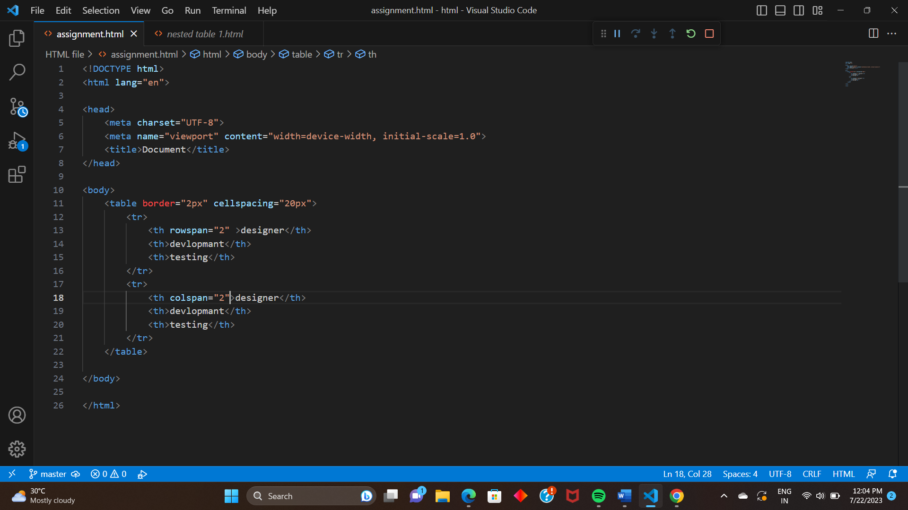

# **Q-11 What is a different between a block-level element and an**

# **inline element?**

**A** Block level element

* A block level element always takes up the full width.
* A block level element always starts on a new line.
* <p>, <div>

Inline element

* An inline element only takes up much width as content.
* An inline element does not starts on a new line.
* <a>, <b>, <map>, <img>
* 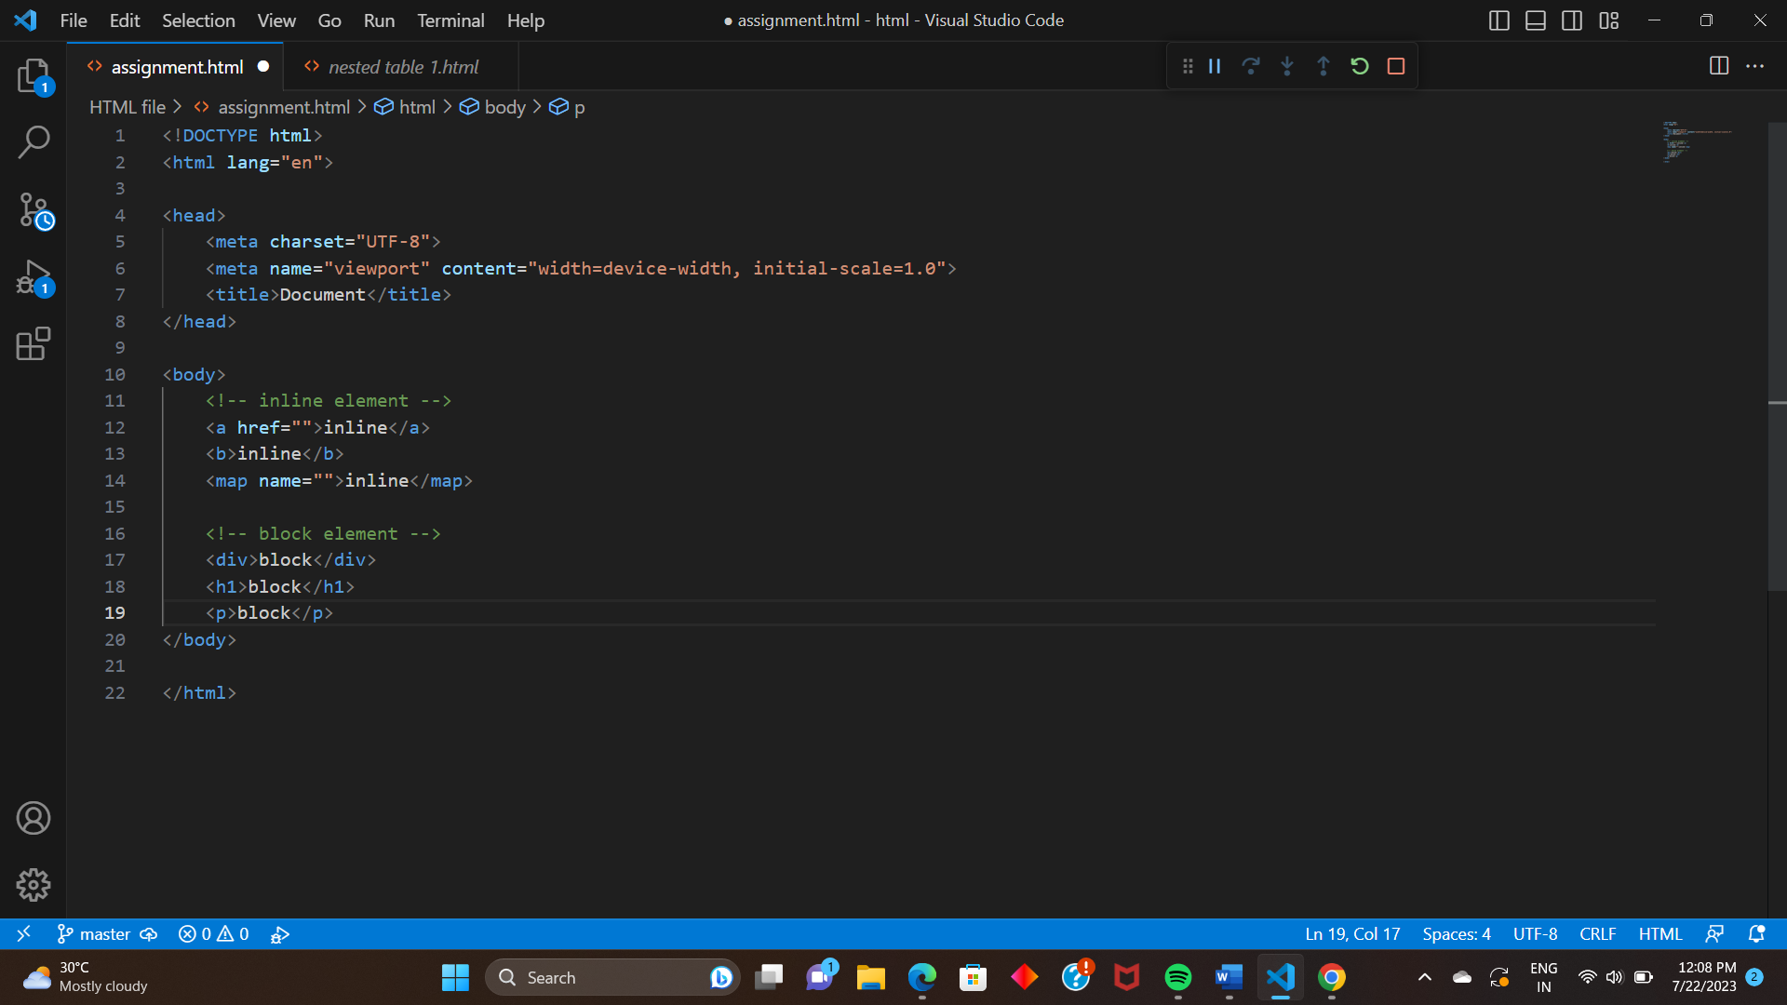

# **Q-12 How to create a Hyperlink in HTML?**

**A** Create a Hyperlink in HTML

* Use the <a> element to define a link.
* Use the href attribute to define the link address.
* Use the target attribute to define where to open the linked document.
* 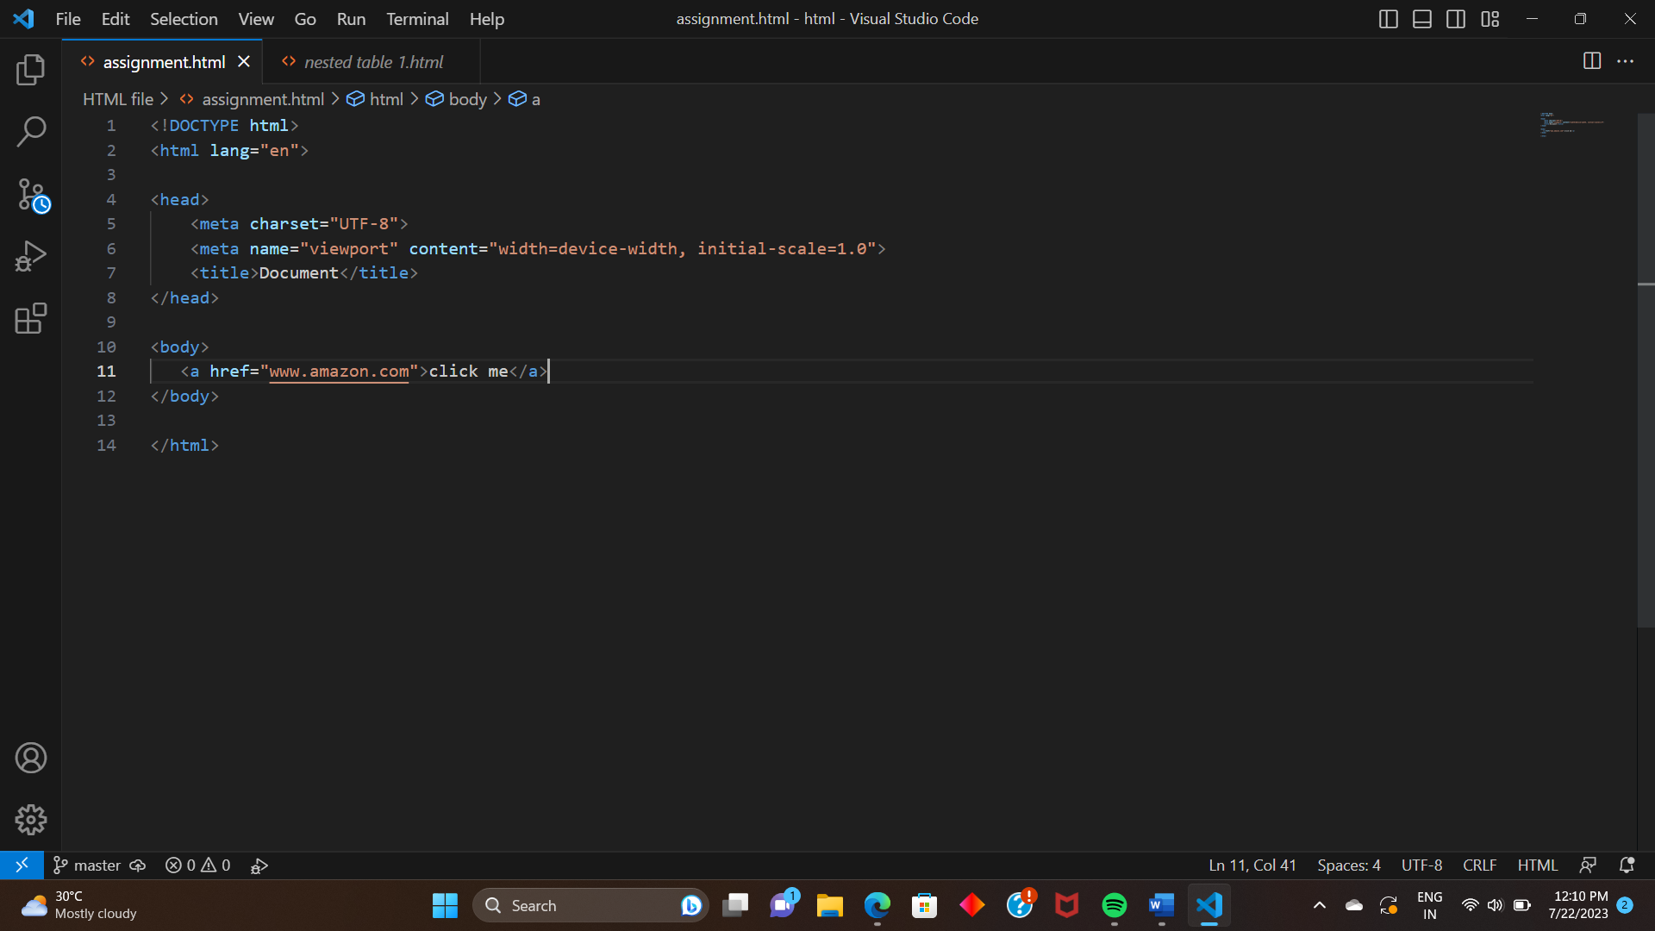

# **Q-13 What is the use of an iframe tag?**

**A** The <iframe>tag specifies an inline frame.

An inline frame is used to embed another document

Within the currebt HTML document. 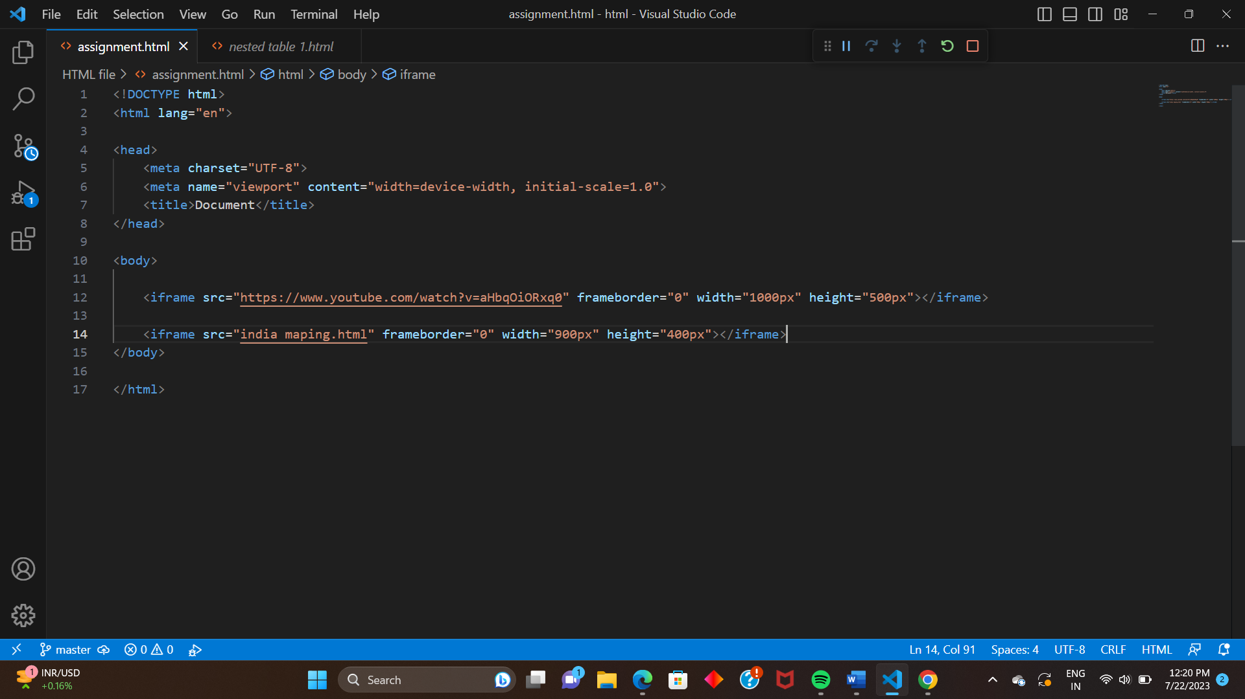

# **Q-14 What is the use of a span tag? Explain with example?**

**A** The <span> tag is much like the <div> element, but <div> is a

Block-level element and <span> is an inline element.

The <span> tag is an inline container used to mark up a part

of a text, or a part of a document.

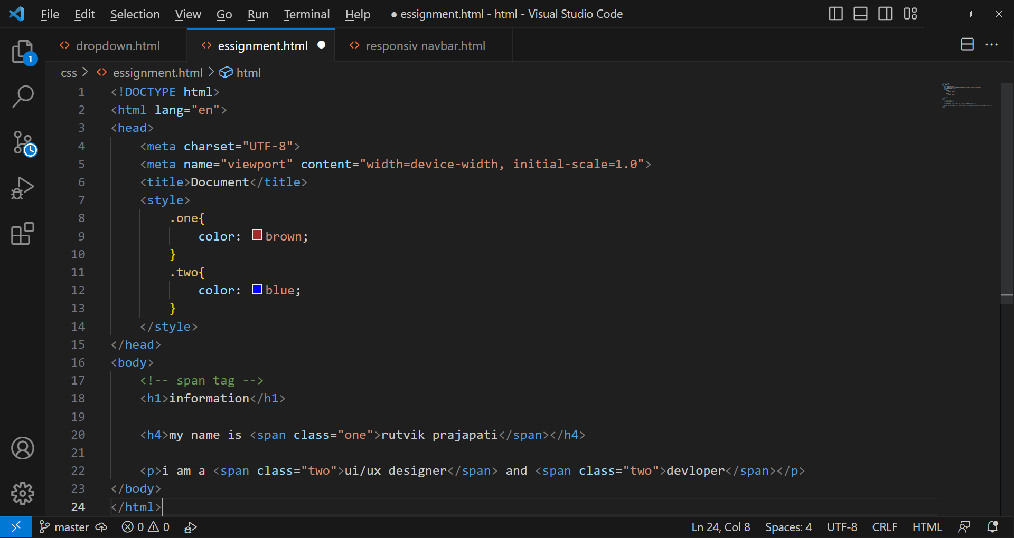

# **Q-15 How to insert a picture into a background image of a web**

# **Page? With example.**

**A** to insert a picture into the background of a web page use

background image attribute, You can use css to set the

background images and position it Accordingly.

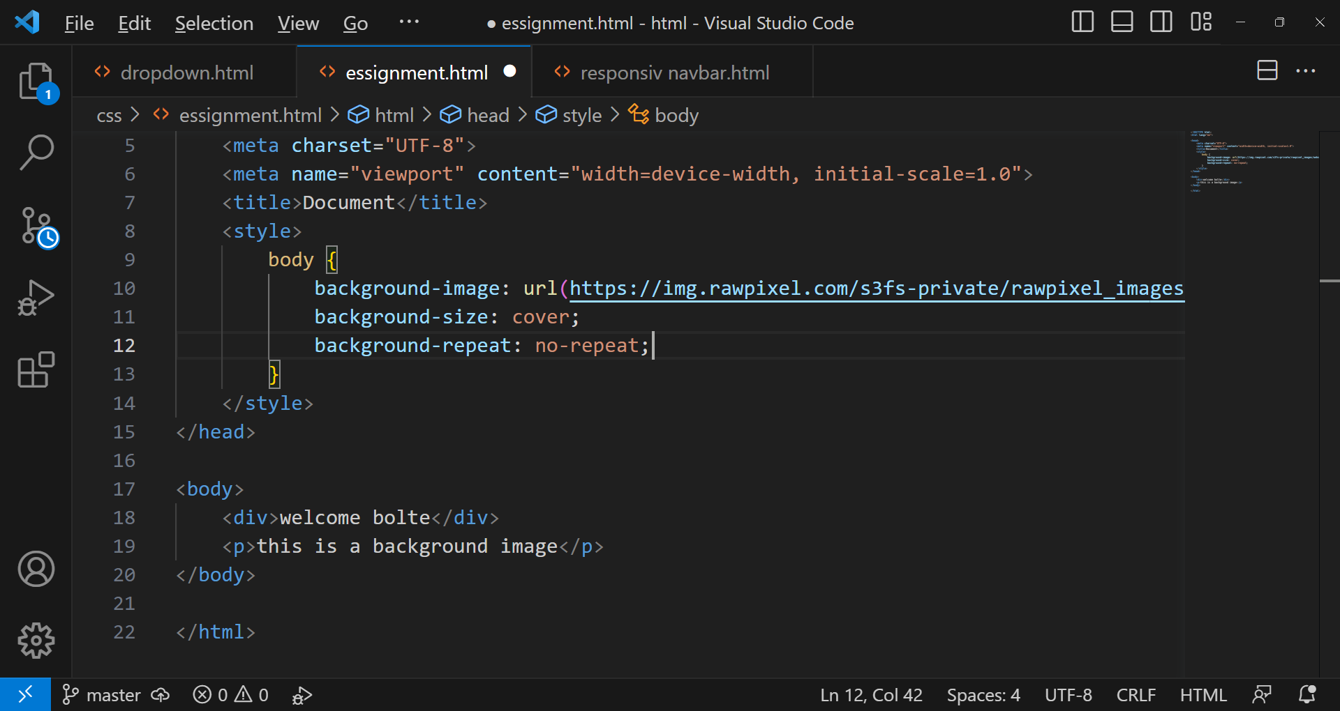

# **Q-16 How are active links different from normal links?**

**A** Normal links, also known as static links, are the most common

type of links used in HTML.

They are used to navigate between, different web pages or

Sections within a web page.

Active links referred to as dynamic links, are links that change

their appearance or behavior based on certain conditions or

user interaction.

# **Q-17 What are the different tags to separate sections of text?**

**A** <h1> to <h6> tags are used to define heading of different

Levels.

<p> tag is used to define paragraphs of text.

<div> tag is generic container.

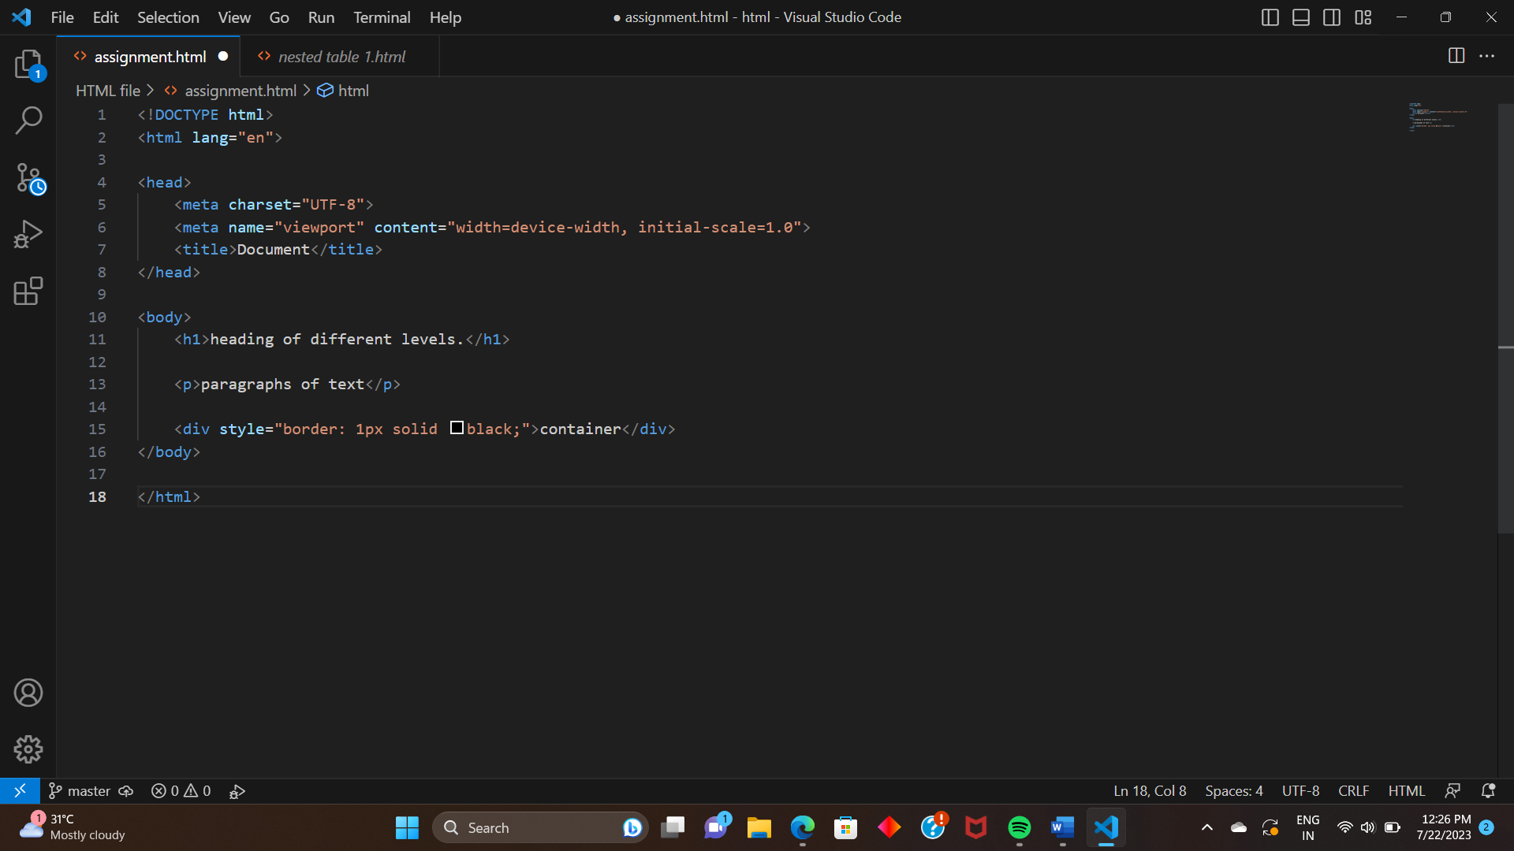

# **Q-18 What is SVG?**

**A** SVG stand for scalable vector graphics.

SVG is used to define vector-based graphics for the Web.

SVG defines the graphics in XML format.

Every element and every attribute in SVG files can be

animated.

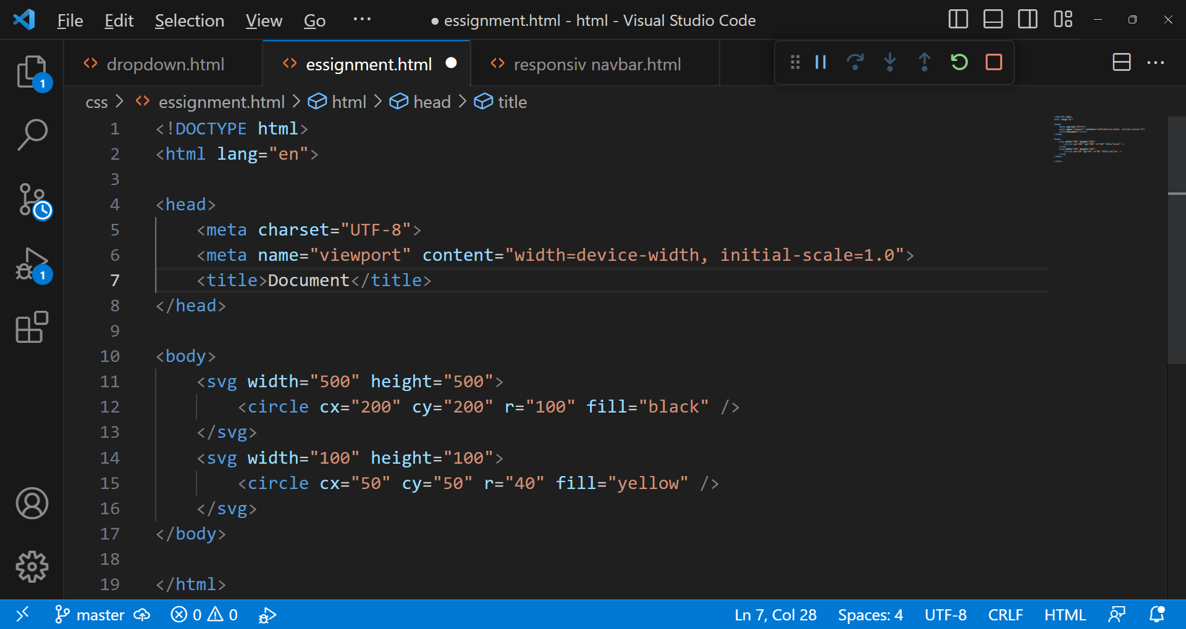

# **Q-19 What is difference between HTML and XHTML?**

**A** HTML and XHTML are both markup languages used to create

web pages and applications. HTML and XHTML have some

key differences that set them apart.

In HTML there is no mandatory rule to write the entire mark

up in uppercase or lower case. It can also be a combination of

both.

In XHTML every tag and attribute used inside must be in

lowercase.

In HTML not mandatory to add document label <DOCTYPE>

at the top of every page. We can even skip it.

In XHTML mandatory to add a document Lble <DOCTYPE>

At the beginning of the page.

# **Q-20 What are logical and physical tags in HTML.**

A **Physical tag:** Provides a visual appearance to the text.

Ex - <b> Used to bold the text written between it.

<i> Used to make text italic.

<strong> Used to inform the browser that the text is

important.

**Logical tag:** Adds some logical or semantic value to the text.

Ex - <em> Used to display content in italics.

<main> Use the main content of a web page.

<del> define text.