Software Testing Assignment

Module-1:

* What is SDLC .
* SDLC is a Software Development life cycle.
* SDLC is a structure that defines the process for planning , implementation , testing, documentation , deployment and ongoing maintenance and support.
* What is software testing?
* Software testing is a process used to identify the correctness, completeness and quality of the developed computer software.
* What is agile methodology?
* Agile software testing is a methodology that helps developers to test their code continuously and rapidly.
* This methodology also allows testers to get immediate feedback from customers.
* In this testing, there are various roles and responsibilities of different team members.
* WHAT is SRS?
* A software requirement specification is a complete description of the behavior of the system to be developed.
* In SRS, there are three type

Types of requirement.

🡪Customer requirements.

🡪Functional requirements.

🡪NON- Functional requirements.

* What is oops?
* OOPS stands for Object – oriented programming language.
* OOP is faster and easier to execute.
* OOP provides a clear structure for the program.
* Write Basic Concepts of oops.
* There are four fundamental concepts of Object - oriented programming ­

🡪Inheritance

🡪Encapsulation

🡪Polymorphism

🡪Data abstraction.

* What is object?
* Classes are nothing without objects.
* We can create a multiple objects from a class.
* We create a objects to call the class function
* Objects of a class are created using the new keyword.
* What is Class?
* Class is a user defined data type in PHP.
* Class is basically a collection of variable method and member function.
* In order to define a new class, PHP provides a keyword class, which is followed by a name.
* What is encapsulation
* It is a concept where we encapsulate all the data and member function together to form an object.
* Wrapping up the data member and method together into a single unit is called Encapsulation.
* What is inheritance
* Inheritance in OOP = When a class derives from another class.
* An inherited class is defined by using the extends keywords.
* There are two types of inheritance:

🡪 Multiple inheritance

🡪Multilevel inheritance

* What is polymorphism
* IT is a concepts that allows you to create a Classes with different functionalities in a single interface.
* There are two types:

🡪Overloading

🡪Overriding

* Write SDLC phases with basic introduction.
* There are six phases in SDLC .

🡪Requirements Collection/Gathering – Establish what customer Needs

🡪Analysis – Model and specify the requirements

🡪Design – Model and specify a Solution

🡪Implementation – Construct a solution in software

🡪Testing – validate the solution against the requirements.

🡪Maintenance – Repair defects and adapt the solution to the new requirements.

* Explain phases of the waterfall model.
* Requirements – The aim of this phase is to understand the exact requirements of the customer and to document properly.
* Design phase -- This phase aims to transform the requirements gathered in the SRS in to a suitable form which permits further coding in a programming language.
* Implementation and unit testing – During this phase, design is implemented .If the SDD is complete, the implementation or coding phase smoothly, because all the information needed by software developers is contained in the SDD.
* Integration and system Testing -- Unit testing determines the efficiency of individual modules.

🡪 IN this phase, the modules are tested for their interactions with each other and with the system.

* Operation and maintenance phase -- Maintenance is the task performed by every user once the software has been delivered to the customer, installed, and operational.
* Write Phases of spiral model?

🡪Planning.

🡪Risk Analysis.

🡪Engineering.

🡪Evaluation.

* Write agile manifesto principles?
* Our highest priority is to satisfy the customer through the early and continuous delivery of valuable Software.
* Business people and developers must work together daily throughout the project.
* Working software is the primary measure of progress.
* Continuous attention to technical excellence and good design enhances agility.
* Simplicity – the art of maximizing the amount of work not done – is essential.
* The best architectures, requirements, and design emerge from self – organizing teams.
* Explain working methodology of agile model and also write pros and cons?
* This method focus on the ability of a team to be flexible, encouraging team member to identify uncertainties in their projects and adapt to challenges.
* The Agile methodology is most associated with software development projects.
* Pros and Cons—
* Pros:

🡪 Little or no planning required.

🡪Easy to manage.

🡪 Gives flexibility to developers.

🡪Resource requirements are minimum.

🡪Promotes teamwork and cross training.

* Cons:

🡪Not suitable for handling complex dependencies.

🡪More risk of sustainability, maintainability and extensibility.

🡪Transfer of technology to new team members may be quite challenging due to lack of documentation.

* Draw Use case on online book shopping.

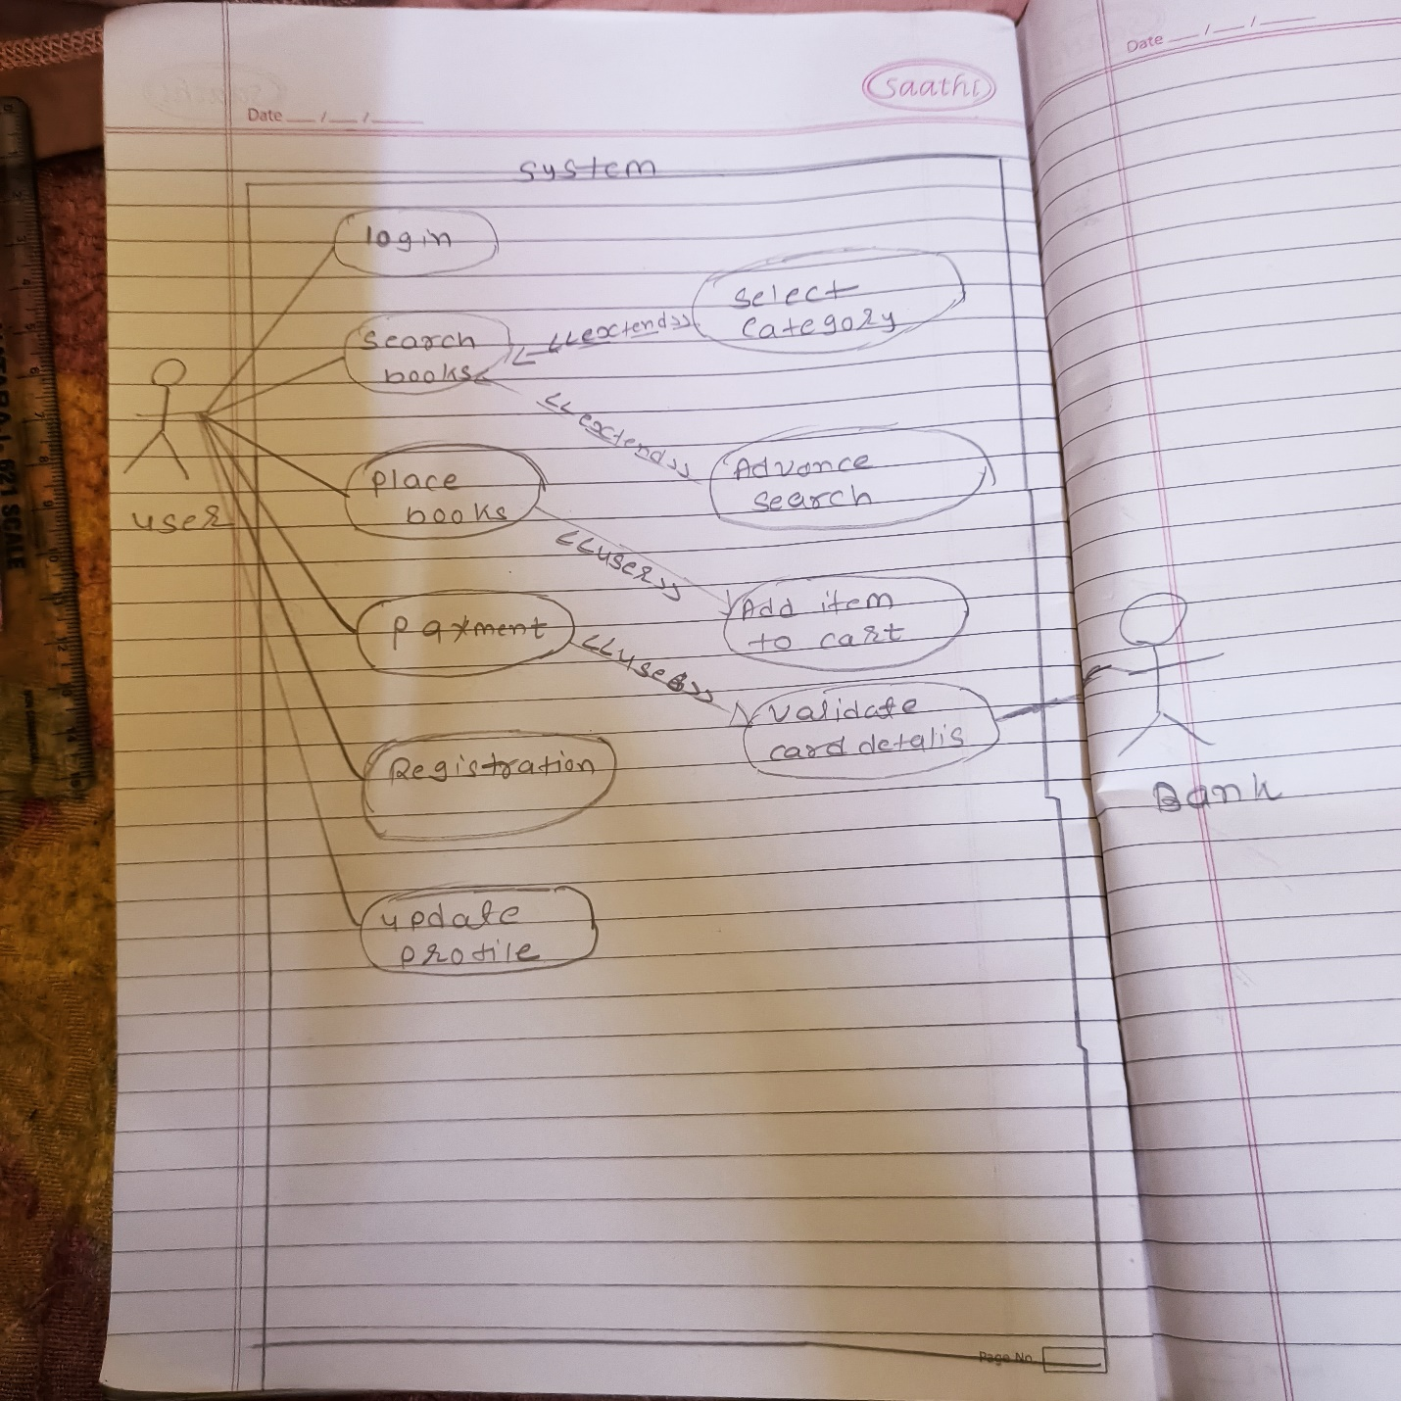

* Draw Use case on online bill payment system.(paytm)

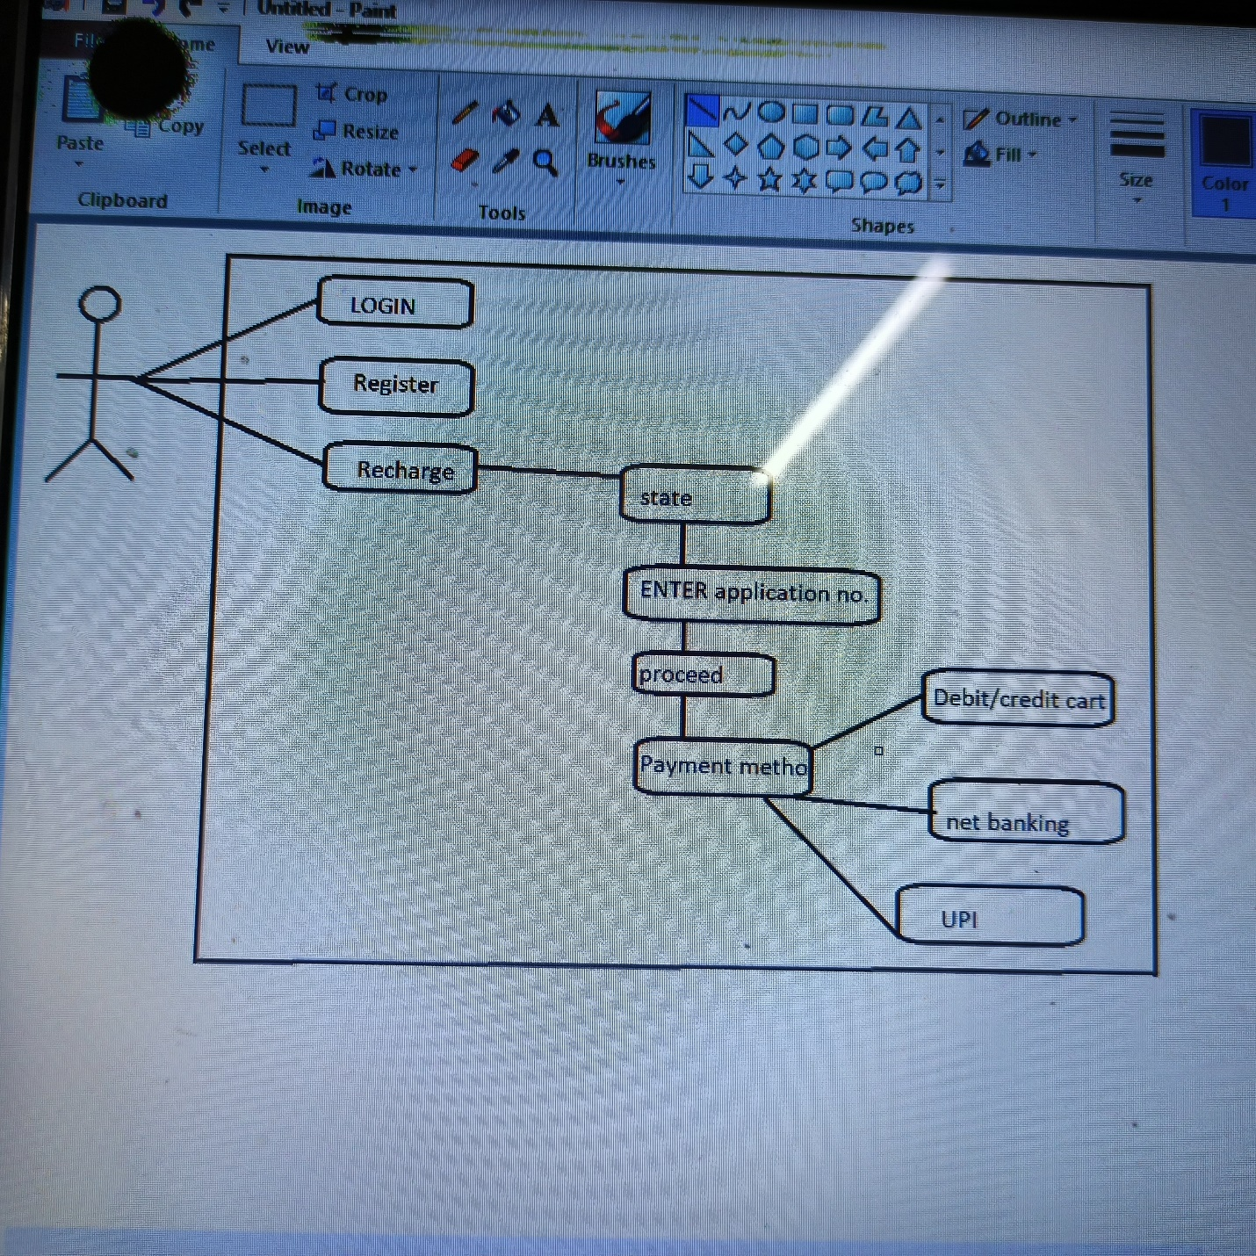

* Draw usecase on online shopping product using COD.

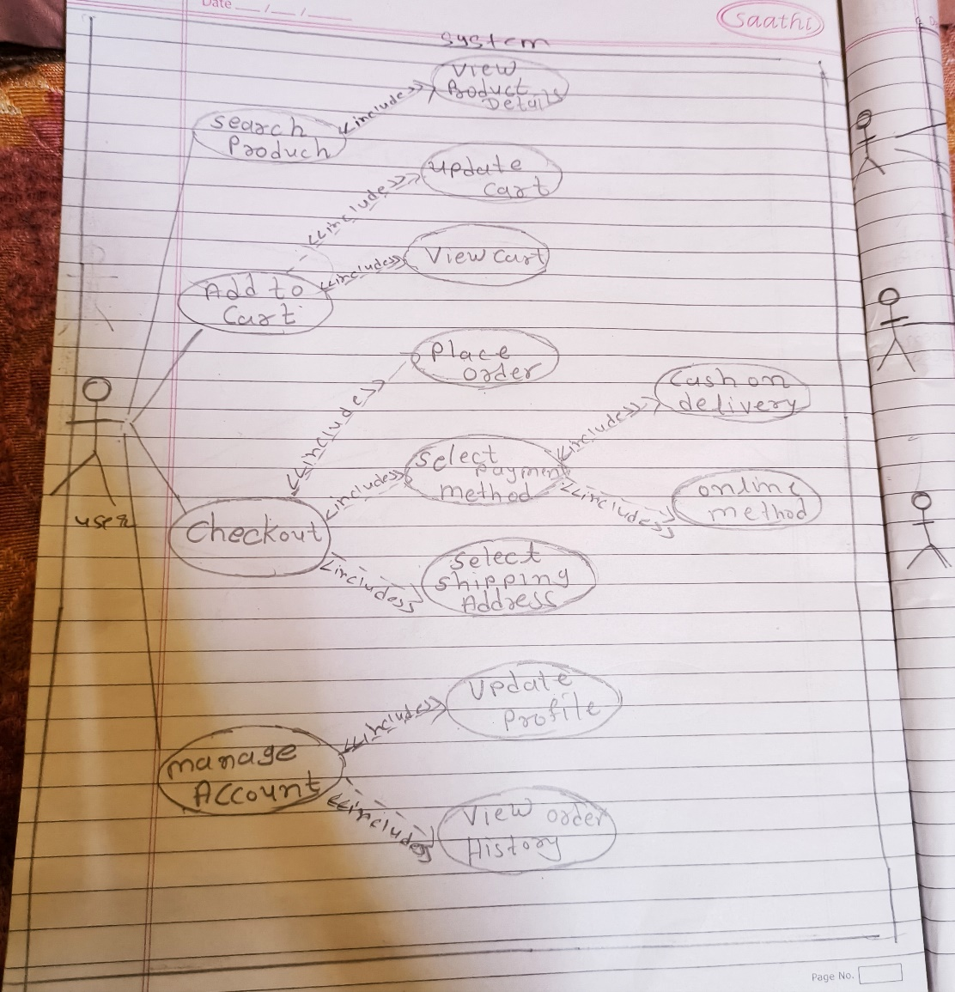

* Draw usecase on online shopping product using payment gateways.

