**Software Engineering Assignment**

**MODULE: 1**

**SE – Overview of IT Industry**

***1. What is software? What is software engineering?***

Software is a collection of instructions, data, or computer programs that are used to run machines and carry out particular activities**.**

Software engineering is the process of developing, testing and deploying computer applications to solve real-world problems by adhering to a set of engineering principles and best practices. The field of software engineering applies a disciplined and organized approach to software development with the stated goal of improving quality, time and budget efficiency, along with the assurance of structured testing and engineer Certification.

***2. Explain types of software.***

***The software is divided into two categories:***

System Software

* Operating System
* Language Processor
* Device Driver

Application Software

* + General Purpose Software
  + Customize Software
  + Utility Software

System Software

System software is software that directly operates the computer hardware and provides the basic functionality to the users as well as to the other software to operate smoothly.

* Operating System**:** It is the main program of a computer system. When the computer system ON it is the first software that loads into the computer’s memory.
* **Language Processor:**As we know that system software converts the human-readable language into a machine language and vice versa.
* Device Driver**:**A device driver is a program or software that controls a device and helps that device to perform its functions. Every device like a printer, mouse, modem, etc. needs a driver to connect with the computer system eternally.

Application Software

Software that performs special functions or provides functions that are much more than the basic operation of the computer is known as application software. Or in other words, application software is designed to perform a specific task for end-users.

There are different types of application software and those are:

* General Purpose Software**:**This type of application software is used for a variety of tasks and it is not limited to performing a specific task only. For example, MS-Word, MS-Excel, PowerPoint, etc.
* Customized Software**:**This type of application software is used or designed to perform specific tasks or functions or designed for specific organizations. For example, railway reservation system, airline reservation system, invoice management system, etc.
* Utility Software**:**This type of application software is used to support the computer infrastructure. It is designed to analyze, configure, optimize and maintains the system, and take care of its requirements as well. For example, antivirus, disk fragmenter, memory tester, disk repair, disk cleaners, registry cleaners, disk space analyzer, etc.

***3. What is SDLC? Explain each phase of SDLC***

The software development lifecycle (SDLC) is the cost-effective and time-efficient process that development teams use to design and build high-quality software. The goal of SDLC is to minimize project risks through forward planning so that software meets customer expectations during production and beyond***.***

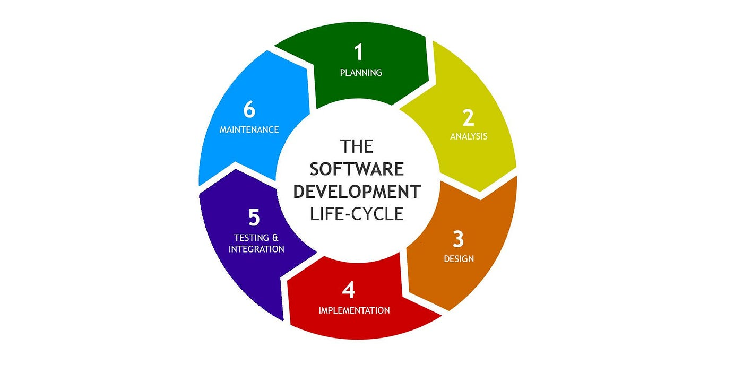

**Planning**

In the Planning stage, the product team discusses and examines the desired features, functionalities, and overall product goals with stakeholders. The development team analyzes existing systems and workflows, determines technical feasibility, and defines the project milestones.

This stage’s goal is to create an overview of the project, determine the requirements that must be met, and lay the product groundwork. The output of this phase is a Software Requirements Specification (SRS) document that includes all the software, hardware, security, and network specifications of the product under development.

Any ambiguities or misunderstandings in this phase can lead to costly errors and rework during development. Thoroughly understanding and documenting requirements is vital to building software that meets the needs of the users and the organization while staying within scope, time, and budget constraints.

**Analysis**

The Analysis stage involves creating a comprehensive project plan that sets timelines, determines resource allocation, and defines deliverables.

This phase of the SDLC also involves creating the software architecture and design. Designers take into account the desired user experience (UX) and create user interface (UI) design elements that balance usability, intuitiveness, and visual appeal.

Prototyping is sometimes part of this stage. The quality assurance (QA) team develops a test strategy in this phase, as well, detailing what they’ll test and how they’ll test it.

**Design**

Imagine you are building a software solution. To create it, you require a clear plan of how it should function and look. This is called ‘Design Specification’ in the world of software development. It serves as an instruction manual for everybody on the team. This stage is about taking all the information you gathered in the previous stage and turning it into a step-by-step software development guide.  
People involved, such as customers and developers, overview the guide and recommend necessary changes. It is like a group of engineers analyzing a SaaS product and saying, “Maybe we should simplify the chat function.” It is a super essential stage of the software development life cycle. Any failure will result in either cost overruns or total project shutdown.

**Implementation**

This is where the system development life cycle begins, using clean code as much as possible. Every software engineer must stick to the plan and blueprint decided in the earlier stages. Also, follow the guidelines properly and use the best coding practices. For example, each file name must be written in a specific style so everything looks organized and neat. Following these rules makes it easier to comprehend what the entire team is working on.

**Testing**

Testing plays a crucial role in the software development life cycle. It is like you followed the correct recipe (plan and guide stages) to bake (development stage) a pie (software). Now, you want to make sure that the pie is delicious before serving it to your guests (customers), so you take a bite. That bite is testing to ensure you have baked a yummy pie.

In the testing stage, you look for deficiencies and flaws in your software. You fix those problems until the solution meets the original requirements. The development team uses automation and manual testing to analyse bugs in the software. Also, the testing phase should run side-by-side with the development stage.

**Maintenance**

At this stage, you aim to deploy the software into the production environment so users can interact with it. But it also depends on your organization’s decision. Many companies opt to move the software through various deployment environments, such as staging or testing. This permits stakeholders to overcome costly mistakes before releasing the software in the market. It is also true that the product may miss some important functionalities, so you keep room for corrections through maintenance. This helps advance the solution to match the latest trends.

***4. What is DFD? Create a DFD diagram on Flipkart***

Data flow diagrams are used to graphically represent the flow of data in a business information system. DFD describes the processes that are involved in a system to transfer data from the input to the file storage and reports generation.

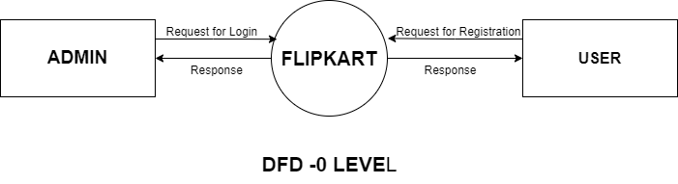

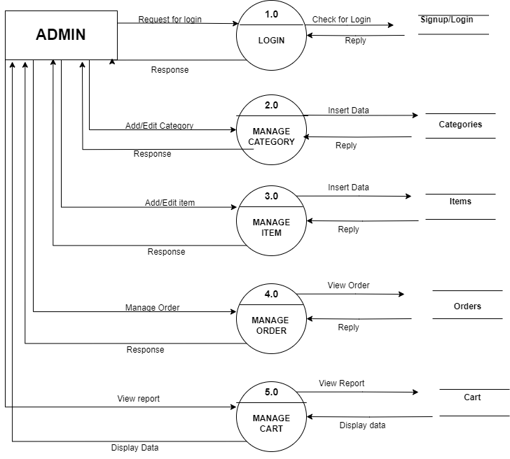

**DFD -1 Level**

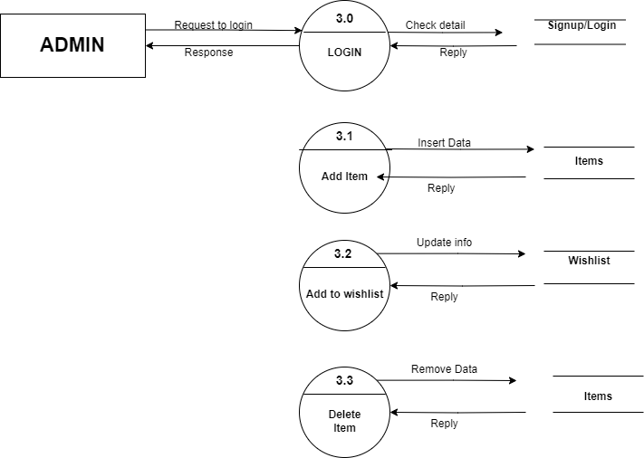

**DFD-2 Level**

***5. What is Flow chart? Create a flowchart to make addition of two numbers***

A flowchart is a type of diagram that represents a workflow or process. A flowchart can also be defined as a diagrammatic representation of an algorithm, a step-by-step approach to solving a task.

The flowchart shows the steps as boxes of various kinds, and their order by connecting the boxes with arrows***.***

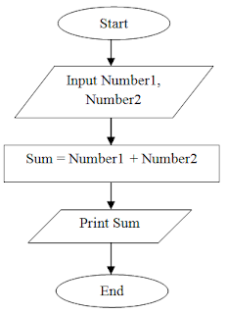

***6. What is Use case Diagram? Create a use-case on bill payment on paytm.***

A use case diagram is a graphical depiction of a user's possible interactions with a system. A use case diagram shows various use cases and different types of users the system has and will often be accompanied by other types of diagrams as well. The use cases are represented by either circles or ellipses***.***

