**“IEducation”**

**(The college management system)**

**Group Details:-**

1.202312060 : Khushi Trivedi

2.202312059 : Dhruv Parmar

3.202312017 : Rutvik Nakum

4.202312128 : Sharma Alkesh

**INDEX**

|  |  |  |
| --- | --- | --- |
| **Sr. No** | **Topics** | **Page No** |
| 1 | **Introduction**               1.1 Project Profile | 3 |
| 2 | **Proposed System**               2.1 Scope               2.2 Objective               2.3 Expected Outcomes               2.4 Milestones  2.5 Definition, Acronym and Abbreviation | 3 |
| 3 | **Requirements**               3.1 Functional and Non-functional Requirements | 6 |
| 4 | **System Planning**               4.1 User Stories  4.2 Used Cases | 7 |
| 5 | **System Analysis and Modelling**              5.1 UML Diagram                     5.1.1 Use Case Diagram                     5.1.2 Class Diagram                     5.1.3 Activity Diagram  5.1.4 Sequence Diagram              5.2 E-R Diagram              5.3 Data Flow Diagram              5.4 Decision Tree | 16 |
| 6 | **Software Design**               6.1 Interface Design (Page snapshots) | 33 |
| 7 | **Future Enhancement**  **7.1** Lessons Learnt    7.2 Mistakes  7.3 Achievments | 59 |

**1. Introduction**

The IEducation mobile application is a comprehensive software solution designed to streamline and enhance the administrative and academic processes within educational institutions.

Developed to cater to the needs of both administrators and students, IEducation serves as a centralized platform for managing various aspects of college operations efficiently.

1.1 Problem Statement:

1.1.1 The current educational management systems lack efficient communication channels, causing delays, errors, and a lack of transparency in college operations.

1.1.2 Manual paperwork and fragmented systems hinder administrative tasks, while students struggle to access essential services and resources due to outdated processes.

1.1.3 There is a pressing need for a modern, user-friendly mobile application to streamline administrative and academic processes, improving overall efficiency and enhancing the learning experience for students.

**2. Proposed System**

2.1. SCOPE

2.1.1 Authentication and User Management:

• Implement secure login functionality for admins and students.

• Allow users to register and manage their accounts.

• Provide forgot password functionality for account recovery.

2.1.2 Student Management:

• Allow admins to view, add, edit, and delete student records.

• Manage student details including personal information, contact details,

and academic information.

2.1.3 Academic Management:

• Enable admins to manage course timetables, including adding, updating,

and deleting schedule entries.

• Allow posting of important notices, announcements, and events for

students and staff.

• Facilitate the uploading and sharing of study materials such as lecture

notes, presentations, and assignments.

2.1.4 Attendance and Academic Progress Tracking:

• Provide students with the ability to view their attendance percentage and

track academic progress.

• Enable admins to monitor student attendance and access attendance

records.

2.1.5 Leave Management:

• Allow students to apply for leave, with admins having the ability to

approve or reject leave requests.

2.1.6 Examination Management:

• Enable students to access examination results, seating plans, and course-related materials.

• Allow admins to publish examination results and manage examination- related information.

2.1.7 Library and Fee Management:

• Enable students to check library fines and pay fees.

• Allow admins to track library transactions and view students' fees status.

2.1.8 Staff Management:

• Provide admins with the ability to view and manage teaching and non-

teaching staff details, including contact information and department details.

2.1.9 System Management:

• Implement a secure logout functionality for both admins and students.

• Ensure data security and integrity throughout the system.

2.2 Objectives of the system:

2.2.1 Develop a user-friendly mobile application, IEducation, to centralize and streamline college operations.

2.2.2 Provide administrators with tools for efficient management of student and staff

information, course scheduling, examination management, library transactions, and financial tracking.

2.2.3 Enable students to access essential services conveniently, including

registration, attendance tracking, assignment submission, fee payments, and academic resources.

2.2.4 Enhance communication between students and administrators through real-

time notifications, announcements, and updates.

2.2.5 Improve transparency and accountability in college operations by centralizing

data and providing secure access to authorized users.

2.2.6 Facilitate seamless integration with existing systems and databases to

minimize disruption and ensure smooth transition.

2.3 Expected outcomes:

2.3.1 Increased efficiency in administrative tasks, leading to time and cost savings

for the institution.

2.3.2 Improved communication and collaboration between students and

administrators.

2.3.3 Enhanced accessibility to essential services and resources for students, leading to improved satisfaction and academic performance.

2.3.4 Streamlined processes and reduced paperwork, resulting in a more

environmentally friendly and sustainable approach to college management.

2.3.5 Enhanced data security and privacy measures to protect sensitive information.

2.3.6 Greater transparency and accountability in college operations, fostering trust

and confidence among stakeholders.

2.4 Milestones

1. User Authentication and Basic Functionality
2. Notices, Announcements, and Study Materials
3. Attendance Monitoring and Leave Management
4. Examination Results and Staff Management
5. Library Transactions and Fees Management
6. User Experience Improvements
7. Student Portal Features

2.5 Definition, Acronym and Abbreviation:

The IEducation mobile application is an integrated solution that facilitates the management of administrative tasks, academic resources, and student services in educational institutions.

IEducation provides administrators with robust features such as secure login authentication, user-friendly interfaces for managing student and staff information, course scheduling, examination management, library transactions, and financial tracking.

Additionally, students can utilize IEducation to access essential services including registration, attendance tracking, assignment submission, fee payments, and academic resources such as course materials and examination results. With its user-centric design and comprehensive functionality, IEducation aims to optimize operational efficiency, enhance communication, and improve the overall learning experience within the college environment.

• SRS: Software Reqiurement Specification.

• COMS - College Operations Management System.

• IEducation - Interactive Education.

• CRUD: Create, Read, Update, Delete.

• API: Application Programming Interface.

• UI: User Interface.

• UX: User Experience.

• URL: Uniform Resource Locator.

• CPU: Central Processing Unit.

**3. Environment Specification**

3.1 Functional And Non-Functional Requirements

Functional Requirements:

1. User Authentication:

• Ability for administrators, students to register and login securely.

• Different levels of access based on user roles (admin, student).

2. Student Management:

• Add, edit, and delete student profiles.

• Assign students to classes.

• Track student attendance.

• Record academic performance (grades, marks, assignments).

3. Teacher Management:

• Add, edit, and delete teacher profiles.

• Assign teachers to classes.

• Schedule and manage teacher timetables.

4. Class Management:

• Create and manage class schedules.

• Assign students to classes.

5. Attendance Tracking:

• Record daily attendance for students.

• View attendance reports for students and classes.

6. Academic Performance Tracking:

• Record grades, marks, and assignments for students.

7. Examination and Assessment :

• Record exam results.

Non-Functional Requirements:

1. Security:

• Data encryption for sensitive information.

• Role-based access control to ensure data privacy and security.

2. Performance:

• Fast and responsive user interface.

• Scalability to handle a growing number of users and data.

3. Usability:

• Intuitive user interface design.

• Accessibility features to accommodate users with disabilities.

• Multi-platform support (iOS, Android).

4. Reliability:

• High availability with minimal downtime.

• Regular backups and data recovery mechanisms.

5. Compatibility:

• Compatibility with various devices and screen sizes.

6. Maintenance:

• Easy to maintain and update system components.

• Version control and documentation for codebase management.

7. Integration:

• Integration with existing school systems (e.g., student information

systems, learning management systems).

• APIs for integration with third-party services or applications.

8. Performance Monitoring:

• Monitoring and logging of system performance.

4. System Planning

4.1 User Stories

As an admin of the College Operations Management System app, I want to be

able to:

➢ As an admin, I want to be able to log in securely using my email and

password so that I can authenticate my credentials against the database.

➢ As an admin, I want the forget password option available to reset the

password through which I can reset the password if I forget it.

➢ As an admin, I want to view and manage the details including photo,

name,gender,

date of birth,stream, email, contact number, address, blood group of all

registered students so that I can add, edit, or delete student records as

needed.

➢ As an admin, I want to access and view the timetable for various courses

offered by the college, including course name ,subject,date ,time, so that I

can add and update the timetable if there are any changes.

➢ As an admin, I want to post important notices and announcements for

students and staff so that I can categorize notices by topics such as

cultural festivals, college activities, sports, exams, job vacancies, and

general updates, making them visible to the relevant recipients.

➢ As an admin, I want to upload and share study materials such as lecture

notes, presentations, and assignments, allowing for file selection. I also

want to include fields for subject name, stream, semester selection, and

date and time, so that I can organize materials by courses and topics for

easy access by students.

➢ As an admin, I want to manage the list of courses offered by the college so

that I can add new courses, update existing ones, or deactivate courses

that are no longer offered.

➢ As an admin, I want to be able to view the attendance percentage of

students, so that I can monitor their attendance, track their academic

progress, and provide necessary support when needed.

➢ As an admin (teacher), I want to be able to approve or reject leave

requests from students, so that I can effectively manage student absences

from school.

➢ As an admin, I want to publish examination results for all courses, enabling

the upload of results based on stream, and ensuring that they are

accessible only to authorized users, who can view them using their ID

numbers, so that I can ensure that results are accurate and securely

accessible.

➢ As an admin, I want to view the list of teaching and non-teaching staff,

including contact information and department details for each staff

member, and also have the ability to remove staff and teachers who have

left the university, so that I can maintain an updated and accurate staff

directory.

➢ As an admin, I want to track library transactions, specifically knowing which

student has issued which book, so that I can effectively manage the

library's resources and ensure accountability for borrowed items.

➢ As an admin, I want to see the fees status of the students, including details

of students who have paid the fees, the mode of payment, and the date

and time of payment, so that I can accurately track payments and

determine how much fees are remaining for each student.

➢ As admin, I want to be able to log out of the student portal, so that I can

secure my account and ensure privacy.

As an user of the College Operations Management System app, I want to be able

to:

➢ As a student, I want to enter my email, password, and personal details to

register myself in the institute, submit my email address in contact info for

registration confirmation and user ID, and use my username and

credentials to successfully log in to the system, so that I can access the

institute's resources and services.

➢ As a user who has forgotten my password, I want to be able to reset my

password easily, so that I can regain access to my account.

➢ As a user who has forgotten the password, or as a student wanting to

maintain the security of the account, I want to be able to reset or change

my password easily, so that I can regain access to my account and ensure

its security.

➢ As a student I want to be able to edit my personal details, so that I can

keep my account information up-to-date.

➢ As a student, I want to be able to apply for leave when necessary, so that I

can manage my absences from school effectively.

➢ As a student, I want to be able to view my attendance percentage, So that

I can monitor my attendance and track my academic progress.

➢ As a student, I want to be able to view details of assigned homework and

submit completed assignments, so that I can manage my coursework

effectively.

➢ As an admin (teacher), I want to be able to approve or reject leave

requests from students, so that I can effectively manage student absences

from school.

➢ As a student, I want to be able to check whether any dues are pending

against me and pay my semester fee, so that I can ensure timely payment,

avoid any late fees, complete the registration process, and continue my

studies without interruption.

➢ As a student, I want to be able to pay any library fines, so that I can clear

my account and continue to borrow books from the library.

➢ As a student, I want to be able to access my class schedule or timetable,

so that I can attend my classes and manage my time effectively.

➢ As a student, I want to be able to access my examination results or class

assessments, so that I can track my academic performance and identify

areas for improvement.

➢ As a student, I want to be able to access the examination seating plan, so

that I can prepare for exams and know my assigned seat easily.

➢ As a student, I want to be able to view the list of teachers associated with

my courses, so that I can easily contact them for academic queries or

assistance.

➢ As a student, I want to be able to access course materials such as lecture

notes, presentations, and readings, so that I can study and prepare for my

classes effectively.

➢ As a student, I want to be able to view announcements and important

notices from the school or teachers, so that I can stay informed about

events, deadlines, and other relevant information.

➢ As a student, I want to be able to access detailed information about each

of my courses, so that I can understand course requirements, objectives,

and expectations.

➢ As a student, I want to be able to log out of the student portal, so that I can

secure my account and ensure privacy.

**4.2 USE CASES:**

Sure, here are the use cases for all the user stories provided:

**Admin Use Cases:**

* Login Authentication:
  + Initiator: Admin
  + Description: Authenticate admin credentials against the database.
  + Basic Flow of Events:
    - Admin enters email and password.
    - System verifies credentials.
    - If successful, grant access to the admin dashboard.
  + Exceptional Flow of Events:
    - If authentication fails, display error message.
* Forgot Password:
  + Initiator: Admin
  + Description: Reset admin password through email verification.
  + Basic Flow of Events:
    - Admin clicks "Forgot Password" link.
    - Enters registered email.
    - System sends password reset link.
    - Admin clicks link, resets password.
  + Exceptional Flow of Events:
    - If email is not registered, display error message.
    - If there's an issue sending the reset email, display error message.
    - If reset link is expired or invalid, prompt for another request.
    - If database update fails, display error message.
* Manage Student Details:
  + Initiator: Admin
  + Description: Add, edit, or delete student records.
  + Basic Flow of Events:
    - Admin navigates to student management section.
    - Views list of students.
    - Adds, edits, or deletes student records.
  + Exceptional Flow of Events:
    - None specified.
* Timetable Management:
  + Initiator: Admin
  + Description: View and update course timetables.
  + Basic Flow of Events:
    - Admin accesses timetable section.
    - Views existing timetables.
    - Adds or updates timetable entries.
  + Exceptional Flow of Events:
    - None specified.
* Notice and Announcement Posting:
  + Initiator: Admin
  + Description: Post notices and announcements.
  + Basic Flow of Events:
    - Admin accesses notice section.
    - Posts notices, categorizes by topics.
  + Exceptional Flow of Events:
    - None specified.
* Upload Study Materials:
  + Initiator: Admin
  + Description: Upload study materials for courses.
  + Basic Flow of Events:
    - Admin uploads study materials.
    - Includes subject, stream, semester, date, and time.
  + Exceptional Flow of Events:
    - None specified.
* Manage Courses:
  + Initiator: Admin
  + Description: Add, update, or deactivate courses.
  + Basic Flow of Events:
    - Admin navigates to course management.
    - Adds, updates, or deactivates courses.
  + Exceptional Flow of Events:
    - None specified.
* View Attendance:
  + Initiator: Admin
  + Description: View student attendance percentage.
  + Basic Flow of Events:
    - Admin accesses attendance section.
    - Views attendance percentage.
  + Exceptional Flow of Events:
    - None specified.
* Approve Leave Requests:
  + Initiator: Admin (Teacher)
  + Description: Approve or reject student leave requests.
  + Basic Flow of Events:
    - Admin (Teacher) receives leave request.
    - Approves or rejects leave request.
  + Exceptional Flow of Events:
    - None specified.
* Publish Examination Results:
  + Initiator: Admin
  + Description: Publish examination results for courses.
  + Basic Flow of Events:
    - Admin uploads results based on stream.
    - Results accessible to authorized users.
  + Exceptional Flow of Events:
    - None specified.
* View Staff Details:
  + Initiator: Admin
  + Description: View details of teaching and non-teaching staff.
  + Basic Flow of Events:
    - Admin accesses staff directory.
    - Views list of staff members.
  + Exceptional Flow of Events:
    - None specified.
* Track Library Transactions:
  + Initiator: Admin
  + Description: Track which students have borrowed which books.
  + Basic Flow of Events:
    - Admin accesses library transaction records.
    - Views borrowing history.
  + Exceptional Flow of Events:
    - None specified.
* View Fees Status:
  + Initiator: Admin
  + Description: View fees payment status of students.
  + Basic Flow of Events:
    - Admin accesses fees section.
    - Views payment details of students.
  + Exceptional Flow of Events:
    - None specified.
* Logout:
  + Initiator: Admin
  + Description: Securely log out of the system.
  + Basic Flow of Events:
    - Admin clicks on logout button.
    - System logs out the admin user.
  + Exceptional Flow of Events:
    - None specified.

**Student Use Cases:**

* Register/Login:
  + Initiator: Student
  + Description: Register or log in to the student portal.
  + Basic Flow of Events:
    - Student accesses the registration/login page.
    - Enters email and password.
    - System verifies credentials.
    - If registration, system creates a new student account.
    - If login, grant access to the student dashboard.
  + Exceptional Flow of Events:
    - If invalid credentials, display error message.
* Forgot Password:
  + Initiator: Student
  + Description: Reset student password through email verification.
  + Basic Flow of Events:
    - Student clicks "Forgot Password" link.
    - Enters registered email.
    - System sends password reset link.
    - Student clicks link, resets password.
  + Exceptional Flow of Events:
    - If email not found, display error message.
* Edit Personal Details:
  + Initiator: Student
  + Description: Modify personal information in the student profile.
  + Basic Flow of Events:
    - Student accesses the profile editing section.
    - Makes desired changes to personal details.
    - Submits the updated information.
  + Exceptional Flow of Events:
    - If error in submission, display error message.
* Apply for Leave:
  + Initiator: Student
  + Description: Request leave from classes or academic activities.
  + Basic Flow of Events:
    - Student accesses the leave application section.
    - Fills out leave request form with details.
    - Submits the leave request.
  + Exceptional Flow of Events:
    - If leave request denied, display notification.
* View Attendance Percentage:
  + Initiator: Student
  + Description: Access attendance records and view attendance percentage.
  + Basic Flow of Events:
    - Student navigates to the attendance section.
    - System displays attendance records and percentage.
  + Exceptional Flow of Events:
    - If no attendance records found, display message.
* View Homework and Submit Assignments:
  + Initiator: Student
  + Description: Access assigned homework, submit completed assignments.
  + Basic Flow of Events:
    - Student navigates to the assignments section.
    - Views assigned homework.
    - Submits completed assignments.
  + Exceptional Flow of Events:
    - If submission deadline passed, display warning.
* Check Dues and Pay Semester Fee:
  + Initiator: Student
  + Description: View and pay outstanding fees for the semester.
  + Basic Flow of Events:
    - Student accesses the fees section.
    - Views dues and payment options.
    - Makes payment.
  + Exceptional Flow of Events:
    - If payment fails, display error message.
* Pay Library Fines:
  + Initiator: Student
  + Description: Pay fines for overdue library books.
  + Basic Flow of Events:
    - Student accesses the library fines section.
    - Views fines owed.
    - Makes payment.
  + Exceptional Flow of Events:
    - If payment successful, update fine status.
* Access Class Schedule:
  + Initiator: Student
  + Description: View personal class schedule.
  + Basic Flow of Events:
    - Student accesses the schedule section.
    - Views class schedule.
  + Exceptional Flow of Events:
    - If no schedule available, display message.
* Access Examination Results:
  + Initiator: Student
  + Description: View examination results.
  + Basic Flow of Events:
    - Student navigates to the results section.
    - Views examination results.
  + Exceptional Flow of Events:
    - If results not published yet, display message.
* Access Examination Seating Plan:
  + Initiator: Student
  + Description: View seating arrangement for examinations.
  + Basic Flow of Events:
    - Student accesses the seating plan section.
    - Views seating arrangement.
  + Exceptional Flow of Events:
    - If seating plan not available, display message.
* View List of Teachers:
  + Initiator: Student
  + Description: Access list of teachers associated with courses.
  + Basic Flow of Events:
    - Student navigates to the teachers section.
    - Views list of teachers.
  + Exceptional Flow of Events:
    - If no teachers listed, display message.
* Access Course Materials:
  + Initiator: Student
  + Description: Access lecture notes, presentations, and readings.
  + Basic Flow of Events:
    - Student accesses the course materials section.
    - Views available materials.
  + Exceptional Flow of Events:
    - If no materials available, display message.
* View Notices and Announcements:
  + Initiator: Student
  + Description: Access important notices and announcements.
  + Basic Flow of Events:
    - Student navigates to the notices section.
    - Views notices and announcements.
  + Exceptional Flow of Events:
    - If no notices available, display message.
* View Course Details:
  + Initiator: Student
  + Description: Access detailed information about courses.
  + Basic Flow of Events:
    - Student selects a course from the course list.
    - Views course details.
  + Exceptional Flow of Events:
    - If no details available, display message.
* Logout:
  + Initiator: Student
  + Description: Securely log out of the student portal.
  + Basic Flow of Events:
    - Student clicks on logout button.
    - System logs out the student user.
  + Exceptional Flow of Events:
    - None specified.

**5. System Analysis and Modelling**

* 1. UML Diagram
     1. Use Case Diagram

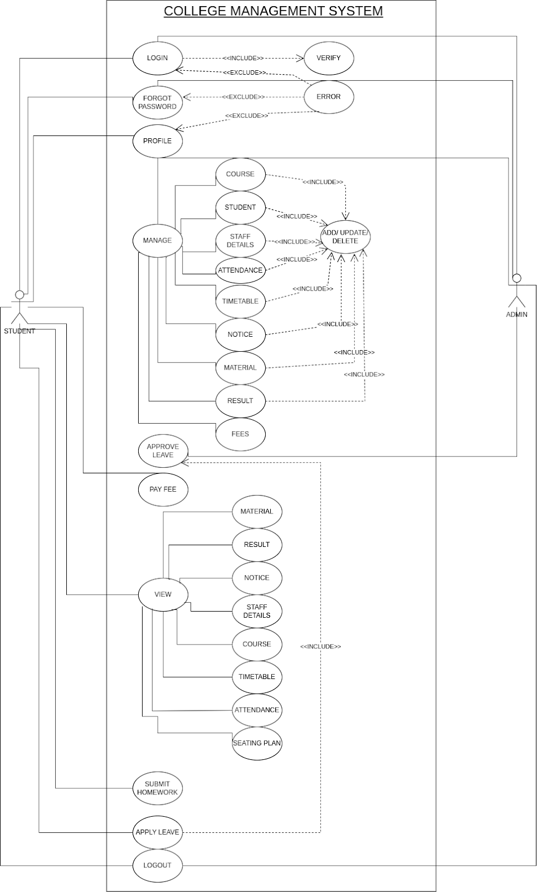

5.1.2 Class Diagram

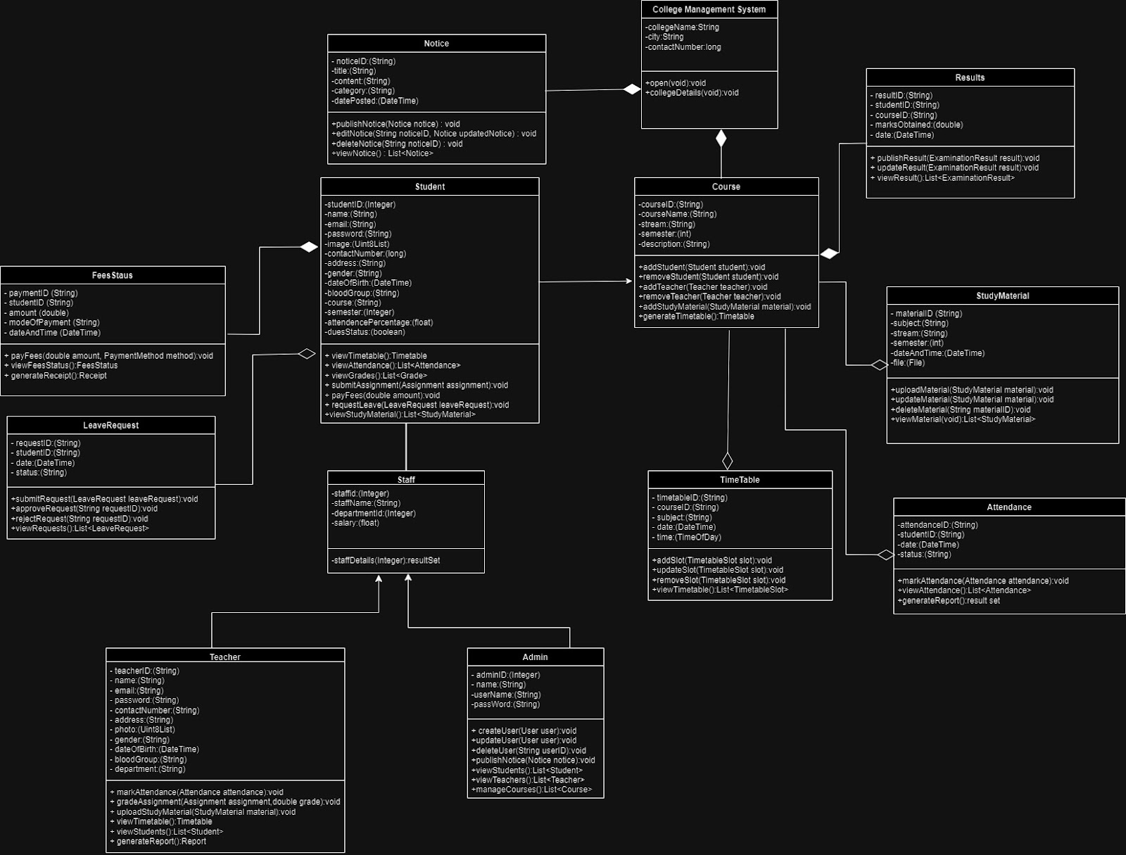

* + 1. Activity Diagram

ADMIN

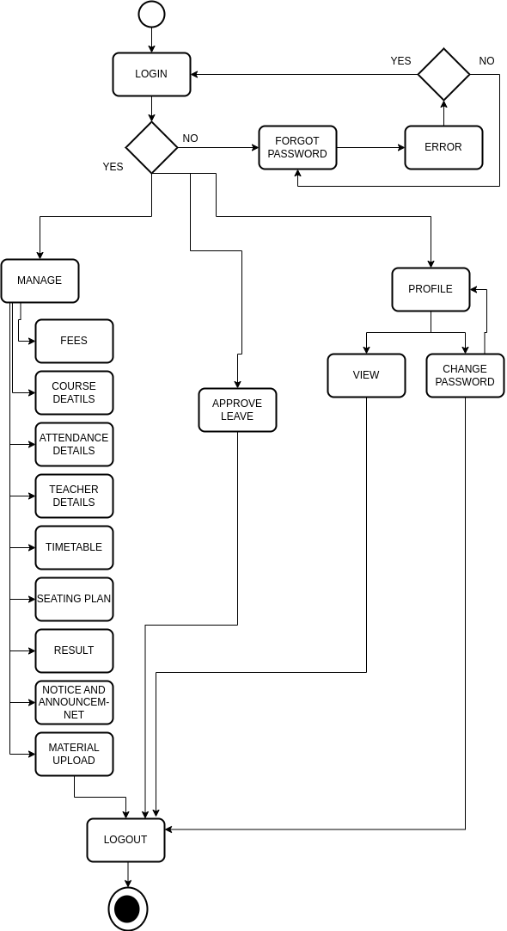

STUDENT

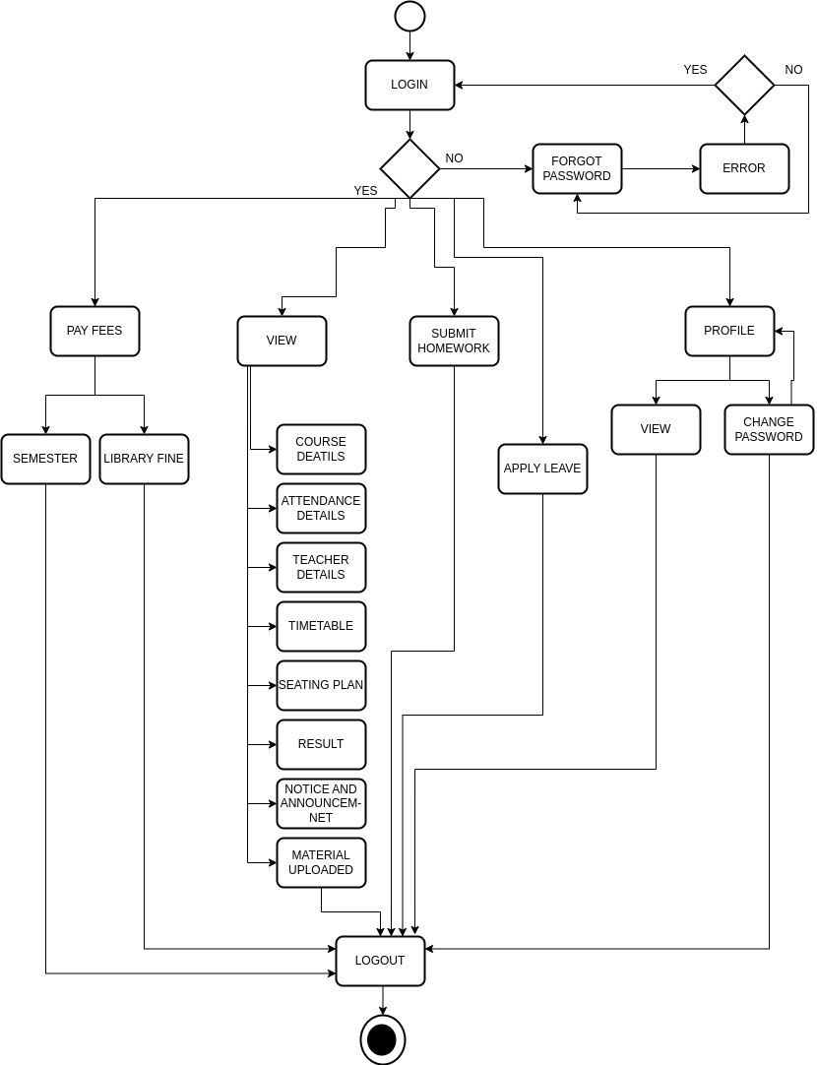

* + 1. Sequence Diagram

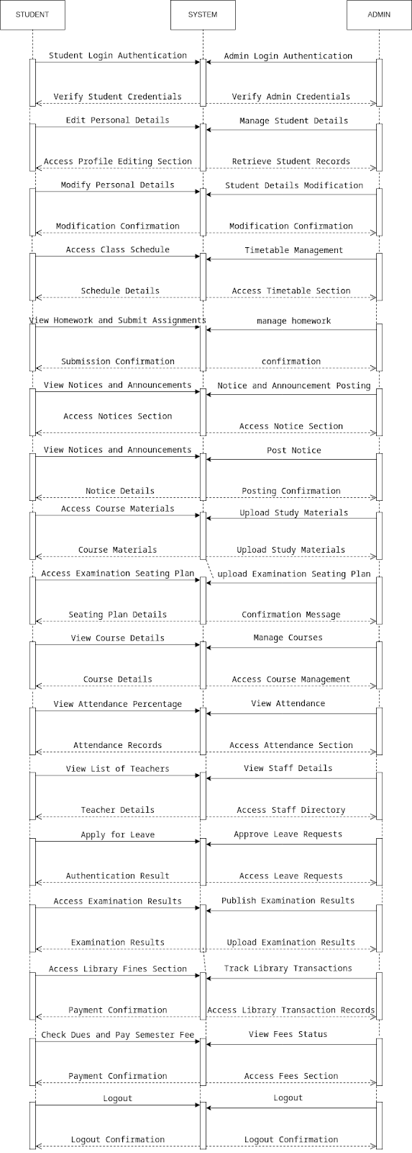

* 1. E-R Diagram

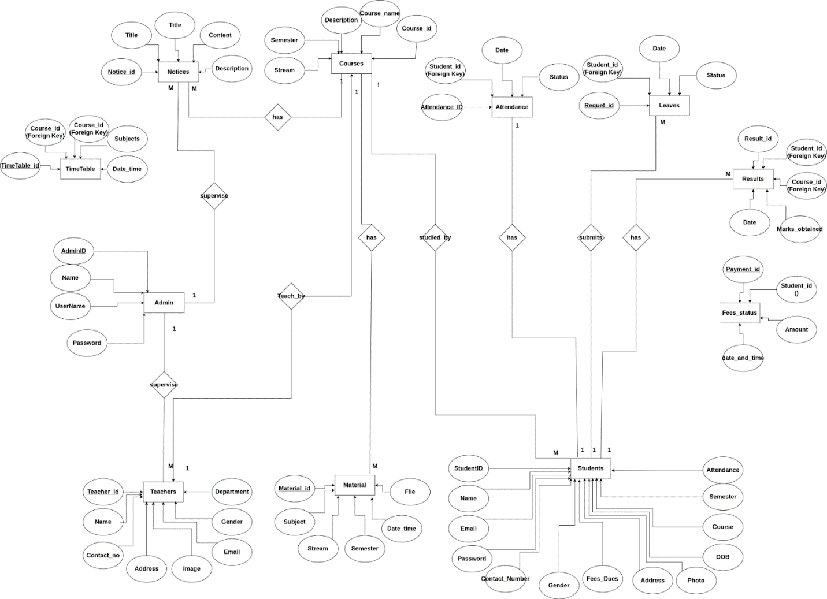

* 1. Data Flow Diagram

LEVEL 0

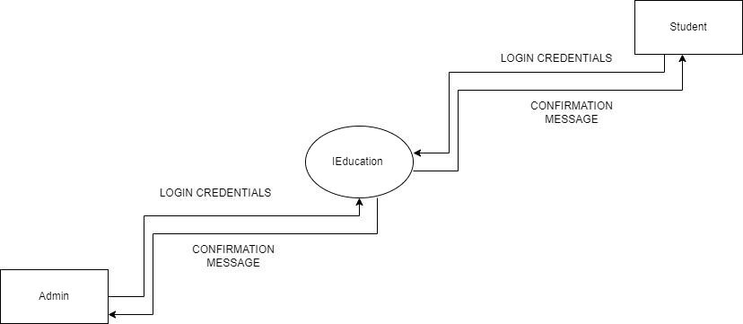

LEVEL 1 ADMIN

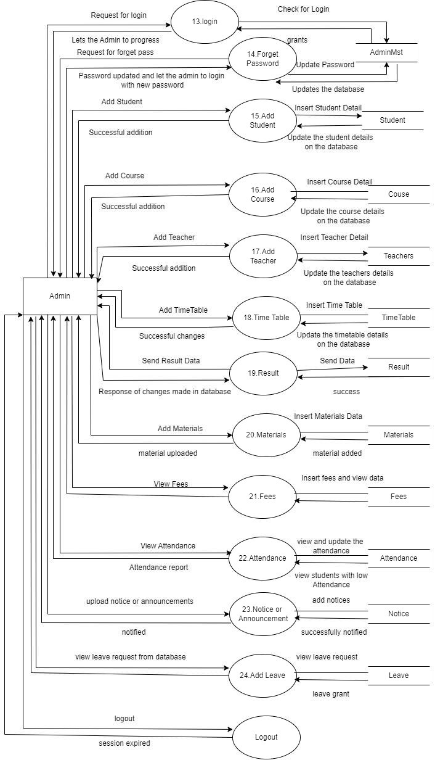

LEVEL 1 STUDENT

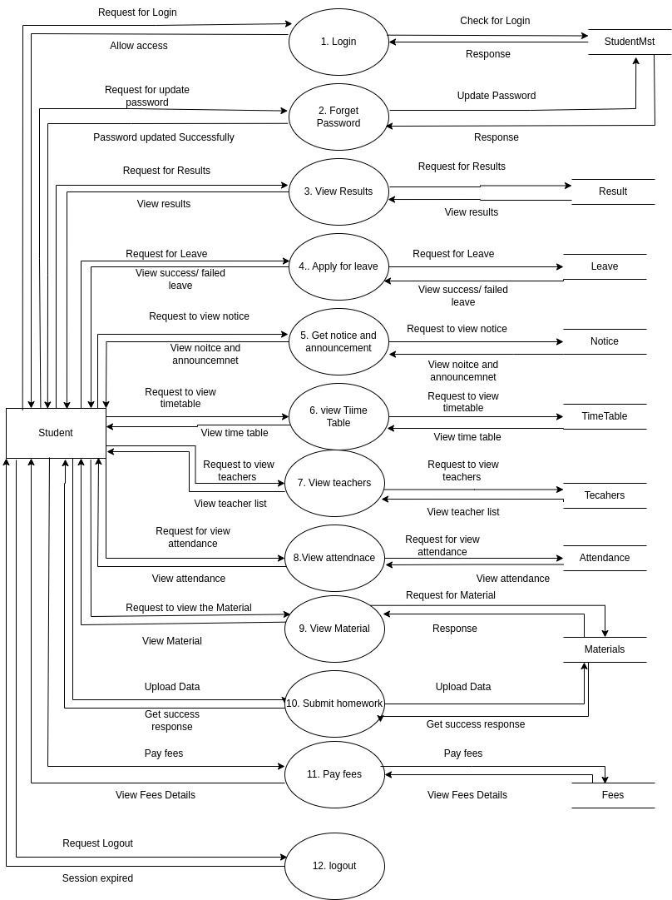

LEVEL 2 ADMIN

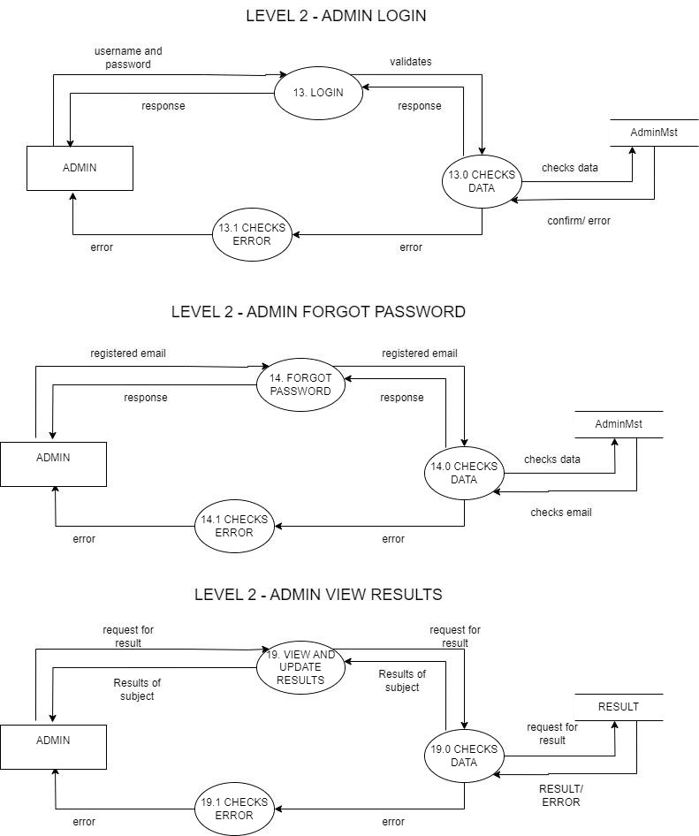

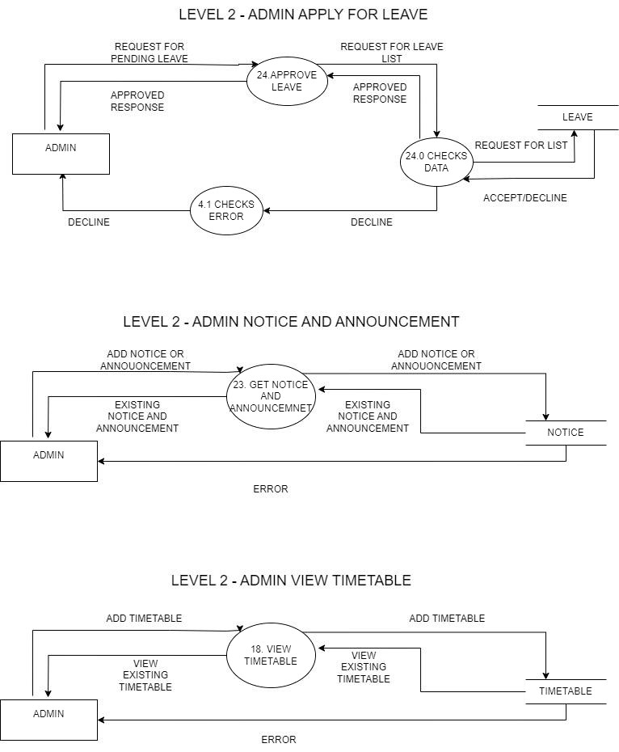

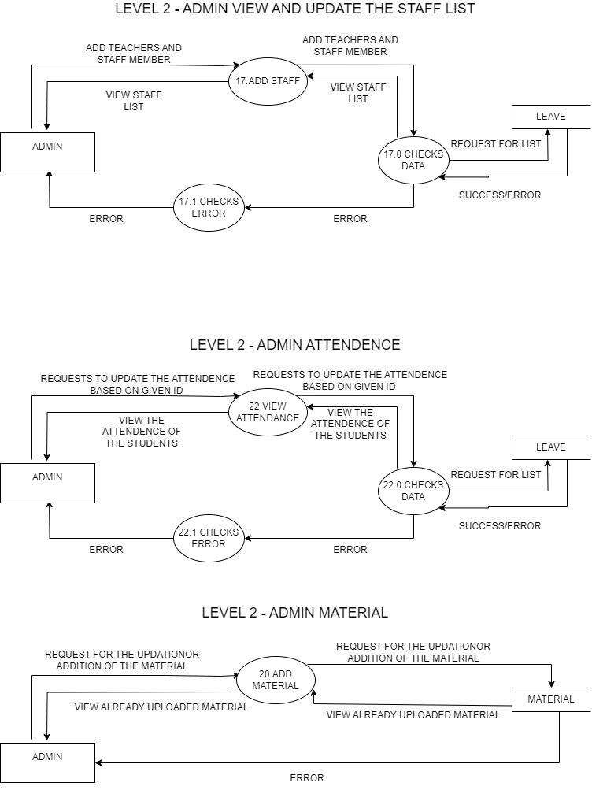

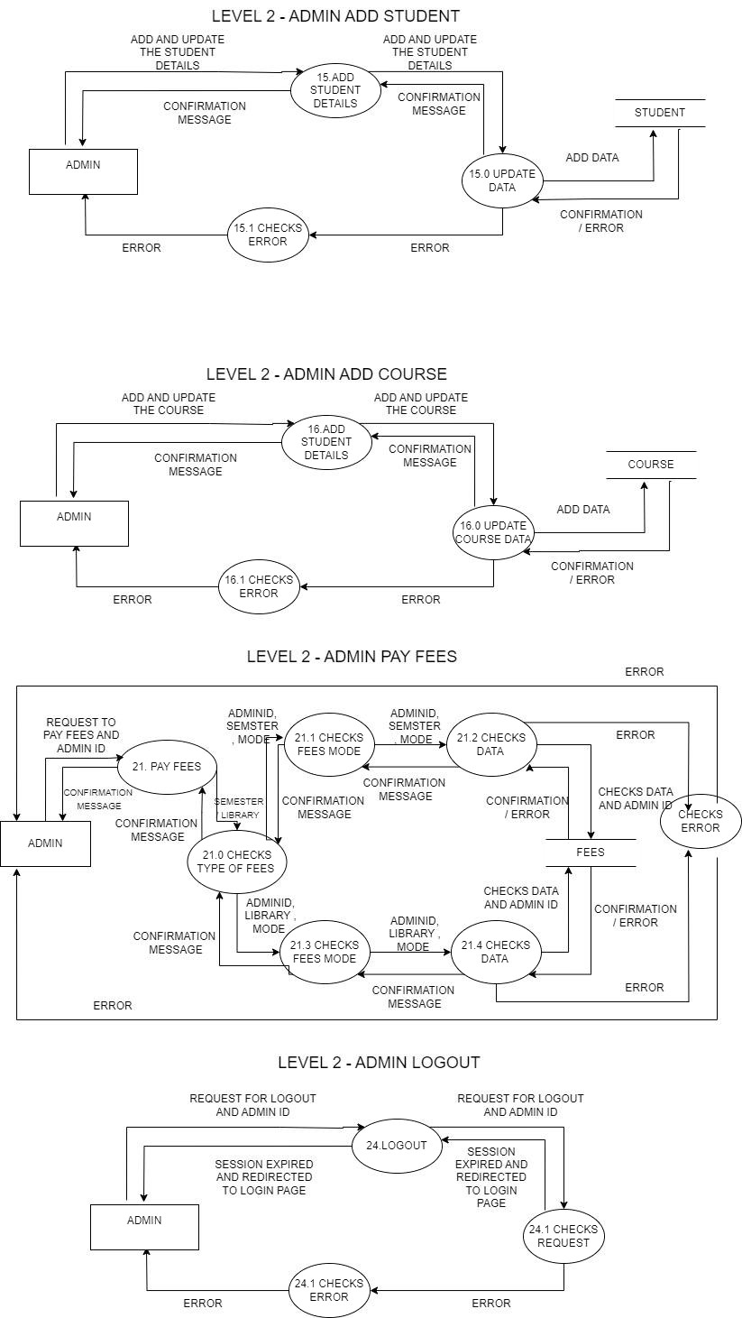

LEVEL 2 STUDENT

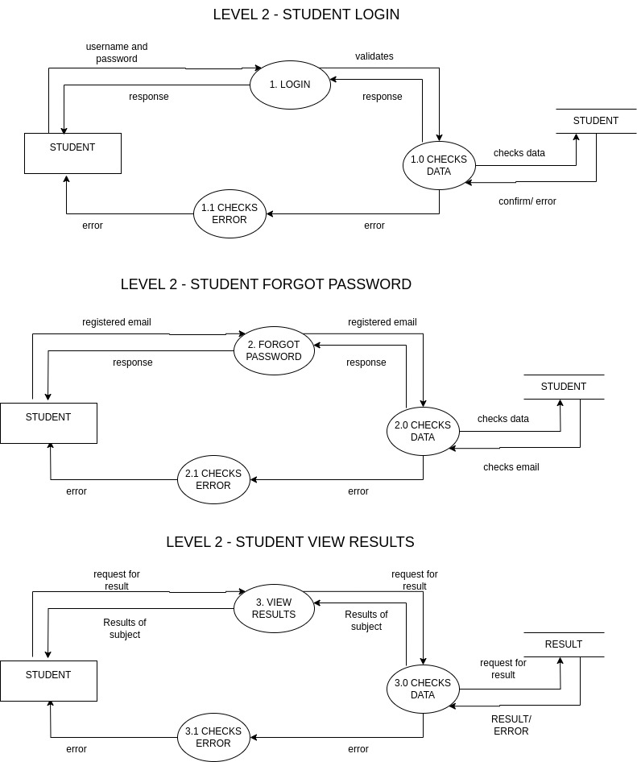

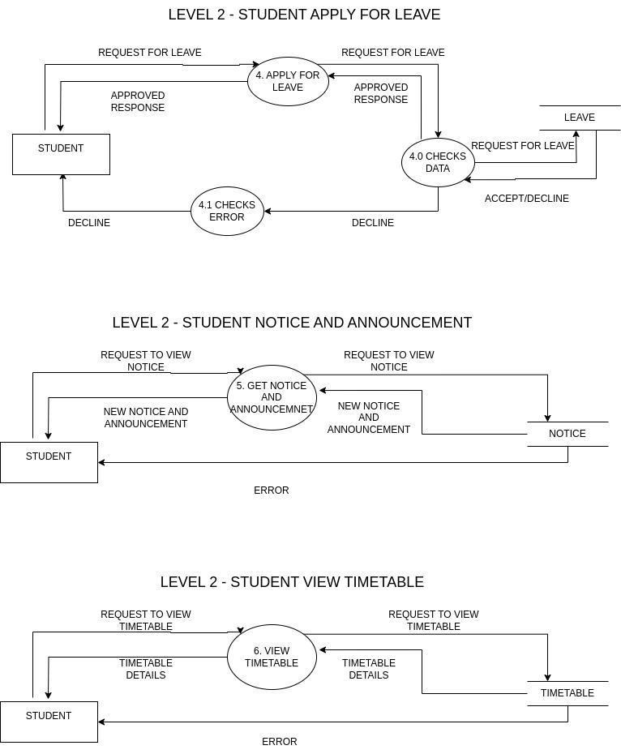

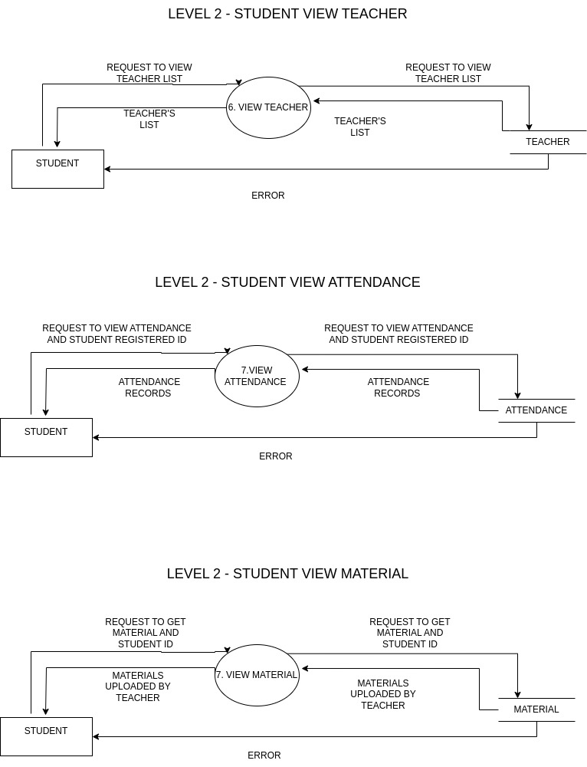

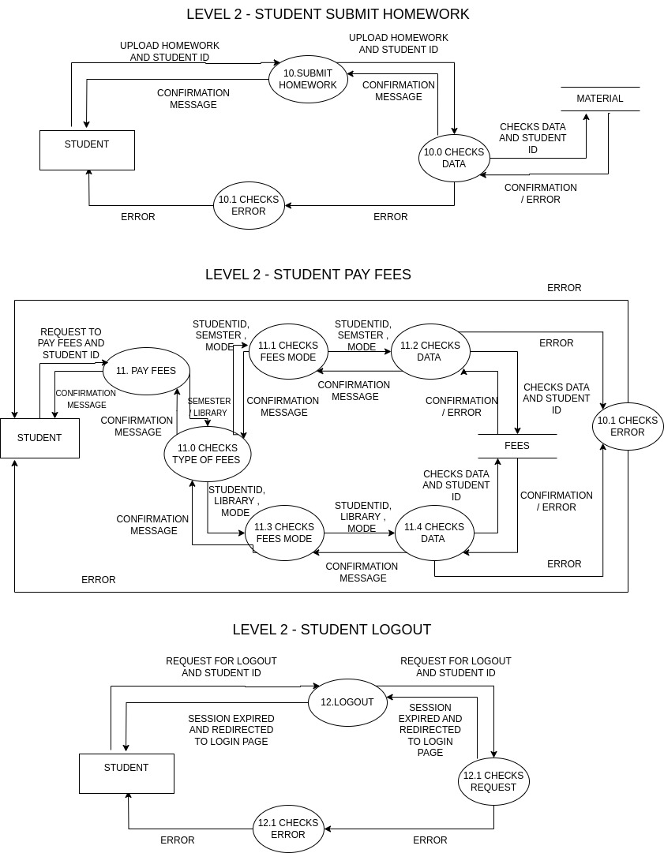

* 1. DECISION TREE

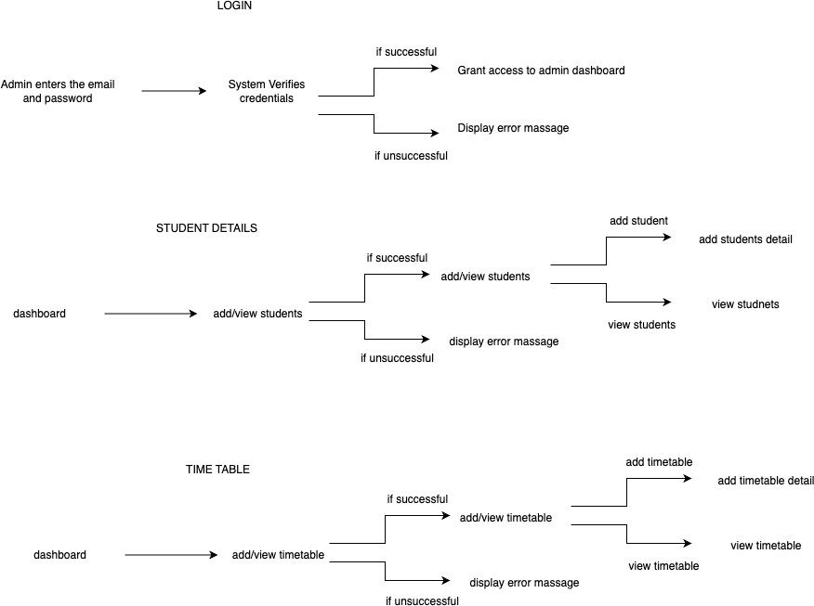

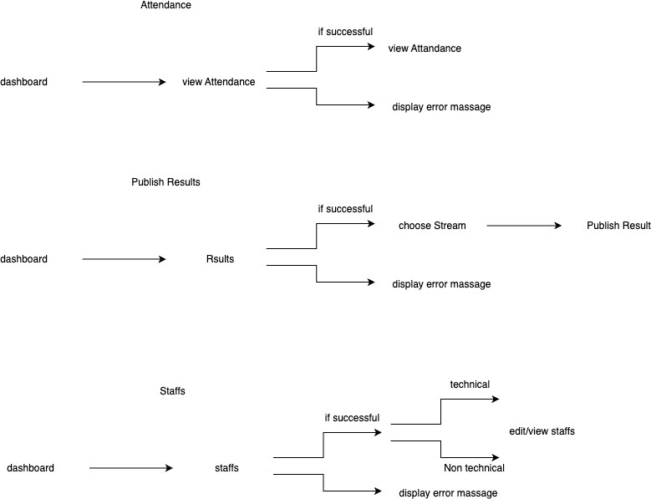

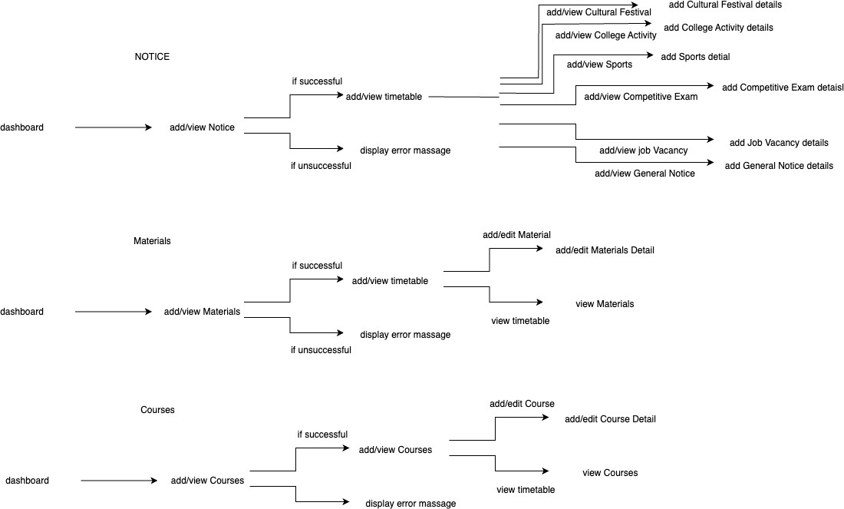

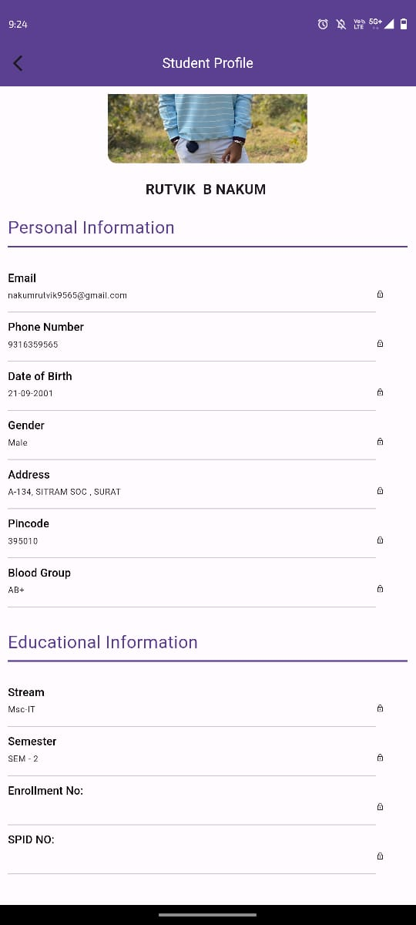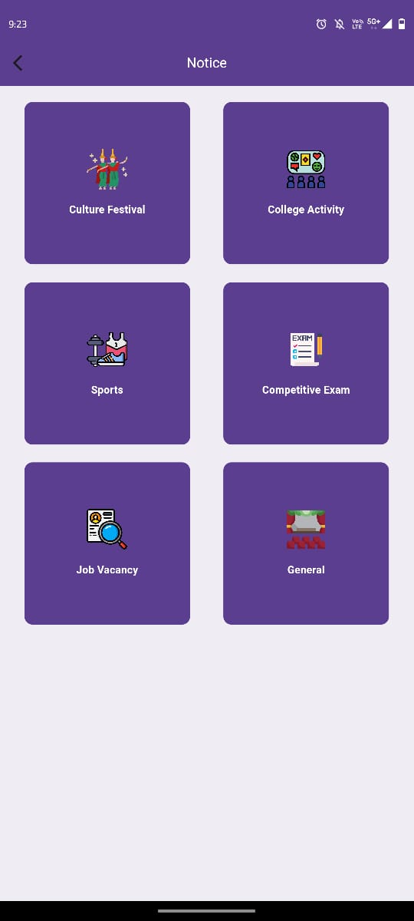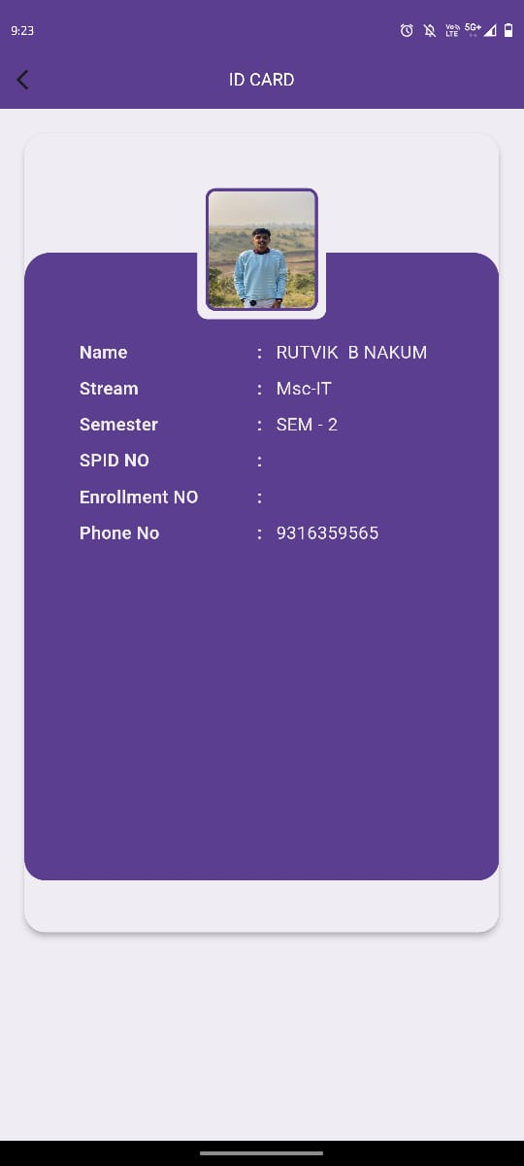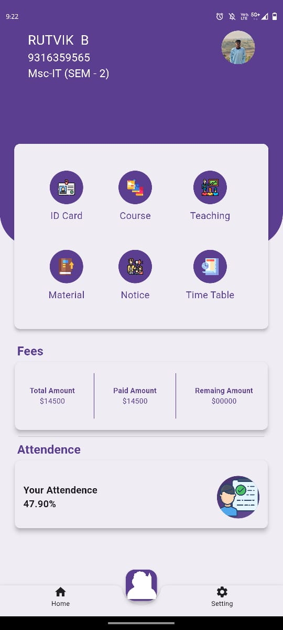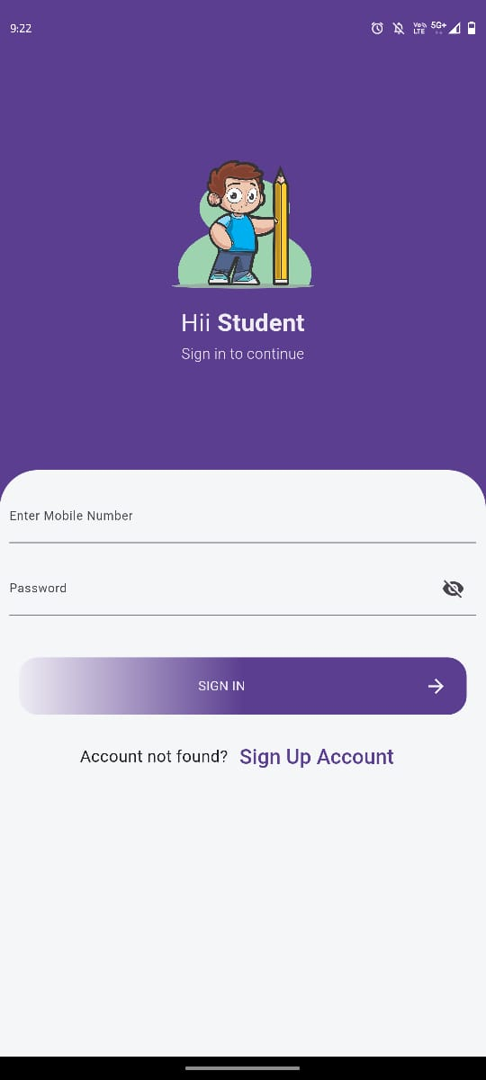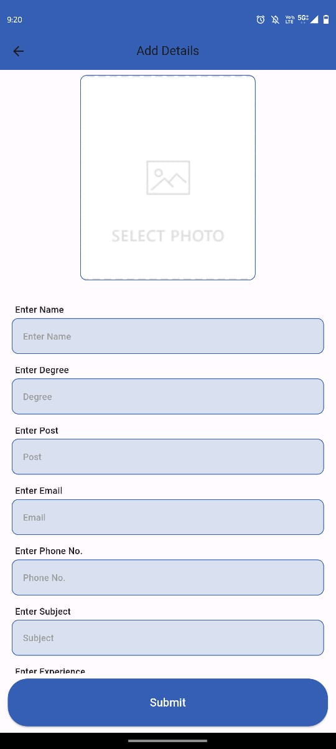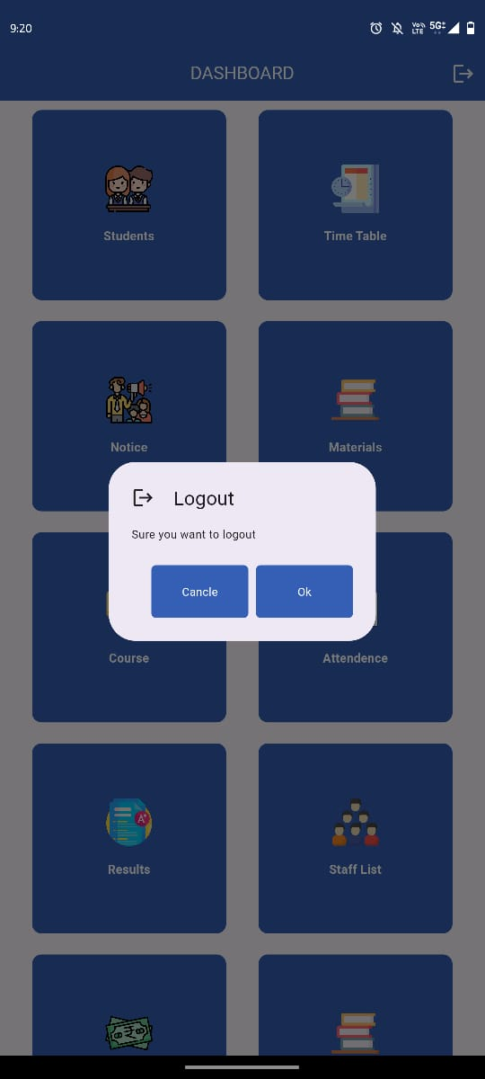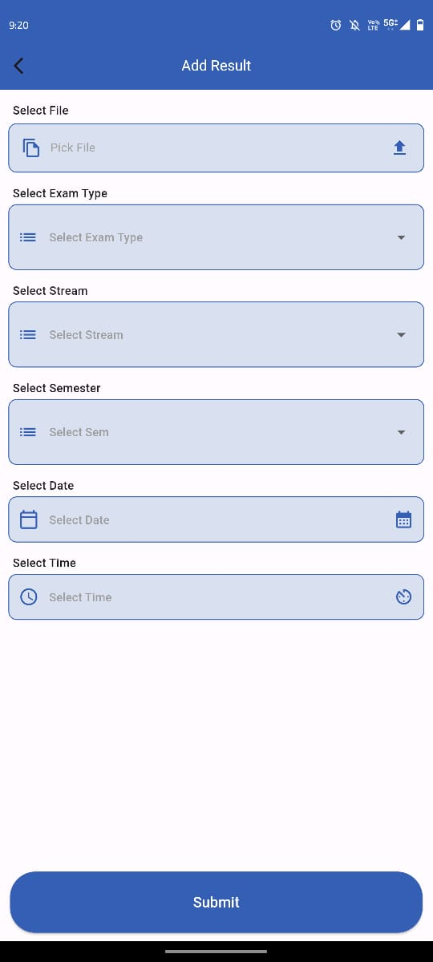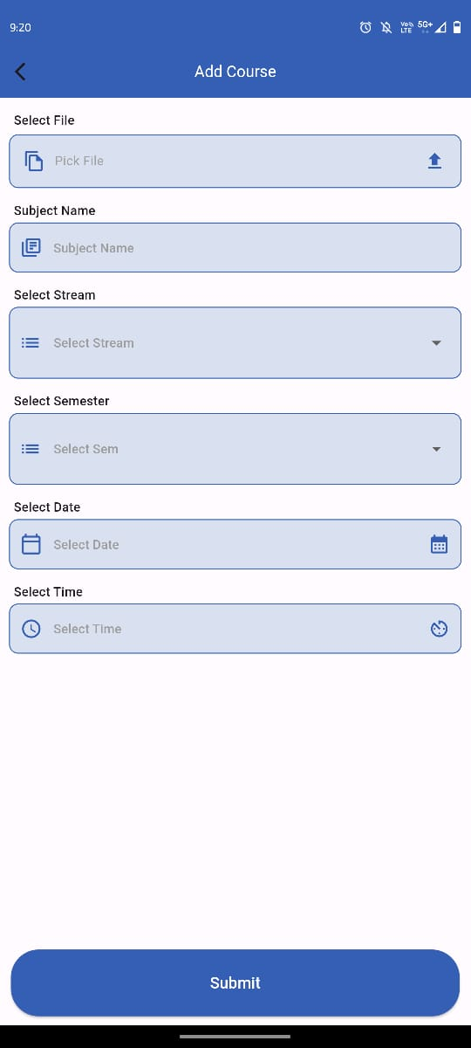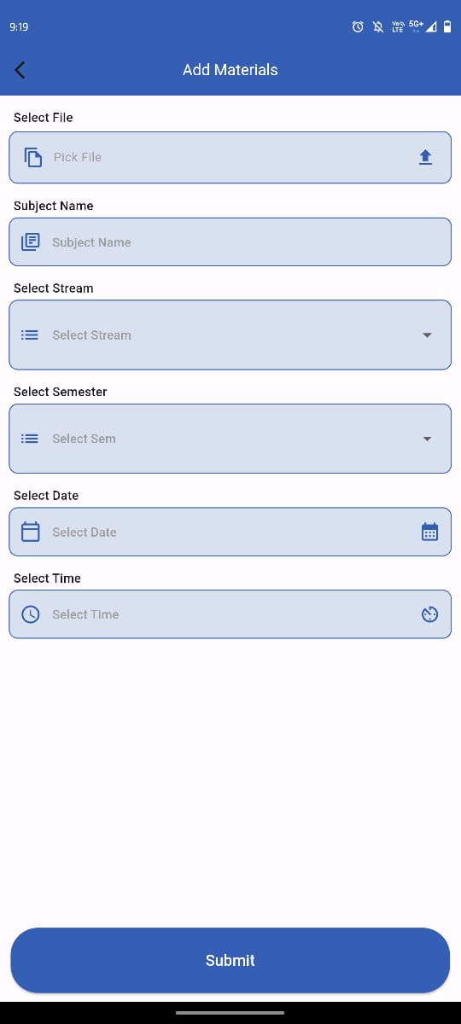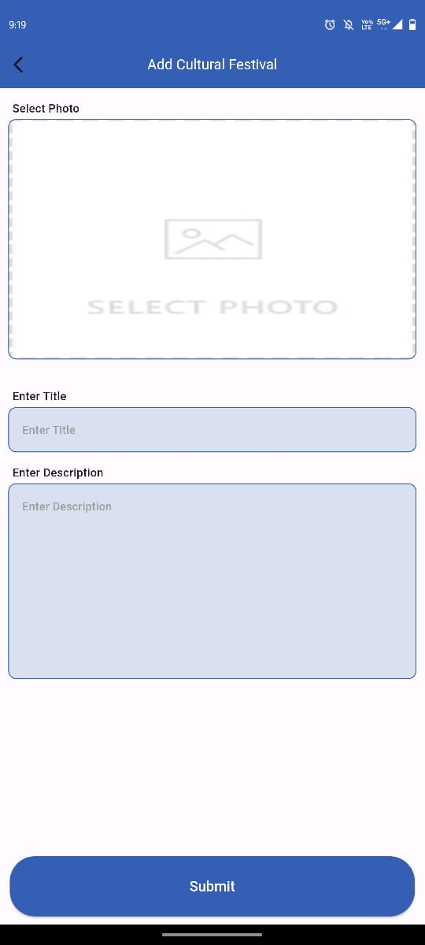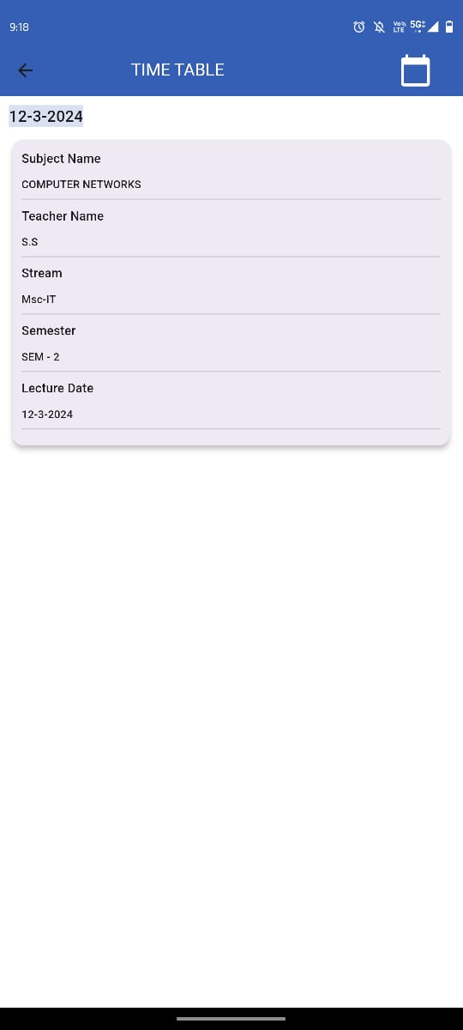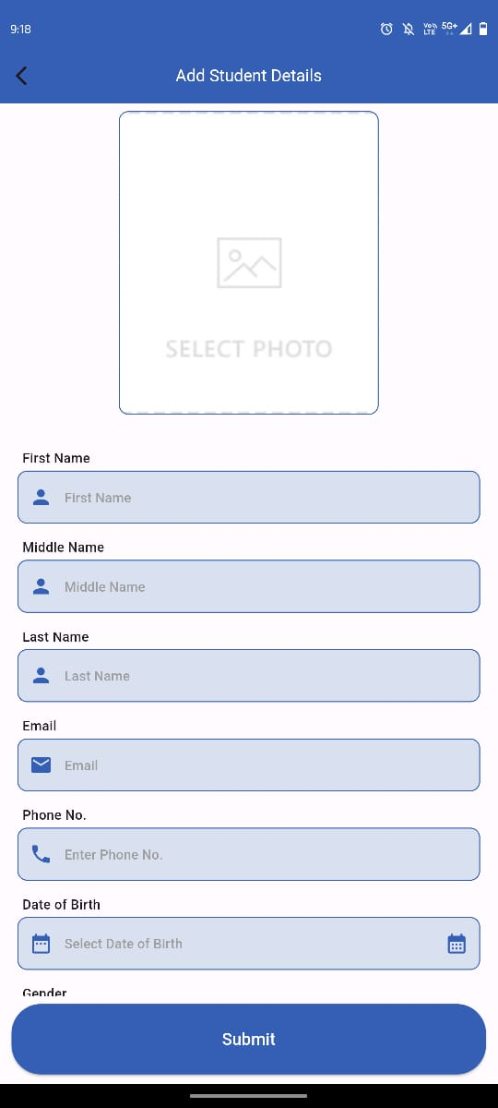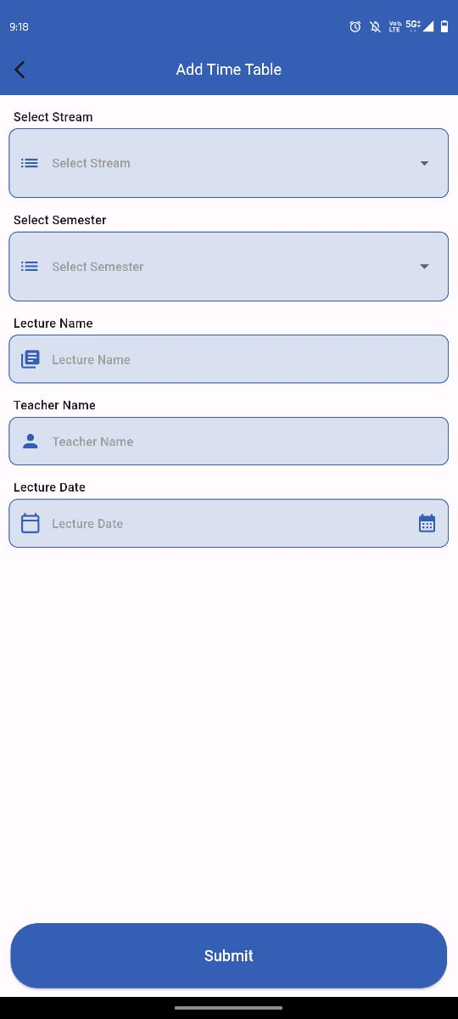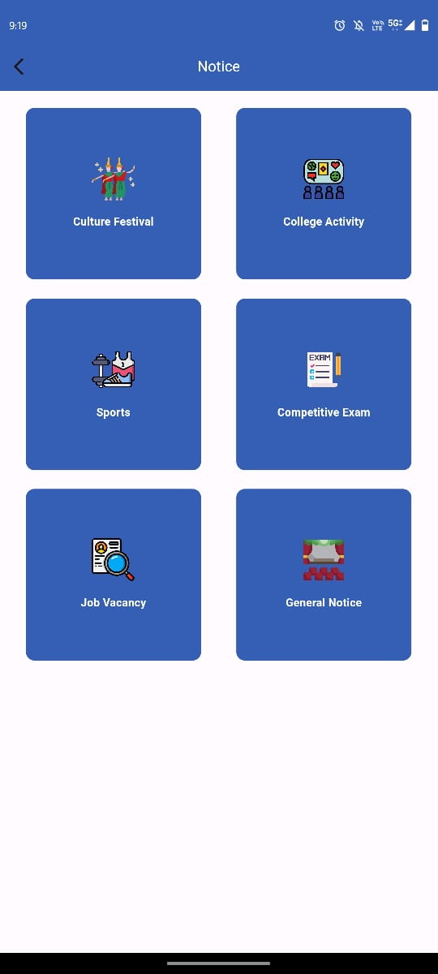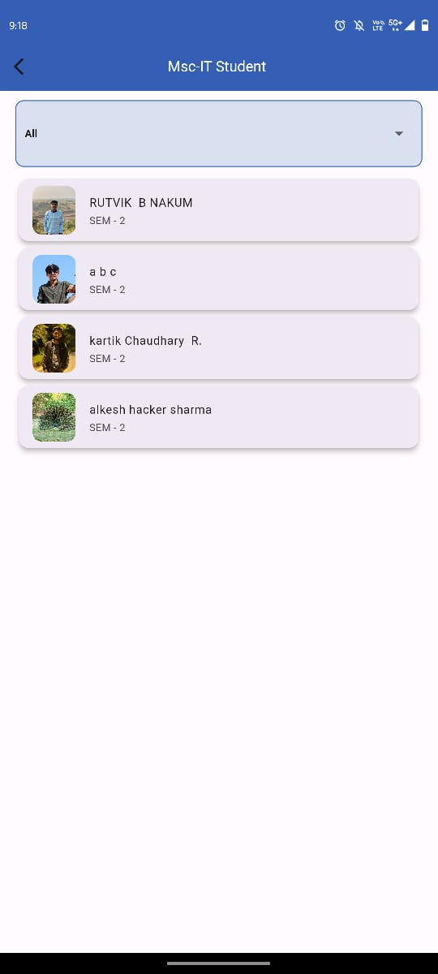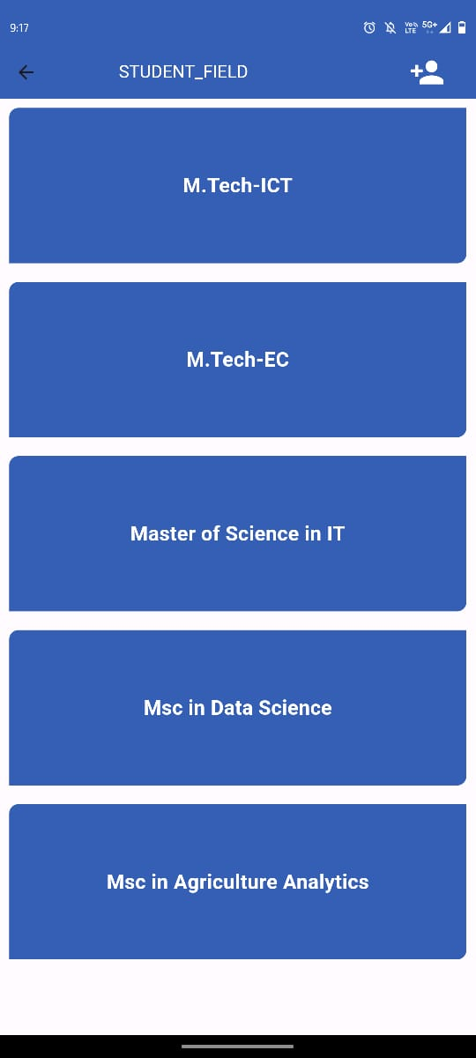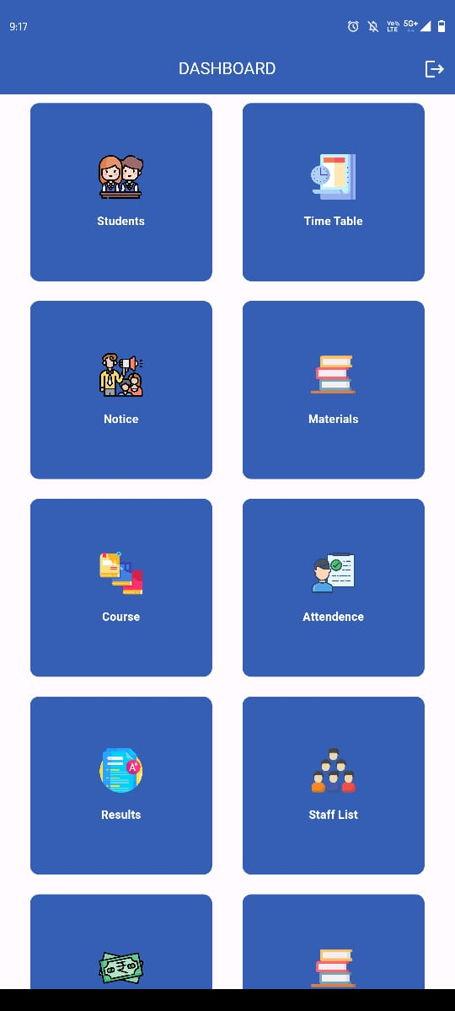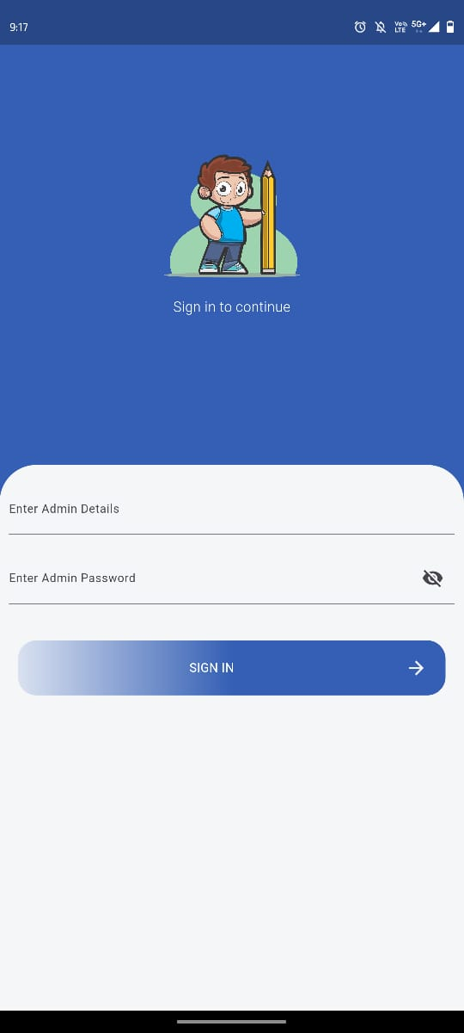

**7. Future Enhancement**

**7.1** Lessons Learnt

1.User-Centric Design : Prioritizing user needs and feedback throughout the development process is crucial for creating a system that is intuitive and valuable to its users. Incorporating features like password options and easy-to-use interfaces enhances user experience.

2.Security Measures : Implementing robust security measures, such as secure login processes and encrypted databases, is essential for safeguarding sensitive information and ensuring user privacy.

3. Effective Communication : Clear and frequent communication among team members, stakeholders, and users helps in understanding requirements, resolving issues promptly, and ensuring project alignment with expectations.

4. Adaptability and Flexibility : Remaining flexible and adaptable to changing requirements, technology advancements, and unforeseen challenges is essential for successful project delivery. Being open to iteration and improvement fosters resilience and innovation.

5. Continuous Improvement : Embracing a culture of continuous improvement fosters innovation, drives efficiency, and ensures that the software remains relevant and valuable over time. Regular feedback collection and iteration based on user insights are key to staying ahead of evolving needs and expectations.

7.2 Mistakes

1.Dependency Management Issues:

Conflicting Dependencies: Failure to manage dependencies properly caused conflicts between different parts of the system, leading to errors during compilation.

Outdated Dependencies: Neglected to update dependencies regularly exposed the system to security vulnerabilities or compatibility issues with other software components.

2. Database Design Flaws(Data Redundancy): Not normalizing the database properly resulted in redundant data storage, increasing storage requirements and potentially causing data inconsistency.

7.3 ACHIEVEMENTS

1. Secure Authentication : Implemented secure login for admins and users.

2. Student Record Management : Developed efficient system for managing student details.

3. Dynamic Timetable : Created dynamic timetable system for course scheduling.

4. Notice & Announcement : Implemented categorized notice system for students and staff.

5. Study Material Sharing : Developed seamless system for sharing study materials.

6. Course Management: Efficiently managed course offerings, including updates and deactivation.

7. Attendance Monitoring : Implemented system for tracking student attendance.