

**PROJECT REPORT**

**Social Media App**

Submitted in partial fulfillment of the requirement for the

3rd Semester of

**MASTER IN COMPUTER APPLICATION**

**TO**

**RK UNIVERSITY, RAJKOT**

**Submitted By**

Student Name :- Rutvik Kamani Enrollment No : 22SOECA21028

Under The Guidance Of

**Internal Guide External Guide Head of Department**

Nirav Pandya, Malay Bhalodiya Dr. Paresh Tanna

Assistant Professor, Owner, BCA/MCA Department,

RK University, Meghsundar Pvt Ltd, School of Engineering,

Rajkot Ahmedabad - Gujarat RK University, Rajkot



**SCHOOL OF ENGINEERING, RK UNIVERSITY, RAJKOT**

**DECLARATION**

We hereby certify that we are the sole author(s) of this project work and that neither any part of this project work nor the whole of the project work has been submitted for a degree to any other University or Institution. We certify that, to the best of my/our knowledge, our project work does not infringe upon anyone’s copyright nor violate any proprietary rights and that any ideas, techniques, quotations, or any other material from the work of other people included in my/our project document, published or otherwise, are fully acknowledged in accordance with the standard referencing practices. We declare that this is a true copy of my/our project work, including any final revisions, as approved by my/our project review committee.

**Signature of Student Signature of faculty**

Date :- 9/12/2023

Place :- RK University - Rajkot



**CERTIFICATE**

This is to certify that the work which is being presented in the Project Report entitled **“Social Media App”,** in partial fulfilment of the requirement for the completion of **Master of Computer Application** and submitted to the School of Engineering, RK University, is an authentic record of my our own work carried out during a period from **June 2023  to December 2023.**

The matter presented in this Project Report has not been submitted by me us for the award of any other degree elsewhere.

**Signature of Student (S)**

Name :- Rutvik Kamani _________________

Enrollment No :- 22SOECA21028

This is to certify that the above statement made by the student(s) is correct to the best of my knowledge.

**Internal Guide External Guide Head of Department**

Nirav Pandya, Malay Bhalodiya Dr. Paresh Tanna

Assistant Professor, Owner, BCA/MCA Department,

RK University, Meghsundar Pvt Ltd, School of Engineering,

Rajkot Ahmedabad - Gujarat RK University, Rajkot

December 2023



**SCHOOL OF ENGINEERING, RK UNIVERSITY, RAJKOT**

**Table Of Contents**

|  |  |
| --- | --- |
| **TITLE** | **PAGE NO** |
| * Acknowledgement | 05 |
| * Abstract | 06 |
| * Introduction | 07 |
| * Project summery | 07 |
| * Purpose | 07 |
| * Project management | 08 |
| * Project planning and schedule | 08 |
| * Schedule representation | 09 |
| * System requirement study | 10 |
| * User characteristics | 10 |
| * Hardware | 11 |
| * System analysis | 12 |
| * Study of current system | 12 |
| * Feasibility study | 12 |
| * Data dictionary | 13 |
| * Use case diagram | 15 |
| * ER Diagram | 16 |
| * Data modelling | 17 |
| * System design | 18 |
| * Flow chart | 18 |
| * Testing | 20 |
| * Test plan | 20 |
| * Testing strategy | 21 |
| * Testing methods | 22 |
| * Testing cases | 23 |
| * Screen short | 25 |
| * Limitation & future enhancement | 31 |
| * Conclusion and discussion | 32 |
| * References | 33 |

**Acknowledgement**

* I would like to express my sincere gratitude to all those who have been instrumental in the successful completion of this project, Social Media WebApp. Their support and contributions have made this endeavor possible.
* Thank you for your tireless efforts in coding, designing, testing, and refining every aspect of the app. Your commitment to excellence has truly made Your Social Media Web App Name a remarkable platform.
* We extend our gratitude to our advisory board members for their invaluable insights, guidance, and strategic input. Your expertise has been instrumental in shaping the vision and direction of Your Social Media Web App Name.
* A special thank you to our beta testers for their time and dedication in providing valuable feedback. Your input has been crucial in refining and enhancing the user experience of Your Social Media Web App Name.
* We express our gratitude to the members of our community who actively contributed ideas, reported issues, and provided continuous feedback. Your enthusiasm and support have been integral to the growth of Your Social Media Web App Name.

**Abstract**

* The Social Media Web Application project aims to create a dynamic and engaging platform for users to connect, share, and communicate in a virtual space.
* In response to the growing significance of social interactions in the digital age, this project focuses on developing a user-friendly, feature-rich web application that facilitates seamless communication and content sharing.

**Introduction**

* Project summery
* The Social Media Web Application project is a comprehensive endeavor aimed at creating a dynamic and user-friendly platform for online social interactions.
* Recognizing the pervasive influence of social media in today's digital landscape, our project focuses on delivering a feature-rich web application that facilitates seamless communication, content sharing, and community building.
* Purpose
* The purpose of a Social Media Web Application can be multifaceted, encompassing various goals and objectives. Here are some common purposes and functionalities associated with social media web applications:
* Connectivity and communication
* Contact sharing
* Notification and engagement
* Entertainment and information
* Education and learning

**Project management**

* Project planning and schedule
* Posting as soon as an idea strikes can be tricky. You’re more likely to make mistakes and typos. Plus, you’ll miss out on opportunities to collaborate with other teams.
* Social media calendars are the perfect solution. They provide social media marketers with dedicated time to create, edit, collaborate on, and schedule posts.
* And you’ll never miss posting about obscure holidays like National Pizza Day again.
* In this post, we’ll show you how to build an effective calendar filled with content that engages audiences on all of your platforms.
* A social media content calendar is a spreadsheet or app used to plan, organize, and track social media posts.
* Like a traditional calendar, a social media calendar provides a big-picture view of the coming weeks and months. It helps you coordinate content so you don’t miss big events or deadlines.
* A good social media calendar tells you the following about each scheduled post:
* The time and date you plan to publish
* The social media platform and account you will share it on
* Post format (in-feed post, story, etc.)
* Content materials (e.g., copy, photos, or video)
* Hashtags and links to use
* Project Plan
* You are probably wondering how to make a social media app and whether it’s a financially viable decision or not.
* This article is your step-by-step guide to social network app development. You will learn the best ways to build a social media app and turn it into a successful business.

Here is an overview of the process to create your own social network app:

* Explore financial benefits of social app development
* Choosing social media app type
* Find your target audience
* Decide on the revenue model
* Come up with a USP and strategy
* Choose basic and advanced features
* Find the best development option
* Choose technology stack
* Start the development process
* Start app promotion
* Measure and analyze results
* Plan further development and support
* Schedule representation

|  |  |  |  |  |
| --- | --- | --- | --- | --- |
| Development Time | July | August | September | October |
| Preliminary Inventory |  |  |  |  |
| System Analysis |  |  |  |  |
| System Design |  |  |  |  |
| Coding |  |  |  |  |
| Testing |  |  |  |  |

**System Requirement study**

* User characteristics
* Understanding user characteristics is crucial for designing and developing a Social Media Web Application that meets the diverse needs and preferences of its users.

Here are key user characteristics to consider:

* Demographics:

**Age**: Different age groups may have varying preferences and expectations. Consider creating an interface that is appealing and intuitive for the target age range.

**Gender**: Some features or content may be gender-specific, so understanding the gender distribution can help tailor the user experience.

* Social interests and hobbies

**Interest Groups:** Recognize and support various interest groups within the platform to foster a sense of community.

**Hobbies and Activities:** Provide features that allow users to share and connect based on their hobbies and activities.

* Communication preferences

**Communication Styles:** Some users prefer short text updates, while others may favor longer-form content or multimedia. Accommodate different communication styles.

**Frequency of Interaction:** Understand how often users want to engage with the platform and adjust notification settings accordingly.

* Privacy concerns

**Privacy Preferences:** Implement robust privacy controls to allow users to customize the visibility of their content and personal information.

**Data Security Awareness:** Communicate security measures to assure users that their data is protected.

**Hardware**

* Recommended hardware
* To run the application system in the computer the minimum configuration required is as below:
* Multi-core processor
* 8 GB or more for better performance
* SSD for faster data retrieval
* Recommended software
* The configuration of the system which is used for the development such as coding and testing is given as below :
* Windows 10 or more
* Visual Studio
* Mysql or any Database

**System Analysis**

* Study of current system
  + System Study is a Problem-Solving technique that decomposed a system into its component pieces for the purpose of the studying how well those component parts work and interact to accomplish their purpose.
  + According to the Merriam-Webster dictionary, systems analysis is the process of studying a procedure or business in order to identify its goals and purposes and create systems and procedures that 5ill achie1e them in an efficient Way.
  + Analysis and synthesis, as scientific methods, always go hand in hand; they complement one another. Every synthesis is built upon the results of a preceding analysis, and every analysis requires a subsequent synthesis in order to verify and correct its results.
* Feasibility study
  + Whatever we think need not be feasible. It is wise to think about the feasibility of any problem we undertake. Feasibility is the study of impact, which happens in the organization by the development of a system. The impact can be either positive or negative. When the positives nominate the negatives, then the Page 16 of 55 system is considered feasible. Here the feasibility study can be performed in two ways such as technical feasibility and Economical Feasibility.
  + The developing system must be justified by cost and benefit. Criteria to ensure that effort is concentrated on project, which will give best, return at the earliest. One of the factors, which affect the development of a new system, is the cost it would require.
  + Since the system is developed as part of project work, there is no manual cost to spend for the proposed system. Also all the resources and already available, it given an indication of the system is economically possible for development.
* Data Dictionary
* Database :- socialbook

Table :- User

|  |  |  |  |
| --- | --- | --- | --- |
| **NO** | **NAME** | **TYPE** | **CONSTRUCTOR** |
| 1 | Id | Bigint(20) | Primary key |
| 2 | First_name | Varchar(150) |  |
| 3 | Last_name | Varchar(150) |  |
| 4 | Email | Varchar(150) |  |

Table :- followerscount

|  |  |  |
| --- | --- | --- |
| **No** | **Name** | **Type** |
| 1 | Id | Bigint(20) |
| 2 | Follower | Varchar(100) |
| 3 | User | Varchar(100) |

Table :- likepost

|  |  |  |  |
| --- | --- | --- | --- |
| **No** | **Name** | **Type** | **CONSTRUCTOR** |
| 1 | Id | Bigint(20) | Primary key |
| 2 | post_id | Varchar(100) |  |
| 3 | Username | Varchar(100) |  |

Table :- post

|  |  |  |
| --- | --- | --- |
| **No** | **Name** | **Type** |
| 1 | Id | Bigint(20) |
| 2 | User | Varchar(100) |
| 3 | Image | Varchar(100) |
| 4 | Caption | Longtext |
| 5 | Created_at | Datetime(6) |
| 6 | No_of_likes | Int(11) |

Table :- profile

|  |  |  |  |
| --- | --- | --- | --- |
| **No** | **Name** | **Type** | **CONSTRUCTOR** |
| 1 | Id | Bigint(20) | Primary key |
| 2 | Id_user | Int(11) |  |
| 3 | Bio | Longtext |  |
| 4 | Profileimg | Varchar(100) |  |
| 5 | Location | Varchar(100) |  |
| 6 | User_id | Int(11) |  |

* Use case diagram

Use case diagram for user

Create Profile

Login

View Profile

Edit Profile

User

Post Content

Like

Comment

Search

Logout

Use-case-diagram for Admin

Admin

Manage user account

Delete Content

Show all user

* ER Diagram

follower_count

user

like_post

post

profile

* Data Modelling
  + A data model shows the client’s information needs and business processes through entities, relationships and data required within the system. It complements the data flow diagram which shows how the data is processed.
  + Data models can be conceptual (high level entities and relationships to document business concepts or high Level requirements), logical (more detailed information on entities, attributes and relationships by often expanding the conceptual model to include attributes, columns, fields and keys) or physical (how data is stored and managed in an application).
  + Data models are diagrams supported by textual descriptions. They can include people, places, things, concepts, attributes and relationships. Textual descriptions are usually included dictionary.

**System Design**

* Flow Chart
* 0 Level

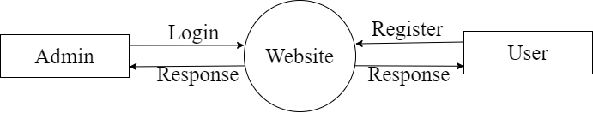

* 1 Level

Login

Manage User

Manage all user activity

Admin

Logout

* 2 Level

Login

Add Post

Add Description Post

User

Add Follower

Add Following

Manage Account

Logout

**Testing**

* Software testing is the process of evaluating and verifying that a software product or application does what it is supposed to do. The benefits of testing include preventing bugs, reducing development costs and improving performance.
* Test Plan
* Like any project, the testing also should be driven by a plan. The test plan generates the report for the execution and tracking of the entire testing project.
* Preparing the test plan
  + What needs to be the tested-the scope of testing, including clear identification of what will be the tested & what will not be tested.
  + How the testing is going to be performed -breaking down the testing into small and manageable tasks and identifying the strategies to be used for carrying out the tasks.
  + Resource needed for testing.
  + The timelines by which the testing activities will be performed.
  + Risks that may be faced in all of the above, with appropriate Page 25 of 55 mitigation and contingency plans.
* Testing Strategy
* Writing a Test Strategy effectively is a skill that every tester should achieve in their career. It initiates your thought process that helps to discover many missing requirements. Thinking and test planning activities help the team to define the Testing scope and Test coverage.
* It helps Test managers to get the clear state of the project at any point. The chances of missing any test activity are very low when there is a proper test strategy in place.
* Test execution without any plan rarely works. I know teams who write strategy document but never refer back while test execution. The Testing Strategy plan must be discussed with the whole team so that the team will be consistent with its approach and responsibilities.
* In tight deadlines, you can’t just waive any testing activity due to time pressure. It must at least go through a formal process before doing so.
* Testing methods
* Testing methodologies are the strategies and approaches used to test a particular product to ensure it is fit for purpose. Testing methodologies usually involve testing that the product works in accordance with its specification, has no undesirable side effects when used in ways outside of its design parameters, and will fail safely in the worst-case scenario.
* As software applications get ever more complex and intertwined and with the large number of different platforms and devices required to test, it is more important than ever to have a robust testing methodology.
* Without the proper development and testing methodologies for modern software, projects will inevitably go over budget, take longer than necessary, and not meet stakeholder expectations.
* Two Types of Testing

1. Blackbox Testing

Blackbox Testing can be used to validate the report meets all the specified requirements. Testers can review the report against the project objectives and deliverables to ensure that they are adequately addressed.

1. Whitebox Testing

Whitebox Testing for a project report involves examining the structure and organization of the document. Testers analyse how well the report is structured, including the logical flow of sections, of information, and the overall organization.

* Testing Cases

|  |  |
| --- | --- |
| **Test Case Specification** | **Description** |
| Test Case ID | Unique ID to identify/report the bug if present in the functionality of software |
| Test Case Objective | The purpose of the test. The lists can be generated to perform intended task for which software is developed. Results should always follow the test case objective |
| Pre-requisite | This can include environment setup, supporting software environment setup. for the project, or any fields in which user will give the input. So that test cases can be planned accordingly. |
| Steps | This includes steps to be performed to give the input to the system, so that system can perform its specified task and display the result accordingly. If automated testing is used, then, these steps are translated to the scripting language of the tool. |
| Input Data | The choice of input data will be depended on the test case itself and the technique followed in the test case. For E.X. equivalence partitioning, boundary value analysis etc. |
| Expected Result | It can be the user required output to be shown |
| Actual Result | This step should do a comparison of the expected and actual results to highlight any differences. |
| Status | Whether expected results and actual result match, if it matches then PASS or else FAIL |

**Screen short**

* Register Page

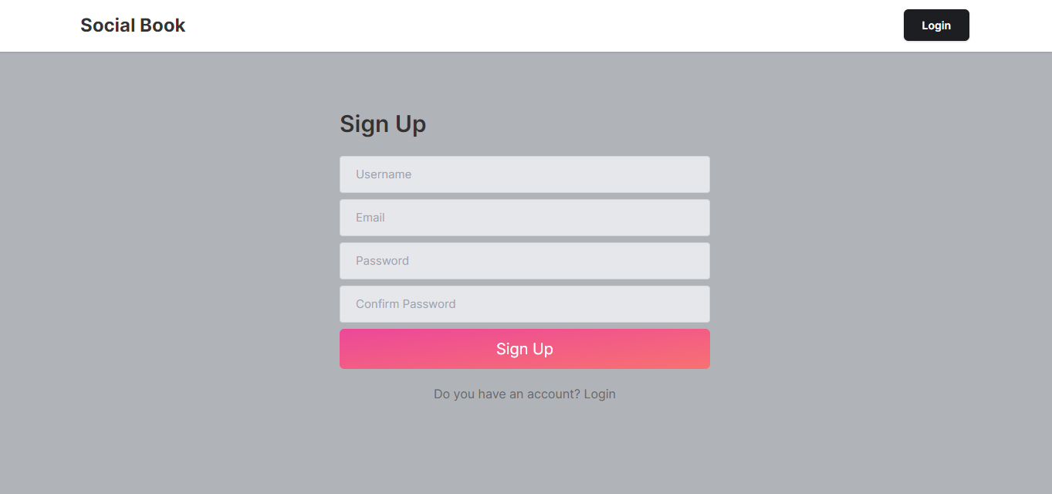

This is user register page

* Login Page

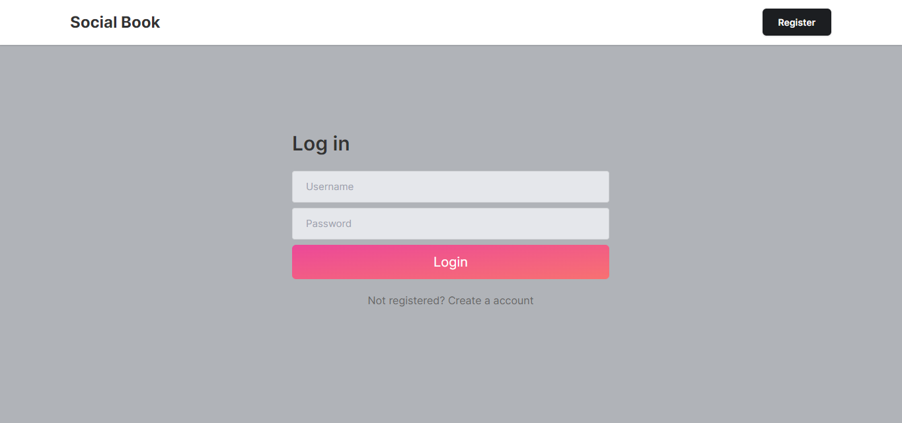

This is login page

* Home Page

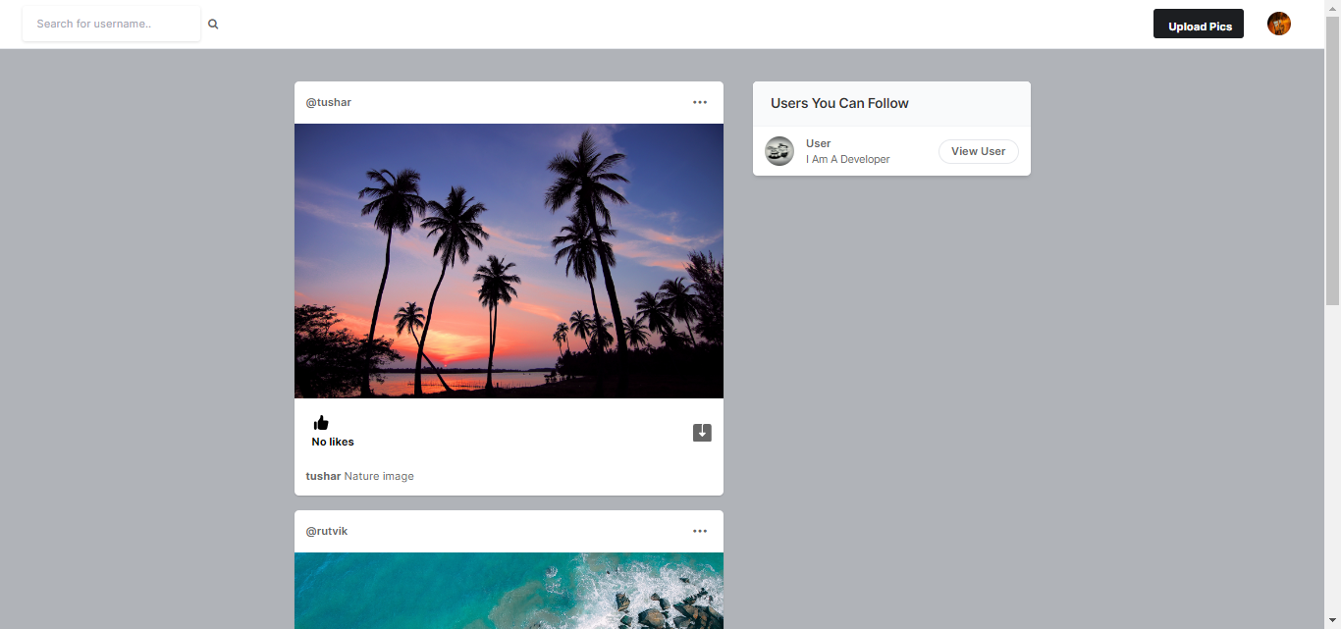

This is user home page

* Search User

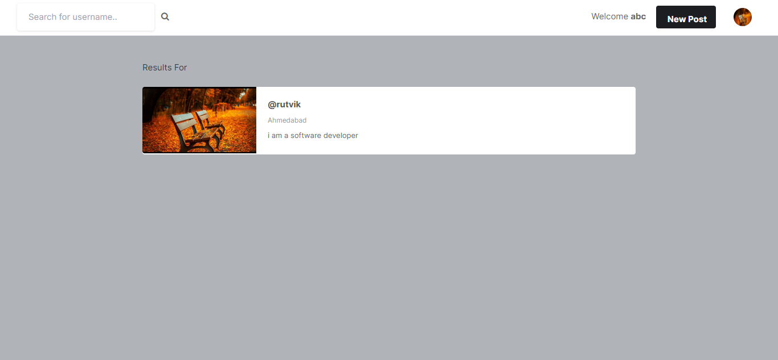

This is search user page

* User setting page

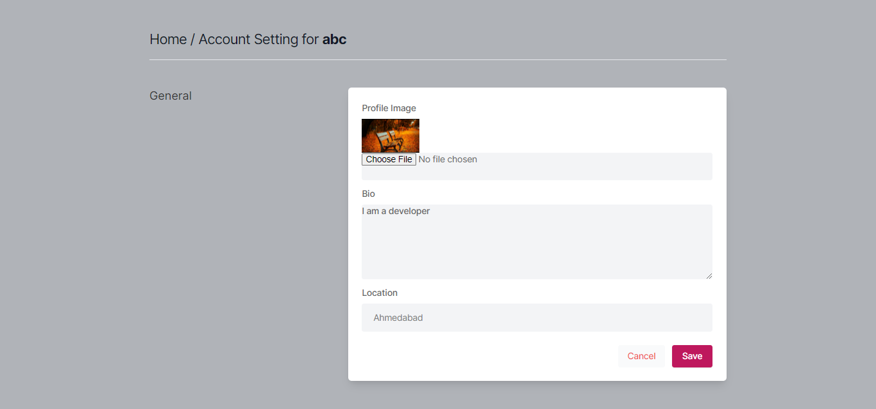

This is user setting page

* Upload image page

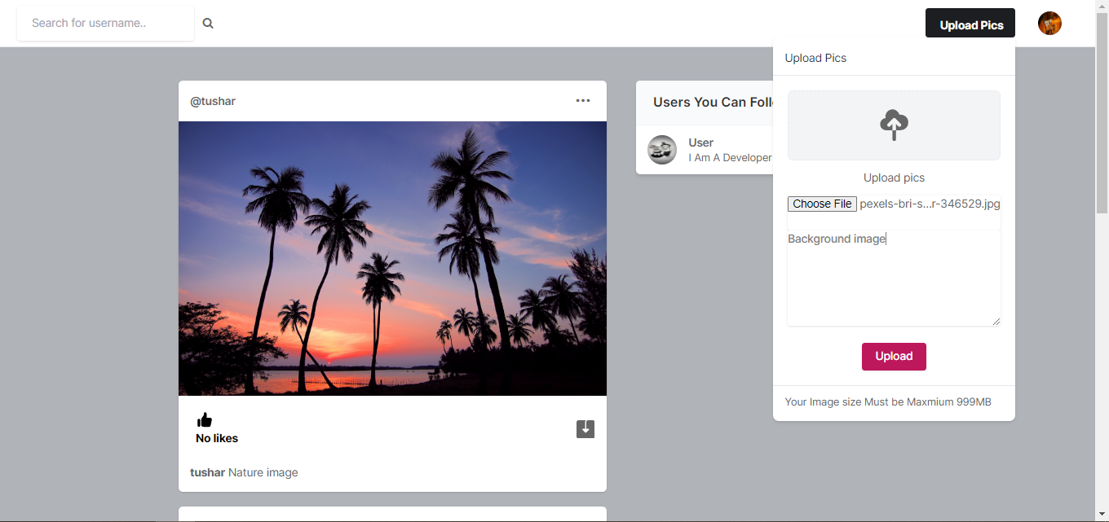

This is image upload page

* User profile page

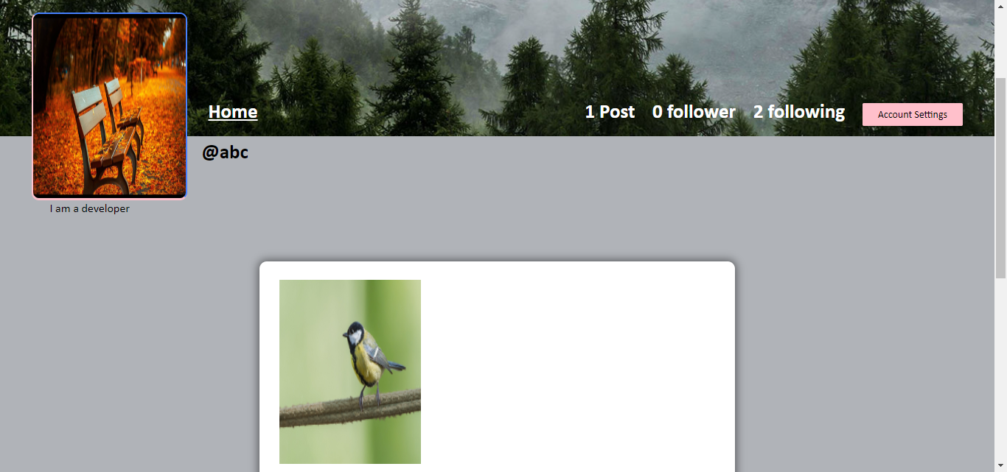

This is user profile page

* Admin panel

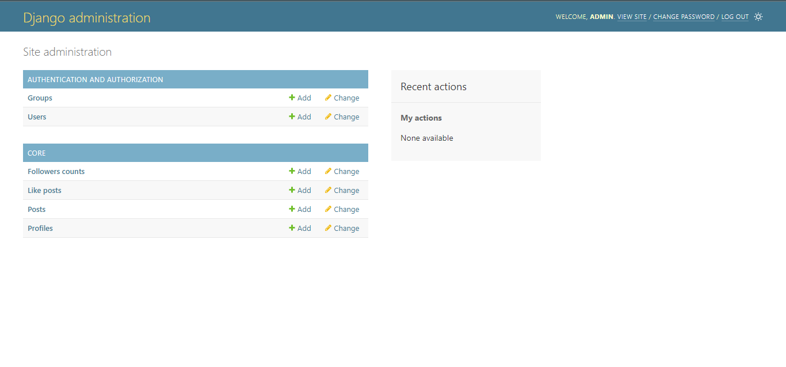

This is admin panel page

* User profile page

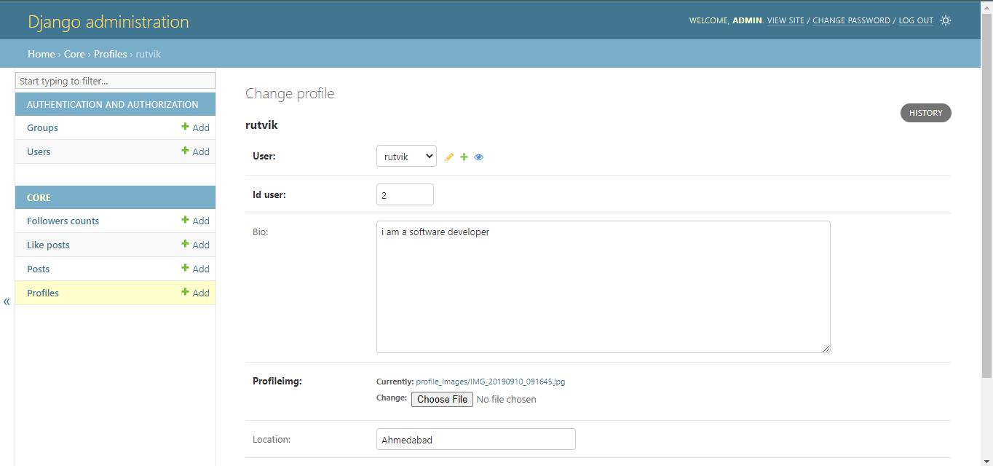

This is user profile page

* User post page

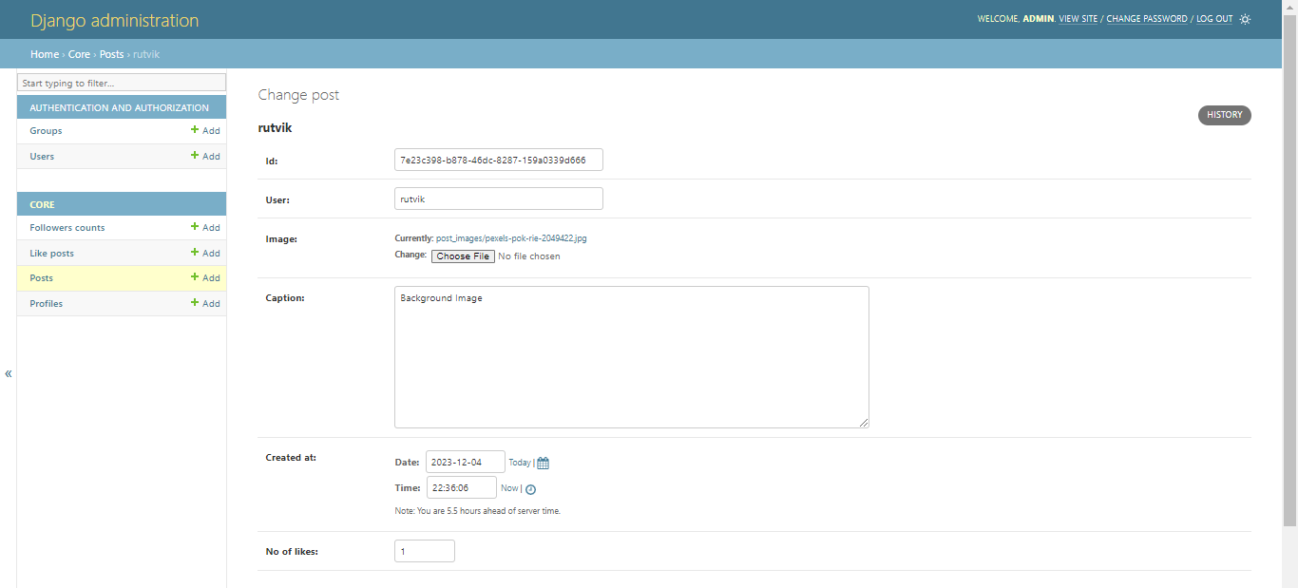

This is user post page

* User like post page

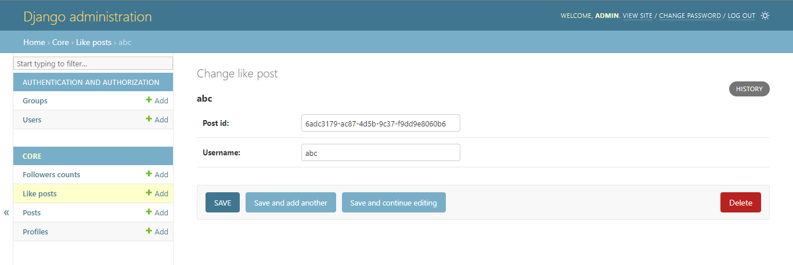

This is user like page

* Followers count page



This is followers count page

**Limitation & future enhancement**

* Using social media management platforms has its drawbacks as well. Like Hootsuite, it’s also being known to cause effectively penalties by the algorithm of the social media platform that it’s being posted to.
* So, there’s has been times where we’ve seen the reach of the post that’s came from a social media management tool being posted on Facebook has not received the same amount of reach as opposed to the post that’s been placed organically on Facebook.
* Another instance would be posts sent via Facebook scheduler which is intended to go live at an optimum time coming from the scheduler may not always perform as well as compared to something being posted live, real time, as it happens.
* These software has the tendency to have bugs or to have issues that can cause scheduling issues, image issues, not rendering the image the way that you want it to, not picking up on links in the same way other social media platform might.

**Conclusion and discussion**

* The effects from social media are very complex and vary from person to person. Based on our data we found that many people either experience negative effects or notice them in other people
* However, in the time we’ve had to conduct research we were not able to find direct and clear causation, but we are hoping with more time and further research so we can get clearer conclusions.
* All of the interviewees said that they want to decrease how much they use social media and their phone in general but we failed to ask them if they would.
* With the knowledge of both positive and negative affects it would be interesting to see if they would and would give good insight into how addicted our generation is.
* These types of questions could lead to good information that could help us figure out why we are all so addicted to our devises.

**References**

* Search Engines
  + <https://www.google.com/>
* Visited Sites
  + <https://docs.djangoproject.com/en/4.1/>
  + <https://github.com/>
  + <https://www.geeksforgeeks.org/django-tutorial/>
  + <https://stackoverflow.com/>