The Silent Epidemic: HIV Among the World’s Children
A UNICEF Data Report | BAA1030
AUTHOR
Rutvik Hudl
PUBLISHED
April 14, 2026

1 Introduction
Every year, hundreds of thousands of children are born into a world where HIV still poses a devastating threat. Despite decades of global health efforts, the epidemic continues to disproportionately affect the world’s most vulnerable populations — particularly in Sub-Saharan Africa.
In 2024 alone, South Africa recorded an estimated 39,000 new HIV infections, making it the hardest-hit country in this dataset. Mozambique followed with 17,000, and India with 15,000 — together these three countries account for a staggering share of global new infections.
This report uses UNICEF data to explore the global landscape of new HIV infections, examining:
- Which countries carry the heaviest burden of new infections
- How national wealth relates to HIV outcomes
- Whether progress is being made over time
- The relationship between child underweight rates and HIV burden
“AIDS is no longer just a disease, it is a human rights issue.” — Nelson Mandela

2 Data & Methodology
The analysis draws on three UNICEF datasets:
- unicef_indicator_1.csv — Estimated number of new HIV infections by country (2010–2024), broken down by sex
- unicef_indicator_2.csv — Child underweight rates (Weight-for-age below -2 SD) by country and year
- unicef_metadata.csv — Country-level metadata including GDP per capita, life expectancy, and population
All monetary values are expressed in constant 2015 USD. Values reported as ranges (e.g., <100) have been converted to their numeric midpoint for analysis.
📦 Load libraries and data
✅ Indicator 1 (HIV): 3,769 rows, 14 columns
✅ Indicator 2 (Underweight):3,124 rows, 14 columns
✅ Metadata: 13,715 rows, 15 columns

Sex categories in Indicator 1: ['Female', 'Male', 'Total']
Year range: 2010 – 2024
🔧 Prepare analysis datasets
Countries in HIV dataset: 85
Top 5 by new infections (2024):
country obs_value time_period
South Africa 39000.0 2024
Mozambique 17000.0 2024
India 15000.0 2024
Uganda 6000.0 2024
Tanzania, United Republic of 5900.0 2024

3 🗺️ Global Overview — World Map
The map below reveals a stark geographic concentration of new HIV infections. Sub-Saharan Africa — particularly eastern and southern regions — bears a disproportionate share of the global burden, while high-income nations in Europe and North America show dramatically lower rates.
🗺️ World Map Chart
Downloaded shapefile ✅
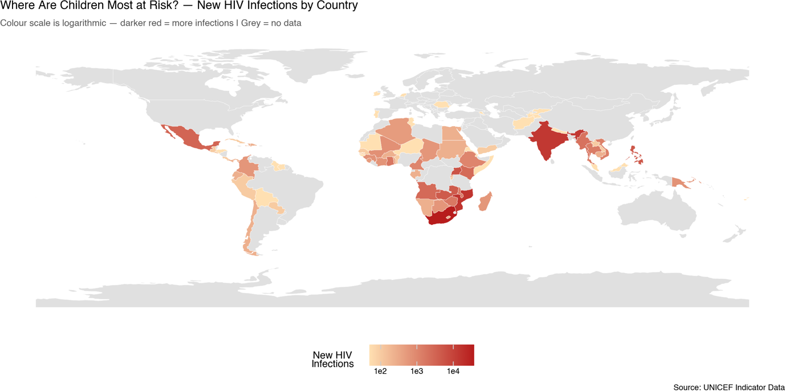
Figure 1: Estimated new HIV infections per country, most recent year available. Grey = no data.
The map makes the geographic inequality unmistakable. Southern and Eastern Africa dominate in deep red, while most of Europe, North America, and East Asia remain pale — reflecting not just disease burden but also vast differences in healthcare access, prevention infrastructure, and socioeconomic conditions.

4 📊 The Hardest Hit Countries — Bar Chart
Looking at individual countries, the concentration of the epidemic becomes even clearer. The 15 countries below collectively account for the vast majority of all new HIV infections recorded in UNICEF data.
📊 Bar Chart
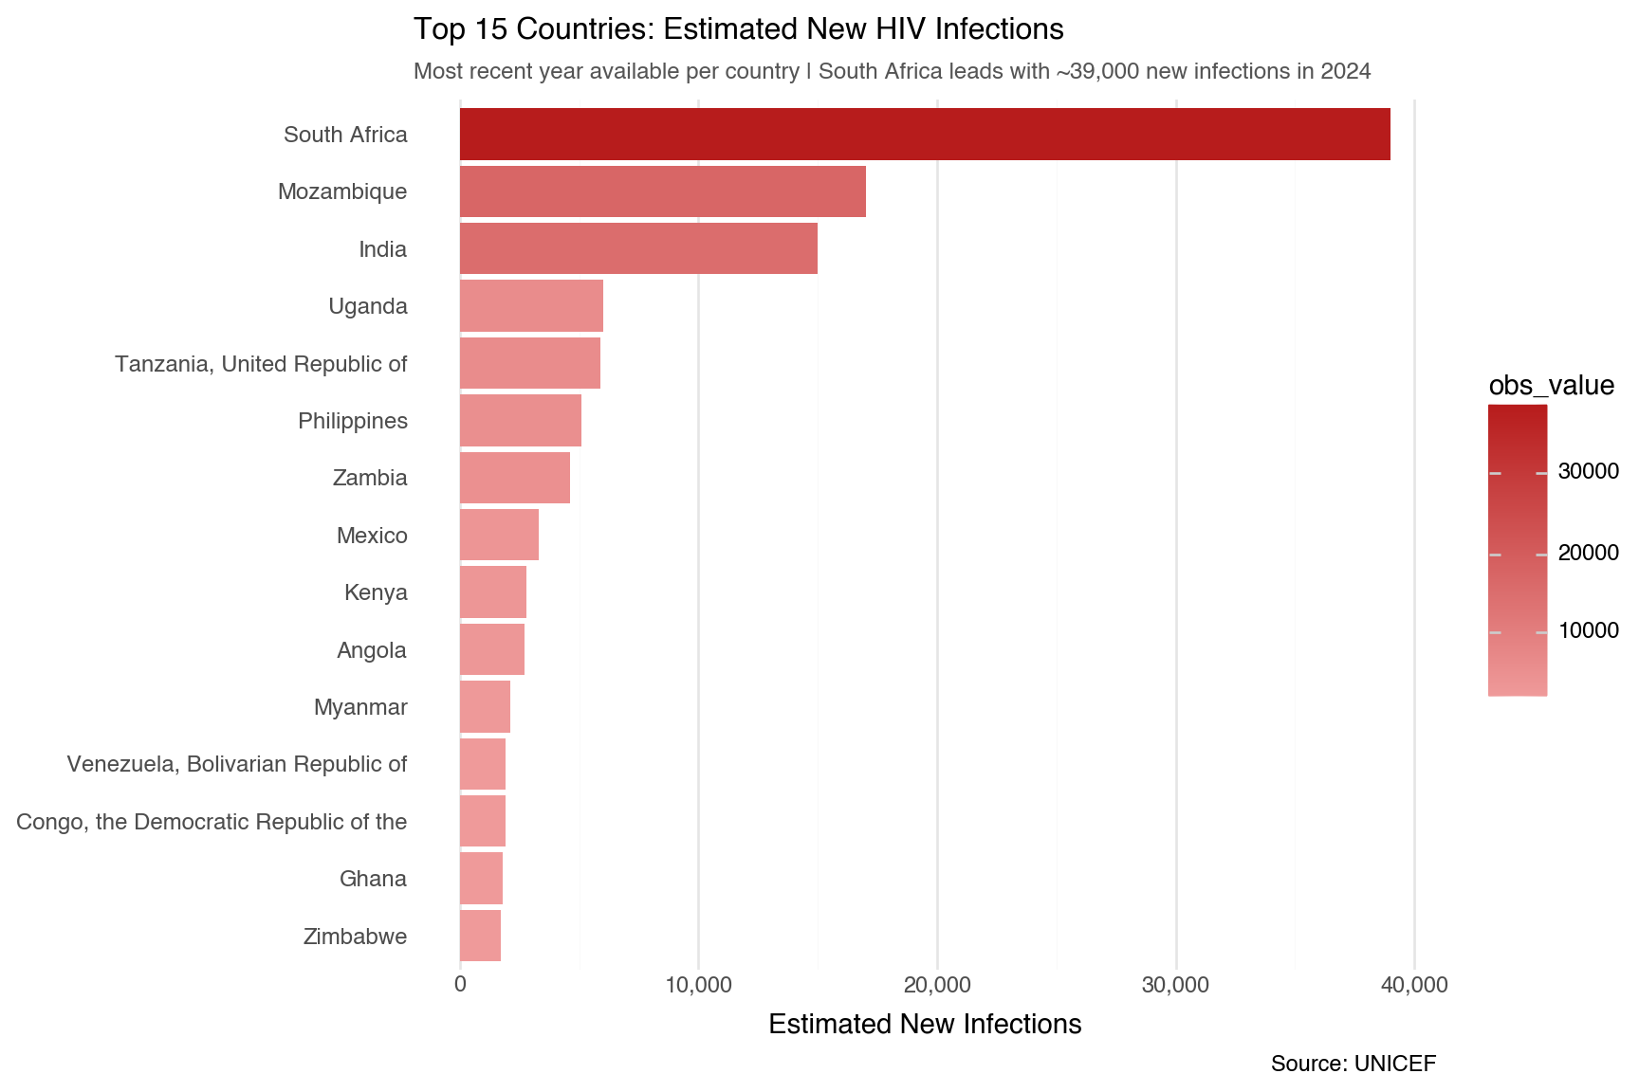
Figure 2: Top 15 countries by estimated new HIV infections (most recent year available).
South Africa stands in a category of its own with nearly 39,000 new infections in 2024 — more than double that of second-placed Mozambique (17,000). India’s appearance in third place is a reminder that the epidemic is not purely an African story. All 15 countries on this list share common risk factors: limited healthcare infrastructure, high poverty rates, and — in many cases — ongoing humanitarian crises.

5 💰 Does Wealth Determine Outcomes? — Scatterplot
A fundamental question in global health policy is whether economic development alone can drive down HIV infection rates, or whether targeted interventions are necessary regardless of a country’s wealth.
📈 Scatterplot with Linear Regression
Countries available for scatter: 84
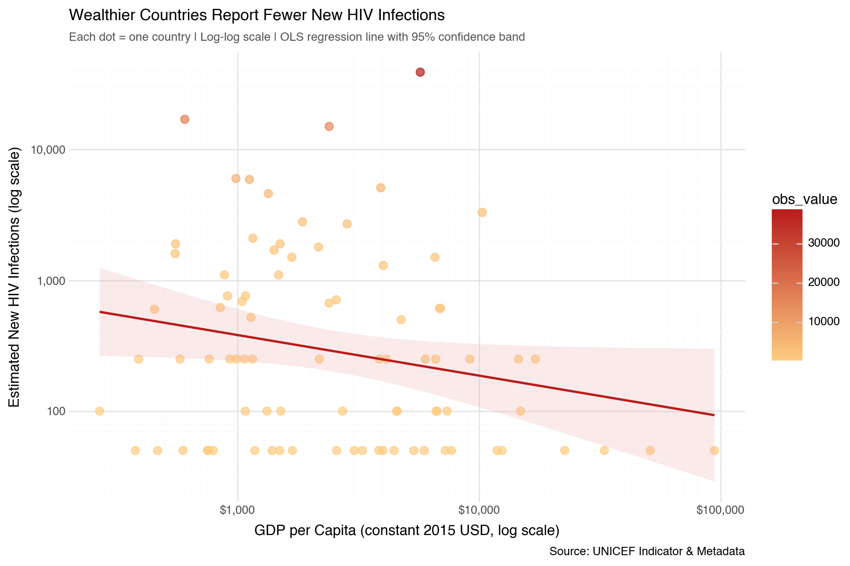
Figure 3: GDP per capita vs. new HIV infections per country. Both axes use log scale.
The downward-sloping regression line confirms a clear negative relationship — as GDP per capita rises, new HIV infections tend to fall. However, the wide scatter around the line is equally important: several lower-income countries achieve surprisingly low infection rates, demonstrating that policy choices, healthcare access, and community interventions can meaningfully decouple outcomes from national wealth.

6 📉 Is the World Making Progress? — Time Series
Progress against HIV must be measured over time. The chart below tracks how new infection estimates have changed year-by-year across five of the highest-burden countries in the dataset.
📉 Time Series Chart
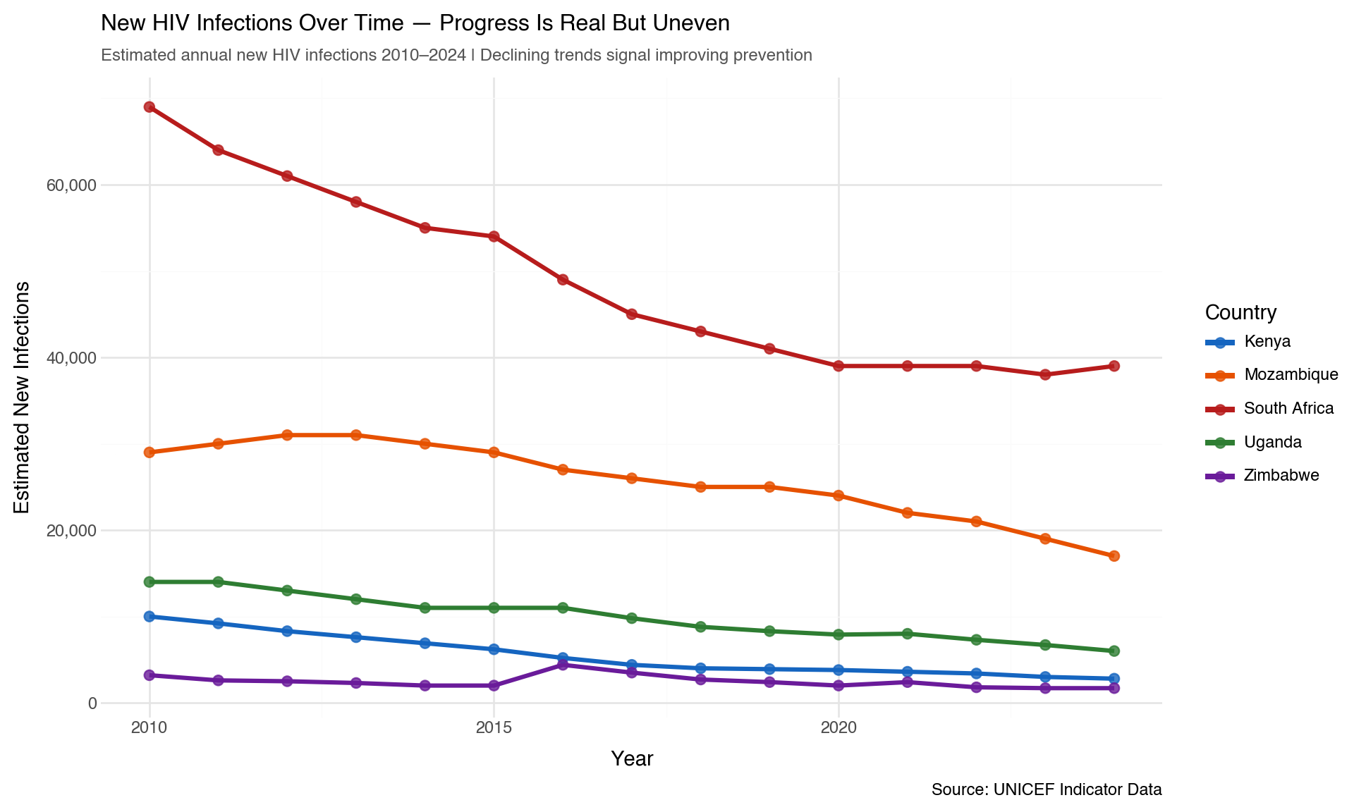
Figure 4: Trends in estimated new HIV infections over time (2010–2024), selected countries.
The time-series tells a story of cautious optimism. South Africa, despite its high absolute numbers, shows a meaningful downward trend from its 2010 peak — a testament to its large-scale antiretroviral therapy (ART) rollout. Zimbabwe and Uganda show similarly encouraging declines. Mozambique, however, remains elevated, highlighting that progress is fragile and requires sustained investment. Without continued political will and funding, these trends can — and do — reverse.

7 🔍 Key Findings
The four visualisations together reveal a coherent and urgent picture:
- Geography is destiny for too many children. The world map shows HIV infections are overwhelmingly concentrated in Sub-Saharan Africa, with South Africa, Mozambique, and Tanzania recording the highest burdens.
- The top 15 countries account for the vast majority of global infections. South Africa alone recorded nearly 39,000 new infections in 2024 — a figure that demands targeted, country-specific intervention.
- Wealth matters, but it is not sufficient. The scatterplot confirms a negative relationship between GDP per capita and infection rates, yet significant variation exists — proving that policy and healthcare infrastructure matter independently of income.
- Progress is real, but fragile. Declining trends in South Africa, Zimbabwe, and Uganda are encouraging, but Mozambique’s persistent high rates remind us the work is far from over.

8 ✅ Conclusion
The UNICEF data examined in this report makes one conclusion unavoidable: the HIV epidemic remains a profound violation of children’s rights, concentrated in the countries least equipped to respond.
The global community has the tools — antiretroviral therapy, prevention programmes, and community health workers. What is needed is sustained commitment: to funding, to equity, and to the children who cannot yet advocate for themselves.
“We have the tools to end AIDS. What we need is the will.” — UNAIDS

Report rendered with Quarto. Analysis conducted in Python using pandas for data manipulation and plotnine for visualisation. Geographic boundaries from Natural Earth via GeoPandas. Data source: UNICEF Open Data.

