WEEK -1
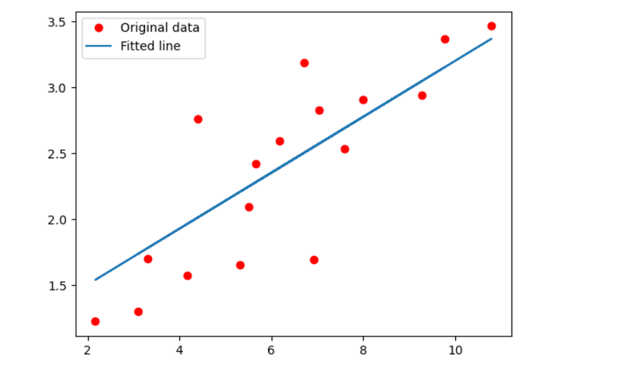
WEEK -2
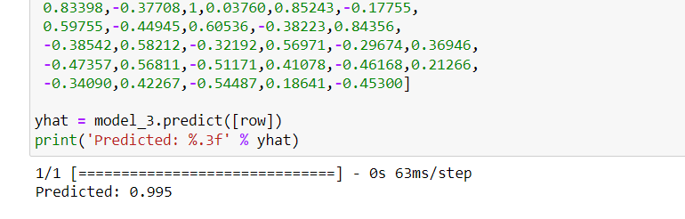

WEEK -3
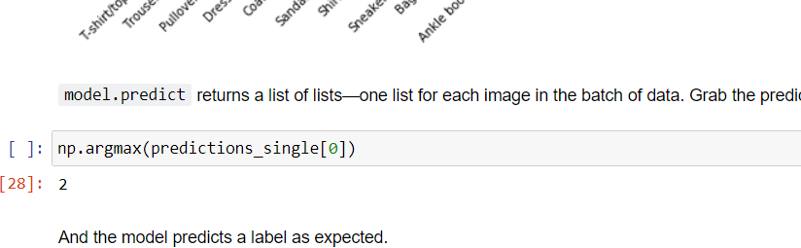

WEEK -4
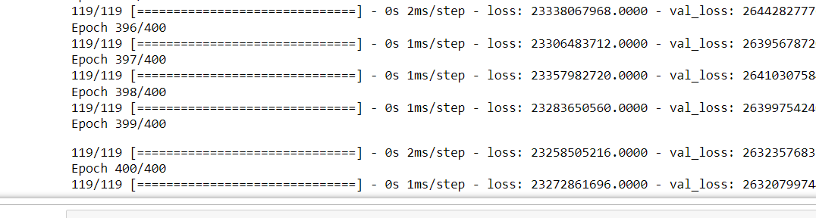

WEEK -5 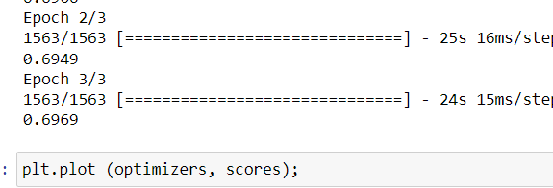

WEEk-6 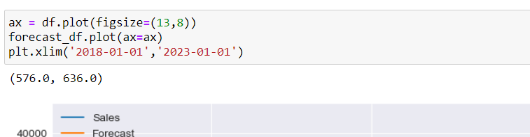

WEEK-7

WEEK-8
CNN Autoencoders
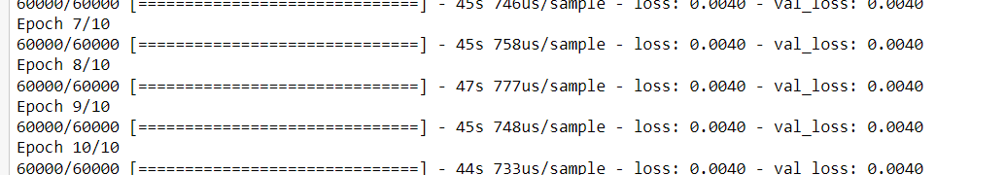

Simple Autoencoders
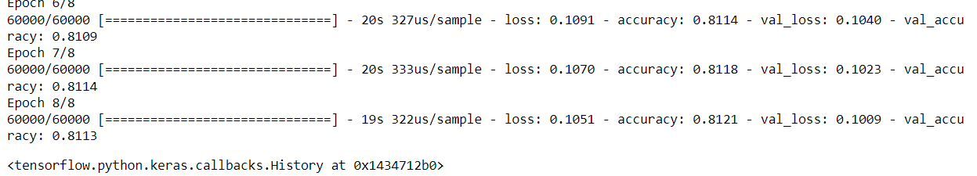

WEEK-9

WEEK-10
