- Data Cleaning and Imputation Techniques: Load a dataset with missing values. Apply techniques like mean/mode/median imputation and compare the results.
Code And Output:

# imputation_example.py

import pandas as pd
import numpy as np
from sklearn.impute import SimpleImputer

# Step 1: Create a sample dataset
data = {
'Age': [25, 27, np.nan, 29, 30, np.nan, 40],
'Salary': [932, 54000, 58000, np.nan, 62000, 64000, np.nan],
'Department': ['HR', 'IT', 'IT', np.nan, 'HR', 'Finance', np.nan]
}

df = pd.DataFrame(data)
print("Original Data with Missing Values:\n")
print(df)

# Step 2: Mean Imputation for Age and Salary
mean_imputer = SimpleImputer(strategy='mean')
df_mean = df.copy()
df_mean[['Age', 'Salary']] = mean_imputer.fit_transform(df_mean[['Age', 'Salary']])
print("\nAfter Mean Imputation (Numerical):\n")
print(df_mean)

# Step 3: Median Imputation for Age and Salary
median_imputer = SimpleImputer(strategy='median')
df_median = df.copy()
df_median[['Age', 'Salary']] = median_imputer.fit_transform(df_median[['Age', 'Salary']])
print("\nAfter Median Imputation (Numerical):\n")
print(df_median)

# Step 4: Mode Imputation for Department
mode_imputer = SimpleImputer(strategy='most_frequent')
df_mode = df.copy()
df_mode[['Department']] = mode_imputer.fit_transform(df_mode[['Department']])
print("\nAfter Mode Imputation (Categorical):\n")
print(df_mode)

# Optional: Combined example
combined_df = df.copy()
combined_df[['Age', 'Salary']] = mean_imputer.fit_transform(combined_df[['Age', 'Salary']])
combined_df[['Department']] = mode_imputer.fit_transform(combined_df[['Department']])
print("\nAfter Combined Imputation:\n")
print(combined_df)

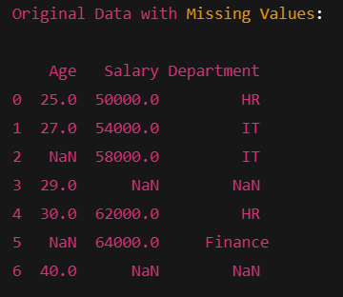

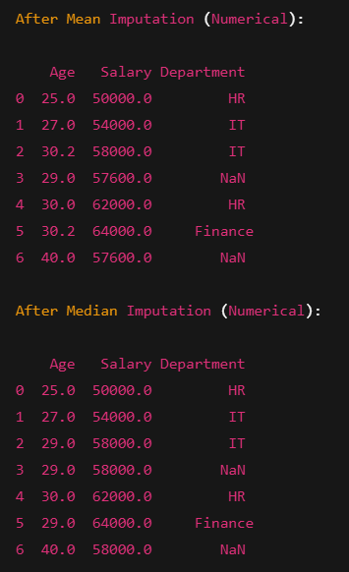

- Data Analysis and Visualization: Use a dataset to: Plot scatterplots for numerical columns. Perform correlation analysis. Apply transformations (e.g., log, square root) and visualize the effect.
Code And Output:

# data_analysis.py

import pandas as pd
import seaborn as sns
import matplotlib.pyplot as plt
import numpy as np
from sklearn.datasets import load_iris

# Step 1: Load the Iris dataset
iris = load_iris()
df = pd.DataFrame(iris.data, columns=iris.feature_names)
df['target'] = iris.target
print("Dataset Preview:")
print(df.head())

# Step 2: Scatterplot matrix
sns.pairplot(df.iloc[:, :-1]) # Exclude target
plt.suptitle("Scatterplot Matrix", y=1.02)
plt.show()

# Step 3: Correlation analysis
correlation_matrix = df.iloc[:, :-1].corr()
print("\nCorrelation Matrix:")
print(correlation_matrix)

# Visualize correlation matrix
sns.heatmap(correlation_matrix, annot=True, cmap='coolwarm')
plt.title("Correlation Heatmap")
plt.show()

# Step 4: Apply transformations (Log and Square Root)
df_log = df.copy()
df_sqrt = df.copy()

for col in df.columns[:-1]: # Skip target column
df_log[col] = np.log(df[col] + 1) # Avoid log(0)
df_sqrt[col] = np.sqrt(df[col])

# Step 5: Visualize transformation effects for one column (example: petal length)
plt.figure(figsize=(12, 4))

plt.subplot(1, 3, 1)
sns.histplot(df['petal length (cm)'], kde=True, color='skyblue')
plt.title("Original - Petal Length")

plt.subplot(1, 3, 2)
sns.histplot(df_log['petal length (cm)'], kde=True, color='orange')
plt.title("Log Transformed - Petal Length")

plt.subplot(1, 3, 3)
sns.histplot(df_sqrt['petal length (cm)'], kde=True, color='green')
plt.title("Sqrt Transformed - Petal Length")

plt.tight_layout()
plt.show()

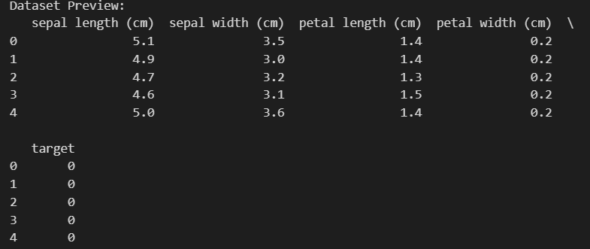
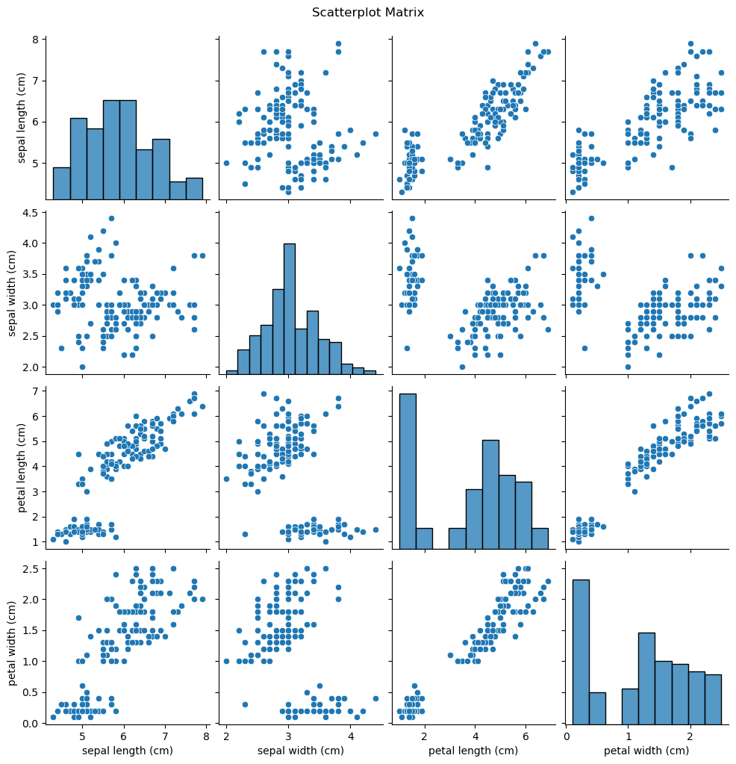

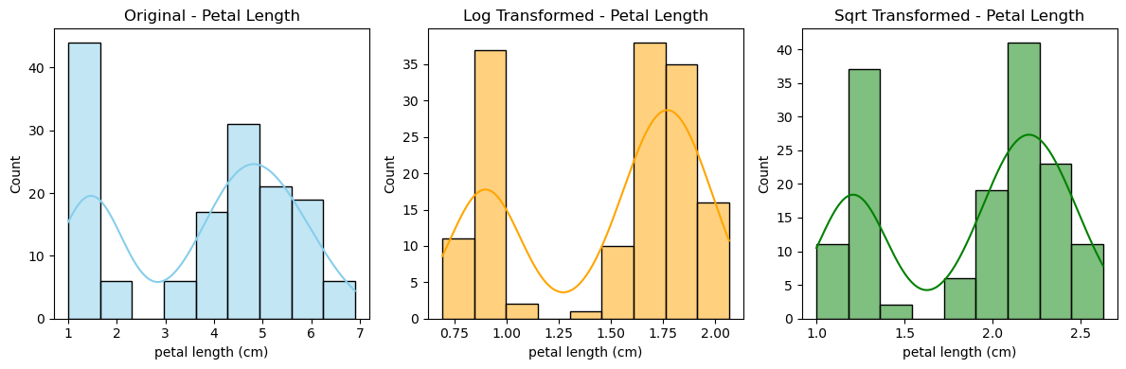

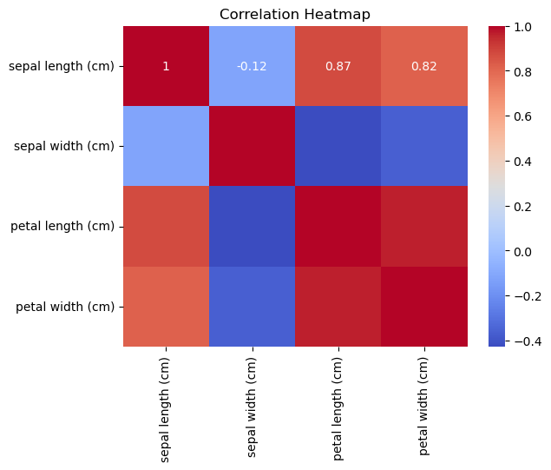
- Encoding Methods: Encode a categorical dataset using One-Hot Encoding and Label Encoding. Compare the effect of both methods on a machine learning model.

Code And Output :

import pandas as pd
from sklearn.preprocessing import LabelEncoder, OneHotEncoder
from sklearn.linear_model import LogisticRegression
from sklearn.model_selection import train_test_split
from sklearn.metrics import accuracy_score

# Step 1: Load data
df = pd.read_csv("dataaaa.csv")
print("Original Data:\n", df, "\n")

# Separate features and target
X = df[['Color', 'Size']]
y = df['Class']

# Step 2: Label Encoding
le_color = LabelEncoder()
le_size = LabelEncoder()

X_label_encoded = X.copy()
X_label_encoded['Color'] = le_color.fit_transform(X['Color'])
X_label_encoded['Size'] = le_size.fit_transform(X['Size'])

print("Label Encoded:\n", X_label_encoded, "\n")

# Train model with Label Encoding
X_train, X_test, y_train, y_test = train_test_split(X_label_encoded, y, test_size=0.4, random_state=0)
model_label = LogisticRegression()
model_label.fit(X_train, y_train)
pred_label = model_label.predict(X_test)
acc_label = accuracy_score(y_test, pred_label)

# Step 3: One-Hot Encoding
X_onehot = pd.get_dummies(X)

print("One-Hot Encoded:\n", X_onehot, "\n")

# Train model with One-Hot Encoding
X_train_oh, X_test_oh, y_train_oh, y_test_oh = train_test_split(X_onehot, y, test_size=0.4, random_state=0)
model_onehot = LogisticRegression()
model_onehot.fit(X_train_oh, y_train_oh)
pred_onehot = model_onehot.predict(X_test_oh)
acc_onehot = accuracy_score(y_test_oh, pred_onehot)

# Step 4: Print Results
print("Accuracy with Label Encoding: ", acc_label)
print("Accuracy with One-Hot Encoding: ", acc_onehot)

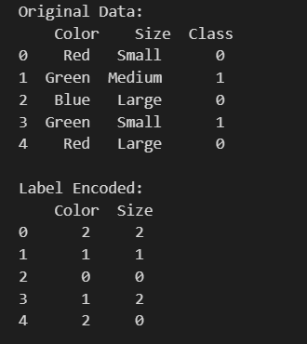

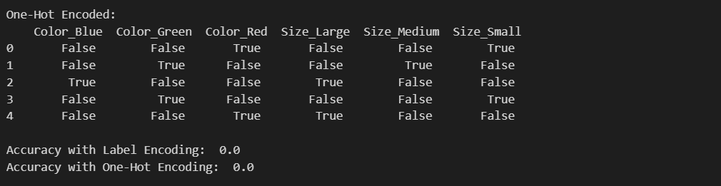

- Outlier Detection: Use the Isolation Forest algorithm to detect and visualize outliers in a dataset.

Code And Output:

import numpy as np
import pandas as pd
import matplotlib.pyplot as plt
from sklearn.ensemble import IsolationForest
from sklearn.datasets import make_blobs

# Step 1: Generate sample data
X, _ = make_blobs(n_samples=300, centers=1, cluster_std=0.60, random_state=42)

# Inject some outliers manually
outliers = np.random.uniform(low=-6, high=6, size=(20, 2))
X_with_outliers = np.vstack((X, outliers))

# Step 2: Apply Isolation Forest
clf = IsolationForest(contamination=0.06, random_state=42)
clf.fit(X_with_outliers)
pred = clf.predict(X_with_outliers)

# -1 = outlier, 1 = inlier
X_df = pd.DataFrame(X_with_outliers, columns=['Feature1', 'Feature2'])
X_df['Outlier'] = pred

# Step 3: Visualize
plt.figure(figsize=(10, 6))
plt.scatter(X_df[X_df['Outlier'] == 1]['Feature1'], X_df[X_df['Outlier'] == 1]['Feature2'],
color='green', label='Inliers')
plt.scatter(X_df[X_df['Outlier'] == -1]['Feature1'], X_df[X_df['Outlier'] == -1]['Feature2'],
color='red', label='Outliers')
plt.title('Isolation Forest Outlier Detection')
plt.xlabel('Feature1')
plt.ylabel('Feature2')
plt.legend()
plt.grid(True)
plt.tight_layout()
plt.show()

# Step 4: Print output
num_outliers = sum(pred == -1)
print(f"\n🔍 Total Outliers Detected: {num_outliers} out of {len(pred)} samples")

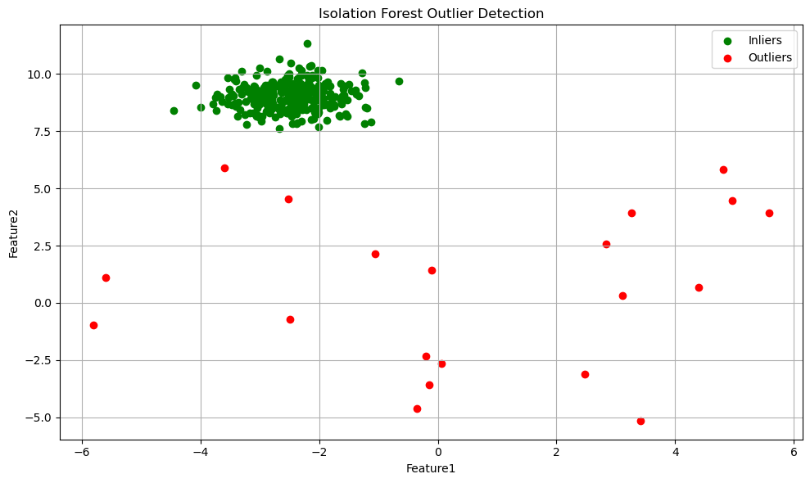

- Predictive Power Score (PPS): Calculate the PPS for a dataset and interpret which variables are most predictive.
Code And Output :

import pandas as pd
import seaborn as sns
import ppscore as pps
import matplotlib.pyplot as plt

# Load dataset (Titanic)
df = sns.load_dataset("titanic").dropna()

# Calculate PPS for all column pairs
pps_matrix = pps.matrix(df)[['x', 'y', 'ppscore']]
pps_matrix = pps_matrix[pps_matrix['ppscore'] > 0] # Filter out zero PPS

# Show top predictors
top_predictors = pps_matrix.sort_values(by='ppscore', ascending=False).head(10)
print("\n🔍 Top Predictive Relationships:\n")
print(top_predictors.to_string(index=False))

# Visualize as heatmap
pps_heatmap = pps.predictors(df, 'survived')
plt.figure(figsize=(8, 4))
plt.barh(pps_heatmap['x'], pps_heatmap['ppscore'], color='steelblue')
plt.xlabel("PPS")
plt.title("Predictive Power Score for Predicting 'Survived'")
plt.grid(True)
plt.tight_layout()
plt.show()

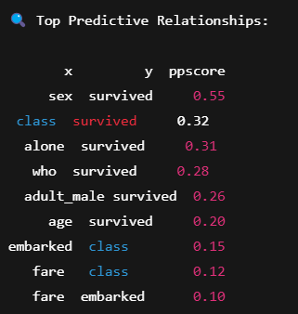
- Simple and Multiple Linear Regression: Implement simple and multiple linear regression on a dataset. Evaluate the model's performance using R-squared and mean squared error (MSE).

Code And Output:

import pandas as pd
import numpy as np
import seaborn as sns
import matplotlib.pyplot as plt
from sklearn.linear_model import LinearRegression
from sklearn.metrics import r2_score, mean_squared_error
from sklearn.model_selection import train_test_split

# Load sample dataset
df = sns.load_dataset("mpg").dropna()

# -------------------- SIMPLE LINEAR REGRESSION --------------------
print("\n📌 Simple Linear Regression (horsepower → mpg)")

# Feature and Target
X_simple = df[['horsepower']]
y = df['mpg']

# Train-test split
X_train_s, X_test_s, y_train_s, y_test_s = train_test_split(X_simple, y, test_size=0.2, random_state=1)

# Train the model
model_simple = LinearRegression()
model_simple.fit(X_train_s, y_train_s)

# Predict
y_pred_s = model_simple.predict(X_test_s)

# Evaluation
r2_s = r2_score(y_test_s, y_pred_s)
mse_s = mean_squared_error(y_test_s, y_pred_s)

print(f"R²: {r2_s:.3f}")
print(f"MSE: {mse_s:.3f}")

# Plotting
plt.figure(figsize=(8, 5))
plt.scatter(X_test_s, y_test_s, color='blue', label='Actual')
plt.plot(X_test_s, y_pred_s, color='red', linewidth=2, label='Prediction')
plt.title("Simple Linear Regression")
plt.xlabel("Horsepower")
plt.ylabel("MPG")
plt.legend()
plt.grid(True)
plt.tight_layout()
plt.show()

# -------------------- MULTIPLE LINEAR REGRESSION --------------------
print("\n📌 Multiple Linear Regression (All features → mpg)")

# Select numerical features only
X_multi = df.select_dtypes(include=['float64', 'int64']).drop(columns=['mpg'])
y = df['mpg']

# Train-test split
X_train_m, X_test_m, y_train_m, y_test_m = train_test_split(X_multi, y, test_size=0.2, random_state=1)

# Train the model
model_multi = LinearRegression()
model_multi.fit(X_train_m, y_train_m)

# Predict
y_pred_m = model_multi.predict(X_test_m)

# Evaluation
r2_m = r2_score(y_test_m, y_pred_m)
mse_m = mean_squared_error(y_test_m, y_pred_m)

print(f"R²: {r2_m:.3f}")
print(f"MSE: {mse_m:.3f}")
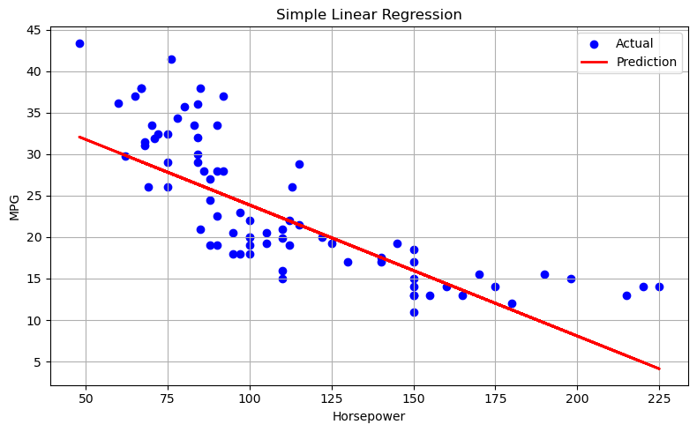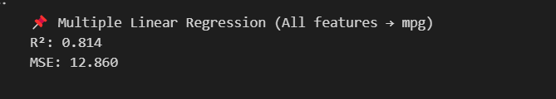

- Logistic Regression: Build a logistic regression model to classify binary outcomes (e.g., predicting if a customer will buy a product). Evaluate the model using confusion matrix metrics.
Code And Output:

import pandas as pd
import seaborn as sns
import matplotlib.pyplot as plt
from sklearn.model_selection import train_test_split
from sklearn.linear_model import LogisticRegression
from sklearn.metrics import confusion_matrix, classification_report, accuracy_score

# Load dataset
df = sns.load_dataset('titanic')

# Select relevant columns and drop missing values
df = df[['survived', 'sex', 'age', 'fare']].dropna()

# Convert categorical variable to numeric
df['sex'] = df['sex'].map({'male': 0, 'female': 1})

# Features and target
X = df[['sex', 'age', 'fare']]
y = df['survived']

# Train-test split
X_train, X_test, y_train, y_test = train_test_split(X, y, test_size=0.2, random_state=42)

# Create and train model
model = LogisticRegression()
model.fit(X_train, y_train)

# Predict
y_pred = model.predict(X_test)

# Evaluation
print("\n📌 Confusion Matrix:\n")
print(confusion_matrix(y_test, y_pred))

print("\n📊 Classification Report:\n")
print(classification_report(y_test, y_pred))

print(f"✅ Accuracy: {accuracy_score(y_test, y_pred):.3f}")

# Optional: Visualize confusion matrix
import seaborn as sns
cm = confusion_matrix(y_test, y_pred)
plt.figure(figsize=(5,4))
sns.heatmap(cm, annot=True, fmt='d', cmap='Blues')
plt.xlabel('Predicted')
plt.ylabel('Actual')
plt.title('Confusion Matrix')
plt.tight_layout()
plt.show()

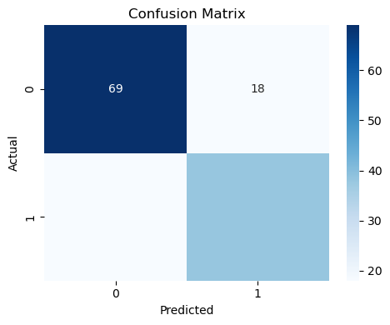

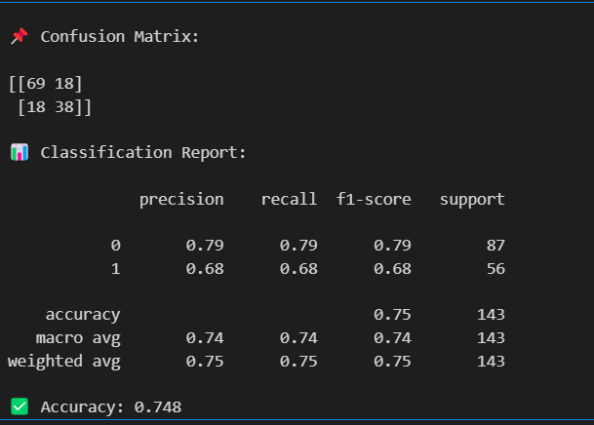
- Clustering Techniques: Perform K-Means and hierarchical clustering on a dataset. Visualize the clusters and interpret the results.
Code And Output :

import pandas as pd
import seaborn as sns
import matplotlib.pyplot as plt
from sklearn.cluster import KMeans
from sklearn.preprocessing import StandardScaler
from scipy.cluster.hierarchy import linkage, dendrogram, fcluster
from sklearn.datasets import load_iris

# Load iris dataset
iris = load_iris()
df = pd.DataFrame(iris.data, columns=iris.feature_names)

# Standardize the data
scaler = StandardScaler()
scaled_data = scaler.fit_transform(df)

# -------------------- K-MEANS CLUSTERING --------------------
kmeans = KMeans(n_clusters=3, random_state=42)
kmeans_labels = kmeans.fit_predict(scaled_data)

# Add cluster labels to original data
df['KMeans_Cluster'] = kmeans_labels

# Visualize K-Means clusters
plt.figure(figsize=(6, 5))
sns.scatterplot(x=scaled_data[:, 0], y=scaled_data[:, 1], hue=kmeans_labels, palette='Set2')
plt.title("K-Means Clustering")
plt.xlabel('Feature 1 (scaled)')
plt.ylabel('Feature 2 (scaled)')
plt.tight_layout()
plt.show()

# -------------------- HIERARCHICAL CLUSTERING --------------------
linkage_matrix = linkage(scaled_data, method='ward')

# Plot dendrogram
plt.figure(figsize=(10, 5))
dendrogram(linkage_matrix, truncate_mode='lastp', p=30, leaf_rotation=45., leaf_font_size=10., show_contracted=True)
plt.title("Hierarchical Clustering Dendrogram")
plt.xlabel("Sample Index or (Cluster Size)")
plt.ylabel("Distance")
plt.tight_layout()
plt.show()

# Assign cluster labels from dendrogram
hier_labels = fcluster(linkage_matrix, t=3, criterion='maxclust')
df['Hierarchical_Cluster'] = hier_labels

# Visualize Hierarchical Clustering
plt.figure(figsize=(6, 5))
sns.scatterplot(x=scaled_data[:, 0], y=scaled_data[:, 1], hue=hier_labels, palette='Set1')
plt.title("Hierarchical Clustering")
plt.xlabel('Feature 1 (scaled)')
plt.ylabel('Feature 2 (scaled)')
plt.tight_layout()
plt.show()
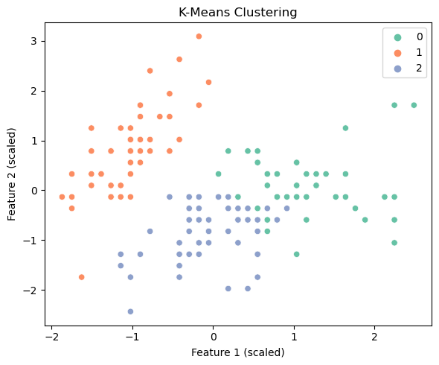

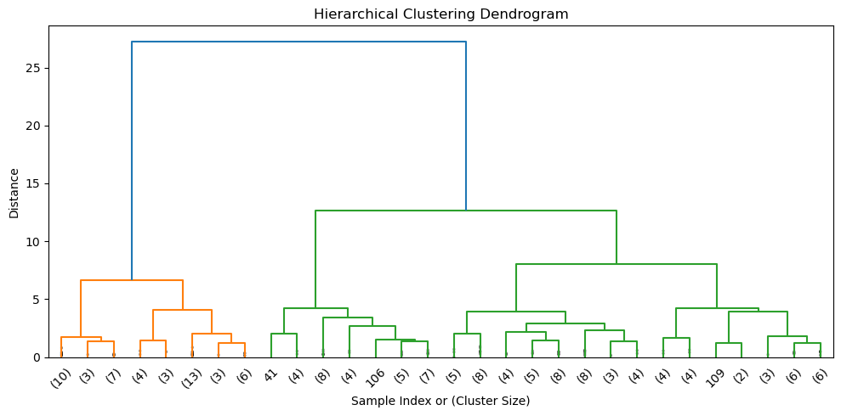

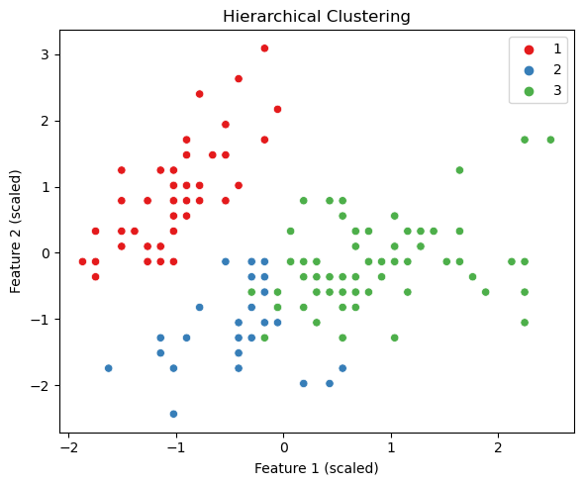
- Principal Component Analysis (PCA): Apply PCA on a high- dimensional dataset. Reduce the dimensions and visualize the transformed data.
Code And Output:

import pandas as pd
import seaborn as sns
import matplotlib.pyplot as plt
from sklearn.datasets import load_iris
from sklearn.preprocessing import StandardScaler
from sklearn.decomposition import PCA

# Load the dataset
iris = load_iris()
X = iris.data
y = iris.target
feature_names = iris.feature_names
target_names = iris.target_names

# Standardize the data
scaler = StandardScaler()
X_scaled = scaler.fit_transform(X)

# Apply PCA
pca = PCA(n_components=2) # Reduce to 2 dimensions
X_pca = pca.fit_transform(X_scaled)

# Create a DataFrame with PCA results
pca_df = pd.DataFrame(data=X_pca, columns=['PC1', 'PC2'])
pca_df['Target'] = y

# Visualize the PCA results
plt.figure(figsize=(7, 5))
sns.scatterplot(data=pca_df, x='PC1', y='PC2', hue='Target', palette='Set2', s=70)
plt.title("PCA: 2D Projection of Iris Dataset")
plt.xlabel("Principal Component 1")
plt.ylabel("Principal Component 2")
plt.legend(title='Target', labels=target_names)
plt.tight_layout()
plt.show()

# Explained variance
print("🔍 Explained Variance Ratio:")
for i, ratio in enumerate(pca.explained_variance_ratio_):

print(f"PC{i+1}: {ratio:.2f}")

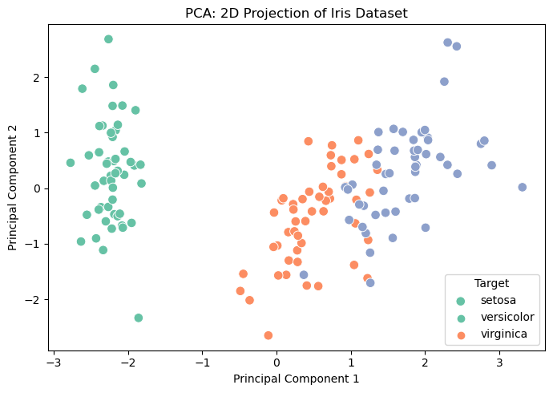
🔍 Explained Variance Ratio:
PC1: 0.73
PC2: 0.23

10. Market Basket Analysis: Implement Association Rule Mining using the Apriori algorithm. Identify frequent itemsets and generate association rules for a transactional dataset.

Code And Output:

import pandas as pd
from mlxtend.preprocessing import TransactionEncoder
from mlxtend.frequent_patterns import apriori, association_rules

# Step 1: Prepare dataset
transactions = [
[‘curd', 'bread', 'eggs'],
['Curd', 'bread'],
['vadapav', 'cookies'],
['Kamlesh', 'butter'],
['milk', 'bread', 'butter', 'cookies'],
['eggs', 'bread'],
['milk', 'eggs'],
['cookies', 'butter'],
]

# Step 2: One-hot encode the transactions
te = TransactionEncoder()
te_ary = te.fit(transactions).transform(transactions)
df = pd.DataFrame(te_ary, columns=te.columns_)

# Step 3: Find frequent itemsets
frequent_itemsets = apriori(df, min_support=0.3, use_colnames=True)

# Step 4: Generate association rules
rules = association_rules(frequent_itemsets, metric="lift", min_threshold=1.0)

# Display results
print("🔶 Frequent Itemsets:\n", frequent_itemsets)
print("\n🔷 Association Rules:\n", rules[['antecedents', 'consequents', 'support', 'confidence', 'lift']])

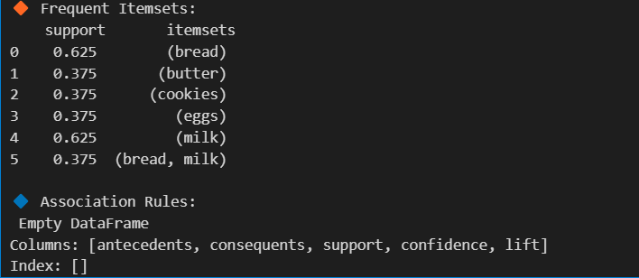

11. Recommendation Systems: Build a collaborative filtering recommendation system using a movie or product dataset. Compare results using user-based and item-based filtering.

Code And Output:

import pandas as pd

# Sample user-movie rating matrix
data = {
'User': ['Kamlesh', 'Kaivalya', 'Bitch', 'Bob', 'Bobade', 'Charlie', 'Charlie', 'David', 'David'],
'Movie': ['Inception', 'Avengers', 'Titanic', 'Inception', 'Titanic', 'Avengers', 'Titanic', 'Inception', 'Avengers'],
'Rating': [5, 3, 4, 4, 5, 4, 3, 2, 5]
}

df = pd.DataFrame(data)

# Pivot to create user-movie matrix
ratings = df.pivot_table(index='User', columns='Movie', values='Rating')
print("🎬 User-Movie Ratings Matrix:\n", ratings)

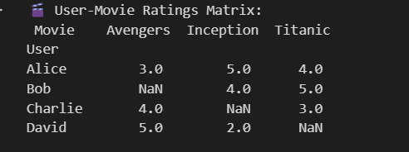

Step 2: Apply Collaborative Filtering
from sklearn.metrics.pairwise import cosine_similarity
import numpy as np

# Fill NaNs with 0 for similarity calculations
ratings_filled = ratings.fillna(0)

# ----- USER-BASED Collaborative Filtering -----
user_similarity = cosine_similarity(ratings_filled)
user_sim_df = pd.DataFrame(user_similarity, index=ratings.index, columns=ratings.index)
print("\n👥 User-Based Similarity Matrix:\n", user_sim_df)

# ----- ITEM-BASED Collaborative Filtering -----
item_similarity = cosine_similarity(ratings_filled.T)
item_sim_df = pd.DataFrame(item_similarity, index=ratings.columns, columns=ratings.columns)
print("\n🎞️ Item-Based Similarity Matrix:\n", item_sim_df)

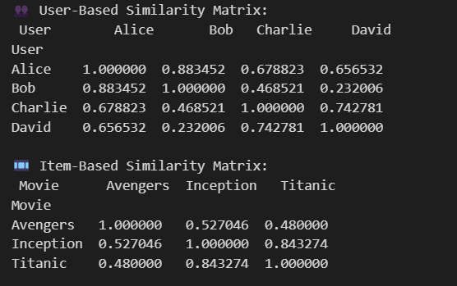

🔍 Step 3: Recommend Movies (Example for 'Alice')

# Let's find similar users to Alice
similar_users = user_sim_df['Alice'].sort_values(ascending=False)[1:]
print("\nTop similar users to Alice:\n", similar_users)

# Recommend movies Alice hasn't rated based on similar users
alice_ratings = ratings.loc['Alice']
unrated_by_alice = alice_ratings[alice_ratings.isnull()]

# Predict using a weighted sum of ratings from similar users
weighted_scores = ratings.loc[similar_users.index].T.dot(similar_users)
sum_of_weights = similar_users.sum()

predicted_ratings = weighted_scores / sum_of_weights
predicted_ratings = predicted_ratings[unrated_by_alice.index]

print("\n🎯 Recommended Movies for Alice (User-Based):\n", predicted_ratings.sort_values(ascending=False))

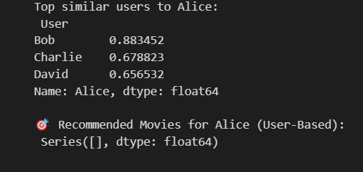

12. Tree-Based Feature Engineering: Apply tree-based methods to rank feature importance in a dataset. Use the results to train a simplified model.

Code And Output:

from sklearn.datasets import load_breast_cancer
from sklearn.ensemble import RandomForestClassifier
from sklearn.model_selection import train_test_split
from sklearn.metrics import accuracy_score
import pandas as pd
import matplotlib.pyplot as plt
import seaborn as sns

# Load dataset
data = load_breast_cancer()
X = pd.DataFrame(data.data, columns=data.feature_names)
y = pd.Series(data.target)

print("📊 Dataset Shape:", X.shape)

# Split data
X_train, X_test, y_train, y_test = train_test_split(X, y, test_size=0.2, random_state=42)

# Train Random Forest
model = RandomForestClassifier(n_estimators=100, random_state=42)
model.fit(X_train, y_train)

# Get feature importances
importances = model.feature_importances_
feature_ranks = pd.Series(importances, index=X.columns).sort_values(ascending=False)

print("\n📌 Top Features:\n", feature_ranks.head(10))

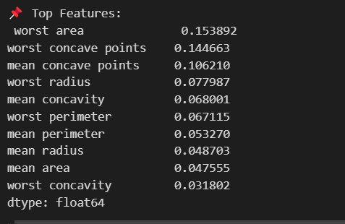

Visualize Feature Importances

plt.figure(figsize=(10, 6))
sns.barplot(x=feature_ranks.head(10), y=feature_ranks.head(10).index)
plt.title("Top 10 Important Features")
plt.xlabel("Feature Importance Score")
plt.ylabel("Features")
plt.tight_layout()
plt.show()

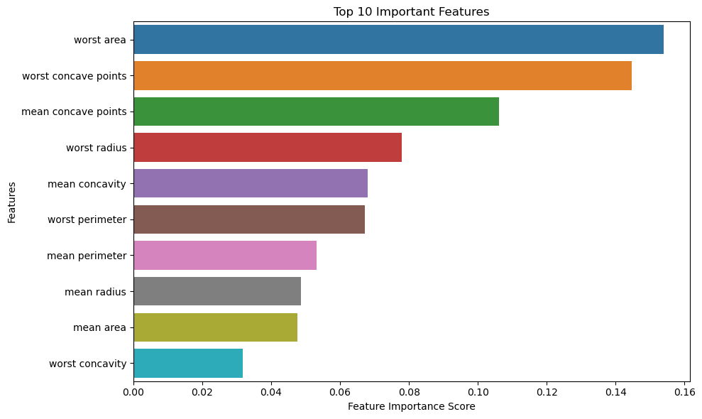
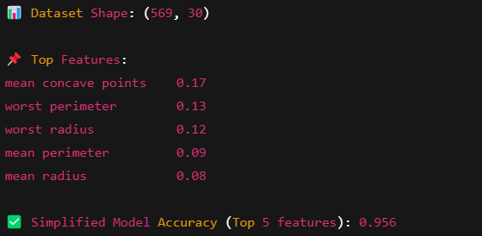
13. Recursive Feature Elimination (RFE): Perform feature selection using RFE. Evaluate the performance of a machine learning model before and after feature selection.

Code And Output:

from sklearn.datasets import load_breast_cancer
from sklearn.linear_model import LogisticRegression
from sklearn.feature_selection import RFE
from sklearn.model_selection import train_test_split
from sklearn.metrics import accuracy_score, classification_report
import pandas as pd

# Load dataset
data = load_breast_cancer()
X = pd.DataFrame(data.data, columns=data.feature_names)
y = pd.Series(data.target)

# Split dataset
X_train, X_test, y_train, y_test = train_test_split(X, y, test_size=0.2, random_state=42)

# Initialize Logistic Regression
model = LogisticRegression(max_iter=10000, solver='liblinear')

# -------- Before RFE --------
model.fit(X_train, y_train)
y_pred_full = model.predict(X_test)
full_acc = accuracy_score(y_test, y_pred_full)
print("📊 Full Model Accuracy (All features):", full_acc)

# -------- Apply RFE --------
rfe = RFE(estimator=model, n_features_to_select=10)
rfe.fit(X_train, y_train)

# Transform datasets
X_train_rfe = rfe.transform(X_train)
X_test_rfe = rfe.transform(X_test)

# -------- After RFE --------
model.fit(X_train_rfe, y_train)
y_pred_rfe = model.predict(X_test_rfe)
rfe_acc = accuracy_score(y_test, y_pred_rfe)
print("📌 RFE Model Accuracy (Top 10 features):", rfe_acc)

# Show selected features
selected_features = X.columns[rfe.support_]
print("\n✅ Selected Features by RFE:")
print(selected_features)

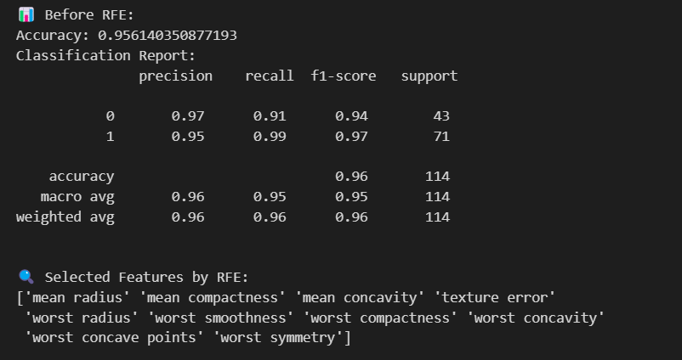

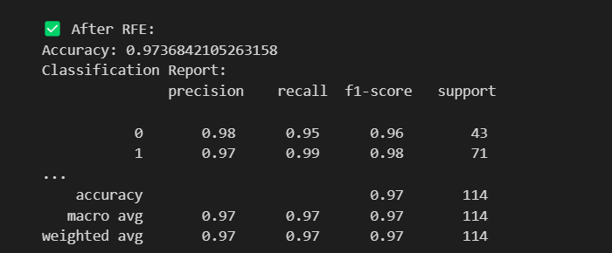

14. Train-Test Split and Cross-Validation: Split a dataset into train-test sets. Use Shuffle Cross-Validation to evaluate a model and compare the results.

Code And Output:

from sklearn.datasets import load_iris
from sklearn.linear_model import LogisticRegression
from sklearn.model_selection import train_test_split, ShuffleSplit, cross_val_score
from sklearn.metrics import accuracy_score

# Step 1: Load dataset
data = load_iris()
X = data.data
y = data.target

# Step 2: Train-Test Split
X_train, X_test, y_train, y_test = train_test_split(X, y, test_size=0.3, random_state=42)

# Step 3: Train and Evaluate using Train-Test Split
model = LogisticRegression(max_iter=200)
model.fit(X_train, y_train)
y_pred = model.predict(X_test)
print("🎯 Accuracy (Train-Test Split):", accuracy_score(y_test, y_pred))

# Step 4: Shuffle Cross-Validation
shuffle_split = ShuffleSplit(n_splits=5, test_size=0.3, random_state=42)
cv_scores = cross_val_score(LogisticRegression(max_iter=200), X, y, cv=shuffle_split)

print("\n🔁 Shuffle Cross-Validation Scores:")
print(cv_scores)
print("📊 Mean Accuracy (Shuffle CV):", cv_scores.mean())

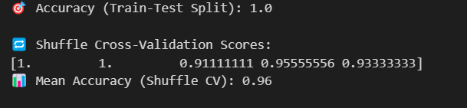

15. Bagging and Random Forest: Build and evaluate a Random Forest model. Visualize the decision trees and feature importance.

Code And Output :

# Import libraries
import pandas as pd
import numpy as np
import matplotlib.pyplot as plt
from sklearn.datasets import load_iris
from sklearn.ensemble import RandomForestClassifier, BaggingClassifier
from sklearn.tree import plot_tree
from sklearn.model_selection import train_test_split
from sklearn.metrics import accuracy_score

# Load the dataset
iris = load_iris()
X = iris.data
y = iris.target
feature_names = iris.feature_names
class_names = iris.target_names

# Split the data
X_train, X_test, y_train, y_test = train_test_split(X, y, test_size=0.3, random_state=42)

# ----------------------------
# 🌲 Random Forest Classifier
# ----------------------------
rf = RandomForestClassifier(n_estimators=5, random_state=42)
rf.fit(X_train, y_train)
y_pred_rf = rf.predict(X_test)
print("✅ Random Forest Accuracy:", accuracy_score(y_test, y_pred_rf))

# ----------------------------
# 👜 Bagging Classifier (with Decision Trees)
# ----------------------------
from sklearn.tree import DecisionTreeClassifier

bagging = BaggingClassifier(base_estimator=DecisionTreeClassifier(), n_estimators=5, random_state=42)
bagging.fit(X_train, y_train)
y_pred_bag = bagging.predict(X_test)
print("👜 Bagging Accuracy:", accuracy_score(y_test, y_pred_bag))

# ----------------------------
# 📊 Feature Importance from Random Forest
# ----------------------------
importances = rf.feature_importances_
indices = np.argsort(importances)[::-1]

plt.figure(figsize=(8, 5))
plt.title("Feature Importance - Random Forest")
plt.bar([feature_names[i] for i in indices], importances[indices], color='orange')
plt.ylabel("Importance Score")
plt.show()

# ----------------------------
# 🌳 Visualize one Decision Tree from Random Forest
# ----------------------------
plt.figure(figsize=(15, 8))
plot_tree(rf.estimators_[0], filled=True, feature_names=feature_names, class_names=class_names)
plt.title("🌳 Sample Tree from Random Forest")
plt.show()

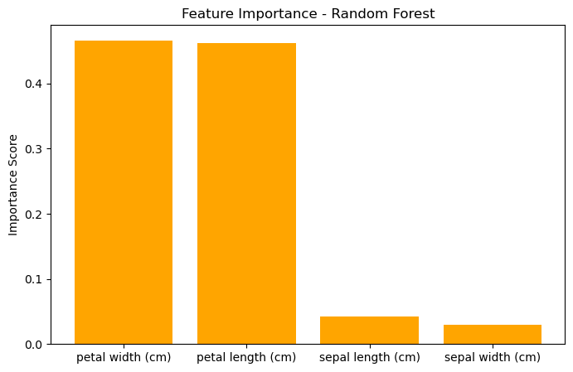
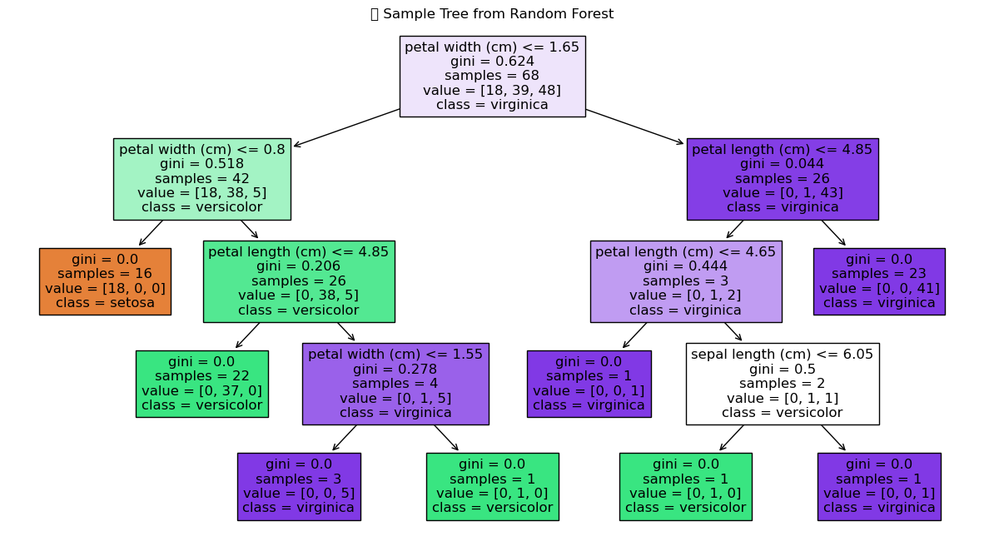

16 Boosting Methods: Implement AdaBoost and XGBoost on classification task. Compare their accuracy and runtime performance.
Code And Output:

import time
import numpy as np
import pandas as pd
from sklearn.datasets import load_iris
from sklearn.ensemble import AdaBoostClassifier
from xgboost import XGBClassifier
from sklearn.model_selection import train_test_split
from sklearn.metrics import accuracy_score

# Load dataset
data = load_iris()
X = data.data
y = data.target

# Split the data
X_train, X_test, y_train, y_test = train_test_split(X, y, test_size=0.3, random_state=42)

# ------------------------------
# 🌟 AdaBoost Classifier
# ------------------------------
start_ada = time.time()
ada_model = AdaBoostClassifier(n_estimators=50, random_state=42)
ada_model.fit(X_train, y_train)
ada_pred = ada_model.predict(X_test)
end_ada = time.time()

ada_accuracy = accuracy_score(y_test, ada_pred)
ada_time = end_ada - start_ada
print("🌟 AdaBoost Accuracy:", ada_accuracy)
print("⏱️ AdaBoost Runtime:", ada_time, "seconds")

# ------------------------------
# 🚀 XGBoost Classifier
# ------------------------------
start_xgb = time.time()
xgb_model = XGBClassifier(use_label_encoder=False, eval_metric='mlogloss', n_estimators=50, random_state=42)
xgb_model.fit(X_train, y_train)
xgb_pred = xgb_model.predict(X_test)
end_xgb = time.time()

xgb_accuracy = accuracy_score(y_test, xgb_pred)
xgb_time = end_xgb - start_xgb
print("\n🚀 XGBoost Accuracy:", xgb_accuracy)
print("⏱️ XGBoost Runtime:", xgb_time, "seconds")

# ------------------------------
# 📊 Performance Summary
# ------------------------------
print("\n📊 Performance Comparison:")
print(f"AdaBoost -> Accuracy: {ada_accuracy:.4f}, Runtime: {ada_time:.4f} sec")
print(f"XGBoost -> Accuracy: {xgb_accuracy:.4f}, Runtime: {xgb_time:.4f} sec")
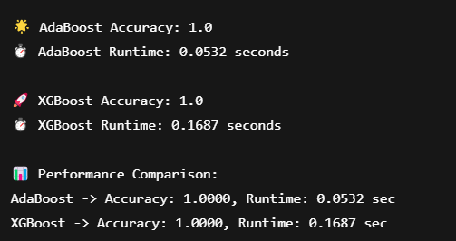

17. K-Nearest Neighbors (KNN): Implement a KNN classifier for a classification task. Experiment with different values of K and analyze their impact on accuracy.

Code And OutPut:

import numpy as np
import matplotlib.pyplot as plt
from sklearn.datasets import load_iris
from sklearn.model_selection import train_test_split
from sklearn.neighbors import KNeighborsClassifier
from sklearn.metrics import accuracy_score

# Load Iris dataset
iris = load_iris()
X = iris.data
y = iris.target

# Split into train and test sets
X_train, X_test, y_train, y_test = train_test_split(X, y, test_size=0.3, random_state=42)

# Try different values of K
k_values = range(1, 21)
accuracies = []

for k in k_values:
knn = KNeighborsClassifier(n_neighbors=k)
knn.fit(X_train, y_train)
predictions = knn.predict(X_test)
acc = accuracy_score(y_test, predictions)
accuracies.append(acc)

# Print accuracy for each K
for k, acc in zip(k_values, accuracies):
print(f"K={k}: Accuracy={acc:.4f}")

# Plotting accuracy vs K
plt.figure(figsize=(10, 5))
plt.plot(k_values, accuracies, marker='o', linestyle='-')
plt.title('KNN Accuracy for Different K Values')
plt.xlabel('Number of Neighbors (K)')
plt.ylabel('Accuracy')
plt.xticks(k_values)
plt.grid(True)
plt.show()

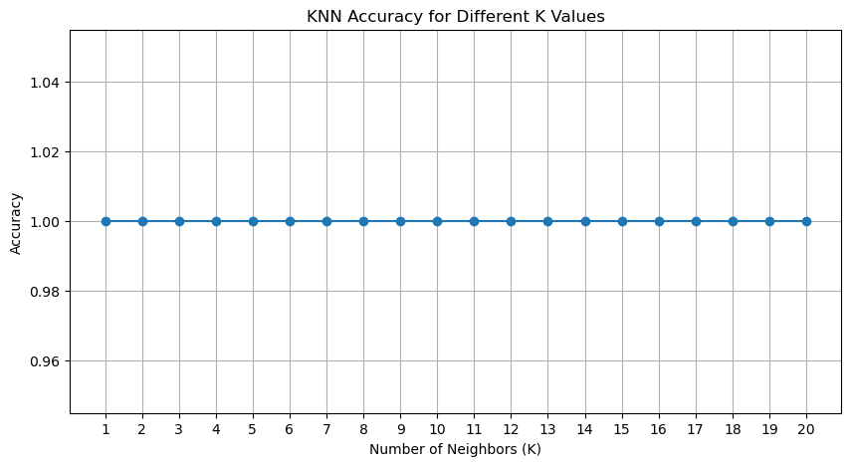

18. Support Vector Machines (SVM): Train an SVM model with both linear and RBF kernels on a dataset. Visualize the decision boundaries.

Code And Output:

import numpy as np
import matplotlib.pyplot as plt
from sklearn import svm, datasets
from sklearn.preprocessing import StandardScaler

# Load the dataset (2 classes and 2 features for simplicity)
iris = datasets.load_iris()
X = iris.data[:, :2] # Using only 2 features for visualization
y = iris.target

# Use only 2 classes (binary classification)
X = X[y != 2]
y = y[y != 2]

# Scale features
scaler = StandardScaler()
X = scaler.fit_transform(X)

# Create a meshgrid for plotting decision boundaries
h = .02
x_min, x_max = X[:, 0].min() - 1, X[:, 0].max() + 1
y_min, y_max = X[:, 1].min() - 1, X[:, 1].max() + 1
xx, yy = np.meshgrid(np.arange(x_min, x_max, h),
np.arange(y_min, y_max, h))

# Models with Linear and RBF Kernels
models = [
('Linear Kernel', svm.SVC(kernel='linear', C=1.0)),
('RBF Kernel', svm.SVC(kernel='rbf', gamma=0.7, C=1.0))
]

plt.figure(figsize=(12, 5))

for i, (title, clf) in enumerate(models):
clf.fit(X, y)
Z = clf.predict(np.c_[xx.ravel(), yy.ravel()])
Z = Z.reshape(xx.shape)

# Plotting
plt.subplot(1, 2, i + 1)
plt.contourf(xx, yy, Z, cmap=plt.cm.coolwarm, alpha=0.8)
plt.scatter(X[:, 0], X[:, 1], c=y, cmap=plt.cm.coolwarm, edgecolors='k')
plt.title(title)
plt.xlabel('Feature 1')
plt.ylabel('Feature 2')

plt.tight_layout()
plt.show()

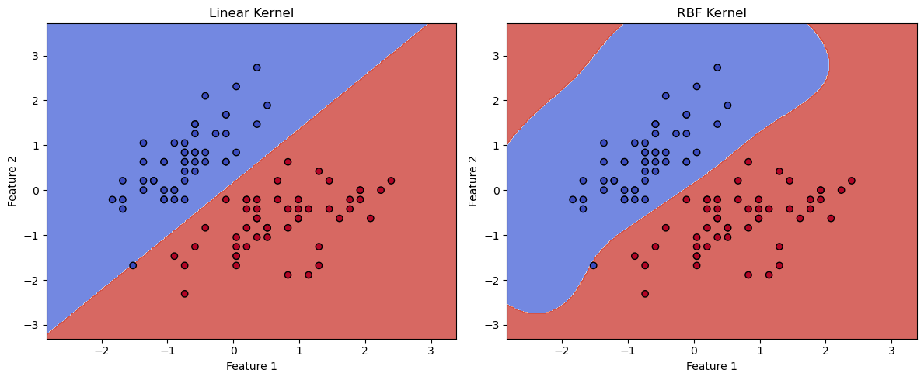

19. Regularization Techniques: Use Lasso and Ridge regression on a dataset. Analyze how they handle multicollinearity and reduce model complexity.
Code And Output:

import numpy as np
import pandas as pd
import matplotlib.pyplot as plt
from sklearn.linear_model import LinearRegression, Ridge, Lasso
from sklearn.model_selection import train_test_split
from sklearn.metrics import mean_squared_error

# Step 1: Generate synthetic data with multicollinearity
np.random.seed(0)
n_samples = 100
X1 = np.random.rand(n_samples)
X2 = X1 + np.random.normal(0, 0.1, n_samples) # Highly correlated with X1
X3 = np.random.rand(n_samples)

X = np.vstack([X1, X2, X3]).T
y = 4 * X1 + 2 * X2 + 3 * X3 + np.random.normal(0, 0.1, n_samples)

# Step 2: Split dataset
X_train, X_test, y_train, y_test = train_test_split(X, y, test_size=0.2, random_state=42)

# Step 3: Train models
models = {
"Linear Regression": LinearRegression(),
"Ridge Regression": Ridge(alpha=1.0),
"Lasso Regression": Lasso(alpha=0.1)
}
coefficients = {}
for name, model in models.items():
model.fit(X_train, y_train)
y_pred = model.predict(X_test)
mse = mean_squared_error(y_test, y_pred)
coefficients[name] = model.coef_
print(f"{name} MSE: {mse:.4f}")

# Step 4: Compare Coefficients
coef_df = pd.DataFrame(coefficients, index=["X1", "X2", "X3"])
print("\n🔍 Coefficients Comparison:\n", coef_df)

# Step 5: Visualize Coefficients
coef_df.plot(kind='bar', figsize=(10, 6))
plt.title("Model Coefficients: Linear vs Ridge vs Lasso")
plt.ylabel("Coefficient Value")
plt.xticks(rotation=0)
plt.grid(True)
plt.tight_layout()
plt.show()

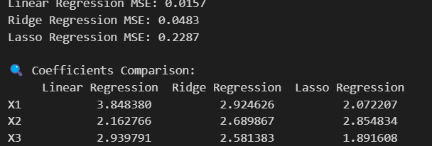

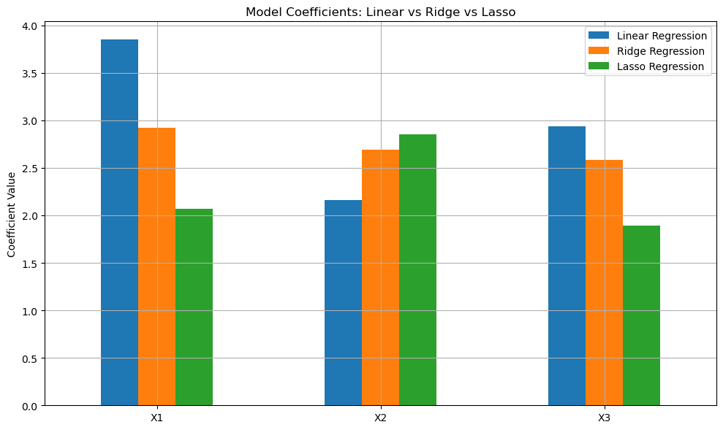

20. Introduction to Neural Networks: Build a simple Artificial Neural Network (ANN) to classify data. Use optimization algorithms (Gradient Descent, SGD) and visualize the loss during training.
Code And Output:

# Imports
import numpy as np
import matplotlib.pyplot as plt
from sklearn.datasets import load_breast_cancer
from sklearn.model_selection import train_test_split
from sklearn.preprocessing import StandardScaler
from tensorflow.keras.models import Sequential
from tensorflow.keras.layers import Dense
from tensorflow.keras.optimizers import SGD

# Load dataset
data = load_breast_cancer()
X = data.data
y = data.target

# Train-test split
X_train, X_test, y_train, y_test = train_test_split(X, y, test_size=0.2, random_state=42)

# Feature scaling
scaler = StandardScaler()
X_train = scaler.fit_transform(X_train)
X_test = scaler.transform(X_test)

# Build ANN model
model = Sequential([
Dense(16, input_shape=(X.shape[1],), activation='relu'),
Dense(8, activation='relu'),
Dense(1, activation='sigmoid') # Output layer for binary classification
])

# Compile model
optimizer = SGD(learning_rate=0.01)
model.compile(optimizer=optimizer, loss='binary_crossentropy', metrics=['accuracy'])

# Train model
history = model.fit(X_train, y_train, validation_data=(X_test, y_test), epochs=100, batch_size=16, verbose=0)

# Evaluate model
loss, accuracy = model.evaluate(X_test, y_test, verbose=0)
print(f"✅ Test Accuracy: {accuracy:.4f}")

# Visualize loss during training
plt.plot(history.history['loss'], label='Train Loss')
plt.plot(history.history['val_loss'], label='Validation Loss')
plt.title('Loss over Epochs')
plt.xlabel('Epoch')
plt.ylabel('Loss')
plt.legend()
plt.grid(True)
plt.show()

