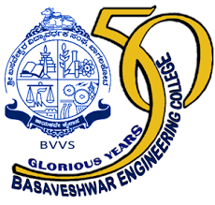

**DEPARTMENT OF ELECTRONICS AND COMMUNICATION ENGINEERING**

**2017-2018**

**MINI PROJECT REPORT**

**“IOT BASED IRRIGATION SYSTEM USING ARDUINO AND CLOUD COMPUTING”**

PROJECT GUIDE HOD

**Prof .M.C.Aralimard Dr. P.N.Kulkarni**

PROJECT ASSOCIATES

**NAME USN**

**MS. DEEPA MUDAKAVI 2BA16EC407**

**Mr. GURURAJ GIDAVEER 2BA16EC410**

**Mr. JABBAR KATHEWADI 2BA16EC411**

**Mr. KALLAPPA TELI 2BA16EC412**