

**DEPARTMENT OF ELECTRONICS AND COMMUNICATION ENGINEERING**

**2017-2018**

**MINI PROJECT REPORT**

**“KRISHI MITRA”**

PROJECT GUIDE HOD

**Prof .M.C.Aralimard Dr. P.N.Kulkarni**

PROJECT ASSOCIATES

**NAME USN**

**MS. DEEPA MUDAKAVI 2BA16EC407**

**Mr. GURURAJ GIDAVEER 2BA16EC410**

**Mr. JABBAR KATHEWADI 2BA16EC411**

**Mr. KALLAPPA TELI 2BA16EC412**

**CONTENTS**

* **Abstract**
* **Introduction**
* **Block diagram**
* **Details of the Block**
* **Sensors details**
* **Program Code**
* **Application**
* **Advantages**
* **Disadvantages**
* **Conclusion**
* **References**

ABSTRACT

A nursery is a place where plants are propagated and grown to usable size. Nurseries may supply plants for gardens, for agriculture, for forestry and for conservation biology. There is no machine available in the market that is affordable and automates the nursery process of seed sowing, watering. There is an immediate need for such machine for every nursery many research laboratories.

We intend to automate the most common and frequent tasks of the farmer.

Our team aims at building a robot that can perform almost all processes prior to harvesting including sowing, weed control and watering.

This is achieved by an electro-mechanical system that can be programmed to do the tasks.

INTRODUCTION

Agricultural robots are a robot deployed for agricultural purposes. Emerging applications of robots or drones in agriculture include weed control, cloud seeding,planting seeds, harvesting, environmental monitoring and soil analysis.

Agriculture has always been the backbone of India for a long time. The project we put forth has been designed to automate the work of a farmer so that he can tirelessly perform his farming tasks.

We propose the machine can reliably sow the seeds, dispense water, fertilizers, insecticides, pesticides to keep the plants healthy and thriving. Since it does not require delicate and costly sensors it is cheaper solution and the machinery is easy to install and maintain. It can be ex Hence our proposed machine will consist sowing apparatus, watering mechanism and insecticide/pesticide application.

BLOCK DIAGRAM

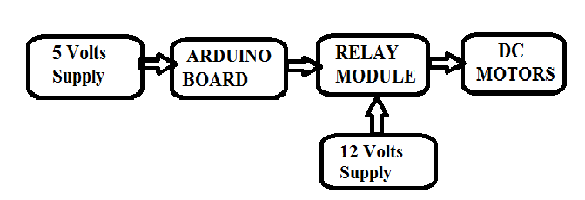

DETAILS OF THE BLOCK

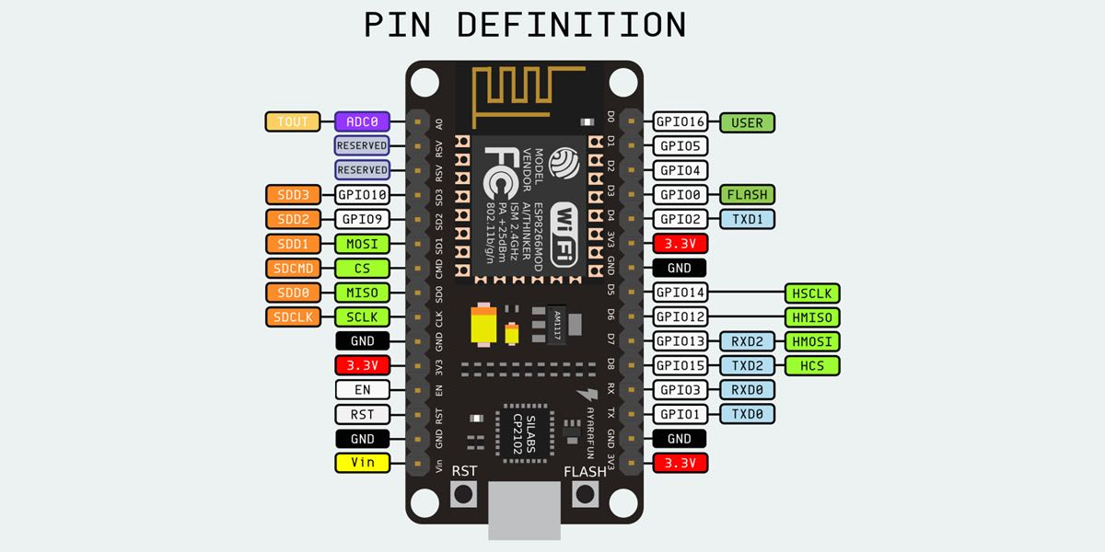

Fig. NodeMCU

Introduction to the Arduino Board Looking at the board from the top down, this is an outline of what you will see (parts of the board you might interact with in the course of normal use are highlighted)

Starting clockwise from the top center:

-Analog Reference pin (orange)

-Digital Ground (light green)

-Digital Pins 2-13 (green)

-Digital Pins 0-1/Serial In/Out - TX/RX (dark green) - These pins cannot be used for digital I/O (digitalRead and digitalWrite) if you are also using serial communication (e.g. Serial.begin).

-Reset Button - S1 (dark blue)

-In-circuit Serial Programmer (blue-green)

-Analog Input Pins 0-5 (light blue)

-Power and Ground Pins (power: orange, grounds: light orange)

-External Power Supply In (9-12VDC) - X1 (pink)

-Toggles External Power and USB Power (place jumper on two pins closest to desired supply) - SV1 (purple)

-USB (used for uploading sketches to the board and for serial communication between the board and the computer; can be used to power the board) (yellow)

DIGITAL PINS

In addition to the specific functions listed below, the digital pins on an Arduino board can be used for general purpose input and output via the pinMode(), digitalRead(), and digitalWrite() commands. Each pin has an internal pull-up resistor which can be turned on and off using digitalWrite() (w/ a value of HIGH or LOW, respectively) when the pin is configured as an input. The maximum current per pin is 40 mA.

-Serial: 0 (RX) and 1 (TX). Used to receive (RX) and transmit (TX) TTL serial data. On the Arduino Diecimila, these pins are connected to the corresponding pins of the FTDI USB-to-TTL Serial chip. On the Arduino BT, they are connected to the corresponding pins of the WT11 Bluetooth module. On the Arduino Mini and LilyPad Arduino, they are intended for use with an external TTL serial module (e.g. the Mini-USB Adapter).

-External Interrupts: 2 and 3. These pins can be configured to trigger an interrupt on a low value, a rising or falling edge, or a change in value. See the attach Interrupt() function for details.

-PWM: 3, 5, 6, 9, 10, and 11. Provide 8-bit PWM output with the analogWrite() function. On boards with an ATmega8, PWM output is available only on pins 9, 10, and 11.

-BT Reset: 7. (Arduino BT-only) Connected to the reset line of the Bluetooth module.

-SPI: 10 (SS), 11 (MOSI), 12 (MISO), 13 (SCK). These pins support SPI communication, which, although provided by the underlying hardware, is not currently included in the Arduino language.

-LED: 13. On the Diecimila and LilyPad, there is a built-in LED connected to digital pin 13. When the pin is HIGH value, the LED is on, when the pin is LOW, it's off.

Analog Pins

In addition to the specific functions listed below, the analog input pins support 10-bit analog-to-digital conversion (ADC) using the analogRead() function. Most of the analog inputs can also be used as digital pins: analog input 0 as digital pin 14 through analog input 5 as digital pin 19. Analog inputs 6 and 7 (present on the Mini and BT) cannot be used as digital pins.

-I2C: 4 (SDA) and 5 (SCL). Support I2C (TWI) communication using the Wire library (documentation on the Wiring website).

DC MOTOR 12V

A DC motor is any of a class of rotary electrical machines that converts direct current electrical energy into mechanical energy. The most common types rely on the forces produced by magnetic fields. Nearly all types of DC motors have some internal mechanism, either electromechanical or electronic, to periodically change the direction of current flow in part of the motor.

The DC motor works on the principle of passing a current in a conductor inside a magnetic field. A force is developed on the conductor. When a group of these conductors are fixed on a rotating armature, a resultant torque is produced from all the forces on the individual conductors.

[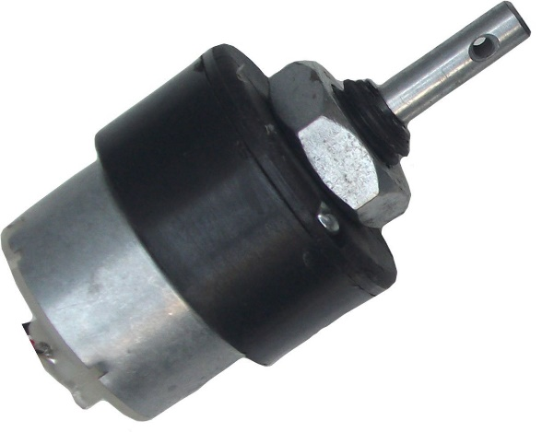](https://www.google.co.in/url?sa=i&source=images&cd=&cad=rja&uact=8&ved=2ahUKEwjhx-b81KzbAhUtuVkKHVKqDQIQjRx6BAgBEAU&url=https%3A%2F%2Fwww.amazon.in%2FRobokart-robokart_133-1000-Geared-motor%2Fdp%2FB010V2M9G4&psig=AOvVaw1wWrY5-N-2xSkzzJXwsMWu&ust=1527743170781709)

A coil of wire with a current running through it generates an electromagnetic field aligned with the centre of the coil. The direction and magnitude of the magnetic field produced by the coil can be changed with the direction and magnitude of the current flowing through it.

A simple DC motor has a stationary set of magnets in the stator and an armature with one or more windings of insulated wire wrapped around a soft iron core that concentrates the magnetic field. The windings usually have multiple turns around the core, and in large motors there can be several parallel current paths. The ends of the wire winding are connected to a commutator. The commutator allows each armature coil to be energized in turn and connects the rotating coils with the external power supply through brushes. (Brushless DC motors have electronics that switch the DC current to each coil on and off and have no brushes.)

The total amount of current sent to the coil, the coil's size and what it's wrapped around dictate the strength of the electromagnetic field created.

[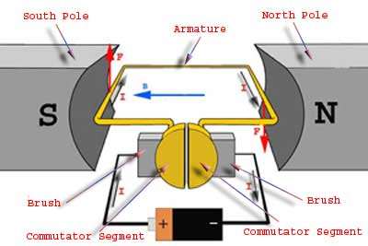](https://www.google.co.in/url?sa=i&source=images&cd=&cad=rja&uact=8&ved=2ahUKEwj5gpnW1azbAhWCm1kKHUbqDqcQjRx6BAgBEAU&url=https%3A%2F%2Felectronics.stackexchange.com%2Fquestions%2F288422%2Frelating-dc-motor-with-the-fleming-right-hand-rule&psig=AOvVaw1VZ77IhTi3gFSTGM1IhJZs&ust=1527743313663078)

The left-hand rule can be used to find the direction of the resultant force on the conductor. The left-hand rule states that if the index of the left-hand points in the direction of the magnetic flux and the middle finger points in the direction of the electric current, the thumb point in the direction of the resultant force.

[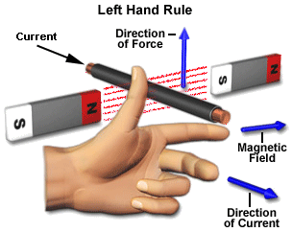](https://www.google.co.in/url?sa=i&source=images&cd=&cad=rja&uact=8&ved=2ahUKEwjBh5i_1azbAhWCtVkKHeHMDZwQjRx6BAgBEAU&url=https%3A%2F%2Fwww.electrical4u.com%2Ffleming-left-hand-rule-and-fleming-right-hand-rule%2F&psig=AOvVaw1VZ77IhTi3gFSTGM1IhJZs&ust=1527743313663078)

RELAY MODULE

[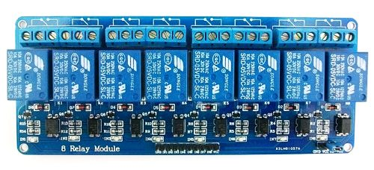](https://www.google.co.in/url?sa=i&source=images&cd=&cad=rja&uact=8&ved=2ahUKEwixjrSZyKzbAhUKp48KHTD3ADMQjRx6BAgBEAU&url=https%3A%2F%2Fwww.14core.com%2Fwiring-8-channel-optocoupler-relay-module%2F&psig=AOvVaw2YZhD9ivFcOWVQqqS3jkCn&ust=1527739682874963)

Fig. 8 Relay Module.

1.The input circuit (black loop) is switched off and no current flows through it until something (either a sensor or a switch closing) turns it on. The output circuit (blue loop) is also switched off.

2.When small current flows in the input circuit, it activates the electromagnet (shown here as a red coil), which produces a magnetic field all around it.

3.The energized electromagnet pulls the metal bar in the output circuit toward it, closing the switch and allowing a much bigger current to flow through the output circuit.

4.The output circuit operates a high-current appliance such as a lamp or an electric motor.

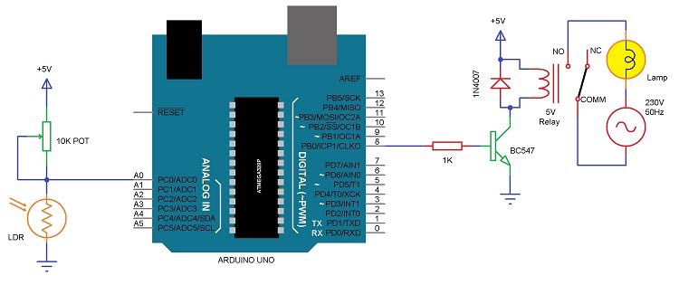

Fig. Relay Circuit

Relays are switches that open and close circuits electromechanically or electronically. Relays control one electrical circuit by opening and closing contacts in another circuit. As relay diagrams show, when a relay contact is normally open (NO), there is an open contact when the relay is not energized.

A relay is an electromagnetic switch operated by a relatively small electric current that can turn on or off a much larger electric current. The heart of a relay is an electromagnet (a coil of wire that becomes a temporary magnet when electricity flows through it). You can think of a relay as a kind of electric lever: switch it on with a tiny current and it switches on ("leverages") another appliance using a much bigger current.

Program Code

#define A 5 //wheels clock wise D1

#define B 4//wheels anti clock wise D2

#define C 0//seeder D3

#define D 2//slider clock wise D4

#define E 14//slider anti clock wise D5

#define F 12//injecting D6

#define G 13//WATERING

void setup(){

pin Mode(A,OUTPUT);

pin Mode(B,OUTPUT);

pin Mode(C,OUTPUT);

pin Mode(D,OUTPUT);

pin Mode(E,OUTPUT);

pin Mode(F,OUTPUT);

pin Mode(G,OUTPUT);

}

void loop(){

for(int k=0;k<3;k++)

{

for(int i=0;i<3;i++)

{

digital Write(A,HIGH);

digital Write(C,LOW);

delay(1000);

digital Write(A,LOW);

digital Write(F,HIGH);

delay(1000);

digital Write(F,LOW);

digital Write(C,HIGH);

digital Write(G,HIGH);

delay(500);

digital Write(G,LOW);

delay(3000);

}

{

digital Write(C,LOW);

digital Write(D,HIGH);

delay(5500);

digital Write(D,LOW);

digital Write(C,HIGH);

digital Write(G,HIGH);

delay(500);

digital Write(G,LOW);

delay(500);

}

for(int j=0;j<3;j++)

{

digital Write(B,HIGH);

digital Write(C,LOW);

delay(1000);

digital Write(B,LOW);

digital Write(F,HIGH);

delay(1000);

digital Write(F,LOW);

digital Write(C,HIGH);

digital Write(G,HIGH);

delay(500);

digital Write(G,LOW);

delay(500);

delay(3000);

}

digital Write(C,LOW);

digital Write(D,HIGH);

delay(5500);

digital Write(C,HIGH);

digital Write(D,LOW);

digital Write(G,HIGH);

delay(500);

digital Write(G,LOW);

delay(500);

}

int i, j, k=0;

for(int k=0;k<3;k++)

{

for(int i=0;i<3;i++)

{

digital Write(A,HIGH);

digital Write(C,LOW);

delay(1000);

digital Write(A,LOW);

digital Write(F,HIGH);

delay(1000);

digital Write(F,LOW);

digital Write(C,HIGH);

digital Write(G,HIGH);

delay(500);

digital Write(G,LOW);

delay(500);

delay(3000);

}

{

digital Write(C,LOW);

digital Write(E,HIGH);

delay(5500);

digital Write(E,LOW);

digital Write(C,HIGH);

digital Write(G,HIGH);

delay(500);

digital Write(G,LOW);

delay(500);

}

for(int j=0;j<3;j++)

{

digital Write(B,HIGH);

digital Write(C,LOW);

delay(1000);

digital Write(B,LOW);

digital Write(F,HIGH);

delay(1000);

digital Write(F,LOW);

digital Write(C,HIGH);

digital Write(G,HIGH);

delay(500);

digital Write(G,LOW);

delay(3000);

}

digital Write(C,LOW);

digital Write(E,HIGH);

delay(5500);

digital Write(C,HIGH);

digital Write(G,HIGH);

delay(500);

digital Write(G,HIGH);

delay(500);

digital Write(E,LOW);

}

}

Application

* Sowing, watering and pesticide/weedicide application process is automated.
* Crop growing process is made efficient for large fields.
* It is useful at time of low availability of labor.
* Possibility to improve the machine without significant design changes.
* Cost efficient
* Easy to install and operate
* Low power consumption

Disadvantages

* Initial investment is high.
* Not entirely farmer independent.
* Requires a basic educated farmer to operate.

Conclusion

Smart Farming encourages sustainable agriculture and can boost the local economy. Small farmers, entrepreneurs and even enthusiasts can enjoy the opportunity to follow the stages of evolution of agricultural crops, to be informed about soil quality and ways of conserving soil resources. They can choose the types of fertilizers and substances that will be dosed by our machine. Thus, customers can grow different types of plants and vegetables and can enjoy natural agricultural products, individually grown according to their preferences. Hence the proposed product as a high social impact and it will be boon for the authority, hospitals and other concerned people.

References

1. [www.arduinouno.com](http://www.arduinouno.com)
2. [www.busboard.com](http://www.busboard.com)
3. [www.arduino.cc/en/main/arduinoboardmega2560](http://www.arduino.cc/en/main/arduinoboardmega2560)

.

Top of Form

Bottom of Form