Question 1:

Basic Entity Relationship Diagram:

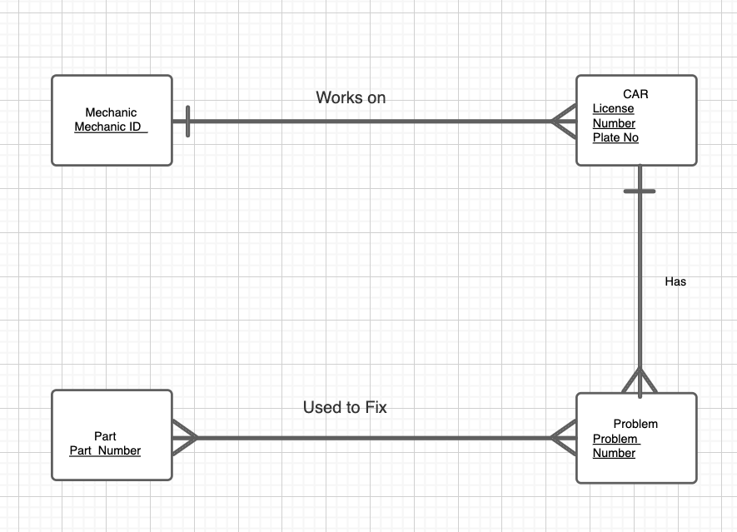

Extended Entity Relationship Diagram:

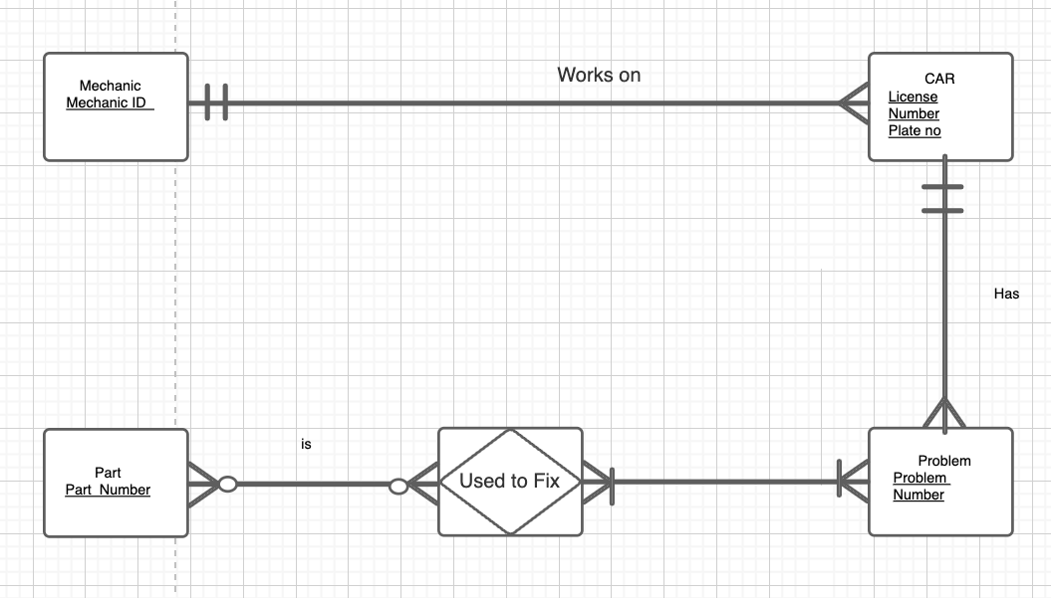

Attributes for each entity-

1. Mechanic (Name, Address,Hourly pay rate, Mechanic ID)
2. Car (License number, Date of repaired, Time when car is in, Time when car is out, Name of Mechanic assigned, plate no)
3. Parts (Description, Quantity in stock, Part no)
4. Problem (Problem Description, Labor Hours, Hourly charge rate, Problem No)

Assumptions:

1. Mechanics works on at least one car.
2. There exists more than one kind of problem for cars.

Question 2:

In my opinion, I do not think the present model could handle the new situation. The changes for the model as per me is as follows:

Basic ER Diagram-

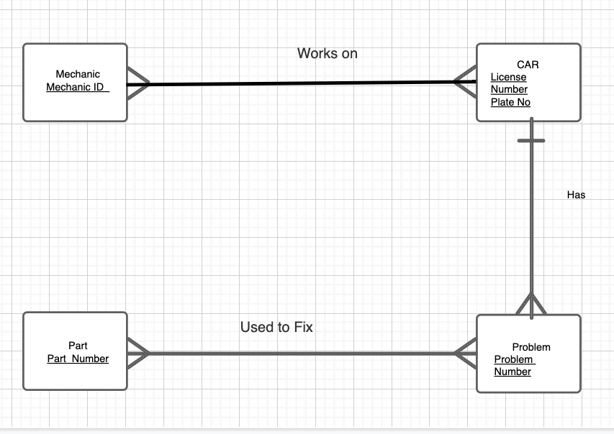

Extended Entity Relationship Diagram-

