Assignment 4

Object Modelling with UML

Q1. Use Case Diagram:

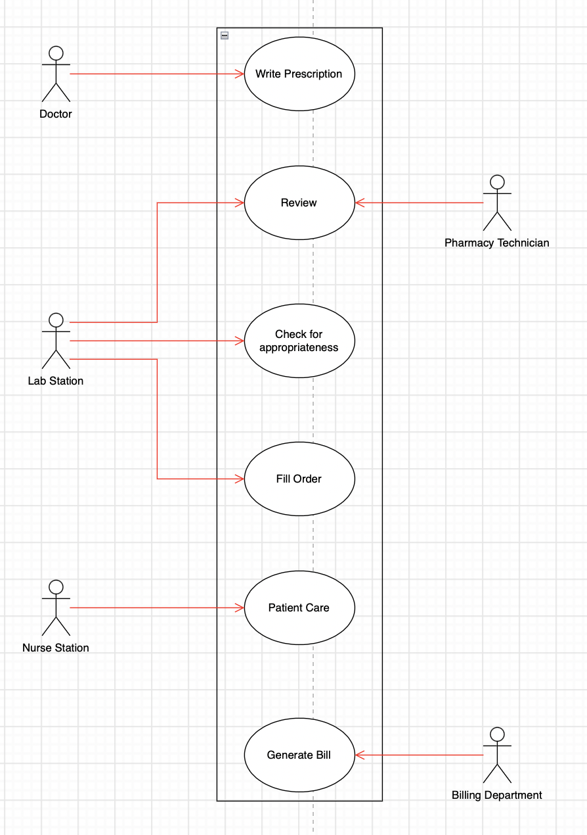

Q2. Class Diagram:

Q3. State Transition Diagram for the Pharmacy Technician:

Q4. Sequence Diagrams:

For a pharmacist at the Lab Station:

For the doctors at Mercy Hospital

