# Small SQL

rascal>displayIndex(|project://smallsql0.21_src|);

2013-11-18 22:14:43 :: Calculating lines of code...

2013-11-18 22:14:43 :: -- Result: 24111 lines of code found. Score: 5

2013-11-18 22:14:43 :: Calculating cyclomatic complexity...

2013-11-18 22:16:19 :: -- Result: Cycl complexity score: 1. Details: ("VERY HIGH":10.4018912500,"MODERATE":8.63921031900,"SIMPLE":59.0892123900,"HIGH":9.32769275400)

2013-11-18 22:16:19 :: Calculating duplicate lines...

2013-11-18 22:19:00 :: debug: total dupes: 9136

2013-11-18 22:19:00 :: -- Result 28% of duplicate code found. Score: 1.

2013-11-18 22:19:00 :: Calculating size per unit...

2013-11-18 22:19:53 :: Total size: 24111.

2013-11-18 22:19:53 :: Very high: 1990.

2013-11-18 22:19:53 :: High: 2504.

2013-11-18 22:19:53 :: Medium: 8561.

2013-11-18 22:19:53 :: Very high: 8%.

2013-11-18 22:19:53 :: High: 10%.

2013-11-18 22:19:53 :: Medium: 36%.

2013-11-18 22:19:53 :: -- Result: all methods initialized. Score: 1.

2013-11-18 22:19:53 :: Calculating unittest coverage...

2013-11-18 22:20:23 :: -- Result: 2124/1634 (76.9303201500%) methods invoked. Score: 3.

2013-11-18 22:20:23 :: Product properties:

Duplication: --

Complexity: --

UnitTesting: o

Volume: ++

UnitSize: --

2013-11-18 22:20:23 :: Maintainability index:

Changeability: --

Stability: o

Analisability: o

Testability: -

2013-11-18 22:20:23 :: Overall index: -

Ok

# Small SQL

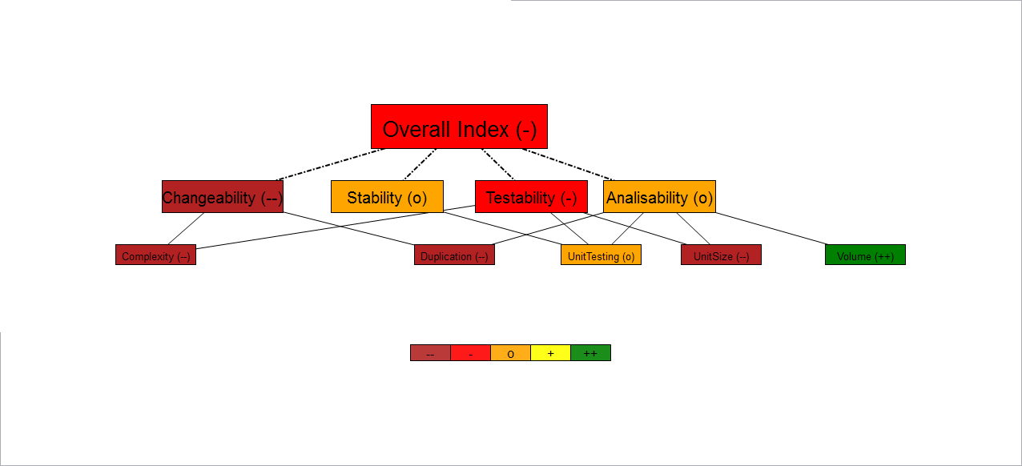

# HSQLDB

# HSQLDB

rascal>displayIndex(|project://hsqldb-2.3.1|);

2013-11-18 22:15:33 :: Calculating lines of code...

2013-11-18 22:15:33 :: -- Result: 168932 lines of code found. Score: 4

2013-11-18 22:15:33 :: Calculating cyclomatic complexity...

2013-11-18 22:27:46 :: -- Result: Cycl complexity score: 1. Details: ("VERY HIGH":12.5186465600,"MODERATE":15.0646413900,"SIMPLE":48.5059077000,"HIGH":13.6362560100)

2013-11-18 22:27:46 :: Calculating duplicate lines...

2013-11-19 00:22:23 :: debug: total lines: 243200

2013-11-19 00:22:23 :: debug: total dupes: 67080

2013-11-19 00:22:23 :: -- Result 28% of duplicate code found. Score: 1.

2013-11-19 00:22:23 :: Calculating size per unit...

2013-11-19 00:32:24 :: Total size: 168932.

2013-11-19 00:32:24 :: Very high: 30416.

2013-11-19 00:32:24 :: High: 24520.

2013-11-19 00:32:24 :: Medium: 64809.

2013-11-19 00:32:24 :: Very high: 18%.

2013-11-19 00:32:24 :: High: 15%.

2013-11-19 00:32:24 :: Medium: 38%.

2013-11-19 00:32:24 :: -- Result: 168932 methods initialized. Score: 1.

2013-11-19 00:32:24 :: Calculating unittest coverage...

2013-11-19 00:36:41 :: -- Result: 10228/6338 (61.9671490000%) methods invoked. Score: 3.

2013-11-19 00:36:41 :: Product properties:

Duplication: --

Complexity: --

UnitTesting: o

Volume: +

UnitSize: --

2013-11-19 00:36:41 :: Maintainability index:

Changeability: --

Stability: o

Analisability: -

Testability: -

2013-11-19 00:36:41 :: Overall index: -

ok