# Small SQL

rascal>displayIndex(|project://smallsql0.21_src|);

2013-11-19 07:28:56 :: Calculating lines of code...

2013-11-19 07:28:56 :: -- Result: 24111 lines of code found. Score: 5

2013-11-19 07:28:56 :: Calculating cyclomatic complexity...

2013-11-19 07:30:10 :: -- Result: Cycl complexity score: 1. Details: ("VERY HIGH":10.4018912500,"MODERATE":8.63921031900,"SIMPLE":59.0892123900,"HIGH":9.32769275400)

2013-11-19 07:30:10 :: Calculating duplicate lines...

2013-11-19 07:32:24 :: debug: total lines: 33029

2013-11-19 07:32:24 :: debug: total dupes: 9136

2013-11-19 07:32:24 :: -- Result 28% of duplicate code found. Score: 1.

2013-11-19 07:32:24 :: Calculating size per unit...

2013-11-19 07:33:07 :: Total size: 24111.

2013-11-19 07:33:07 :: Very high: 1990.

2013-11-19 07:33:07 :: High: 2504.

2013-11-19 07:33:07 :: Medium: 8561.

2013-11-19 07:33:07 :: Very high: 8%.

2013-11-19 07:33:07 :: High: 10%.

2013-11-19 07:33:07 :: Medium: 36%.

2013-11-19 07:33:07 :: -- Result: all methods initialized. Score: 1.

2013-11-19 07:33:07 :: Calculating unittest coverage...

2013-11-19 07:33:34 :: -- Result: 2124/1634 (76.9303201500%) methods invoked. Score: 3.

2013-11-19 07:33:34 :: Product properties:

Duplication: --

Complexity: --

UnitTesting: o

Volume: ++

UnitSize: --

2013-11-19 07:33:34 :: Maintainability index:

Changeability: --

Stability: o

Analisability: o

Testability: -

2013-11-19 07:33:34 :: Overall index: -

ok

# Small SQL

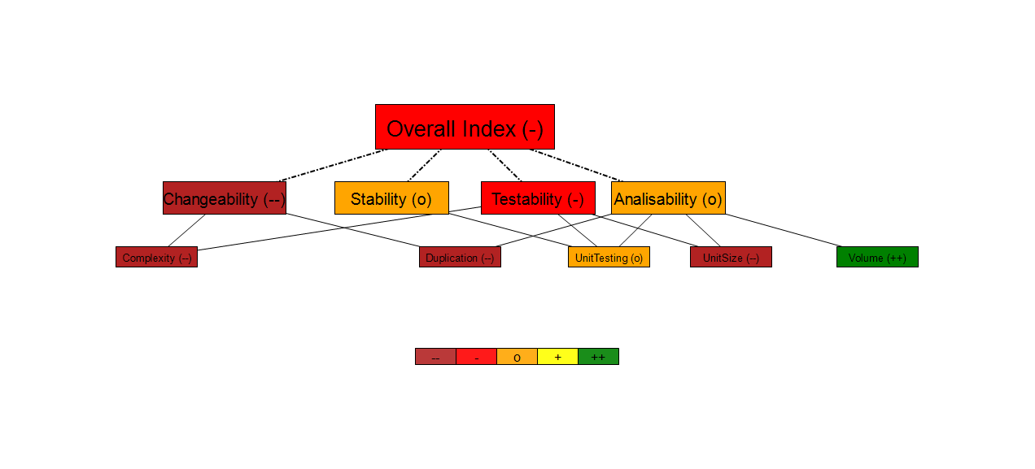

# HSQLDB

# HSQLDB