CASE TOOLS LAB-2

SWE 513

FACULTY: Prof.Aparna
Name:D.Deepika
Regno:13mse1031
Date:01-08-2017

SCRUMWISE Tool

Project Creation
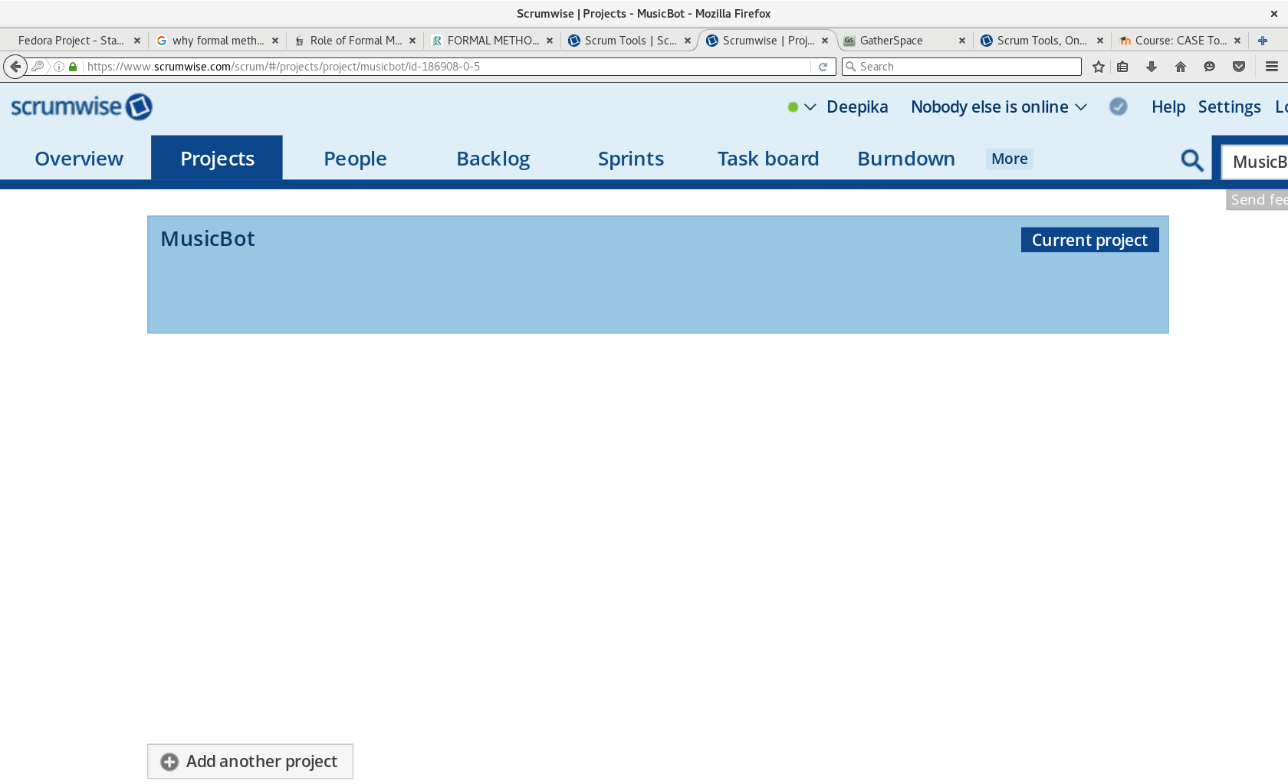

Adding stakeholders
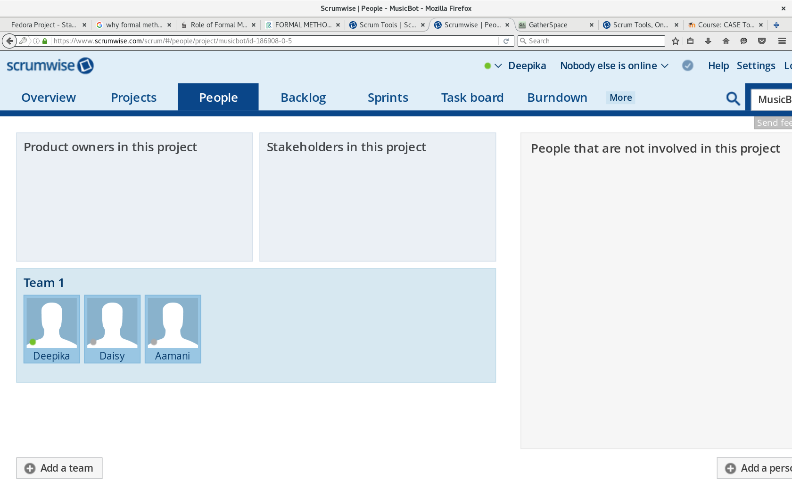

Creating Backlogs
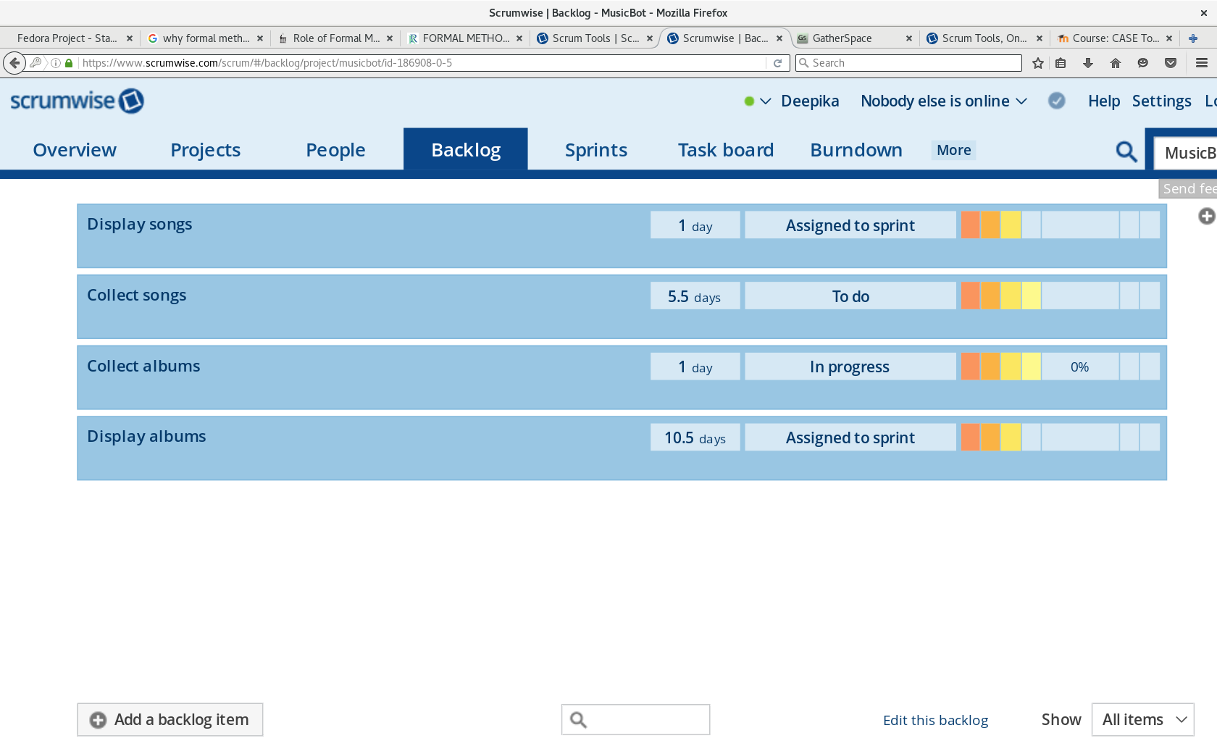
Creating sprints
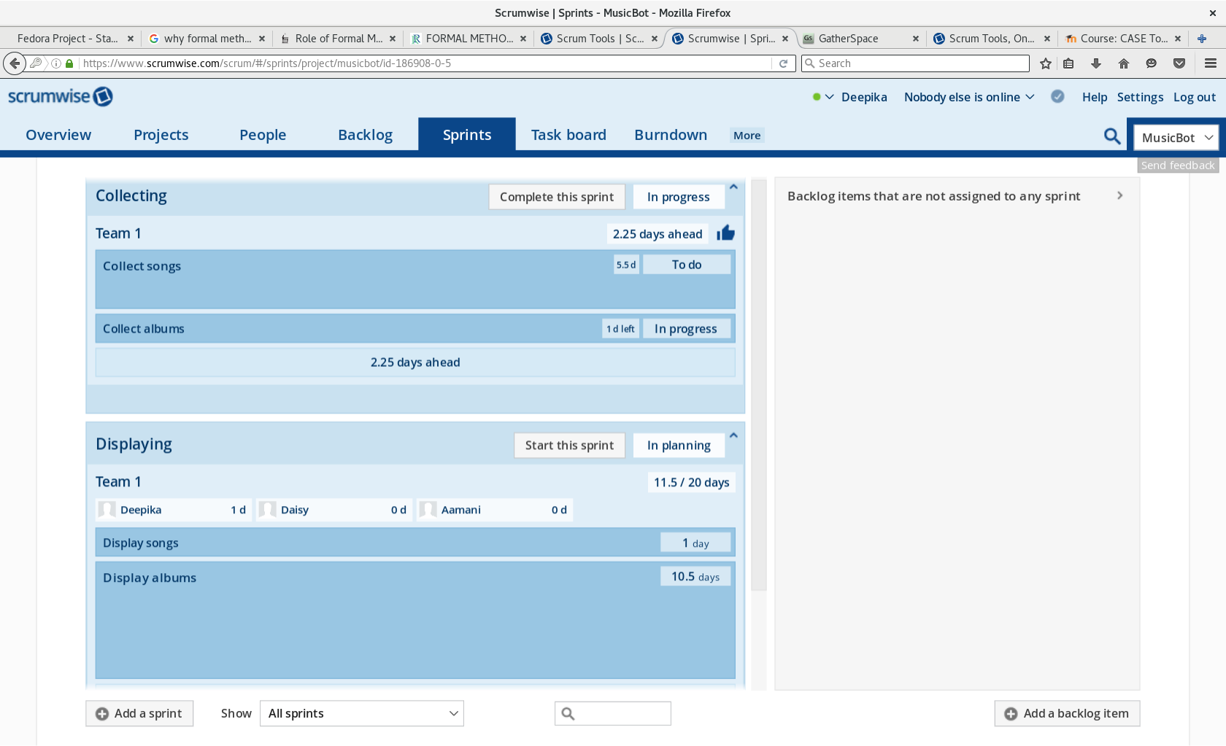
Creating tasks
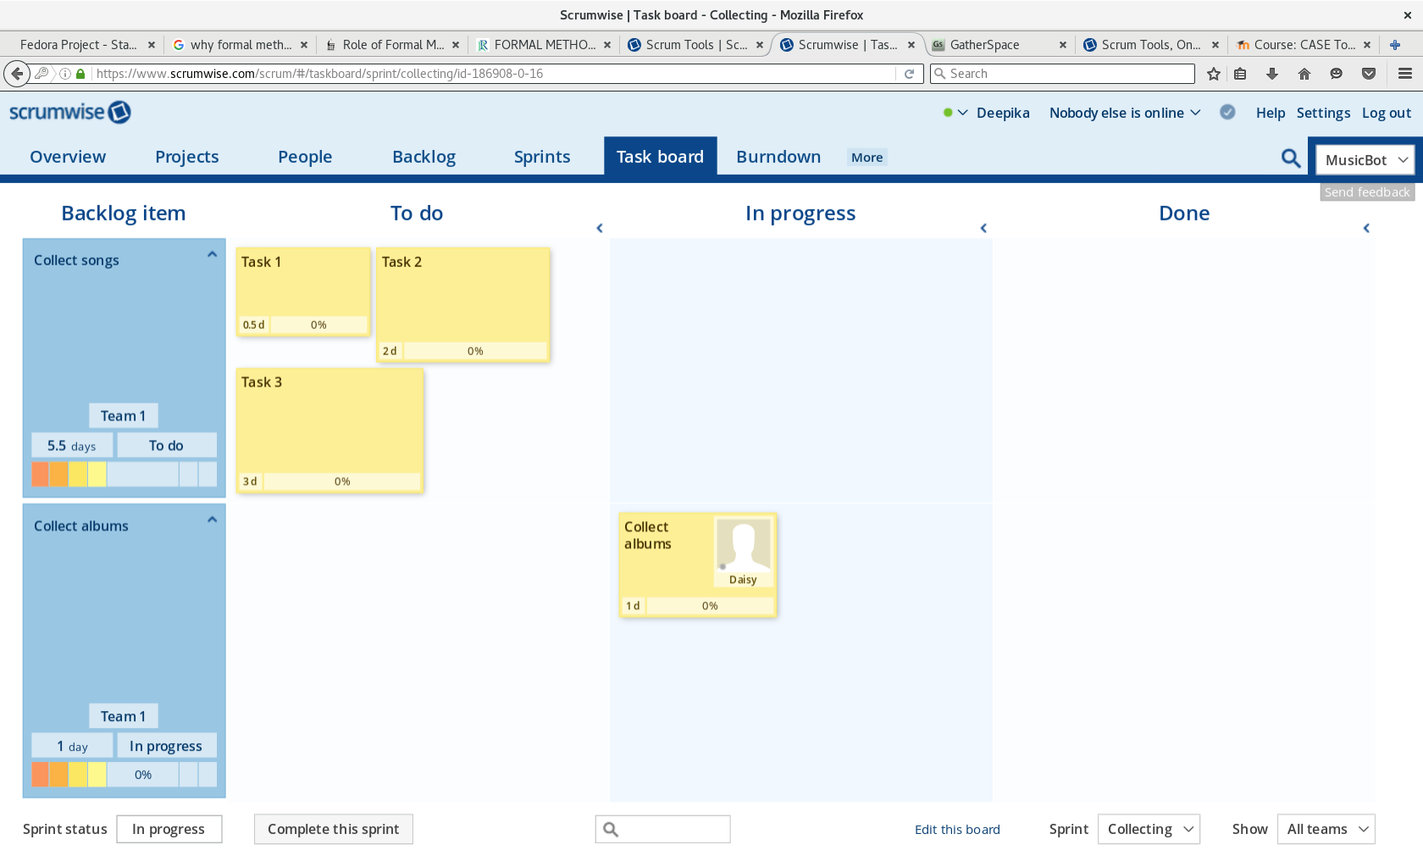
Burn down
