**THE STATE UNIVERSITY OF ZANZIBAR**



**SCHOOL OF COMPUTING COMMUNICATION AND MEDIA STUDIES**

**DEPARTMENT OF COMPUTER SCIENCES AND INFORMATION TECHNOLOGY**

**TUNGUU CAMPUS**

**PROJECT TITLE: JOB APPLICATION SYSTEM**

**LECTURER: MR. MASOUD.H. MMANGA** **COURSE**

**NAME: RUKAYYA RAJAB OMAR**

**BITAM/9/21/039/TZ**

**Link: https://github.com/ruuomar/report.git**

**Introduction**

**Problem Statement**

The system that exist up is manual system. The current job application process is paper based, which lead to different problem, for example time consuming Manual job applications require candidates to fill out physical forms or submit printed, Limited Accessibility, Lack of Real-Time Updates and poor data security also Environmental Impact: The reliance on paper-based applications contributes to paper waste and has a negative impact on the environment.so this situation sometimes peoples occurs corruption which it is very problem in the country.

**OBJECTIVES**

The main objective of this proposed system is to shift from manually system that contains many Problems into computerized system that will help to solve all of the problems that face the Current system. Also in economical will successful since there is enough money to buy devices such as Computers and other resources that will enable to complete such system.

Challenge of current existing system

The current job application process is paper based, which lead to different problem, for example time consuming Manual job applications require candidates to fill out physical forms or submit printed, Limited Accessibility, Lack of Real-Time Updates and poor data security also Environmental Impact: The reliance on paper-based applications contributes to paper waste and has a negative impact on the environment.so this situation sometimes peoples occurs corruption which it is very problem in the country.

**Proposed solution**

System will allow applicant to register which involves national id and hence is enough possible to restrict the use of inaccurate data.

System will allow company to send job vacancy, which can be applied by applicants.

System ensures security as it allows only authorized person to reach their roles.

Data losses will be highly reduced and if happen, recovery is available.

System will select qualified applicants and hence ensures competent will be hired to increase organizational performance.

Administrator will be available if any happen.

**DELIVERABLES**

Software available

Well function of the system

**Requirements**

Functional Requirement

|  |  |
| --- | --- |
| REQ001 | Remove all jobs from their current apply |
| REQ002 | Login in the system |
| REQ003 | Large availability to make all of them to be performed |
| REQ004 | Select job |
| REQ005 | allow the user to insert data |

NON-FUNCTIONAL REQUIREMENT

These are the requirements that have no important to be entered within the system during system developing period. The following are the non-functional requirements according to the system that I propose (JOB APPLICATION MANAGEMENT SYSTEM) :-

|  |  |
| --- | --- |
| REQ001 | Modify to support and work on different language |

Security requirement

|  |  |
| --- | --- |
| REQ001 | User permission |
| REQ002 | password |
| REQ003 | Time limits |

**System use**

Applicant: an applicant is the user in the system that able to create account and apply for job vacancies. They will need to fill required information in order to apply

Administretor:user in the system that able to view applicant also send job for the view applicant

**Requirements system**

Web browser

**Home page**

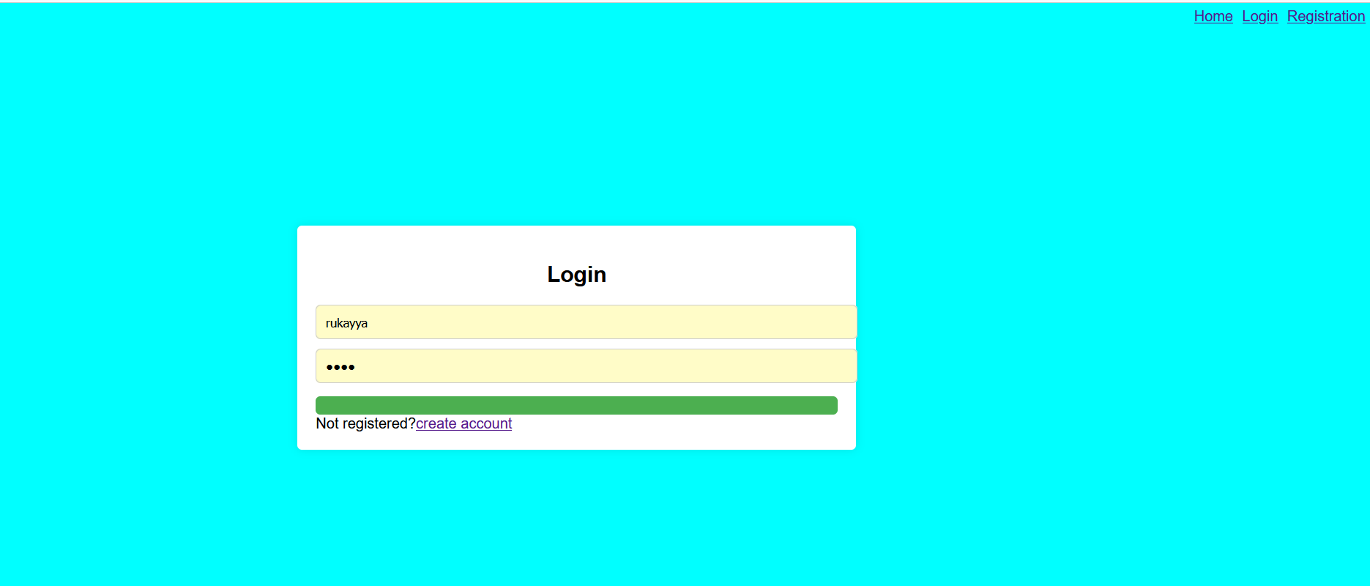

Home page contain the following features

Job: display the list of job

Login: allow registration user to login in an account

Registration: user create account before apply

**Registration:**

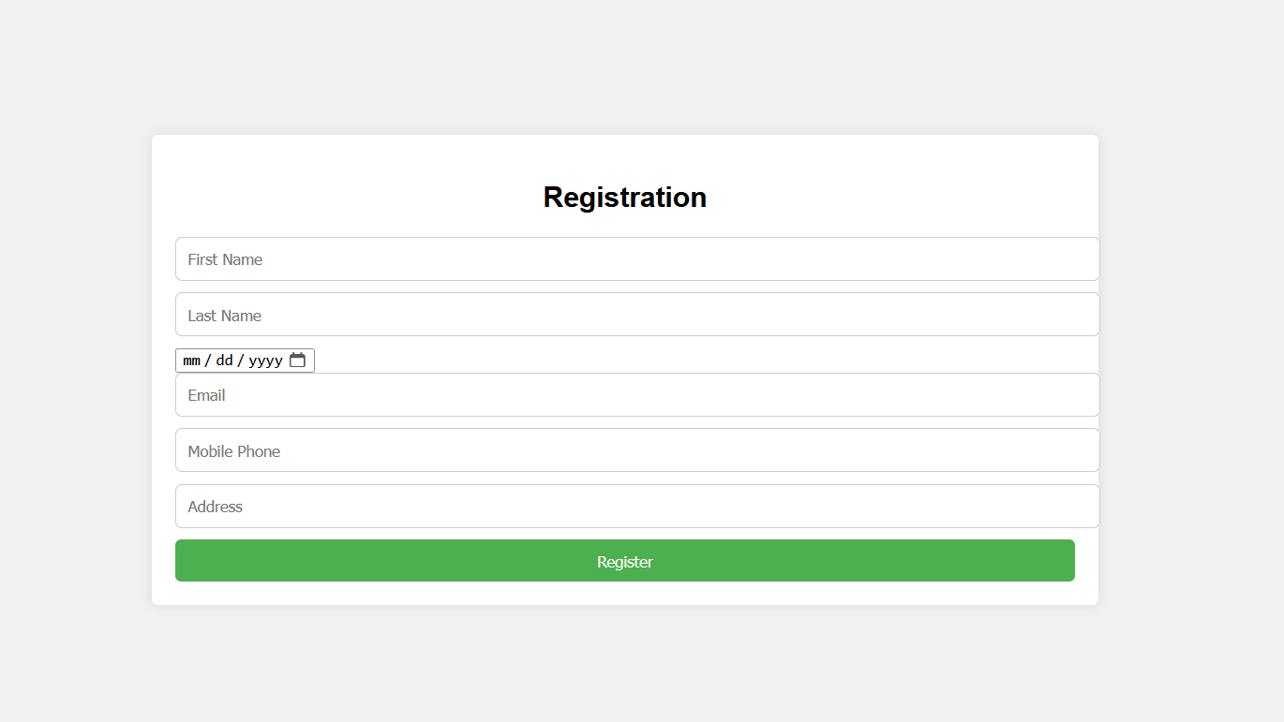

Enter your first name, last name, birth of date, email, mobile phone and Address. click button ‘registration’ for continues

Login:



**Dashboard:**

After login you will be taken to the applicant dashboard. the top menu will contain the button to access job, application, data

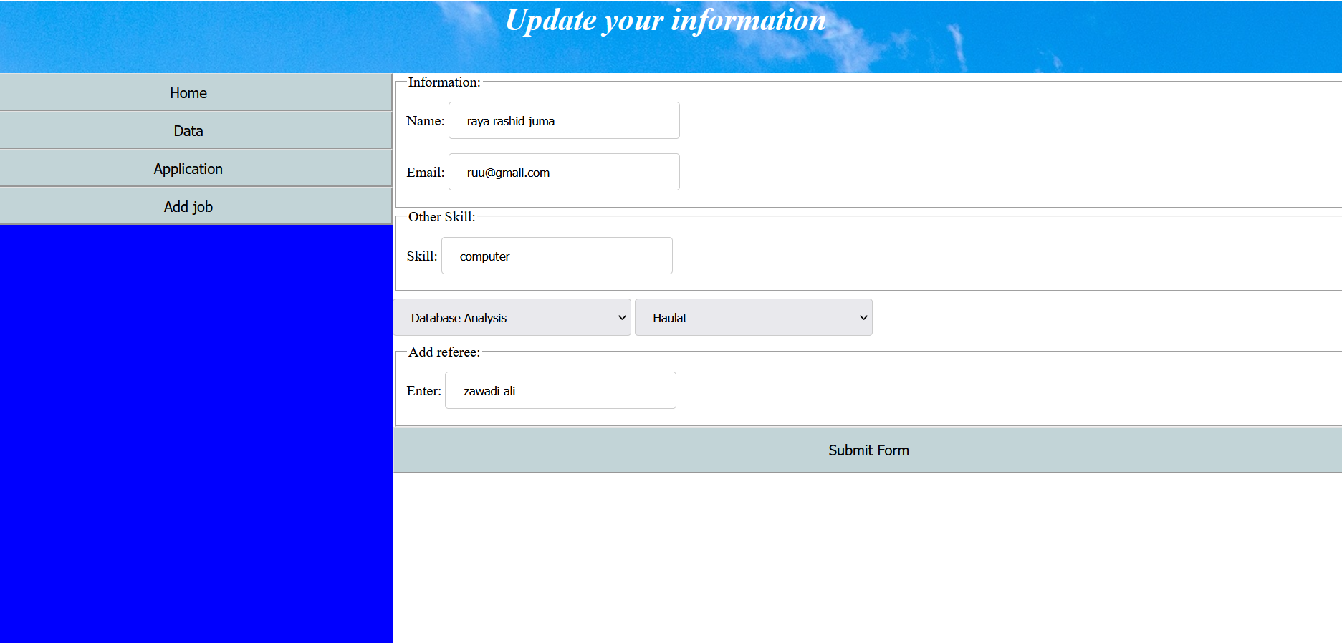

Job: display the list of job

Application: this is form for apply

Data: this show all applicant which is apply

This is the data from my database which show all applicant resisted

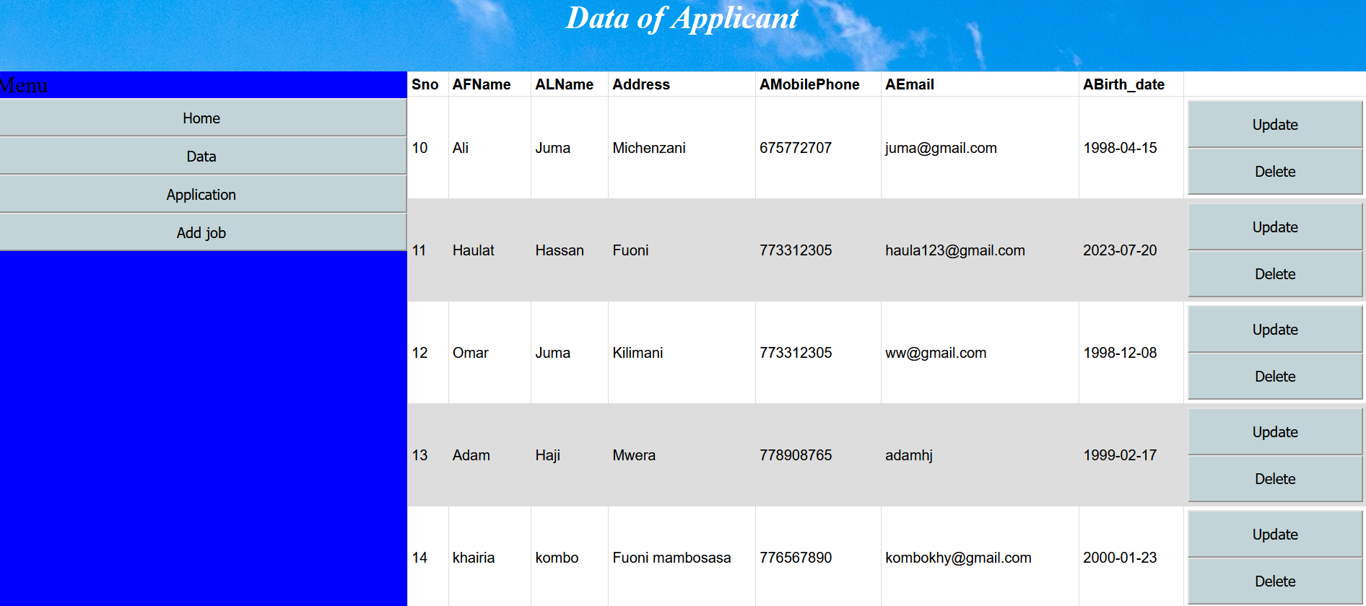

In the system contain three table such as job for the add jobs administrator, applicant and apps for store detail information for Applicant

