**Java Project**

**Documentation Requirements:**

1. Briefly explains the requirements and specification of the project
   1. Client login page:
      1. If the admin wants to sign in, then we have an admin mode option that will redirect the user to the admin login page.
      2. We have a login page where the customer should be able to log in and view all the flights.
      3. On the login page, we have a signup button where new customers can create and register new account.
      4. We also have forgot password button where customer can retrieve their password by giving a few account details and answering the security question.
   2. Admin mode login page:
2. The admin mode page lets the admin log in.
3. Once the login is verified the applications redirects the user to admin flight details page.
   1. Client flight details:
      1. At the client logged in page, the client’s name is displayed on the top left corner.
      2. The client has required fields to filter the search to get the desired flight details. The options are as follows:
         * Leaving from: the client selects the origin state they are travelling from.
         * Going To: the client selects the destination state they are travelling to.
         * Departing: the client selects the date they want to travel on.
         * Returning: the client selects the date they want the return flight on.
      3. After adding all the fields mentioned above, the client will be able to see the flights based of the selection.
      4. The client can then add the flight to their profile after double clicking on the flight they want to add. If the flight is not added before to the client’s profile, the flight will get added. Otherwise, a message will pop up stating that, the selected flight was already added to the client’s profile.
      5. The client can then check their profile by clicking the Check your profile button.
      6. The client can also log out using the Logout button on the top right corner which will direct the user to client login page.
   2. User profile page:
      1. At the client user page, the client’s name is displayed on the top left corner.
      2. The client should be able to see all the selected flights selected by the user.
      3. The user will also have an option the delete any selected flight by highlighting the flight to delete and clicking on the Delete selected flight button.
      4. The user can also add more flight by clicking Go back to select more flight button, which will re direct the user to the client flight details page.
      5. The user can also log out using the Logout button on the top right corner which will direct the user to client login page.
   3. Admin flight details page:
      1. The admin flight details let the admin view all the flights that exists based on the filter just like the client login page but with an addition of selecting the client for which the admin can check the selected flights.
      2. The admin can add new, delete/update flights using the Add/View/Update available flight button.
      3. Admin can also delete a flight using the Delete row button which will delete the admin selected flight.

1. Showing the class diagram using UML:
   1. Hello Controller:

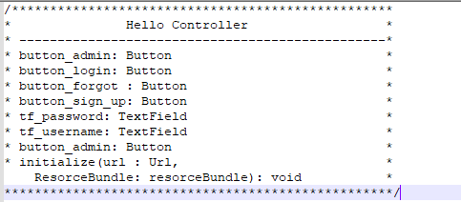

* 1. Logged In Controller:

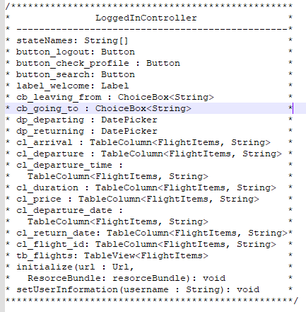

* 1. Signup Controller:

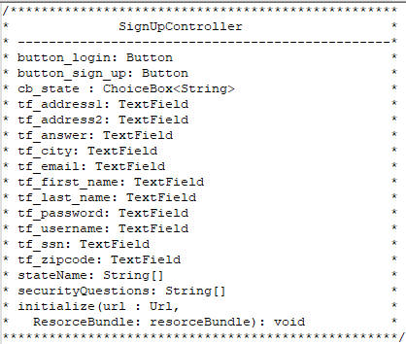

* 1. Forgot password Controller:

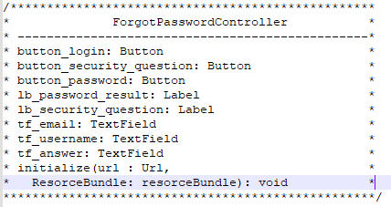

* 1. User Profile Controller:

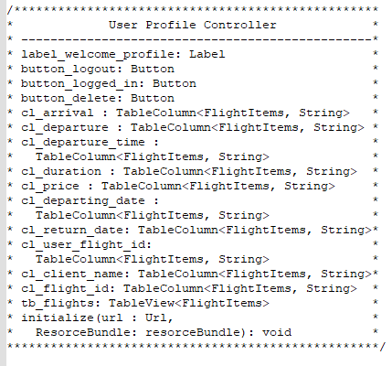

* 1. Admin Sign in Controller:

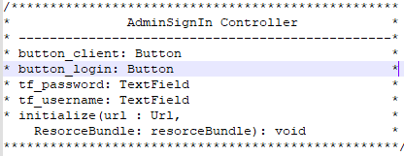

* 1. Admin Logged in Controller:

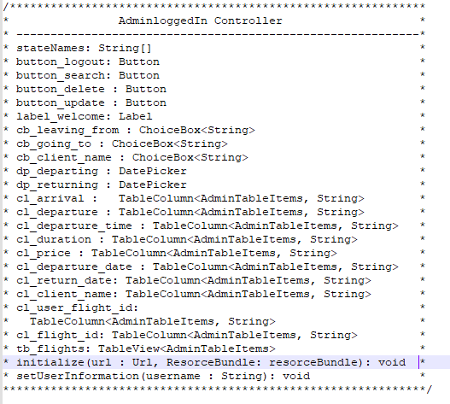

* 1. Admin Flight Look up Controller:

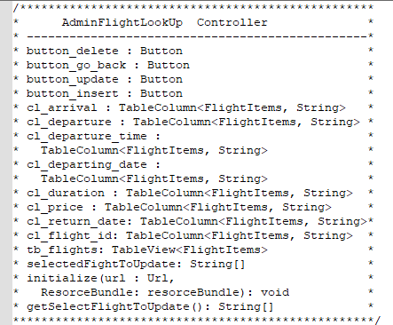

* 1. Admin Insert Controller:

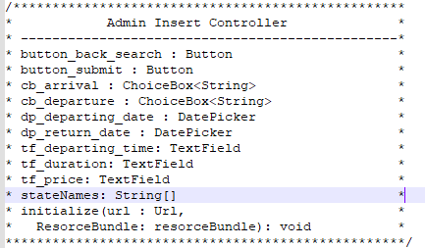

* 1. Admin Update Controller:

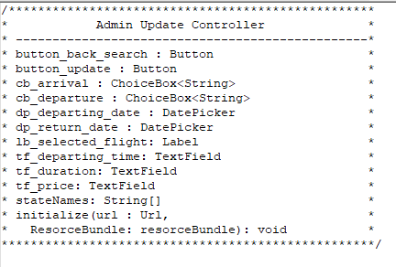

* 1. Admin Table Items

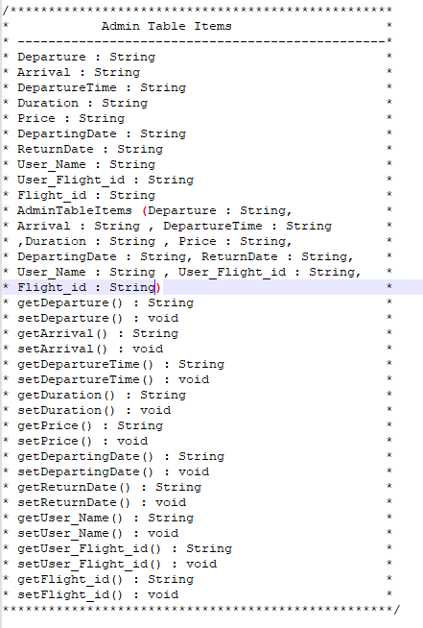

* 1. DB Utils:

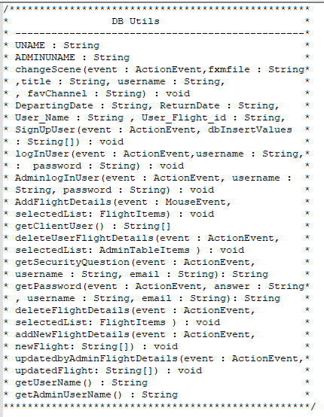

* 1. Flight Items:

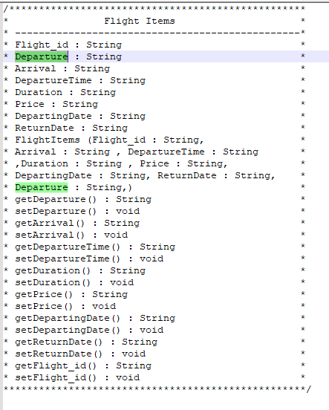

* 1. Table Items:

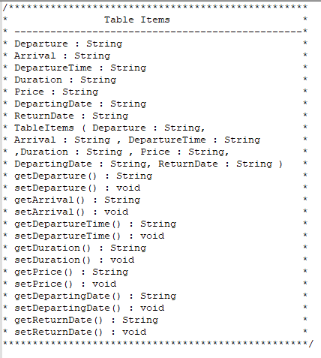

1. Showing the Data Model (Tables and all the PKs and FKs)

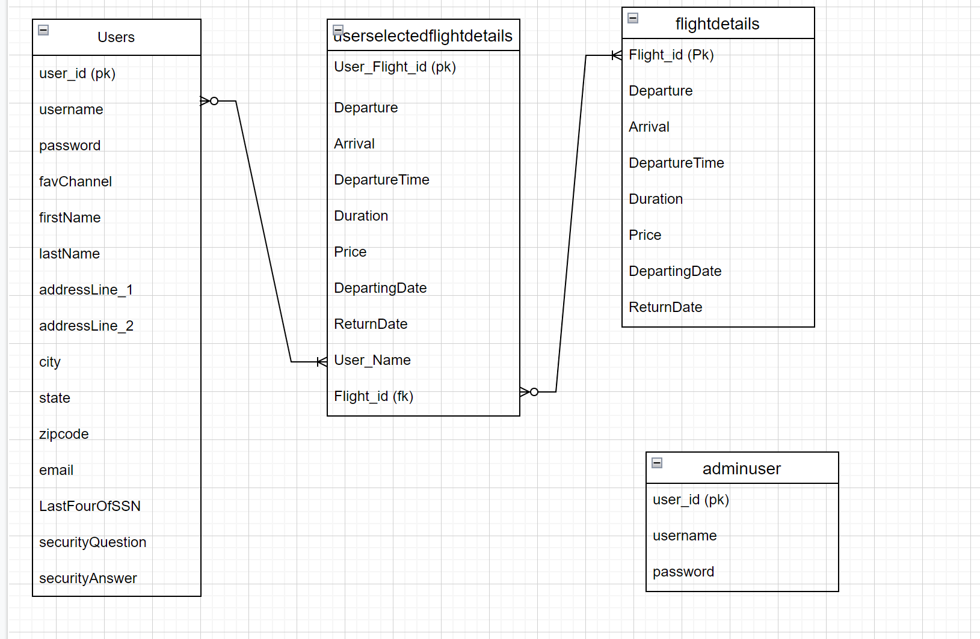

Creating Table Queries:

CREATE TABLE `users` (

`user_id` int(11) NOT NULL AUTO_INCREMENT,

`username` varchar(45) NOT NULL,

`password` varchar(45) NOT NULL,

`favChannel` varchar(45) NOT NULL,

`firstName` varchar(45) NOT NULL,

`lastName` varchar(45) NOT NULL,

`addressLine_1` varchar(45) NOT NULL,

`addressLine_2` varchar(45) DEFAULT NULL,

`city` varchar(45) NOT NULL,

`state` varchar(45) NOT NULL,

`zipcode` varchar(45) NOT NULL,

`email` varchar(45) NOT NULL,

`LastFourOfSSN` varchar(45) NOT NULL,

`securityQuestion` varchar(45) NOT NULL,

`securityAnswer` varchar(45) NOT NULL,

PRIMARY KEY (`user_id`)

) ENGINE=InnoDB AUTO_INCREMENT=95 DEFAULT CHARSET=utf8;

CREATE TABLE `userselectedflightdetails` (

`User_Flight_id` int(11) NOT NULL AUTO_INCREMENT,

`Departure` varchar(90) NOT NULL,

`Arrival` varchar(90) NOT NULL,

`DepartureTime` varchar(90) NOT NULL,

`Duration` varchar(45) NOT NULL,

`Price` varchar(45) NOT NULL,

`DepartingDate` varchar(45) NOT NULL,

`ReturnDate` varchar(45) NOT NULL,

`User_Name` varchar(45) NOT NULL,

`Flight_id` varchar(45) NOT NULL,

PRIMARY KEY (`User_Flight_id`)

) ENGINE=InnoDB AUTO_INCREMENT=54 DEFAULT CHARSET=utf8.

CREATE TABLE `flightdetails` (

`Flight_id` int(11) NOT NULL AUTO_INCREMENT,

`Departure` varchar(90) NOT NULL,

`Arrival` varchar(90) NOT NULL,

`DepartureTime` varchar(90) NOT NULL,

`Duration` varchar(45) NOT NULL,

`Price` varchar(45) NOT NULL,

`DepartingDate` varchar(45) NOT NULL,

`ReturnDate` varchar(45) NOT NULL,

PRIMARY KEY (`Flight_id`)

) ENGINE=InnoDB AUTO_INCREMENT=115 DEFAULT CHARSET=utf8.

CREATE TABLE `adminuser` (

`user_id` int(11) NOT NULL AUTO_INCREMENT,

`username` varchar(45) DEFAULT NULL,

`password` varchar(45) DEFAULT NULL,

PRIMARY KEY (`user_id`)

) ENGINE=InnoDB AUTO_INCREMENT=5 DEFAULT CHARSET=utf8.

1. Briefly explains about functionality and flow of the program
   1. Application Launches with Login page
   2. On the Login page:
      1. Customers can log in if they have existing an account on the Application.
      2. If the Customer is a first-time user, they can Sign up and then log in to the Application.
      3. If Customers have an account and they have forgotten their password, they can click on forgot password and retrieve their password after answering the security Question.
   3. After the Customer logs in, they will see the Flight filter page where the Customer can add a flight
   4. Customers can view all the selected flights using the check your profile button where they can delete the flight they added.
   5. From the login page Admin can redirect themselves to Admin login page using the Admin Login Button where Admin can:
      1. Add a flight
      2. Delete a flight
      3. Update the existing flight